1. Clone data from the Shippers table to the NewShippers table.

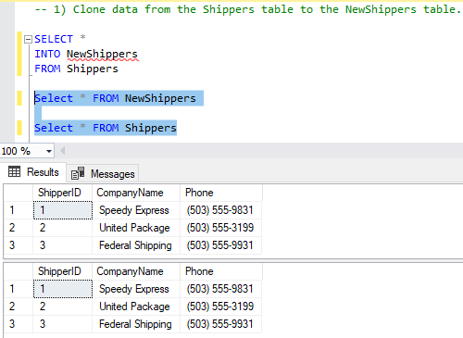

2) Find the set of products (Product Name) and maximum value of units in stock for each one,

-- which is in the range from 25 to 50. Represent records from the min to max value of units in stock.

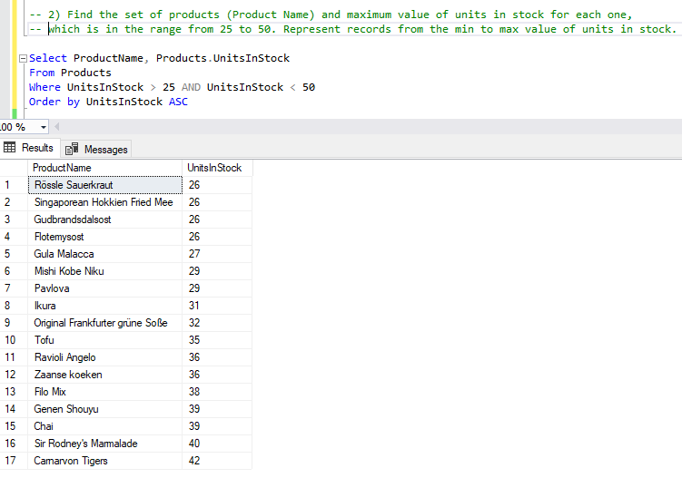

1. Get the list of total quantities of ordered products which consists of: total quantity ordered in Germany and the total quantiy\* 0.7% of products ordered in Sweden. (Result should contain 2 rows)

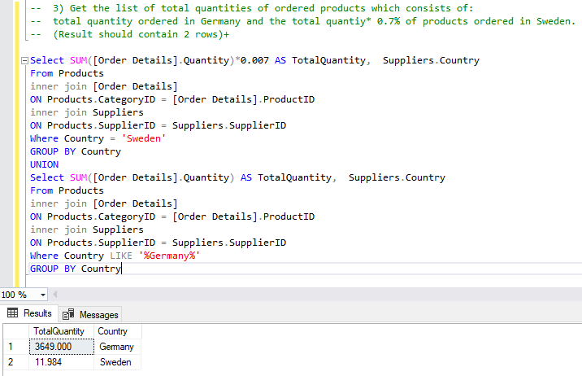

1. Find the list of different countries in Employees and Customers tables.

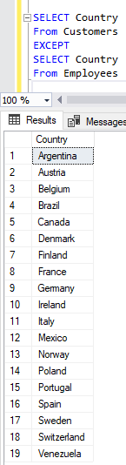

1. Find the list of the same Postal Codes between Suppliers and Employees tables.

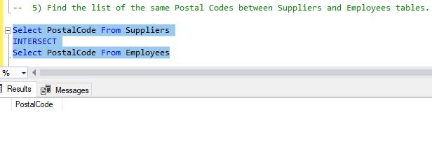

1. Find the top region from which sales specialists were hired.

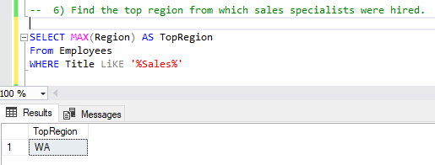

1. Get two lists of products: with a price < 50.00 with a discountinued flag and < 50 without a discountinued flag.

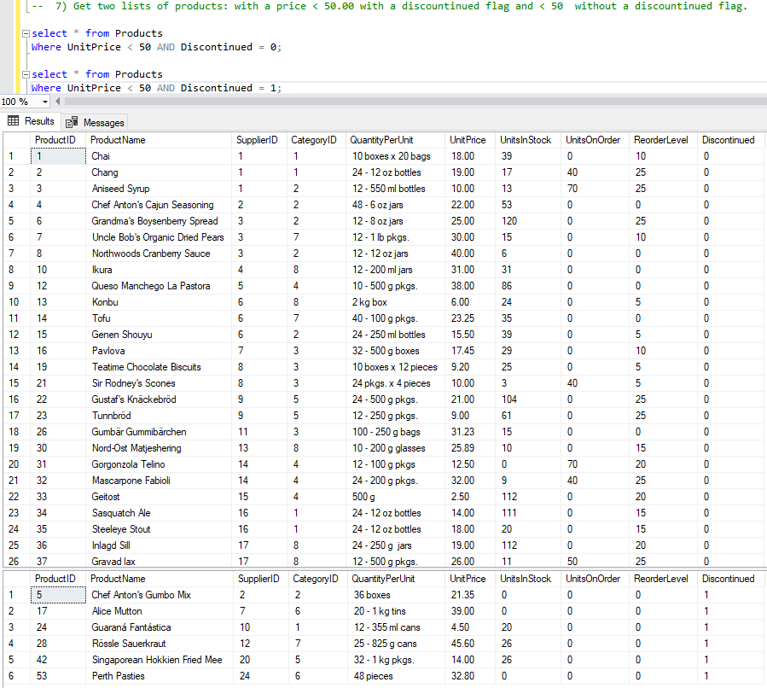

8) Create new table NewProducts based on the Products table with only discountinued products. Compare data sets between Products and NewProducts tables. (Check that only discountinued products are inserted).

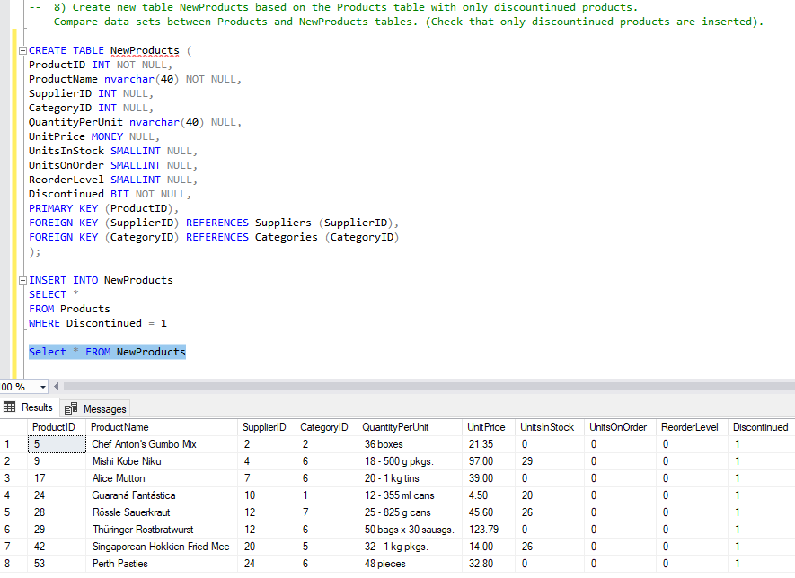

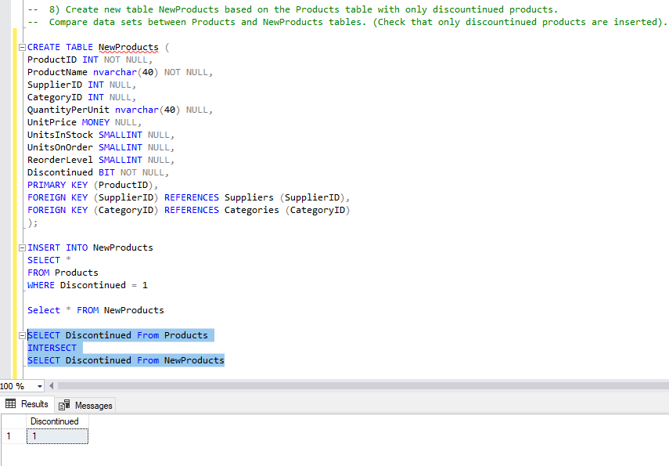

The 9th query is optional

\* Get the list of orders, where a required date is bigger than the Shipped date ( compare in days) and Ship Region is not specified.

