TANK ARENA

Game Design Document

##### Copyright notice / author information / boring legal stuff nobody likes

##### 

## *Index* Index

1. Index
2. Game Design
   1. Summary
   2. Gameplay
   3. Mindset
3. Technical
   1. Screens
   2. Controls
   3. Mechanics
4. Level Design
   1. Themes
      1. Ambience
      2. Objects
         1. Ambient
         2. Interactive
      3. Challenges
   2. Game Flow
5. Development
   1. Abstract Classes
   2. Derived Classes
6. Graphics
   1. Style Attributes
   2. Graphics Needed
7. Sounds/Music
   1. Style Attributes
   2. Sounds Needed
   3. Music Needed
8. Schedule

Game Design  


## Summary

A mix between Jets N Guns upgrades and weapons shopping with arena tank battles!

## Gameplay

* 1. What should the gameplay be like?  
     Player spends time in shop buying parts for their tank and weapons for their tank.  
     After they are satisfied, player goes to the arena to fight waves of other tanks

1. What is the goal of the game, and what kind of obstacles are in the way?  
   Goal is to keep earning more and more, upgrading tank features farther and farther until you can defeat the final arena and become ultimate tank arena champion.   
   The obstacles include other enemy tanks and arena traps that can affect either you or them
2. What tactics should the player use to overcome them?  
   Player should maneuver their tank to avoid traps and shots from opponent tanks. Player should also use some form of shielding. They should overcome their enemies by shooting at them with their weapons and using their character special abilities.

## Mindset

This can make the player feel powerful and self-reliant once they have the cash. More than that, this will make them feel smart for understanding ways to use the terrain and traps to their advantage, ultimately winning against a stronger AI opponent through their cunning. Player will feel good about choosing the sort of upgrade path that makes their life easier.

Technical

## Screens

1. Title Screen
   1. New Game
   2. Load Game (game save holds current tank configuration, current winnings and stats)
   3. Options
      1. Music Volume
      2. Traps toggle
      3. Difficulty
   4. Tutorial (separate full level thing)
   5. Exit
2. Character Select (when starting new game)  
   The player selects which character they will play as. This will impact their special abilities and their starting gear.
3. Level Select  
   Selection of the desired play arena stage. Arenas are different terrains with different amounts of waves of enemies to grind for cash. Known arena info is displayed for convenience (a wave becomes known after it has been conquered)
4. Shop  
   Player spends their time strategically preparing for the fight, picking the best loadout for the situation given the money (also contains info about arena waves somewhere for reference)
5. Arena Scene 1..N  
   Arena has basic landscapes and traps in some locations. Enemies spawn at determined points and come in waves
6. Post arena victory scene 1..N
7. End Credits

## Controls

**During arena combat.** Player will use twin stick controls to independently move tank and rotate main cannon tower for aiming. One 4 directional set will steer tank forward/back and make it turn CW or CCW. Other set of rotations will make the turret move CW or CCW.

There will be controls assigned to 5 weapon groups. To shoot a weapon, player presses the button corresponding to that group. By default all weapons are in group 1.

**During shop.** When buying a weapon, the player selects from 2 sections - mains and sides. The player selects from a list (JnG style) and reads about their various properties, then selects where to slot them on the tank body and they are good to go.

In the components purchase tab there are 3 sections - turrets, chassis and internal parts. The player selects the items they want from the corresponding lists with details, similar to weapons and then get them on the tank (in case of chassis and turret this is a replacement, but for others, the parts might duplicate)

**Overall.** Players will always be able to bring up a menu type thing to exit or restart game. They can also reload or save their current progress using this menu.

## Mechanics

**Arena mechanics:** Tanks should ride around and shoot each other in a tank-like manner, with chassis and turret being spun independently of each other. The tank should feel heavy to move, be maneuverable and leave trails on the arena. Tanks should feel the impact of the hit provided by the projectiles they shoot each other with.

Traps should affect tanks, but not completely destroy chances of winning.

Player should always be able to use their special skill, assuming it’s not busy recharging.

Players get afforded cash prizes when the waves end. They can also get afforded different sums for killing each kind of enemy, tank or otherwise..

**Shop mechanics:** All the weapons go on a tank turret. The turret can have many slots for both tank mains and supplementaries. All non-weapon components go on the chassis, just like the turret itself.

The chassis determines the base construction durability of the tank. On top of this, several types of things can be added, like and engine, tracks, armor plating, shield generator, etc. When a chassis is bought, it has a standard set of tracks and engine out of the box. These are worthless to sell, but they provide the base standard for that chassis. A tank is not allowed to enter the arena without at least a turret, a chassis and an engine and tracks on that chassis.

Arena Design

**Arena 1 Waves:**

*(example)*

## Game Flow

1. Player selects the character they want to play.
2. Player selects the arena they want to play.
3. Player starts with some cash in shop.
4. Alert box describes basic shop stuff in case player needs more than visual cues.
5. Player performs shopping and goes on to arena.
6. A few seconds are provided to get acquainted before the first wave starts appearing. (Always in a visible location that is obvious from staring at level)
7. Player dispatches some waves or waves dispatch player.
8. A correct arena finish clip is played.
9. Spoils of war are counted up and player is asked to retry or go back to arena select.

Development

## Abstract Classes / Components

1. BasePlayerCharacter (might be need to derive specific players based on attributes)
2. BaseTankPart (has a parent BaseTankPart, has shop pictures for both weapon/parts shops, chassis or turret for most)
   1. BaseTankChassis (tank has a main chassis thing that the turret is mounted on)
   2. BaseTankTurret (tank always has a turret that the guns are mounted on)
   3. BaseTankInternalPart (tank has some amount of internals for tanking, such as engines, armor plating, shield generators, tracks, etc. These all attach to the chassis)
3. BaseEnemy (every enemy has a type name, has a bounty amount)
4. BaseTrap (every trap has a trigger area)
5. BaseWeapon (has a reference to parent turret, has shop image and attributes like cost, power, etc.)
   1. BaseMainCannon (base for all the main cannon guns, slow but strong)
   2. BaseSideCannon (base for all supplementary weapons, like miniguns)
6. BaseMapTile (base for all tiles of a particular arena, since the map will be tiled)

## Derived Classes / Component Compositions

1. Player is a BasePlayerCharacter
   1. has a Tank
      1. has a BaseTankTurret
         1. has many BaseMainCannon
         2. has many BaseSideCannon
      2. has a BaseTankChassis
         1. has many BaseTankInternalPart
2. Map
   1. has many BaseMapTile
   2. has many BaseTrap
3. Enemy is a BaseEnemy

Graphics

## Style Attributes

Color scheme should be consistent with WW2 tank styles.

General look of GUI can be metal-factory-military grit type thing.

Firing a shot from the main cannon should have very satisfying visual feedback, make you feel the impact. Intense visual feedback should indicate a powerful shot hitting your own tank. Tank should feel heavy from the graphics, leaving tracks and all.

Well-designed feedback, both good (e.g. leveling up) and bad (e.g. being hit), are great for teaching the player how to play through trial and error, instead of scripting a lengthy tutorial. What kind of visual feedback are you going to use to let the player know they’re interacting with something? That they *can* interact with something?

## Shops Views

WEAPONS SHOP VIEW OVERALL

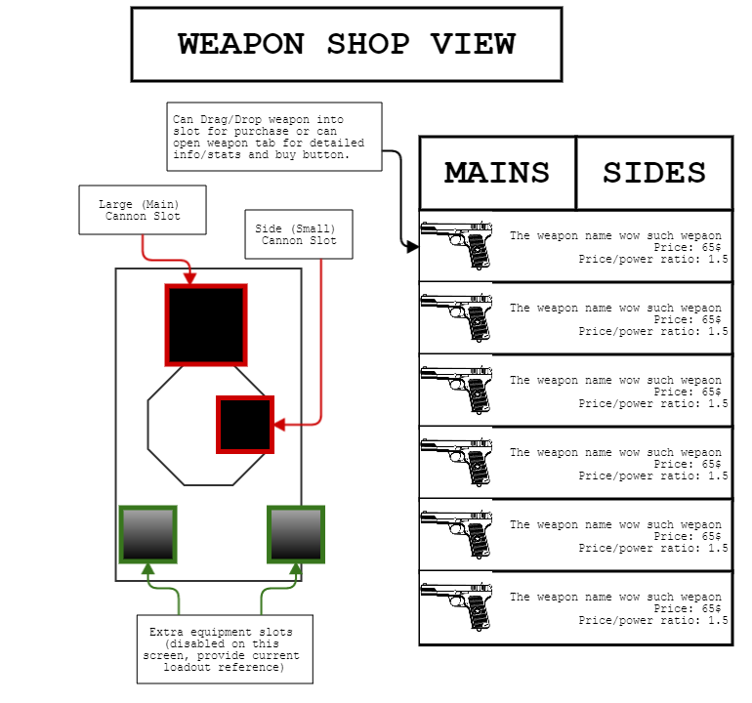

WEAPONS SHOP VIEW DETAILED ON ONE ITEM

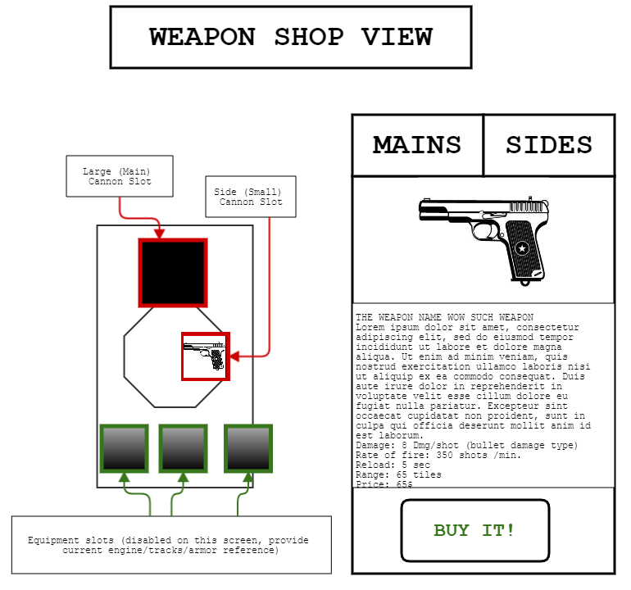

PARTS SHOP VIEW OVERALL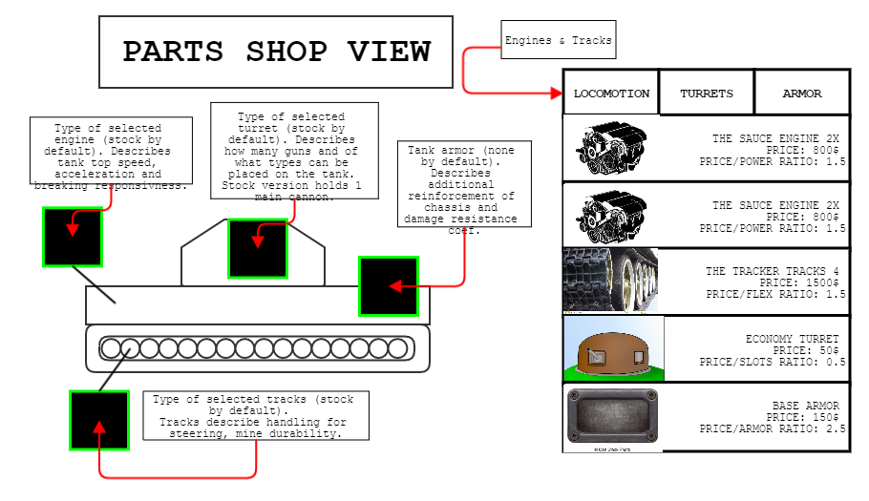

PARTS SHOP VIEW DETAILED ON ONE ITEM

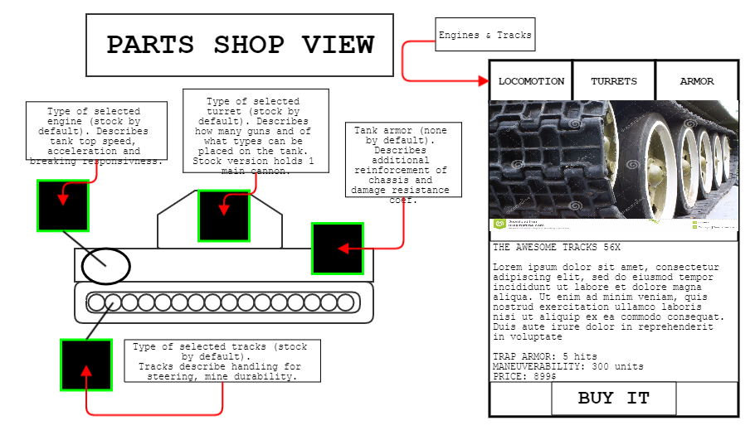

Sounds/Music

## Style Attributes

SFX for shots need to be crunchy. Tanks engines hum while they wait for action.

Good feedback needed on shot and on getting armor hit.

Good UI feedback needed during shopping part (similar to Ex Machina).

## Sounds Needed

1. ARENA
   1. Effects
      1. Heavy main cannon shot effect
      2. Quick side gun shot effect
      3. explosion effect
      4. tank engine running effect
      5. reloading effect
      6. Armor being hit by main gun effect
      7. Armor being hit by side gun effect
   2. Feedback
      1. Victory chime
      2. Defeat chime
      3. Pleasant chime of pickup
2. SHOP
   1. Effects
      1. select item to look at details info sound
      2. buy weapon happy sound
      3. sell item cash register sound
      4. buy part garage sound

## Music Needed

1. Main menu track
2. Non-annoying Shopping track
3. Active arena track (possibly out of random few?)
4. Win track after arena
5. Loss track after arena
6. End of game congrats track