The procedure for the registration of foreign employees engaged in labor activity on the basis of the Agreement (Eurasian Economic Union) from 29.05.2014

Step 1
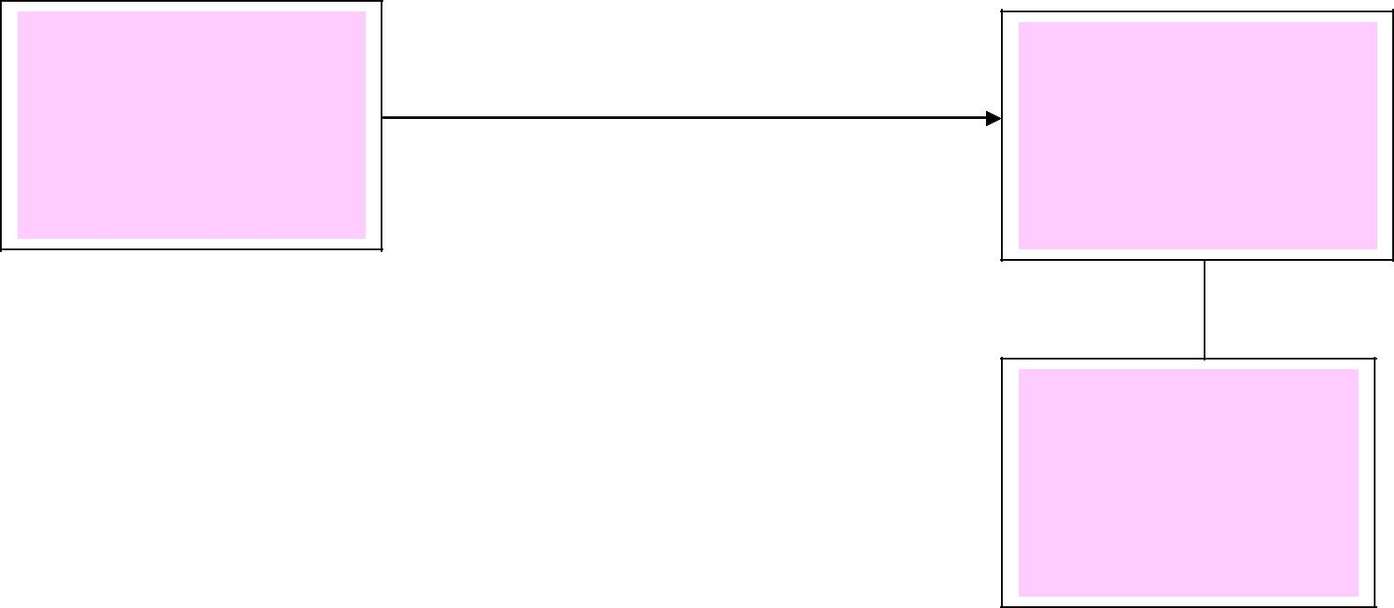
Conclusion of an employment contract with a foreign employee

Step 2

Notification of conclusion of Working Agreement with Foreign Citizen (within 3 working days.) – District of GUVM MVD

Production of Immigration Registration in 3 working days from the end of Working Agreement.

