The procedure for registering WP for 1 year (standard procedure) and working invitation / renewal visas

 | Step 1 |  |  |  |  | Step 2 |  |  |  | Step 3
 | Submission of information on |  |  |  |  | Registration of permission to |  |  |  | Registration of a work permit
 | the need of employee |  |  |  |  | employ and taking employers |  |  |  | (WP) – UVM GU MVD of
 | – territorial TSZN– 30 |  |  |  |  | (RNPIRS) |  |  |  | Russia in Moscow /Moscow
 | calendar days. |  |  |  |  | – UVM GU MVD of Russia in |  |  |  | region- 1 month
 |  |  |  |  |  | Moscow city/Moscow region
 |  |  |  |  |  | 1 Month.
 | Prolongation of the
 | application in the territorial
 | TSZN- every 30 days until the
 | receipt on RNPIRS
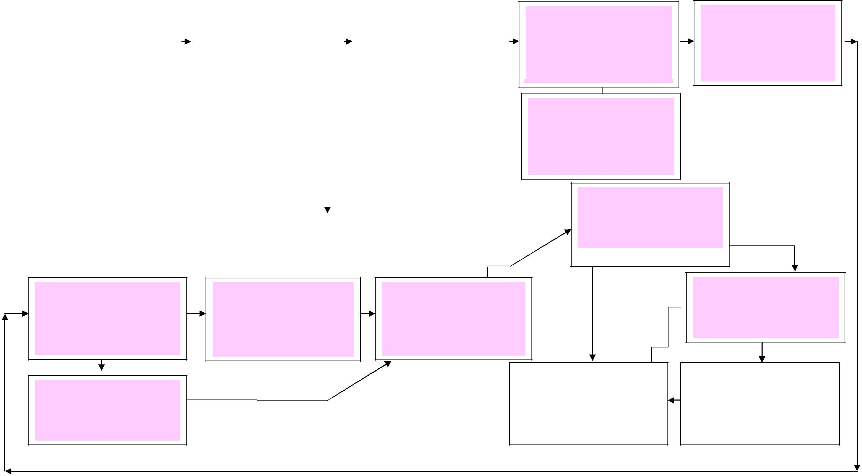
Step 4

Registration of the working invitation (One entry for 3 months) – UVM GU MVD of Russia in Moscow city/ Moscow region- Submission after the receipt od the WP

Accreditation of the company at UVM GU MVD Of Russia MVD of Russia in Moscow city/Moscow region (Unlimited)

Step 5

Forwarding of the original of the working invitation to the citizen (DHL)

10, 11 (Steps)

6 ,7 (Steps)

Registration of single entrance working visa for 3 months. Russian consulate abroad in the country of residence- according to the terms of Consulate (Approximately 1-30w.ds)

Step 8

Notification of the conclusion of an Employment Contract with a foreign citizen (within 3 w.ds) – UVM GU MVD of Russia in Moscow city/Moscow region.

Step 9

Placement on migration registration (within 7 w.ds from date of entrance into Russian Federation).

П Re-registration of a single work visa in multiple (before the end of the term of WP) – UVM GU MVD of Russia in Moscow city/ Moscow region.

12, 13 (Steps)

Renewal of RNPIRS and WP

(within 4 months before the end of WP) – 2 and 3 stages

Step 14

Entrance of foreign citizen into Russian Federation on a one-entrance working visa

Placement on migration |  | Re-registration of multiple visa
registration (within 3 days from |  | without leaving the Russian
day of receiving the multiple visa |  | Federation– UVM GU MVD of
 |  | Russia in Moscow city/Moscow region (within 20w.ds)

