**Introduction**

[Intro catchy paragraph]?

The Large Hadron Collider (LHC) is currently the largest and most advanced particle accelerator laboratory in the world. Sitting a hundred feet below the ground, the LHC spans the length of 27 km (16.5) miles in a ring at the European Organization of Nuclear Research (CERN)[citation]. This particle accelerator sits alongside the French and Swiss border, outside of the historic city of Geneva. Its main function is to accelerate atomic and subatomic particles close to the speed of light, collide these particles and then record the result of the collisions. While this seems like a crude way to study physics, this method reached a monumental breakthrough in 2012, with the verification of the existence of the Higgs Boson resulting in the completion of the standard model of physics[citation]. Since then, the LHC has been used to explore new physics, beyond the standard model it had been built to support.

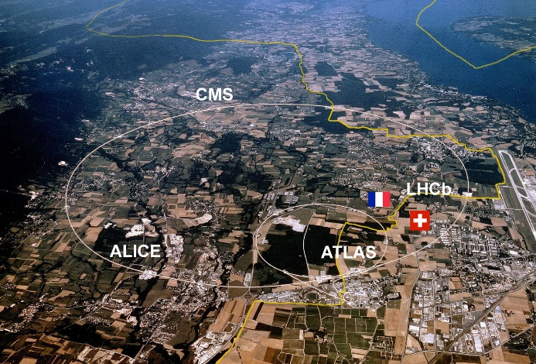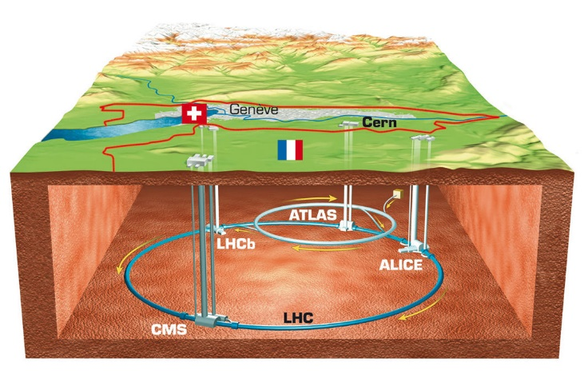

Figure 1: Aerial view of where the LHC sits on the border of France and Switzerland.

The LHC, *like other particle accelerators*, utilize powerful magnetic and electric fields and charged ions to reach high energies prior to collision. Hydrogen atoms are first sent through an electric field to be stripped of atoms, leaving behind positively charged protons. Being positively charged, protons will accelerate in electric fields and arc in magnetic fields, both of which are utilized to accelerate the protons in a circle. The proton steps through a series of acceleration stages through smaller rings with electrical and magnetic fields where it’s joined with other protons into bunches of $1.1*{10}^{11}$ protons. The bunches, once at the correct energy level or speed, are split and injected into the LHC, with half going in each direction around the ring. The split bunches, called beams, converge, and collide in one of four sites: ALICE, CMS, LHCb, and ATLAS. Each collision of energy generates mass which is recorded by sensor instrumentation in each of the collision sites, filtered and sent through data acquisition modules to be stored and read. Despite being a complex and precise process, the LHC is capable of producing 600 million of these collisions every second. These collisions generate as much as 60 terabytes of information every second, placing heavy demands on the sensing and filtering instruments within the collision sites [citation].

Figure 2: ATLAS Pixel Detector

One of the collision sites at the LHC is the ATLAS (A Toroidal LHC ApparatuS). It is the largest general-purpose detector ever made for any collider and sits at 46 meters long, 28 meters in diameter and weighs nearly 7000 tons[citation]. Figure 2 shows the detector to scale against people to demonstrate the size. The detector is really built out of multiple layers or shells of detectors designed to record the trajectory, momentum and energy of the individual particles seen during collisions. The four major components are the Muan Spectrometer, Magnet System, Calorimeters, and the Inner Detector. The Inner Detector is the innermost layer and is further broken down into its own layers with its own innermost layer being the pixel detector.

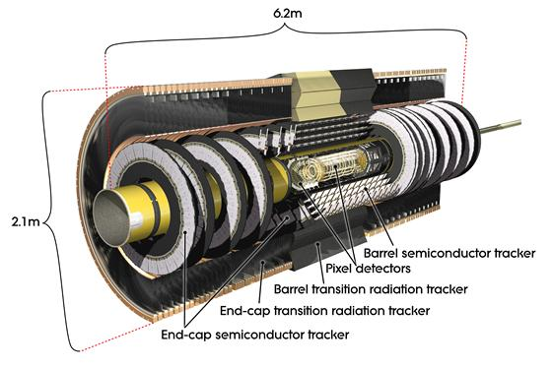

Figure 3: The Inner Tracker (left) and within it is the Pixel Detector (right).

The Pixel Detector contains a silicon chip which is referred to as the Front-End chip whose basic operation is to convert charge from passing particles into a digital value. It also records the length of time this value was above a threshold value, referred to as the Time over Threshold (ToT). These values are bundled into data and passed through to a data acquisition (DAQ) module, in ATLAS’s case this is the Yet Another Rapid Readout (YARR). Unlike the Front-End chip the DAQ modules are stowed away further from the collision point, and further process the data before forwarding it on software databases for analytics.

Figure 4: LHC Shutdown and Luminosity timeline.

Since its opening in 2010 and following its discovery of the Higgs Boson, the LHC has undergone shutdowns in 2013 and in 2018. Another long shutdown (LS) is due in 2024 which aims to increase luminosity, the number of collisions per bunch or the particle flux through detectors, by an order of magnitude, from 300 ${fb}^{-1}$ to 3000. This new High Luminosity LHC (HL-LHC) will demand upgrades to pixel detectors within the ATLAS. Development for the inner tracker has been ongoing over the previous years, with the development of new silicon technology to support and tolerate the increases in occupancy, bandwidth and radiation damage resulting from increase in luminosity.

While the inner layer electronics are being updated to tolerate the increased radiation damage they’ll experience, significantly more electrical anomalies are anticipated to appear within the Front-End chip. Toleration of these anomalies as well as the mitigation of their consequences falls not only on the inner layer electronics but also the upstream DAQs that not only filter and process the incoming data, but will also need to detect and correct failures and corrupt data resulting from radiation damage to the electronics.