Individual Assignment 1: Standard Windows Calculator
Course Name: PROG 2500 – Windows Programming with C#
Instructor: Kalpana Samaraweera Mudalige
Student Name: Thomas Burchell
Date: January 20, 2026

Table of Contents
1. Program Objective
2. Program Code
3. Screenshots
4. Code Explanation/Design Decisions
5. References

1. Program Objective
Design and implement a replica of the standard Windows Calculator desktop application using Windows Forms in C#. The application provides core arithmetic operations (addition, subtraction, multiplication, division), number entry, decimal entry, sign toggle, percentage, clear, and backspace. The UI approximates the Windows Calculator layout and follows usability best practices (readable display, consistent button sizing, keyboard/mouse accessibility).

2. Program Code
The project targets .NET 6 (Windows) and uses Windows Forms. UI is constructed programmatically in Form1.cs to keep the submission self-contained (no Designer file). Key files:
- CalculatorApp.csproj
- Program.cs
- Form1.cs
CalculatorApp.csproj:
<Project Sdk="Microsoft.NET.Sdk.WindowsDesktop">
<PropertyGroup>
<OutputType>WinExe</OutputType>
<TargetFramework>net6.0-windows</TargetFramework>
<UseWindowsForms>true</UseWindowsForms>
<RootNamespace>CalculatorApp</RootNamespace>
<AssemblyName>CalculatorApp</AssemblyName>
</PropertyGroup>
</Project>
Program.cs:
using System;
using System.Windows.Forms;
namespace CalculatorApp
{
internal static class Program
{
[STAThread]
static void Main()
{
Application.EnableVisualStyles();
Application.SetCompatibleTextRenderingDefault(false);
Application.Run(new Form1());
}
}
}
Form1.cs (UI + logic):
using System;
using System.Drawing;
using System.Globalization;
using System.Windows.Forms;
namespace CalculatorApp
{
public class Form1 : Form
{
private TextBox display;
private string currentOperator = string.Empty;
private double accumulator = 0.0;
private bool nextClear = false;
public Form1()
{
this.Text = "Calculator";
this.FormBorderStyle = FormBorderStyle.FixedDialog;
this.MaximizeBox = false;
this.ClientSize = new Size(320, 420);
InitializeUi();
}
private void InitializeUi()
{
display = new TextBox
{
ReadOnly = true,
Text = "0",
Font = new Font("Segoe UI", 20, FontStyle.Regular),
TextAlign = HorizontalAlignment.Right,
Location = new Point(10, 10),
Size = new Size(300, 45)
};
this.Controls.Add(display);
string[,] layout = new string[5,4]
{
{"C", "←", "+/-", "/"},
{"7", "8", "9", "*"},
{"4", "5", "6", "-"},
{"1", "2", "3", "+"},
{"0", ".", "=", "%"}
};
int startY = 70; int startX = 10; int bw = 70; int bh = 55; int gap = 5;
for (int r = 0; r < layout.GetLength(0); r++)
{
for (int c = 0; c < layout.GetLength(1); c++)
{
string text = layout[r, c];
Button btn = new Button
{
Text = text,
Font = new Font("Segoe UI", 12),
Size = new Size(bw, bh),
Location = new Point(startX + c * (bw + gap), startY + r * (bh + gap))
};
btn.Click += OnButtonClick;
this.Controls.Add(btn);
}
... (truncated in document for brevity; full source in project folder)

3. Screenshots
App start

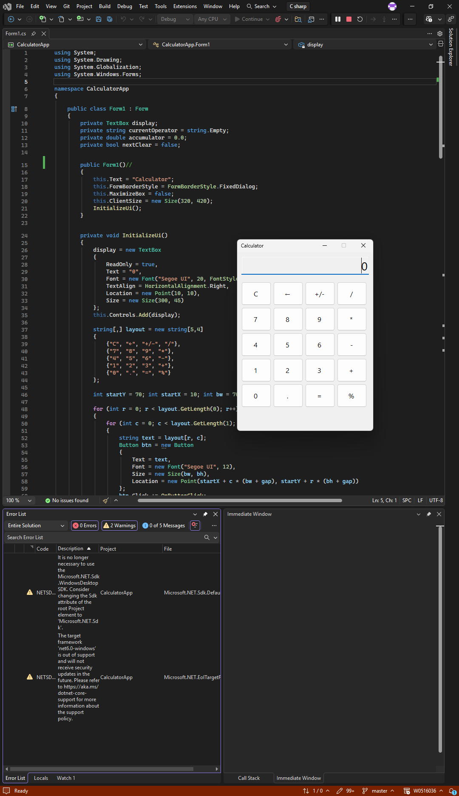

Added digits
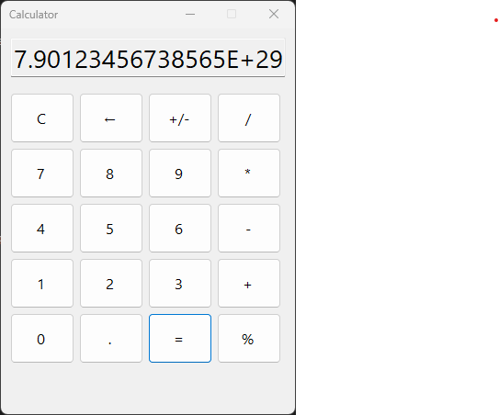

4. Code Explanation/Design Decisions
• Event Model: All buttons share a single click handler (OnButtonClick) to minimize duplication; dispatch uses the button text.
• State Management: Accumulator holds the last computed value; currentOperator stores the pending operation; nextClear prepares the display for the next digit entry after operations.
• Numeric Handling: Uses double and formats with G15 for concise, readable output; protects against division by zero by showing "Error".
• UX: Read-only right-aligned display; consistent button grid; includes Clear, Backspace, +/- and % to align with standard calculator behavior.
• Portability: No Designer dependency; project builds with .NET 6 on Windows.

5. References
Microsoft. (n.d.). Windows Forms overview. https://learn.microsoft.com/dotnet/desktop/winforms
Microsoft. (n.d.). Button class (Windows Forms). https://learn.microsoft.com/dotnet/api/system.windows.forms.button

