PROG 2500 – In-class Assignment 03 Documentation
Student: Tom Burchell
Course: PROG 2500 – Windows Programming in C#
Date: 18 Feb 2026

Overview
Two-form WPF registration with custom controls (labels, text boxes, buttons) enforcing a consistent theme. Form 1 collects data; Form 2 displays it. Password is masked in the display form.

Custom Controls
ThemedLabel, ThemedTextBox, ThemedButton implemented as derived classes templated in Themes/Generic.xaml, ensuring uniform margins, padding, colors, and fonts.

Event Handlers
MainWindow.btnRegister_Click creates a RegistrationData object and opens DisplayWindow. DisplayWindow.Close_Click closes the dialog.

Form 1 – Registration (Screenshot)
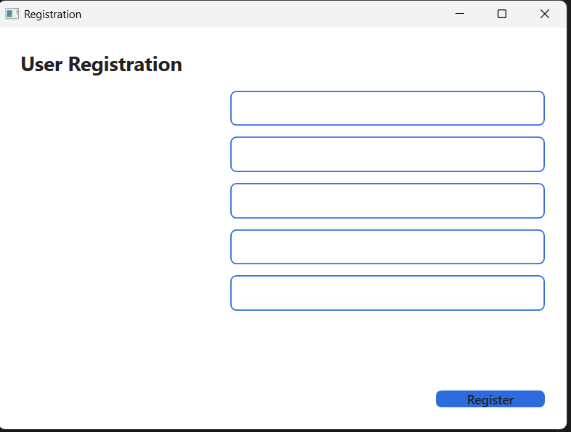

Form 2 – Display (Screenshot)
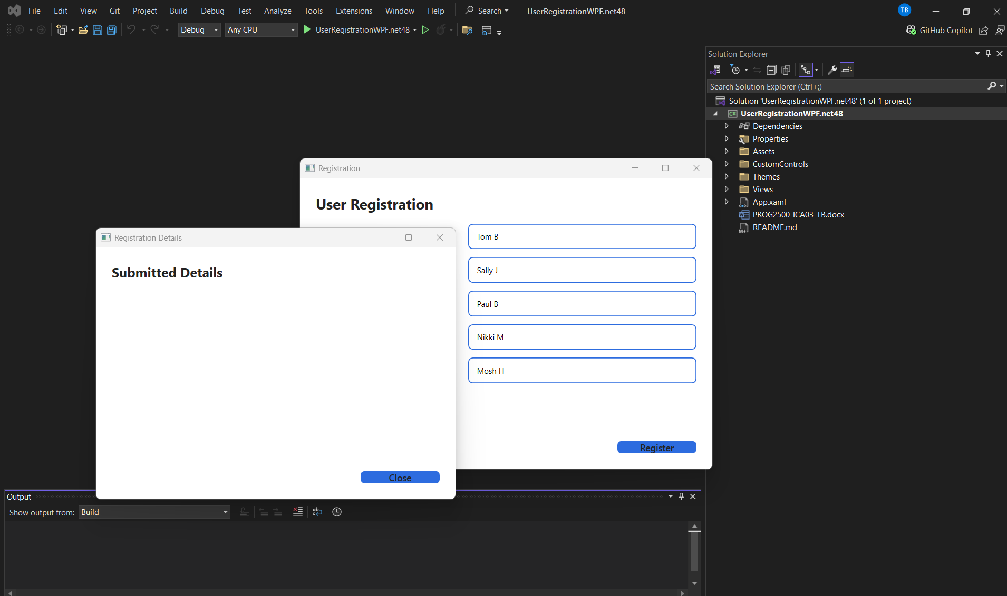

How to Run
Open UserRegistrationWPF.csproj in Visual Studio 2019/2022 with the .NET desktop development workload. Build & run. Enter sample data and click Register to open the Display form.

