PROG2500-A02-TB
Student Management

Tom Burchell
W0516036

Screenshots:
Start up:
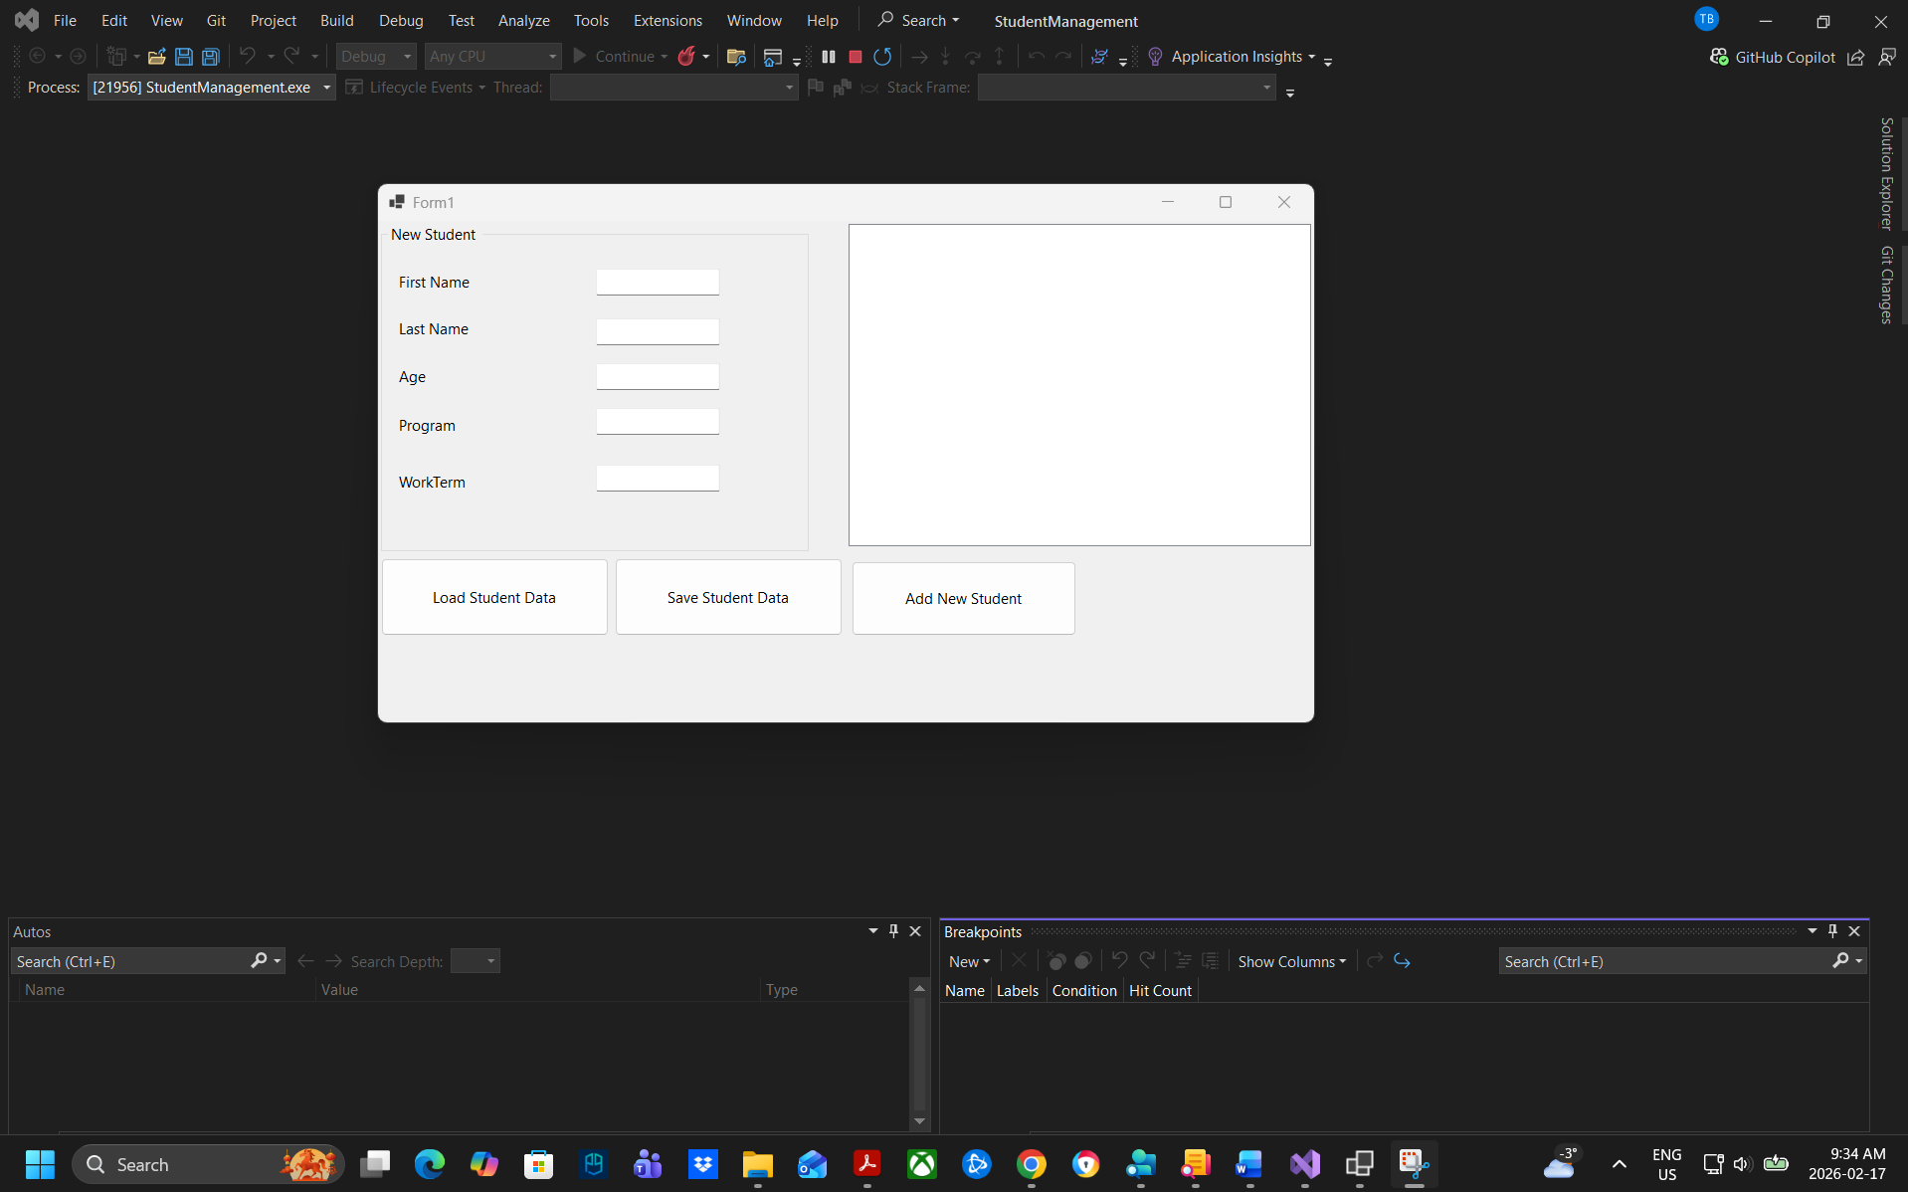
Load data:
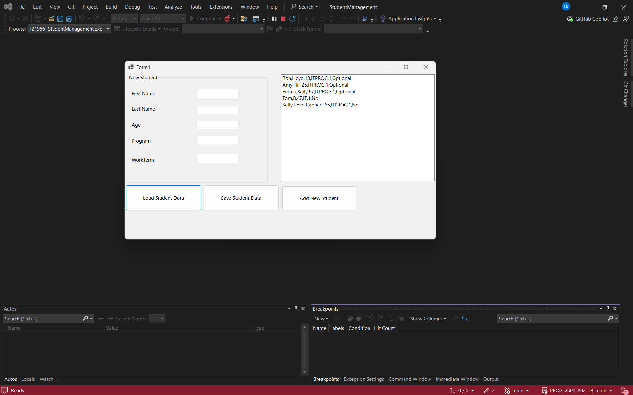
Add data:
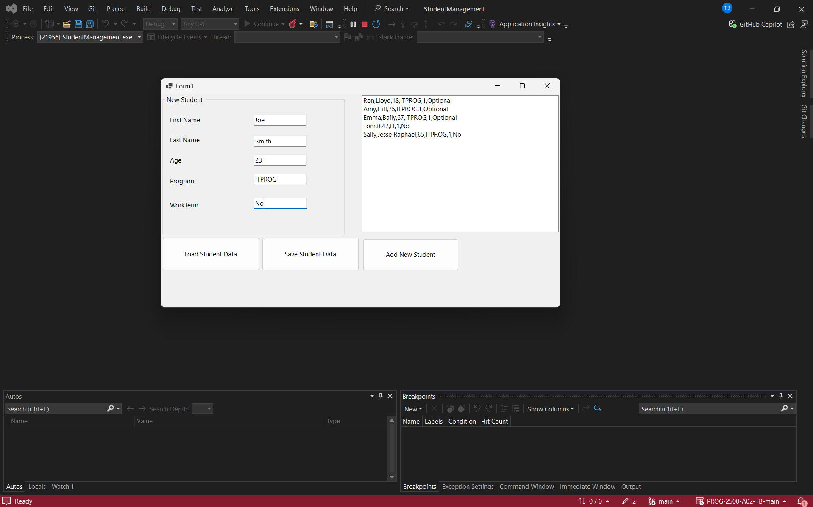
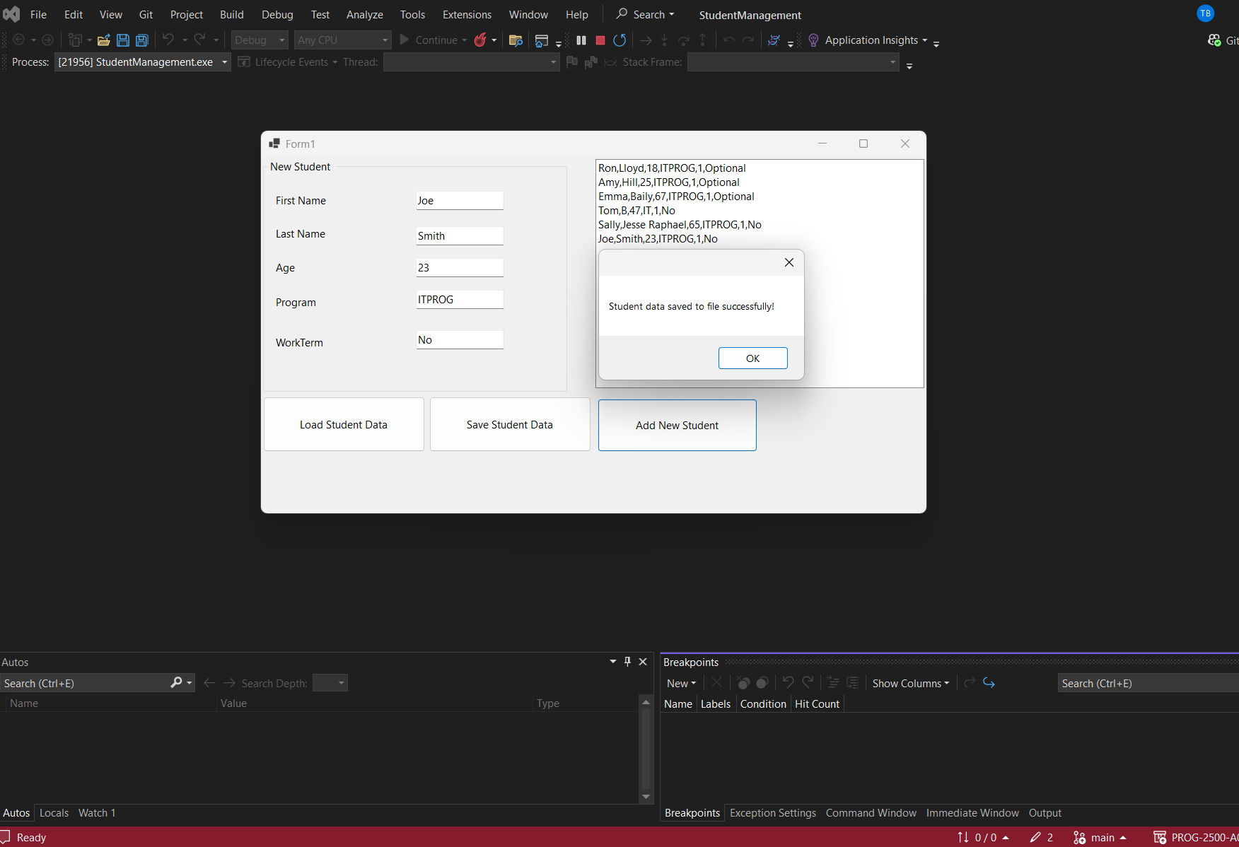
Function and Class explanation:

1. Abstract base class: Student
- Is declared abstract
- Has 4 private fields: fName, lName, age, Program
- Has 4 public properties with different implementation styles:
  - Fname → has validation (rejects null/empty), uses expression-bodied getter, full setter with if
  - LName → auto-implemented property (shorthand { get; set; } syntax was commented out, current version is expression-bodied)
  - Age → has range validation (1–99), throws ArgumentOutOfRangeException when invalid
  - sProgram → simple pass-through property (no validation)
- Has a public constructor that takes 4 parameters and assigns them through the properties (so validation is applied during construction)
- Contains one normal (concrete) method: printClassDetails() → shows a MessageBox with a fixed string
- Declares one abstract method: DisplayStudentDetails() (no body, must be overridden)

2. Derived class: FirstYearStudent
- Inherits from Student
- Also declares it implements interface IStudentData (but the interface itself is not shown in the code)
- Adds two public auto-implemented properties:
  - yearOfStudy
  - workTermStatus
- Has its own constructor that:
  - calls base constructor with 4 parameters
  - hard-codes yearOfStudy = 1
  - stores the extra workTerm parameter into workTermStatus
- Overrides DisplayStudentDetails():
  - shows a MessageBox containing first name, last name, age and program (using the properties)
- Contains instance method Load():
  - creates a new List<FirstYearStudent>
  - attempts to read file "StudentMaster.txt"
  - splits each line by comma
  - expects exactly 6 parts per line
  - creates new FirstYearStudent objects using parts[0,1,2,3,5]
  - adds them to the list
  - returns the list
  - shows MessageBox on success / error
- Contains instance method Save(List<FirstYearStudent> students):
  - overwrites file "StudentMaster.txt"
  - writes one line per student in format: FirstName,LastName,Age,Program,YearOfStudy,WorkTermStatus
  - uses properties to get values
  - shows MessageBox on success / error
- Declares (but does not use) a private field: private List<FirstYearStudent> fstudents;

3. Windows Forms – Form1 (designer-generated part)
- Is a partial class
- Contains many designer-created controls:
Control type | Names (main ones) | Purpose / Location
TableLayoutPanel | tableLayoutPanel1, tableLayoutPanel2 | Main layout, 3 columns, 2 rows
ListBox | listBox1 | Right side, large area
GroupBox | groupBox1 titled "New Student" | Left side, contains input fields
TextBox | txtFname, txtLname, txtAge, txtProgram, txtWorkterm | Input fields inside group box
Label | label1 to label5 | Descriptive text beside textboxes
Button | Load, Save, btnAdd, btnUpdate, btnDelete | Bottom area
- Event subscriptions (from designer) that exist in code:
  - Load.Click → button1_Click
  - Save.Click → Save_Click
  - btnAdd.Click → btnAdd_Click
  - btnUpdate.Click → btnUpdate_Click
  - btnDelete.Click → btnDelete_Click
  - listBox1.SelectedIndexChanged → listBox1_SelectedIndexChanged
- btnUpdate and btnDelete have Visible = false in designer

4. Application entry point
- Standard WinForms Program.cs style
- Calls ApplicationConfiguration.Initialize()
- Runs new Form1()

References (APA 7th ed.) - Educational resources used as reference:

Microsoft Learn. (n.d.). Abstract and sealed classes and class members (C# programming guide).
https://learn.microsoft.com/en-us/dotnet/csharp/programming-guide/classes-and-structs/abstract-and-sealed-classes-and-class-members

Microsoft Learn. (n.d.). Inheritance - derive types to create more specialized behavior.
https://learn.microsoft.com/en-us/dotnet/csharp/fundamentals/object-oriented/inheritance

Microsoft Learn. (n.d.). Automatically implemented properties.
https://learn.microsoft.com/en-us/dotnet/csharp/programming-guide/classes-and-structs/auto-implemented-properties

Microsoft Learn. (n.d.). Properties (C# programming guide).
https://learn.microsoft.com/en-us/dotnet/csharp/programming-guide/classes-and-structs/properties

Microsoft Learn. (n.d.). override (C# reference).
https://learn.microsoft.com/en-us/dotnet/csharp/language-reference/keywords/override

Microsoft Learn. (n.d.). Knowing when to use override and new keywords (C# programming guide).
https://learn.microsoft.com/en-us/dotnet/csharp/programming-guide/classes-and-structs/knowing-when-to-use-override-and-new-keywords

Microsoft Learn. (n.d.). Create a Windows Forms app with C#.
https://learn.microsoft.com/en-us/visualstudio/ide/create-csharp-winform-visual-studio?view=visualstudio

Microsoft Learn. (n.d.). Windows Forms overview.
https://learn.microsoft.com/en-us/dotnet/desktop/winforms/overview

