Program Structures and Algorithms

Spring 2023(SEC –01)

NAME: Anay Rajesh Pampatwar

NUID: 002766273

**Task:** The task is to implement height-weighted Quick Union with Path Compression. Also, Determine the relationship between the number of objects (n) and the number of pairs (m) generated to accomplish this (i.e., to reduce the number of components from n to 1).

**Relationship Conclusion:** The Relation betweennumber of objects (n) and the number of connections (m) is seen to be Linear.

For my test input of ~1000 random pairs, which I have run for 10 times, the equation comes out to be:

m = 4.75*n - 2074

**Evidence to support that conclusion:**

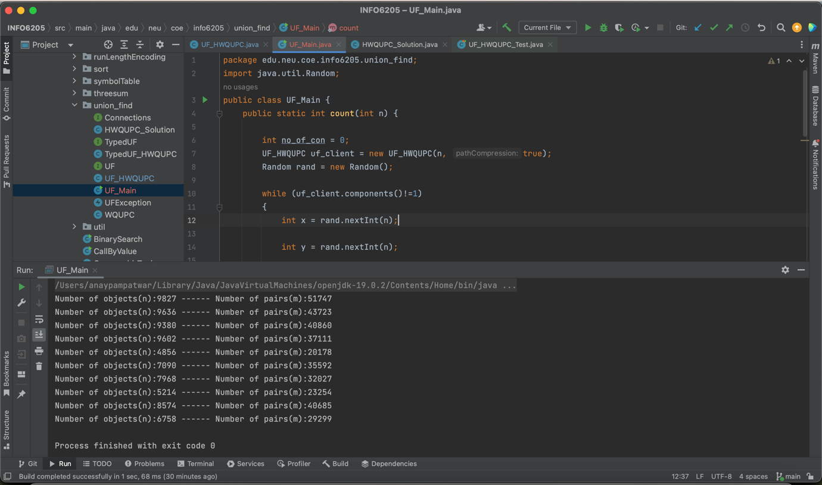

**Graphical Representation:**

|  |  |
| --- | --- |
| N(objects) | M(connections) |
| 9827 | 51747 |
| 9636 | 43723 |
| 9380 | 40860 |
| 9602 | 37111 |
| 4856 | 20178 |
| 7090 | 35592 |
| 7968 | 32027 |
| 5214 | 23254 |
| 8574 | 40685 |
| 6758 | 29299 |

From graph it is evident that the relation between number of objects (n) and the number of connections required(m) to reduce the number of components to 1 by Weighted quick union with path compression is linear in practice.

But in theory the relation is logarithmic:

M = (N*ln(N))/2

For example: N = 7090, the M value theoretically will be,

M = 7090 * ln(7090)/2

M = 31431

Which is nearly equivalent to computed value in above table:

|  |  |
| --- | --- |
| 7090 | 35592 |

**Unit Test Screenshots:**

