SoloOS — Unified Modeling Language (UML) Specification
Author: Anay Sharma | Email: anaysharmabiz@gmail.com
Version: 0.2 | Date: September 12, 2026 | Project: SoloOS
Repository: https://github.com/AnaySharmaCEO/SoloOS | License: MIT License

Document Overview & Architectural Scope
This document compiles all 12 architectural, behavioral, and structural UML models for SoloOS. The models are structured across two clear SDLC phases: Diagrams 1–8 cover the delivered Phase 1 Base CRM foundation, while Diagrams 9–12 specify the in-progress Phase 2 AI-Powered CRM capabilities. Each diagram is rendered as a standalone high-resolution artifact followed by its architectural rationale.

Diagram 1: Use Case Diagram — Base CRM Foundation (Phase 1)
Models the core functional interactions between the primary Freelancer actor and secondary supporting actors (Identity Provider, Payment Gateway) across 13 core use cases inside the SoloOS application boundary, featuring standard «include» and «extend» relationships.

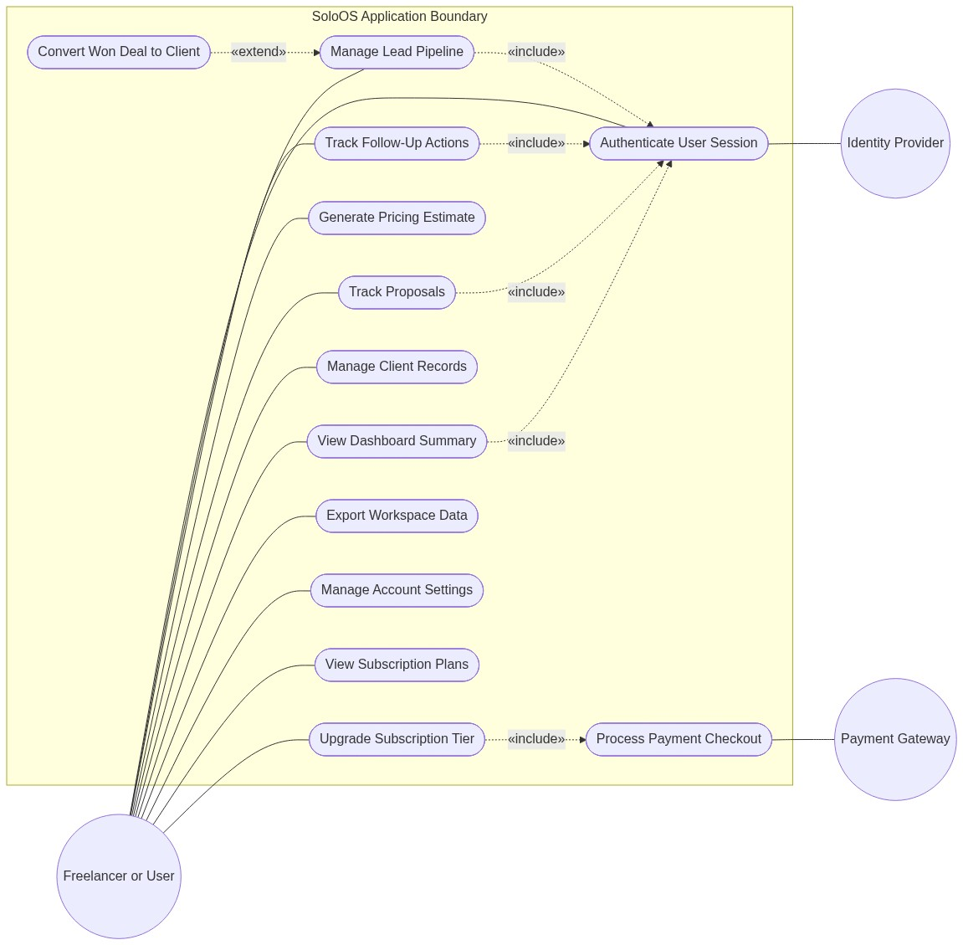

Diagram 2: Conceptual Class Diagram (Domain Model)
Illustrates high-level domain entities (User, Profile, Lead, FollowUp, Client, Proposal, PricingEstimate, Subscription, Plan) and their cardinalities without exposing private physical SQL schemas.

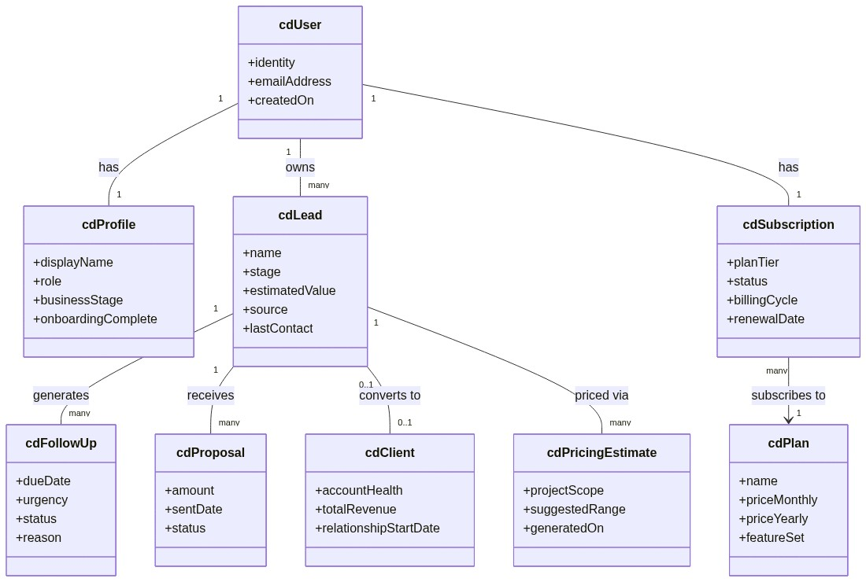

Diagram 3: Entity Relationship Diagram (Logical Data Model)
Defines logical data relationships, foreign associations, and cardinalities between core business entities.

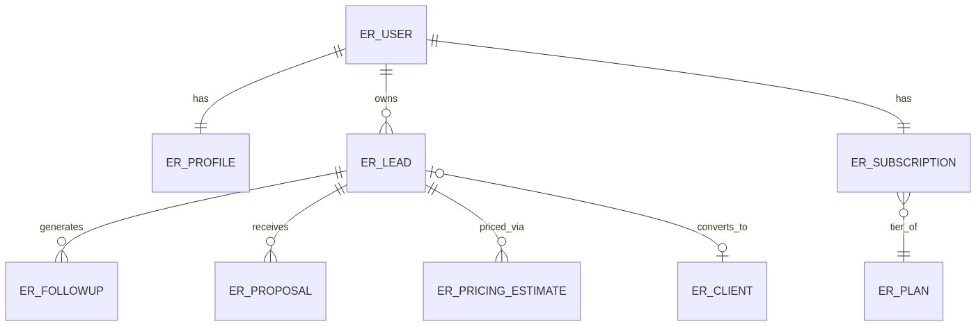

Diagram 4: Sequence Diagram — Lead-to-Client Core Flow
Traces the end-to-end operational sequence from lead entry and follow-up interaction cycles to proposal acceptance and automatic client conversion.

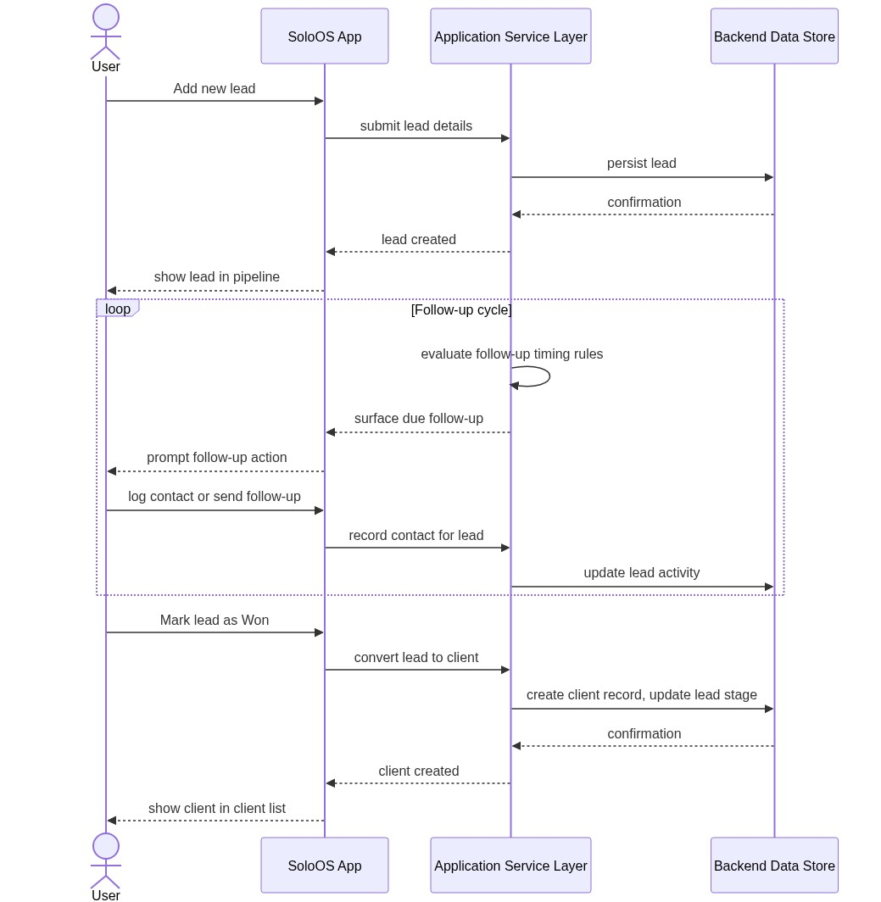

Diagram 5: Sequence Diagram — Subscription Checkout Flow
Details the asynchronous payment orchestration between the client SPA, serverless function layer, Payment Gateway, and authoritative webhook callback handler.

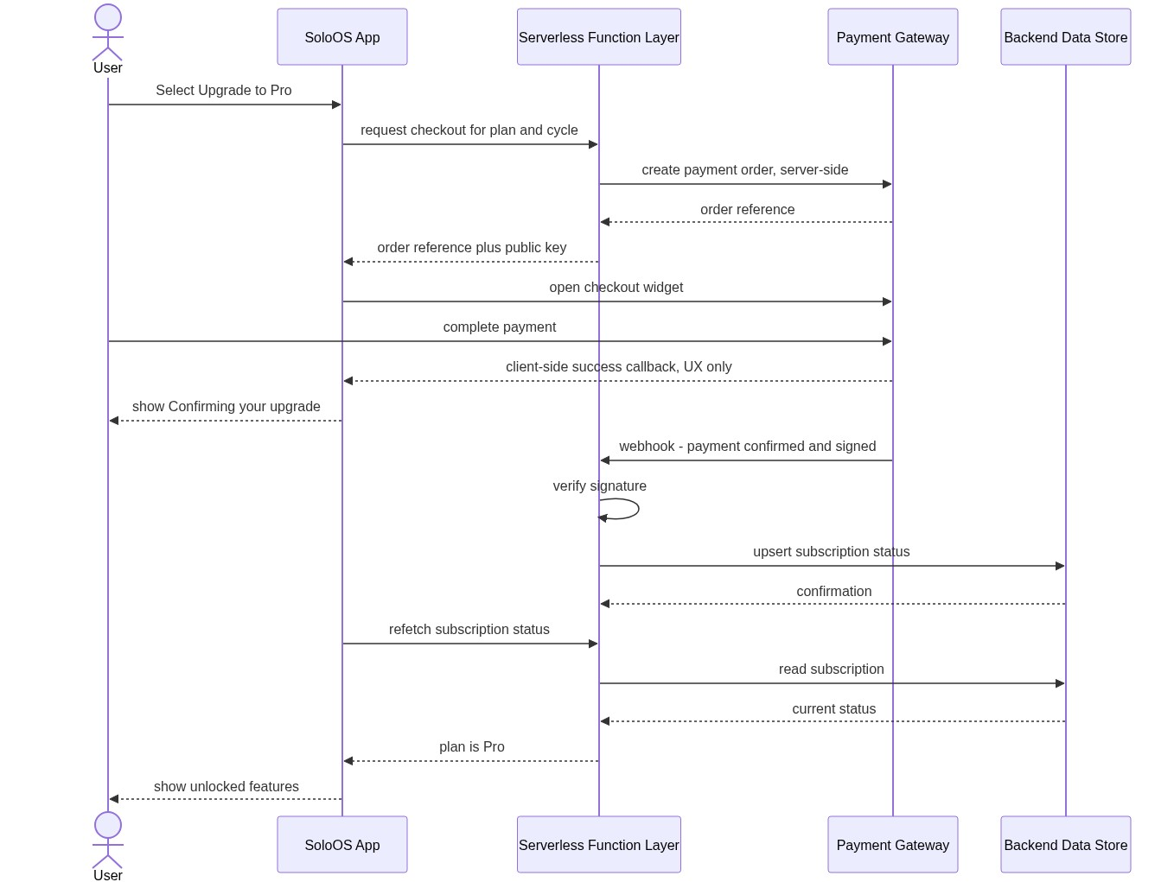

Diagram 6: State Diagram — Lead Lifecycle
Maps out discrete pipeline transitions: New Lead → Contacted → Waiting Reply → Warm Lead / At Risk → Proposal Sent → Won / Lost.

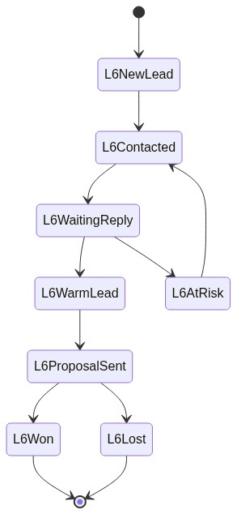

Diagram 7: State Diagram — Subscription Lifecycle
Details subscription states from Free Tier, Pending Checkout, Active Pro, Past Due grace periods, and Cancellation downgrades.

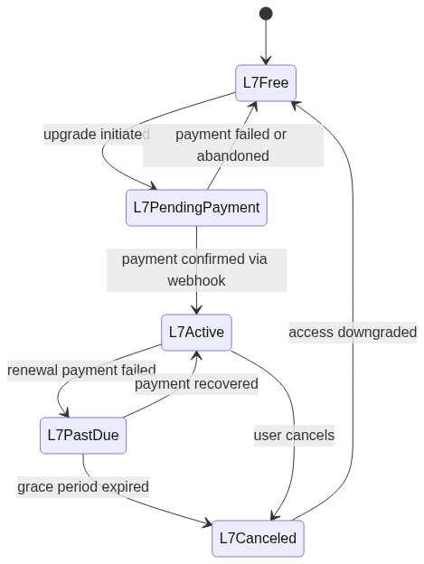

Diagram 8: Component Architecture Diagram (Logical)
Illustrates system layering across Presentation Components, State Management, Domain Services, Integration Adapters, BaaS managed persistence, and external service providers.

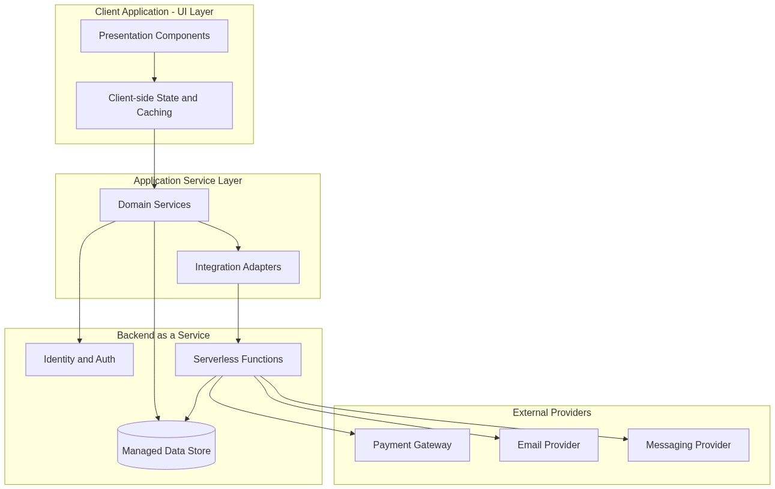

Diagram 9: SDLC Roadmap — Phase 1 Foundation to Phase 2 AI
Depicts the progressive transition and capability evolution from delivered Base CRM modules to Phase 2 AI-assisted intelligent features.

Diagram 10: Extended Use Case Diagram — AI-Assisted Selling (Phase 2)
Models AI use cases (Deal Radar, Personalized Pricing, Client Health Scoring, AI Draft Generation, and Human-in-the-Loop Review) inside the AI subsystem boundary interacting with the Hosted AI Provider.

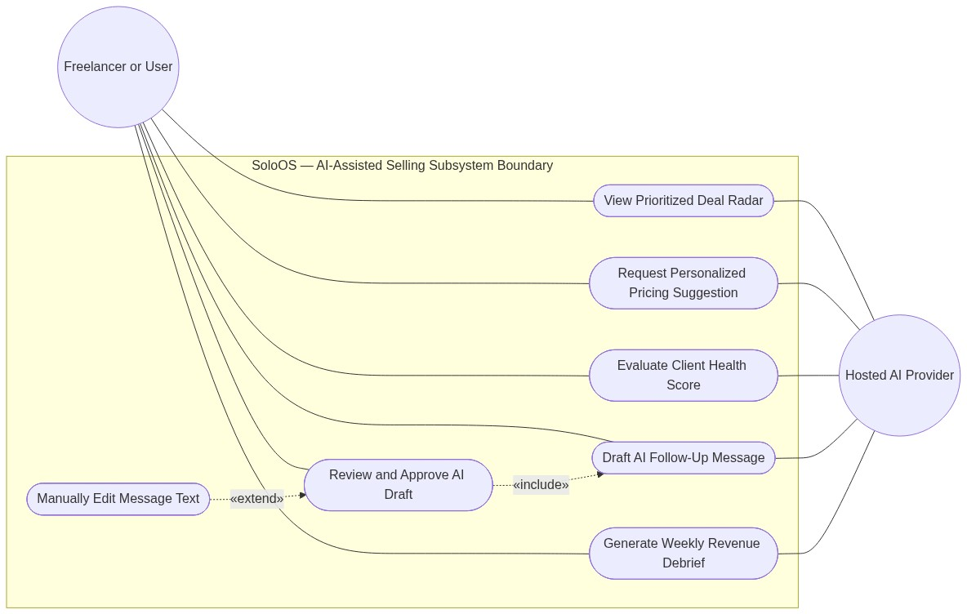

Diagram 11: Extended Architecture — AI Service Layer
Expands system architecture to incorporate the AI Orchestration Service and Hosted AI Provider integration proxy.

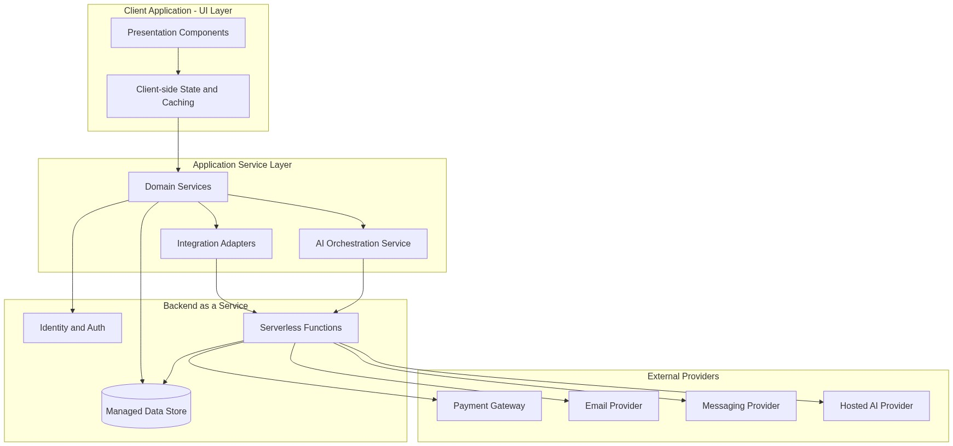

Diagram 12: Sequence Diagram — AI-Assisted Follow-Up Drafting
Specifies the exact interaction flow for AI outreach generation, strictly enforcing mandatory user review and manual approval before any communication is dispatched.

