

Practical File Submission

Course Name: JavaScript Lab Course Code: T-3013 / 0705210508

Submitted by
Anaya Shende 24070521213
Batch: 2024-28 Semester - V Section: A/B/C/D

Submitted to
Dr. Shreyas Rajendra Hole



Department of Computer Science and Engineering

This is to certify that this Practical Record contains the bona fide practical work carried out by Mr./Ms. ,,
bearingPRN. ,ofBatch ,Semester _,

Section ,during the Academic Year _

Date:

Name of Course Teacher:

Signature of Course Teacher:


Name of Student: PRN: Batch: Semester: Section:

Practical  No. | Aim | Performance  Date | Submission  Date | Remarks
1 | 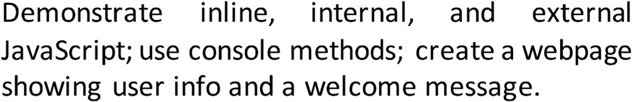
2 | 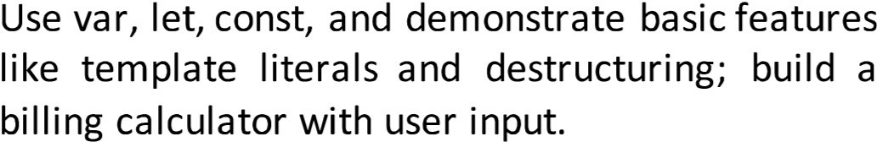
 | Implement control structures and form validation; create a grading system based on user-entered marks.
4 | Use function types, scope, and closures; apply try-catch; build a palindrome checker.
5 | Apply array methods and object handling; create a cart total calculator with discount logic.
6 | Use string functions and regex for email validation, data extraction, and text analysis.
7 | Perform DOM traversal and updates; develop a to-do list app with add, edit, and delete features.
 | Access and validate form fields using events; design a gym admission form with live input checks.
9 | Implement localStorage and sessionStorage to save user preferences like theme settings.
1() | Load and display JSON data using fetch() and jQuery  $.getJSON(); render results dynamically in a table.
 | 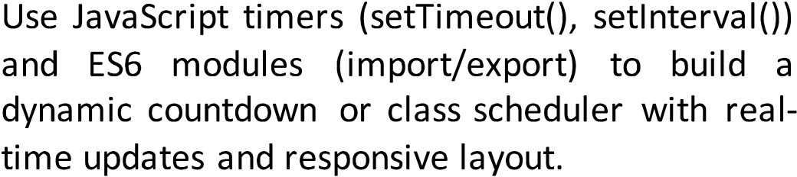

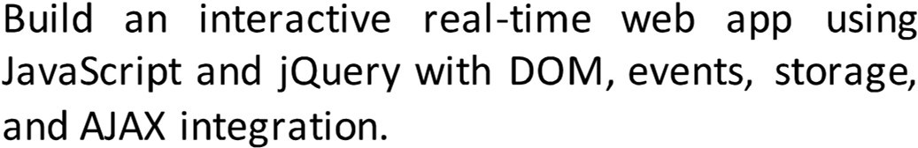
1/;l 12



SYMBIOSIS INSTITUTE OF TECHNOLOGY, NAGPUR
Symbiosis International (Deemed University)
(E>tabllohedundor section 3of theUGC A<:t. 1956)
Re-a«n<llted by NMC with 'A++' Grade I Awarded C..tqory - I by UGC
F-ounder: Prof. Dr. S. B. Mujumdar, M. Sc., Ph. D. (Awarded Padma Bhushan and Padma Shri by President of India)

EXPERIMENT NO: 1

Title : Demonstrate inline, internal, and external JavaScript; use console methods; create a webpage showing user info and a welcome message.
- Software/Tools Required: Visual Studio Code, Google Chrome, HTML5, CSS3, and JavaScript.
- Theory: JavaScript is a scripting language used to make web pages interactive and dynamic. It can be added to an HTML document in three different ways:

Inline JavaScript:
Inline JavaScript is written directly inside an HTML element using event attributes such as onclick. Inthis experiment, it was used to perform an action directly when the user interacted with a webpage element.

Internal JavaScript:
Internal JavaScript is written inside the <script> tag within the same HTML file. In this experiment, JavaScript functions were defined internally and called when specific user interactions occurred on the webpage.

External JavaScript:
External JavaScript is written in a separate . j s file and connected to the HTML document using the <script src=" ... " ></script> tag. In this experiment, external JavaScript was used to keep the scripting code separate from the HTML structure.

CODE :
<!DOCTYPE html>
<html lang="en">
<head>
<meta charset="UTF-8">
<meta name="viewport" content="width=device-width, initial-scale=1.0">
<title>plalindrome Checker</title>
<style>
body {
font-family: monospace; background-color: pink; color: black;
padding: 50px;
}

h1 {
font-size: 20px;
text-transform: uppercase;
}
h2 {
font-size: 60px; font-style: italic; color: black;
}

.box {
background-color: black; color: white;
padding: 20px; width: 600px;
border: 4px solid black;
}

input {
width: 90%; padding: 8px;
margin-bottom: 10px; background-color: white; color: black;
border: 2px solid pink;
}

button {

width: 97%; padding: 10px;
background-color: pink; color: black;
font-weight: bold; border: 2px solid white; cursor: pointer;
}

.result-box {
margin-top: 15px; padding: 10px;
border: 2px dashed pink; display: none;
}
</style>
</head>
<body>

<div class="box">
<h1>Checker</h1>
<p>Is it a palindrome?</p>

<input type="text" id="wordInput" placeholder="Type here...">
<button id="submitBtn">CHECK</button>

<div id="outputDisplay" class="result-box"></div>
<p id="totalChecks">Checks: 0</p>
</div>
<h2> 24070521213</h2>
<script>
const submitBtn = document.getElementById('submitBtn'); const wordInput = document.getElementById('wordInput');
const outputDisplay = document.getElementById('outputDisplay'); const totalChecks = document.getElementById('totalChecks');

function makeCounter() { let count = 0;
return function() { count++;
return count;
};
}
const incrementChecks = makeCounter();

function basicClean(str) {
return str.toLowerCase().replace(/[^a-z0-9]/g, '');
}

const flipString = function(str) { return str.split('').reverse().join('');
};
const checkMatch = (a, b) => a === b; submitBtn.addEventListener('click', function() {
outputDisplay.style.display = "none";

try {
const textValue = wordInput.value;

if (textValue.trim() === "") {
throw new Error("Type a word first!");
}

const clean = basicClean(textValue); const reversed = flipString(clean);
const isTrue = checkMatch(clean, reversed);

const currentCount = incrementChecks(); totalChecks.textContent = "Checks: " + currentCount;

outputDisplay.style.display = "block"; if (isTrue) {
outputDisplay.textContent = "Yes! Matches backward.";
} else {
outputDisplay.textContent = "No! Does not match.";
}

} catch (err) { outputDisplay.style.display = "block";
outputDisplay.textContent = "Error: " + err.message;
}
});
</script>
</body>
</html>

4.0UTPUT
..., 0 User lnforn�l'ltlan X +

("' 7 C © 127.0.0.1:5500/inlir,e.html
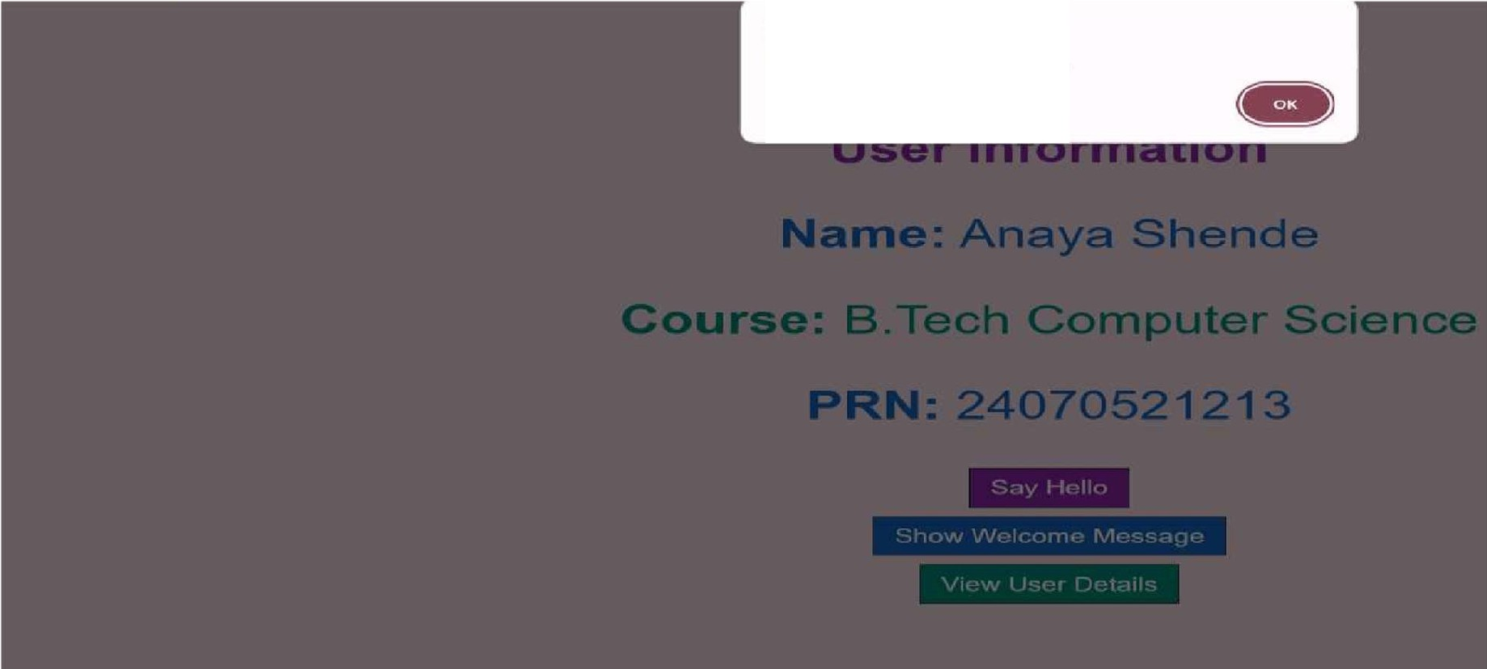
127.0.0.1:5500 says
HeNo Anaya! Welcome to your profile.

v 0 user 1ntormat1on x +

f- ➔ C 0 127.0.0.1:5500/lnllne.html

Welcome, Anaya!
User Information Name: Anaya Shende
Course: B.Tech Computer Science
PRN: 24070521213
Welcome, Anaya! THIS IS EXP1

WIMii
Show Welcome Message

View User Details

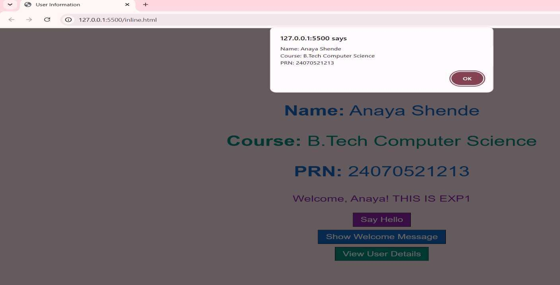
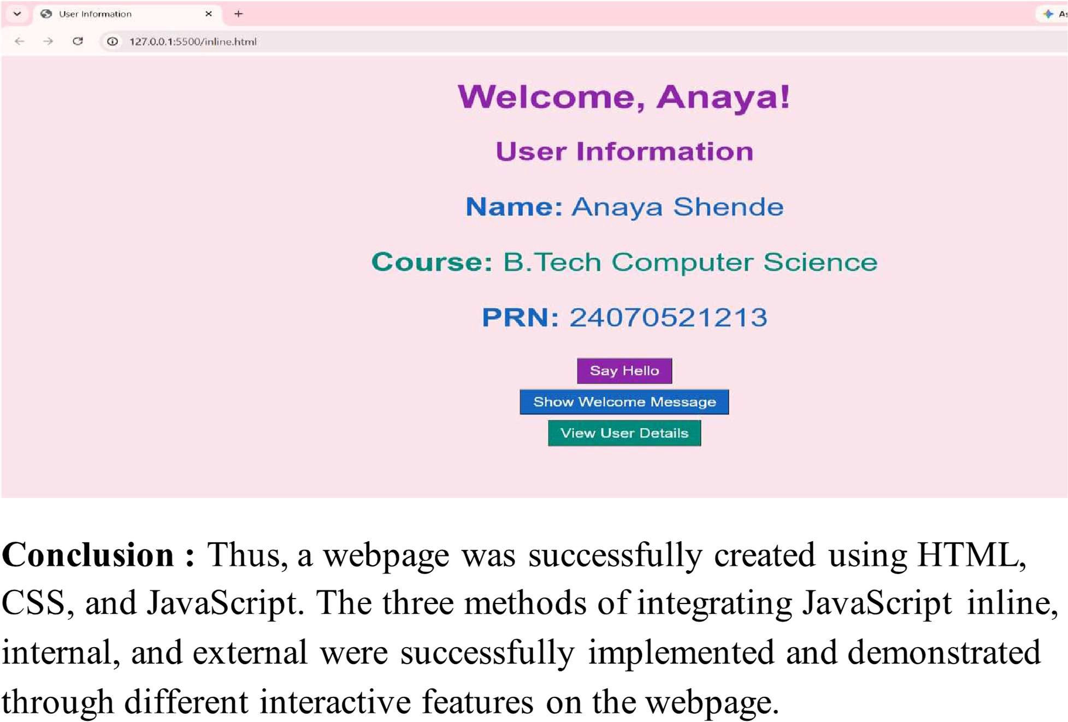

CASE STUDY – 1

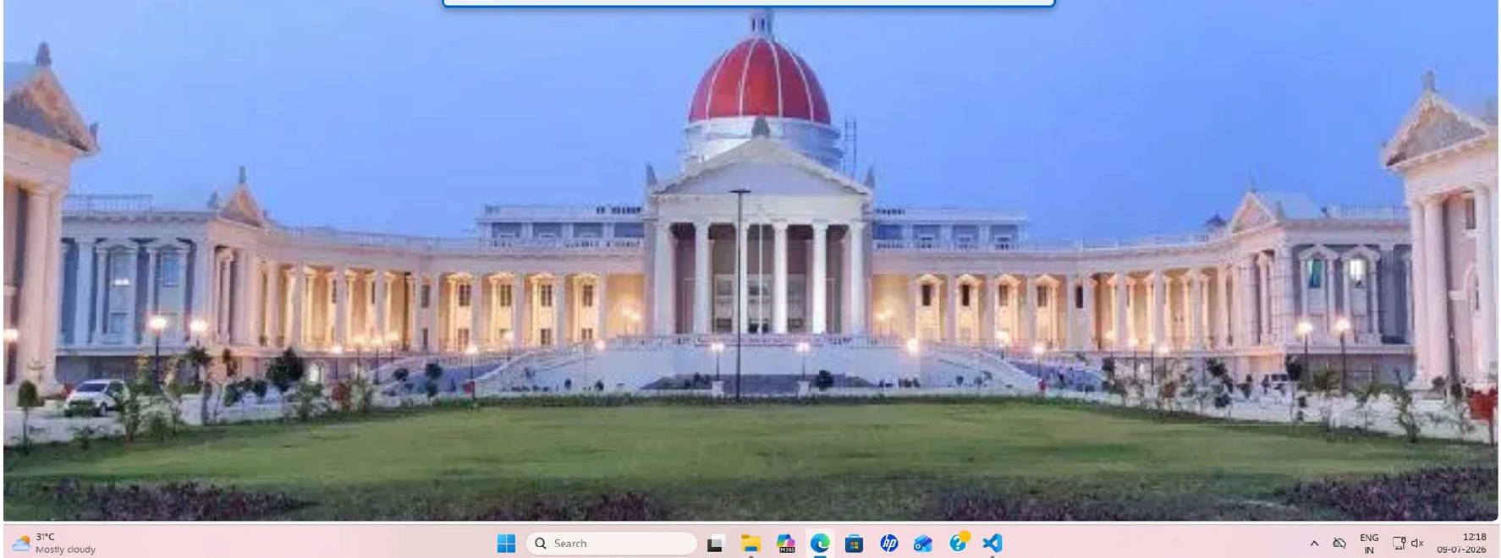

V Q l!TAAGP\l� X +
f- 0 0 127.0D.1:S500lc.asemxfy1.2.html Qct... "


Student Info: Anaya Shende PRN: 24070521213



EXPERIMENT NO – 2

Title
Use var, let, const, and demonstrate basic features like template literals and destructuring; build a billing calculator with user input.

Software/Tools Required
Visual Studio Code (VS Code) , Google Chrome / Any Web Browser , HTML5, JavaScript (ES6)

Theory
JavaScript is a client-side scripting language used to create interactive web pages. In this experiment, a Billing Calculator is developed to calculate the total bill, GST, and final amount based on user input.
The following JavaScript features are demonstrated:

  - var: Used for function-scoped variables and can be redeclared.
  - let: Used for block-scoped variables whose values can be updated.
  - const: Used for constant values that cannot be reassigned, such as the GST rate.
  - Template Literals: Allow variables and expressions to be embedded inside strings using backticks (`) and ${} for easy formatting.
  - Destructuring: Extracts values from an object into individual variables, making the code shorter and more readable.
The program accepts customer details, product name, quantity, and price, calculates the total amount, GST (18%), and final bill, then displays the receipt in a formatted manner.

Code:
<!DOCTYPE html>
<html>
<head>
<title>Billing Calculator</title>
</head>
<body>

<h2>Billing Receipt</h2>

<pre id="receiptBox" style="background: #f0f0f0; padding: 15px; font-family: monospace; font-size: 16px; width: 320px; border: 1px solid #ccc;"></pre>

<script>

const GST_RATE = 0.18;

var customerData = {
customerName: prompt("Enter Customer Name:")
};

var productData = {
productName: prompt("Enter Product Name:"), quantity: parseInt(prompt("Enter Quantity:")),
pricePerItem: parseFloat(prompt("Enter Price Per Item (₹):"))
};

var { customerName } = customerData;
var { productName, quantity, pricePerItem } = productData;

let total = quantity * pricePerItem; let gstAmount = total * GST_RATE; let finalBill = total + gstAmount;

var receiptText = `

================================ BILLING RECEIPT
================================
Customer Name : ${customerName} Product Name : ${productName} Quantity : ${quantity}
Price / Item : ₹${pricePerItem.toFixed(2)}

Total : ₹${total.toFixed(2)}
GST (18%) : ₹${gstAmount.toFixed(2)}

FINAL BILL : ₹${finalBill.toFixed(2)}
================================`;

// Immediately push the text into our HTML container on page load document.getElementById("receiptBox").innerText = receiptText;
</script>

</body>
</html>

OUTPUT -
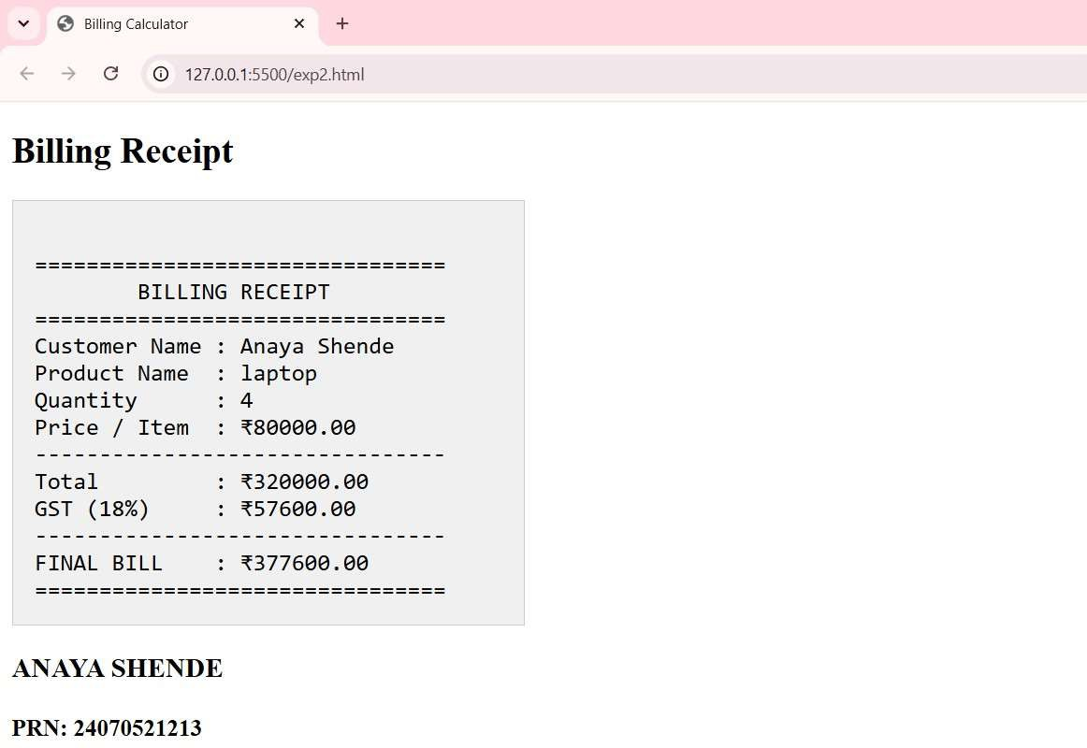

Result/Conclusion
The Billing Calculator was successfully implemented using JavaScript. The program accepted user input, calculated the total amount, GST (18%), and final bill accurately. The experiment successfully demonstrated the use of var, let, const, template literals, and object destructuring while generating a formatted billing receipt.

CASE STUDY 2

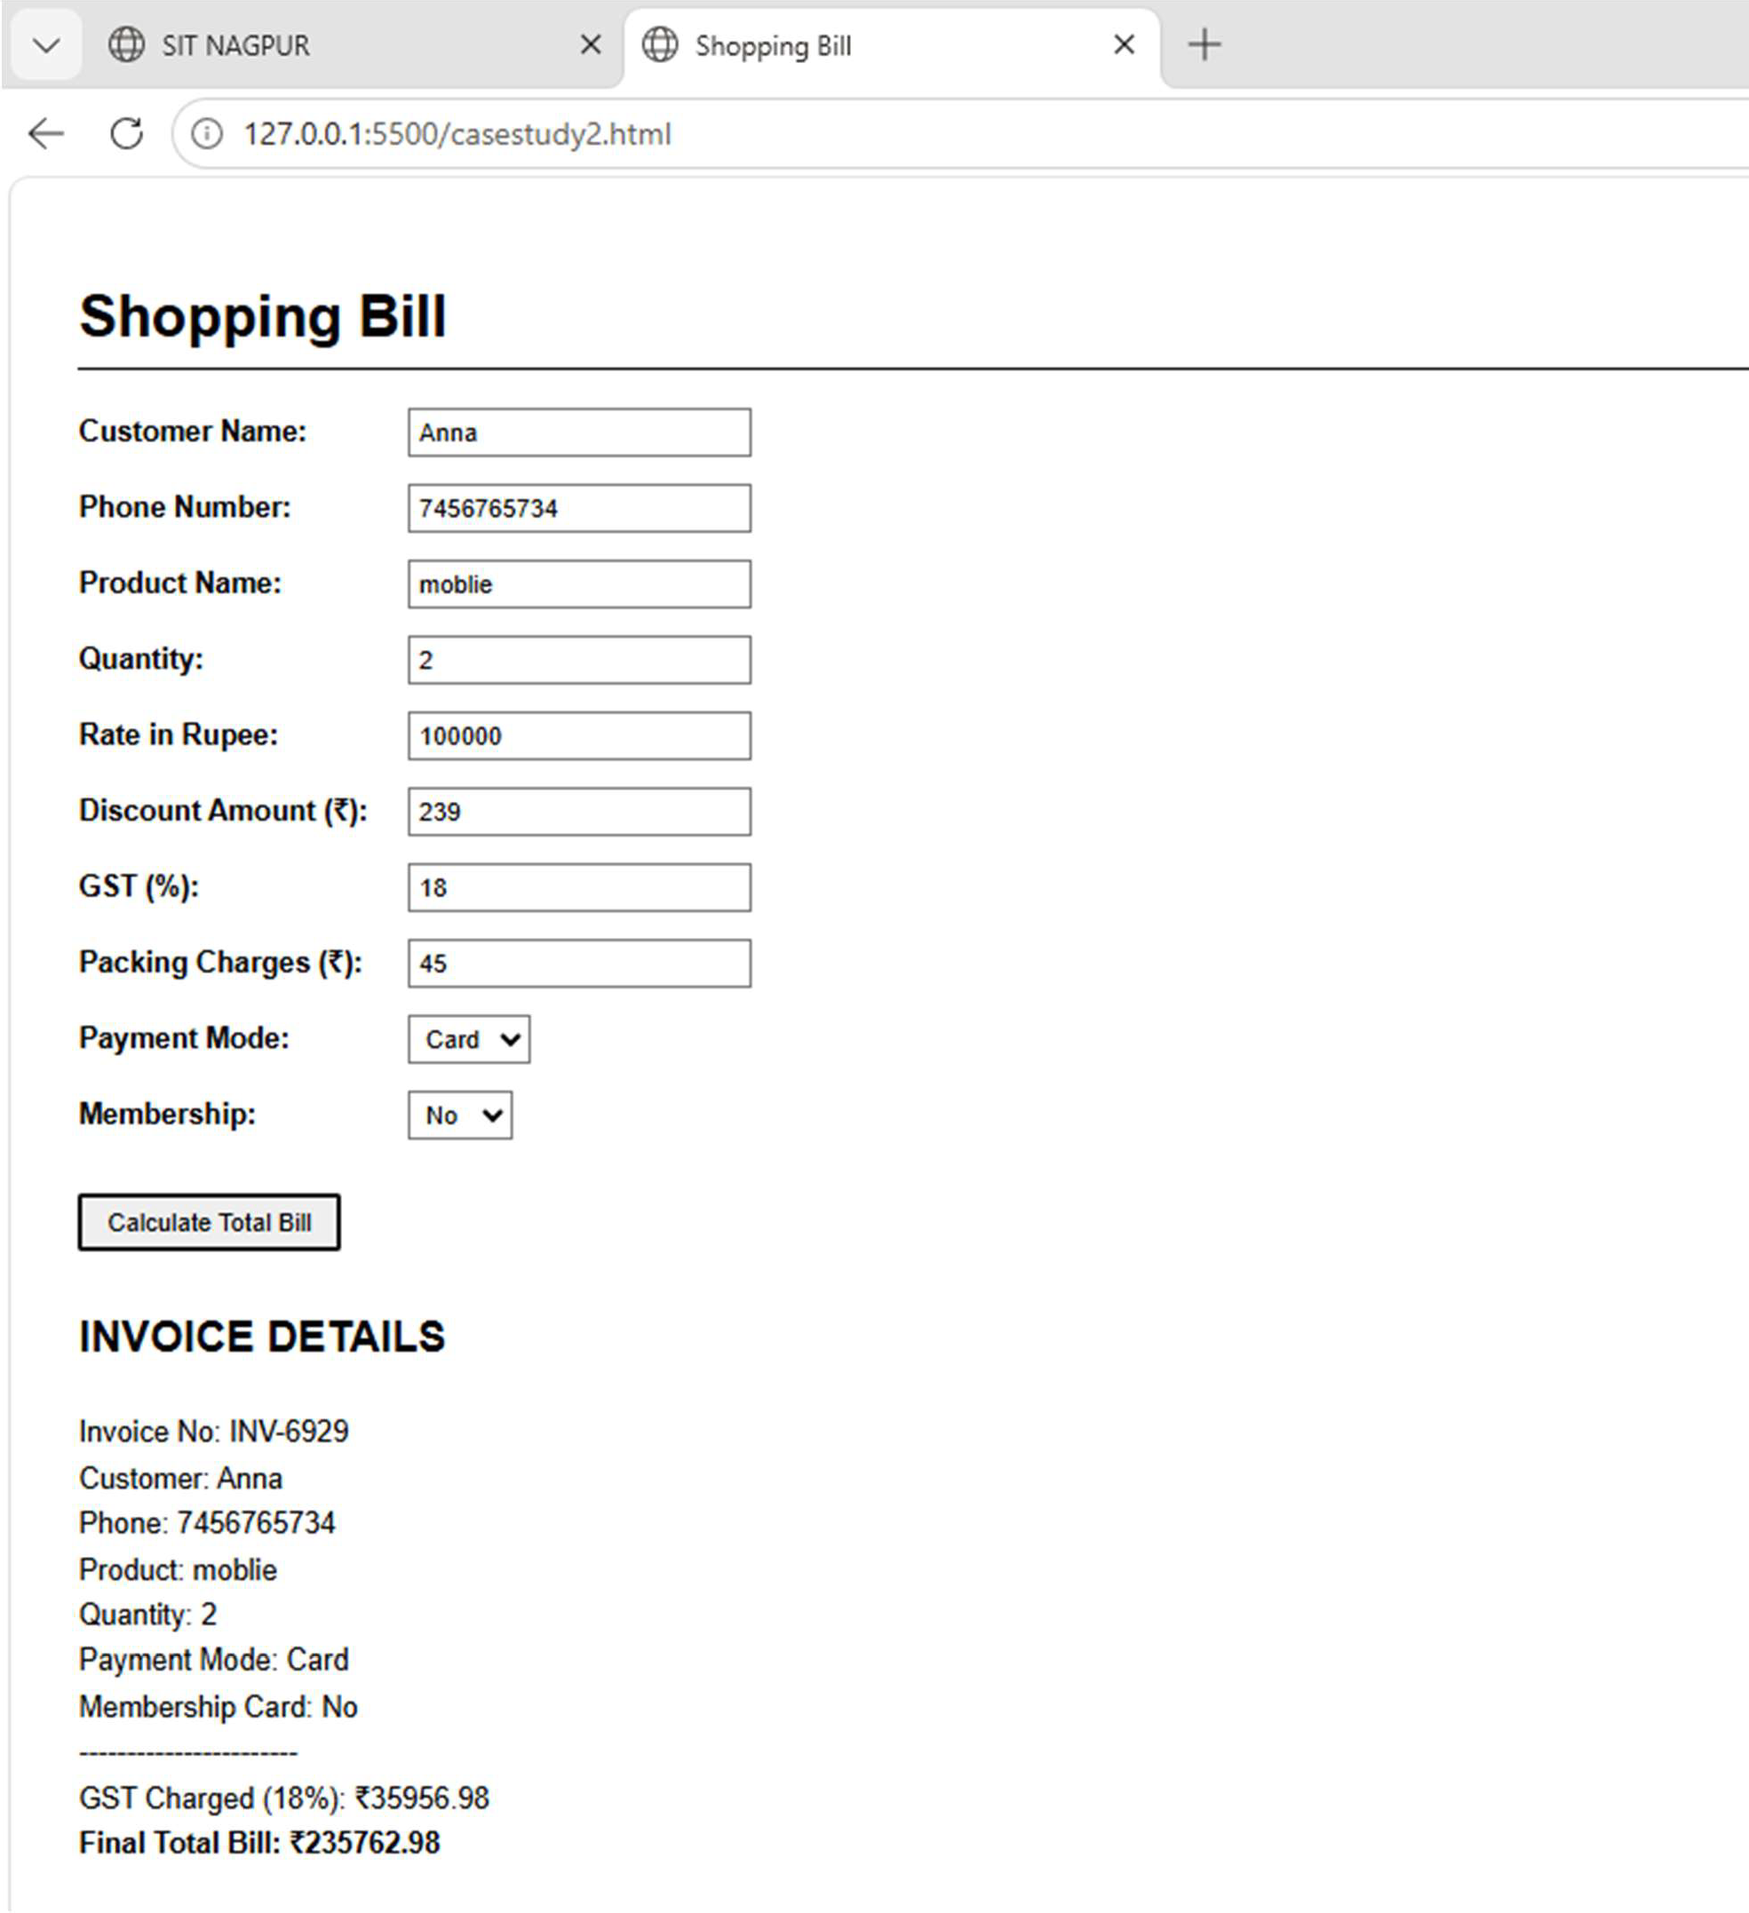


SYMBIOSIS INSTITUTE OF TECHNOLOGY1 NAGPUR

Symbiosis International (Deemed University)
(1;$t1b!Med � section 3of Ille UGC Alt, 1?561
Re-:ac,ndited by NAAC with 'A++' Grad<! I Award@d Ca�ory • I by UGC
Founder: Prof. Or. S. B. MuJumdar, M.Sc., Ph. D. (Awarded Padmi! Bhushan and Padma Shri by Presid,mt of India)

EXPERIMENT - 03

Title- Implementation of Control Structures and Form Validation for an Academic Grading System

Software/ Tools Used

HTML5 , CSS3, JavaScript, Visual Studio Code (VS Code), Google Chrome/ Microsoft Edge Web Browser
Theory - Control structures are fundamental programming constructs used to control the flow of execution in a program. Conditional statements such as if, else if, and else are used to make decisions based on specific conditions.
Form validation is a technique used to verify user input before processing it. It ensures that the entered data follows the required format and falls within acceptable limits. Validation improves data accuracy and prevents incorrect information from being processed.
In this experiment, anAcademicEntryPortalis developed usingHTML, CSS, and JavaScript. The application validates student details such as name, roll number, and marks entered for multiple subjects. Invalid inputs generate error messages, while valid inputs are processed to calculate: Total Marks , Percentage, Grade
The grading system uses conditional control structures to assign grades based on the calculated percentage. This demonstrates the practical application of decision-making statements and input validation in web development.

CODE :
<!DOCTYPE html>
<html lang="en">
<head>
<meta charset="UTF-8">
<meta name="viewport" content="width=device-width, initial-scale=1.0">
<title>Academic report</title>
<style>
body {
font-family: monospace; background-color: #ffffff; color: #111111;
max-width: 400px; margin: 40px auto; padding: 0 20px;
line-height: 1.5;
}
h2 {
border-bottom: 1px solid #111111; padding-bottom: 5px;
text-transform: uppercase; font-size: 1.1rem;
margin-bottom: 20px; margin-top: 30px;
}
.form-group {
margin-bottom: 12px;
}
label {
display: block; font-weight: bold;
margin-bottom: 4px; font-size: 0.85rem;
}
input {
width: 100%; padding: 8px;
border: 1px solid #666666; box-sizing: border-box; font-family: monospace;
}
input:focus { outline: none;

border: 1px solid #111111;
}
input:not(:placeholder-shown):invalid { border-style: dashed;
border-color: #ff0000;
}
button {
width: 100%;
background-color: #111111; color: #ffffff;
border: none; padding: 10px;
font-family: monospace; font-weight: bold; cursor: pointer;
text-transform: uppercase; letter-spacing: 1px; margin-top: 15px;
}
button:hover {
background-color: #444444;
}
.output-box { margin-top: 25px; padding: 15px;
border: 1px solid #111111; display: none;
white-space: pre-line; /* Preserves layout spaces and line breaks */
}
.error-message { color: #ff0000; font-size: 0.8rem; margin-top: 4px; display: none;
}
</style>
</head>
<body>
<h1>24070521213</h1>
<h2>Academic Entry Portal</h2>
<form id="gradeForm" novalidate>
<div class="form-group">
<label for="studentName">Student Name</label>
<!-- Pattern ensures it contains only letters and spaces, matching real-world names -->

<input type="text" id="studentName" placeholder="e.g. Alex Smith" required minlength="2" maxlength="50" pattern="^[a-zA-Z\s]+$">
<div class="error-message" id="nameError">Please enter a valid name using only letters (min 2 characters).</div>
</div>

<div class="form-group">
<label for="rollNo">Roll Number</label>
<!-- Restricts input to numeric roll numbers only -->
<input type="text" id="rollNo" placeholder="e.g. 101" required pattern="^[0-9]+$">
<div class="error-message" id="rollError">Please enter a valid numeric roll number.</div>
</div>

<div class="form-group">
<label for="sub1">Subject 1 Marks (0 - 100)</label>
<input type="number" id="sub1" placeholder="Score 1" required min="0" max="100" step="0.1">
<div class="error-message" id="sub1Error">Marks must be between 0 and 100.</div>
</div>

<div class="form-group">
<label for="sub2">Subject 2 Marks (0 - 100)</label>
<input type="number" id="sub2" placeholder="Score 2" required min="0" max="100" step="0.1">
<div class="error-message" id="sub2Error">Marks must be between 0 and 100.</div>
</div>

<div class="form-group">
<label for="sub3">Subject 3 Marks (0 - 100)</label>
<input type="number" id="sub3" placeholder="Score 3" required min="0" max="100" step="0.1">
<div class="error-message" id="sub3Error">Marks must be between 0 and 100.</div>
</div>

<div class="form-group">
<label for="sub4">Subject 4 Marks (0 - 100)</label>
<input type="number" id="sub4" placeholder="Score 4" required min="0" max="100" step="0.1">
<div class="error-message" id="sub4Error">Marks must be between 0 and 100.</div>

</div>

<button type="submit">Process Report</button>
</form>

<h2>System Output Receipt</h2>
<div id="resultDisplay" class="output-box"></div>

<script>
var reportForm = document.getElementById('gradeForm'); var viewOutput = document.getElementById('resultDisplay');

reportForm.addEventListener('submit', function(event) { event.preventDefault();

let hasErrors = false;
const errorDivs = document.querySelectorAll('.error-message'); errorDivs.forEach(div => div.style.display = 'none');

const nameField = document.getElementById('studentName'); const nameValue = nameField.value.trim();
const namePattern = /^[a-zA-Z\s]+$/;
if (nameValue.length < 2 || nameValue.length > 50 || !namePattern.test(nameValue)) { document.getElementById('nameError').style.display = 'block';
hasErrors = true;
}

const rollField = document.getElementById('rollNo'); const rollValue = rollField.value.trim();
const rollPattern = /^[0-9]+$/;
if (rollValue === '' || !rollPattern.test(rollValue)) { document.getElementById('rollError').style.display = 'block'; hasErrors = true;
}

const subjects = ['sub1', 'sub2', 'sub3', 'sub4']; const scores = {};

subjects.forEach(subId => {
const inputElement = document.getElementById(subId);

const scoreValue = parseFloat(inputElement.value);

if (isNaN(scoreValue) || scoreValue < 0 || scoreValue > 100) { document.getElementById(`${subId}Error`).style.display = 'block'; hasErrors = true;
} else {
scores[subId] = scoreValue;
}
});

if (hasErrors) { viewOutput.style.display = 'none'; return;
}

// Calculations
const totalMarks = scores.sub1 + scores.sub2 + scores.sub3 + scores.sub4; const percentage = totalMarks / 4;

let assignedGrade = ''; if (percentage >= 90) {
assignedGrade = 'A';
} else if (percentage >= 80) { assignedGrade = 'B';
} else if (percentage >= 70) { assignedGrade = 'C';
} else if (percentage >= 60) { assignedGrade = 'D';
} else {
assignedGrade = 'F';
}

// Generate Output Receipt viewOutput.innerHTML = `
=================================== OFFICIAL ACADEMIC REPORT
===================================
STUDENT: ${nameValue.toUpperCase()} ROLL NO: ${rollValue}

Subject 1: ${scores.sub1.toFixed(1)} / 100
Subject 2: ${scores.sub2.toFixed(1)} / 100
Subject 3: ${scores.sub3.toFixed(1)} / 100

Subject 4: ${scores.sub4.toFixed(1)} / 100

TOTAL MARKS: ${totalMarks.toFixed(1)} / 400 PERCENTAGE: ${percentage.toFixed(1)}% FINAL GRADE: ${assignedGrade}
===================================
`;
viewOutput.style.display = 'block';
});
</script>
</body>
</html>

Output:

'v' @A.:odcmocropcrt

X @ .l,a,demcrq,ort X +

� Q 0 127.0.0.1 SS00/1:>P3.himl

24070521213

··
- luu .,,U,. • •�lid ,.de roll n.-r



v @ kademi: report

X @Aca�ic,cpott

X' +

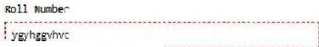
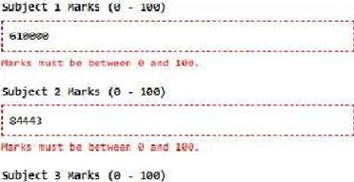
<E- C 0 117.0.0.1 5500/EXP3.html

24070521213

Subjoct111orks(f 1�)

PlO(fSS R!POl:I

suo,,,,1,,1111t11
SUtlJIKI l: ll I HH
!>ut>JKI I,"/ !1"'
Sobjir<t,:1'/1118

Conclusion - The experiment was successfully implemented using Form validation ensured that only valid student details and ma1ks were accepted, while control structures were used to calculate total marks, percentage, and assign grades. The system effectively demonstrates the use of conditional statements and input validation techniques for developing reliable and user-friendly web applications.

CASE STUDY 3

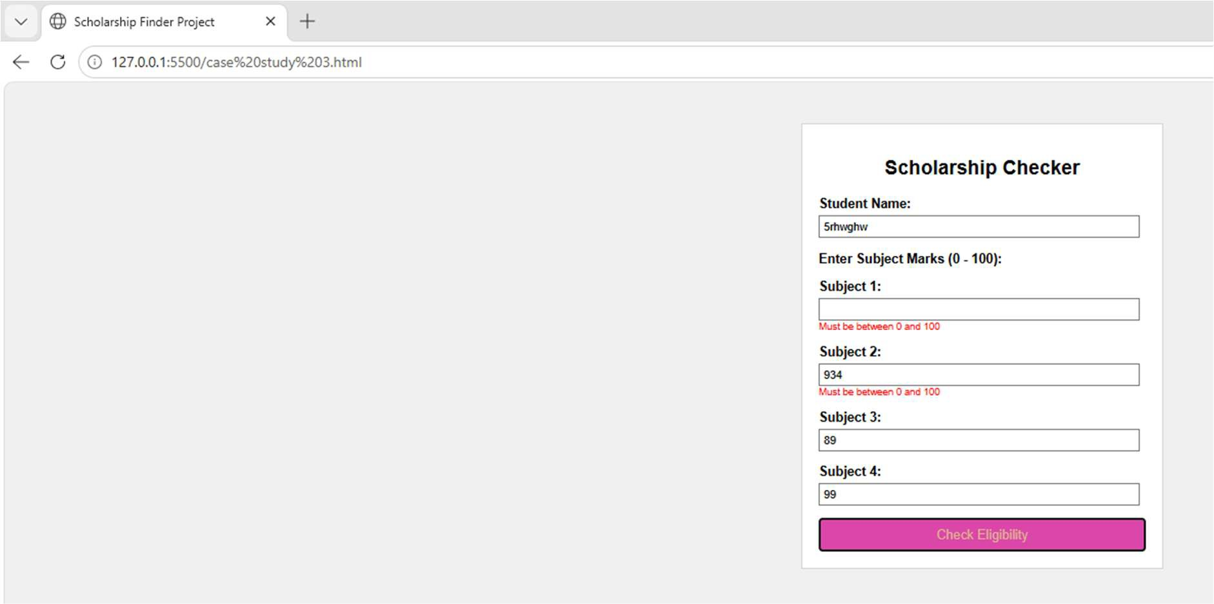

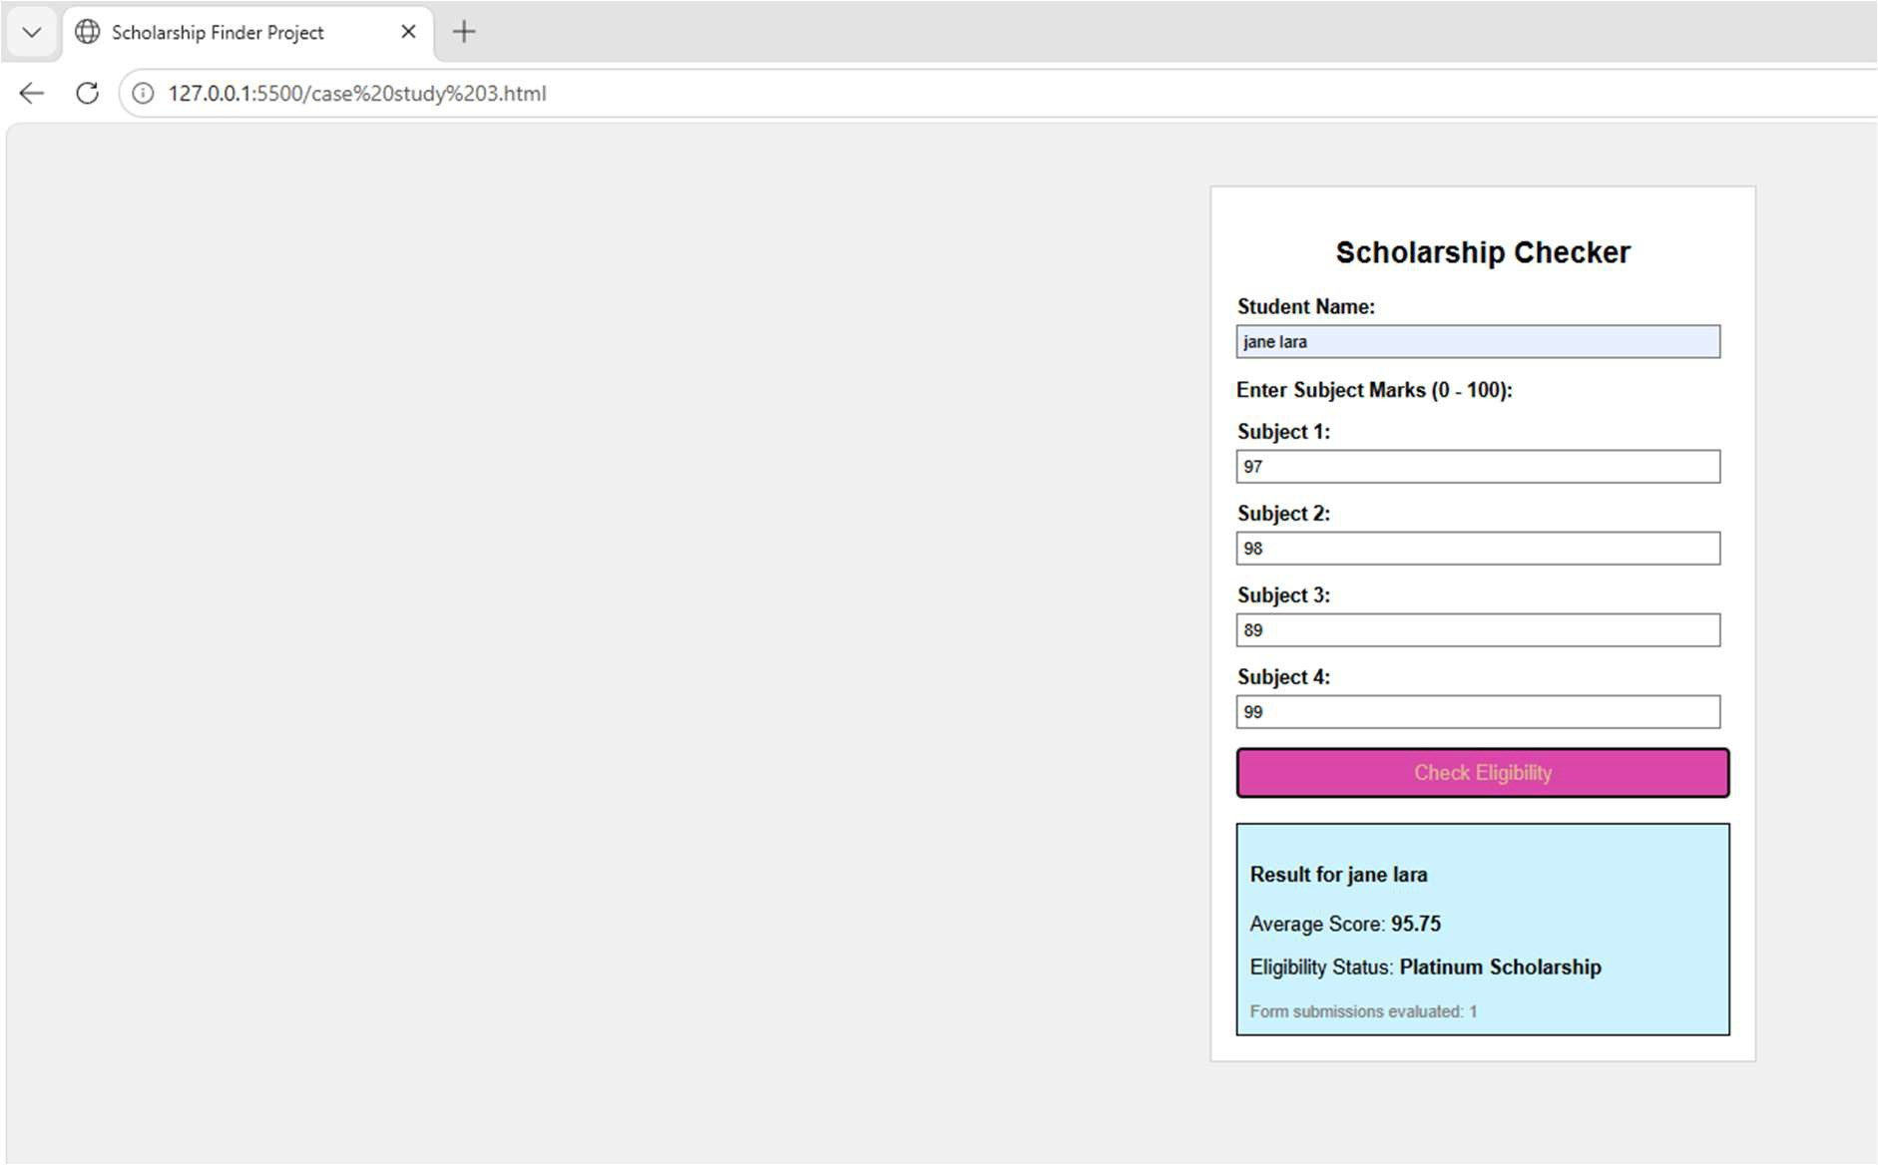


SYMBIOSIS INSTITUTE OF TECHNOLOGY, NAGPUR
Symbiosis International (Deem d University)
(E'$1��� sec:tlon 3ol'lhe U<;C Aa,19561
R�it@d by I\IAAG with 'A<+"Grad@ I Aw3:rdf!d Cah!tory • I by UGC
Founder. Pl'of. Dr. 5. 8. MuJumd.lr, M. Sc., Ph. D. (Awarded Pa-dm.1 Bhush.10 and Padm.:i Shri by President of lndi;1)

EXPERIMENT 4

Aim:
To use function types, scope, and closures, apply try-catch exception handling, and build a palindrome checker.

Tools Used :
Visual StudioCode(VS Code), HTML5, CSS3, JavaScript(ES6), Google Chrome, Live Server.

Theory:
A palindrome is a word, number, or phrase that reads the same forward and backward, This experiment demonstrates the use of JavaScript function types, variable scope, closures, and exception handling. Function declarations, function expressions, and arrow functions are used to organize and reuse code efficiently. Variable scope controls the accessibility of variables, including global scope, local scope, and block scope. Closures allow an inner function to retain access to variables ofits outer function even after the outer function has finished execution, making it useful for maintaining the count of palindrome checks. The
try ... catch statement is used to detect and handle runtime errors without
terminating the program. The palindrome checking process involves accepting user input, converting it to lowercase, reversing the string, comparing the original string with the reversed string, displaying whether it is a palindrome, and updating the total number of checks.

CODE :
<!DOCTYPE html>
<html lang="en">
<head>
<meta charset="UTF-8">
<meta name="viewport" content="width=device-width, initial-scale=1.0">
<title>plalindrome Checker</title>
<style>
body {
font-family: monospace; background-color: pink; color: black;
padding: 50px;
}

h1 {
font-size: 20px;
text-transform: uppercase;
}
h2 {
font-size: 60px; font-style: italic; color: black;
}

.box {
background-color: black; color: white;
padding: 20px; width: 600px;
border: 4px solid black;
}

input {
width: 90%; padding: 8px;
margin-bottom: 10px; background-color: white; color: black;
border: 2px solid pink;

}

button {
width: 97%; padding: 10px;
background-color: pink; color: black;
font-weight: bold; border: 2px solid white; cursor: pointer;
}

.result-box {
margin-top: 15px; padding: 10px;
border: 2px dashed pink; display: none;
}
</style>
</head>
<body>

<div class="box">
<h1>Checker</h1>
<p>Is it a palindrome?</p>

<input type="text" id="wordInput" placeholder="Type here...">
<button id="submitBtn">CHECK</button>

<div id="outputDisplay" class="result-box"></div>
<p id="totalChecks">Checks: 0</p>
</div>
<h2> 24070521213</h2>
<script>
const submitBtn = document.getElementById('submitBtn'); const wordInput = document.getElementById('wordInput');
const outputDisplay = document.getElementById('outputDisplay'); const totalChecks = document.getElementById('totalChecks');

function makeCounter() { let count = 0;

return function() { count++;
return count;
};
}
const incrementChecks = makeCounter();

function basicClean(str) {
return str.toLowerCase().replace(/[^a-z0-9]/g, '');
}

const flipString = function(str) { return str.split('').reverse().join('');
};
const checkMatch = (a, b) => a === b; submitBtn.addEventListener('click', function() {
outputDisplay.style.display = "none";

try {
const textValue = wordInput.value;

if (textValue.trim() === "") {
throw new Error("Type a word first!");
}

const clean = basicClean(textValue); const reversed = flipString(clean);
const isTrue = checkMatch(clean, reversed);

const currentCount = incrementChecks(); totalChecks.textContent = "Checks: " + currentCount;

outputDisplay.style.display = "block"; if (isTrue) {
outputDisplay.textContent = "Yes! Matches backward.";
} else {
outputDisplay.textContent = "No! Does not match.";
}

} catch (err) { outputDisplay.style.display = "block";
outputDisplay.textContent = "Error: " + err.message;
}
});
</script>
</body>
</html>

OUTPUT:
v 0 plalindrome Check.er X +

f- ➔ C <D 127.0.0.1:5500/exp4.html
CHECKER
Is it a palindrome?

anaya

I
CHECK
: No! Does not match.

Checks: 1
24070521213

v 0 plallndrome Checker >< +

� ➔ C © 127.0.0.1:5500/exp4.html
CHECKER
Is it a palindrome?

anna

CHECK

r--------------························································································
l_Yes!_Matches_backward.
Checks: 2
24070521213
Conclusion : The palindrome checker was successfully developed using HTML, CSS, and JavaScript. It correctly identifies palindrome strings while demonstrating the use of function types, variable scope, closures, and try-catch exception handling.

CASE STUDY 4

