CS 499 Final ePortfolio Narrative
Enhancement Two: Algorithms and Data Structures
Asher Nayer
Artifact: CS 300 Course Planner

Brief Description of the Artifact
The artifact selected for Enhancement Two is the CS 300 Data Structures and Algorithms: Analysis and Design Course Planner application. The original artifact was a C++ program that loaded course data from a file, stored courses in a Binary Search Tree, and printed courses in alphanumeric order through in-order traversal.
For the final ePortfolio version, I preserved the Binary Search Tree as the structure responsible for sorted output, but expanded the program into a more complete advising tool. The enhanced program now supports prerequisite parsing, two-pass prerequisite validation, direct course lookup, defensive file handling, and runtime evidence for both valid and invalid input files.

Justification for Inclusion in the ePortfolio
I selected this artifact because it directly demonstrates the algorithms and data structures category of the CS 499 ePortfolio. A course planner is a practical problem because users need both sorted course output and fast course lookup. That makes it useful for demonstrating that different data structures are appropriate for different operations.
The enhanced artifact shows my ability to evaluate requirements and make data-structure trade-offs. The Binary Search Tree remains appropriate for in-order sorted traversal, while the unordered_map index supports fast average-case direct lookup by course number. The two-pass prerequisite validation process also demonstrates algorithmic reasoning because the program must first know the complete set of valid course numbers before it can determine whether each prerequisite is valid.

Enhancement and Final Polish Summary
The Milestone Three enhancement added prerequisite support, more defensive CSV parsing, a hash map lookup index, and clearer Big-O trade-off documentation. The final polish focused on packaging the artifact for the ePortfolio so that the original and enhanced work are easy to compare and verify. No major additional correction was required after grading; the final ePortfolio polish strengthens presentation, file organization, and testing evidence.
Final polish item | Evidence in final artifact
Original/enhanced comparison | The package separates original CS 300 files from enhanced files so the improvement is traceable.
BST plus hash map trade-off | CoursePlanner_Enhanced.cpp keeps BST traversal for sorted output and adds unordered_map for direct course lookup.
Prerequisite validation | The loader uses a two-pass process to validate prerequisites against the complete set of known course numbers.
Defensive input testing | courses_with_errors.csv and error_run_output.txt demonstrate duplicate-course, malformed-row, and invalid-prerequisite handling.
Normal runtime testing | courses_valid.csv and valid_run_output.txt demonstrate successful loading, sorted output, lookup, and prerequisite display.
Visual design evidence | flowchart.png is included to show the enhanced algorithmic workflow and decision points.
Build verification | BUILD_VERIFICATION.txt documents successful C++ compilation with g++ using C++17 flags.

Most relevant final files: CoursePlanner_Enhanced.cpp, courses_valid.csv, courses_with_errors.csv, flowchart.png, valid_run_output.txt, error_run_output.txt, BUILD_VERIFICATION.txt

Enhanced Course Planner Flowchart
The flowchart below illustrates the enhanced Course Planner workflow. It shows how the program opens the course data file, validates file access, parses course rows, validates required fields, stores known course numbers, validates prerequisites, inserts valid courses into the Binary Search Tree, adds courses to the unordered_map index, and then allows the user to print a sorted list or look up an individual course.
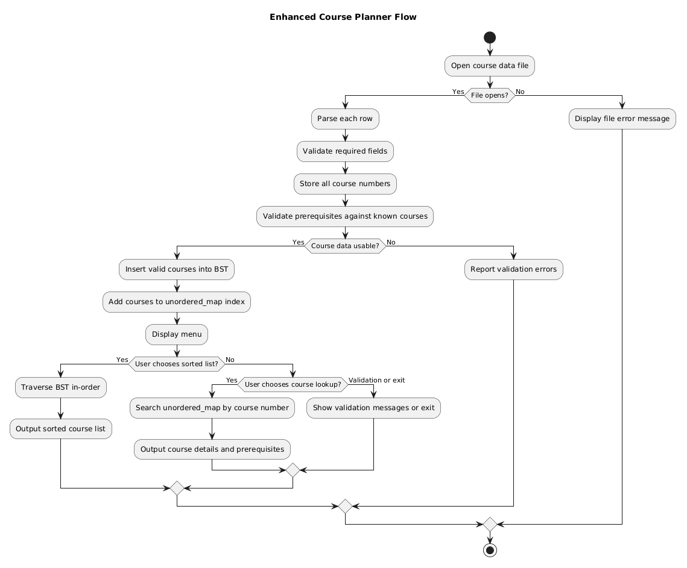
Figure 1. Enhanced Course Planner Flow

Course Outcome Alignment
This enhancement most directly supports the outcome related to designing and evaluating computing solutions using algorithmic principles while managing trade-offs. The final artifact demonstrates that a single data structure is not always the best answer for every operation. The BST supports sorted traversal, the unordered_map supports direct lookup, and the two-pass validation process supports prerequisite correctness.
The enhancement also supports professional communication and industry-practice outcomes because the README, flowchart, test data, runtime output, and final narrative explain the technical decisions in a way that another reviewer can verify. It also supports the security mindset outcome through defensive programming: the program checks file access, validates required fields, rejects malformed rows, reports invalid prerequisites, and avoids treating untrusted input as automatically valid.

Reflection on the Enhancement Process
Enhancing this artifact helped me understand that algorithm design is not only about implementing a data structure correctly. It is also about matching the structure to the behavior the application needs. The original BST was useful for sorted output, but the enhanced advising tool also needed fast lookup and prerequisite validation. Adding an unordered_map and a two-pass load process made the design more complete and more realistic.
One challenge was improving validation without making the program unnecessarily complex. A single-pass loader is easier to write, but it cannot reliably validate prerequisites that may appear later in the file. The two-pass design required more structure, but it produced a more reliable result. Another challenge was making error cases visible; the final polish addresses this by including separate valid and error datasets plus runtime output files that demonstrate the program behavior.

Conclusion
The final polished Course Planner demonstrates growth in algorithms and data structures by combining BST traversal, hash-based lookup, two-pass validation, defensive file parsing, and runtime evidence. It shows that I can evaluate design choices, explain trade-offs, and implement data-structure solutions that are appropriate to the problem being solved.

