**Cucumber-JVM Setup Within Walgressn using Eclipse and SVN**

**Step 1:** Use the Eclipse that has SVN Plugin.

**Step 2:** Checkout the latest Workspace from SVN using the Eclipse. Here is the info:

SVN Repository Name: batch9qa – Checkout from the latest branch. Please see the following screenshot:

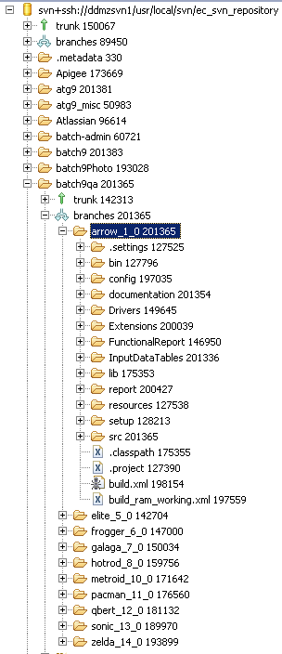

**Step 3:** I have copied the Pre-Configured Eclipse binary and the workspace to the following location on Unix server. Here is the location and filenames:

Location: [axi3@dnbdap01]:/home/nbd/axi3/EcomQA

FileNames:

[axi3@dnbdap01]:/home/nbd/axi3/EcomQA

$ ls -lrt

total 909088

-rw-r--r-- 1 axi3 nbd 394519160 Apr 11 10:53 **eclipse_indigo.zip**

-rw-r--r-- 1 axi3 nbd 70924807 Apr 18 15:41 **workspace.zip**

**Step 4**: Once you have gone through the above steps, you should have a working Eclipse environment, which looks like this:

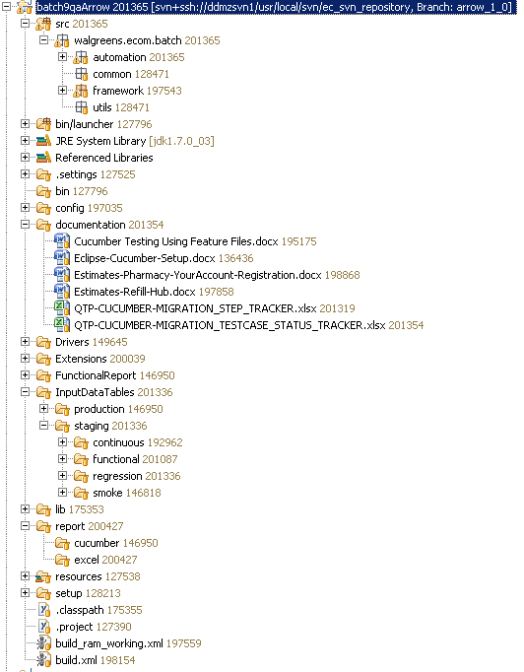

**Step 5:** Open the following feature, which can be used as an example to run the scenarios:

batch9qa/src/walgreens/ecom/batch/automation/staging/features/regression/checkout/loyalty/LoyaltyShoppingCart.feature

Corresponding Step Definitions can be found in the following folder:

batch9qa/src/walgreens/ecom/batch/automation/stepdefinitions/

**Step 6:** Click on the Arrow from the green button as shown in the following picture and then select Run Configuration:

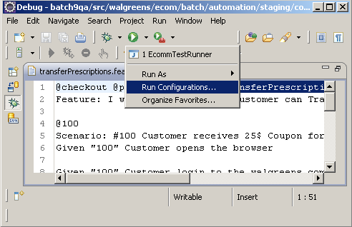

**Step 7:** From the next Window, select Arguments Tab. You should see EcommTestRunner @LTY-CART-1 functional. Click on Run button and then it should start running the Scenario from the LoyaltyShoppingCart.feature file.

