**NANDHA ENGINEERING COLLEGE**

**(Autonomous Institution)**

Erode-638 052



**TABLEAU-TWO CREDIT COURSE**

**IV – Semester**

**B.Tech - Artificial Intelligence and Data Science**

**NAME : J.ANBARASAN**

**BRANCH : B.TECH AI & DS**

**YEAR : II**

What is Tableau ?

**Tableau** is a leading data visualization and business intelligence tool that allows users to connect to various data sources, process the data, and create interactive, shareable dashboards and visual reports. It transforms complex data into easy-to-understand visual formats like graphs, charts, and maps, helping organizations make data-driven decisions quickly. Tableau is known for its simple drag-and-drop interface, real-time data analysis capabilities, and the ability to handle large amounts of data without requiring any programming skills. It is widely used in industries for reporting, analytics, and gaining valuable insights from data.

What we do in Tableau ?

In **Tableau**, we work with data by first connecting it to various sources such as Excel sheets, databases, or cloud platforms. After connecting, we can clean, filter, and prepare the data as needed. Tableau then allows us to create a wide range of visualizations like bar charts, pie charts, line graphs, maps, and dashboards. These visuals help in analyzing trends, patterns, and key insights hidden within the data. With its drag-and-drop feature, we can easily build interactive and dynamic reports without requiring programming skills. Finally, we can share these dashboards and visualizations with others, helping organizations make better and faster data-driven decisions.

Dashboard:

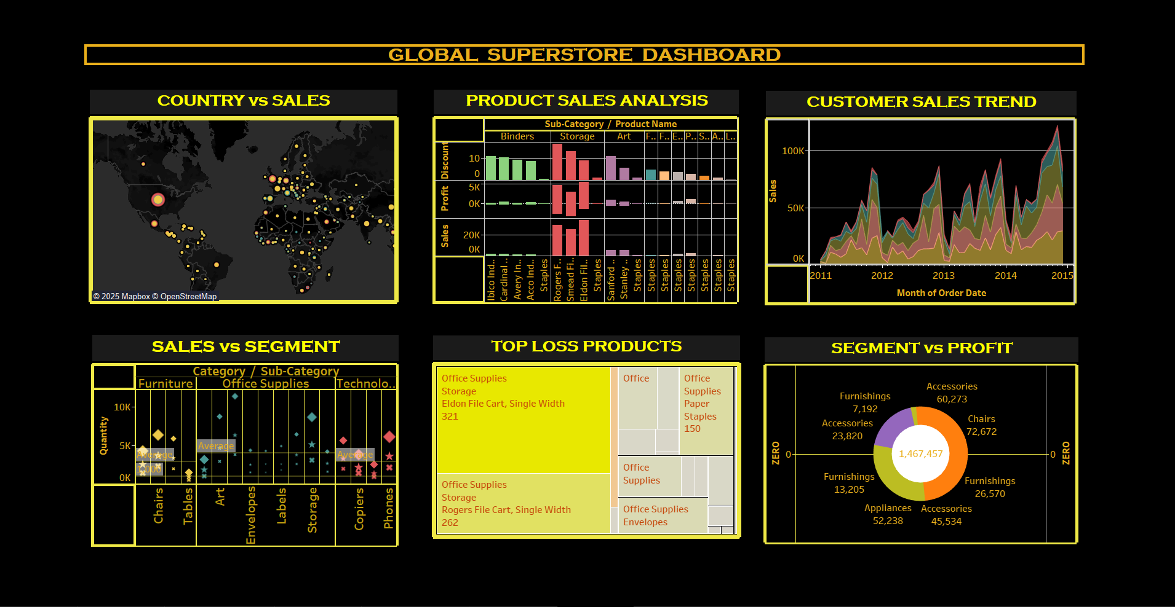

Contents in dashboard:

1. Country vs Sales
2. Sales vs Segment
3. Product Sales Analysis
4. Top Less Product
5. Customer Sales Trend
6. Segment vs Profit

Country vs sales:

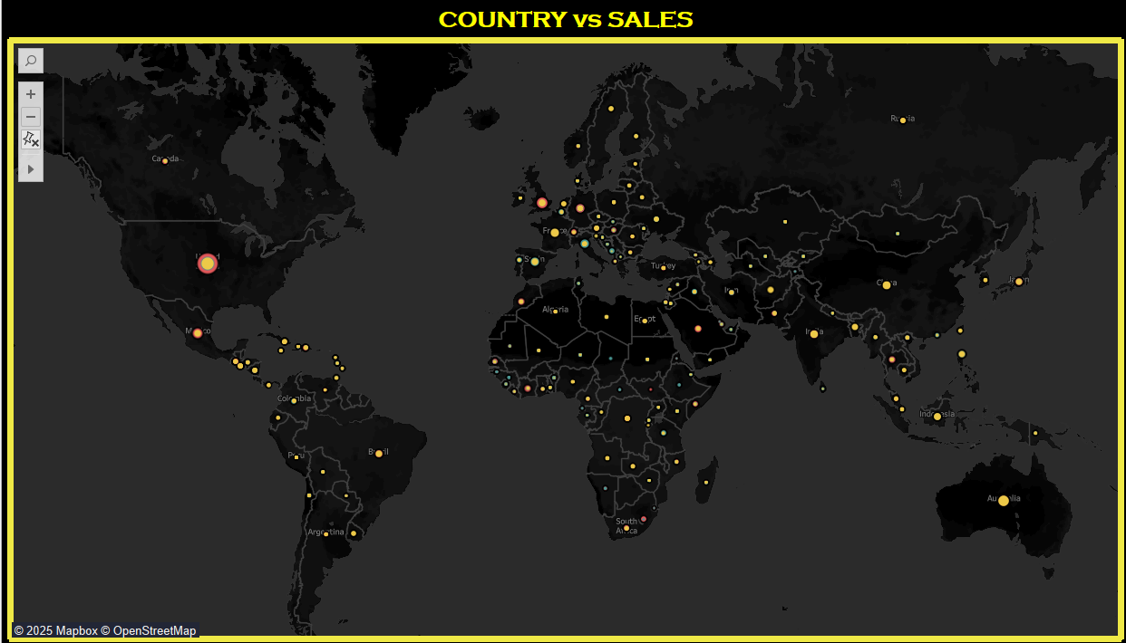

* **World map** shows **geographical spread of sales**.
* **Size and brightness** of circles represent **sales volume**.
* **United States** dominates with the highest concentration of sales.
* Strong activity in **Europe**, **India**, and parts of **South America**.
* **Smaller, noticeable sales** in countries like **Algeria**, where specific products like **"Hewlett Fax Machine, High-Speed"** contributed to revenue.
* **Colour coding by category** (e.g., **Furniture**, **Office Supplies**, **Technology**) helps identify top-performing product types across countries.

Sales vs Segment:

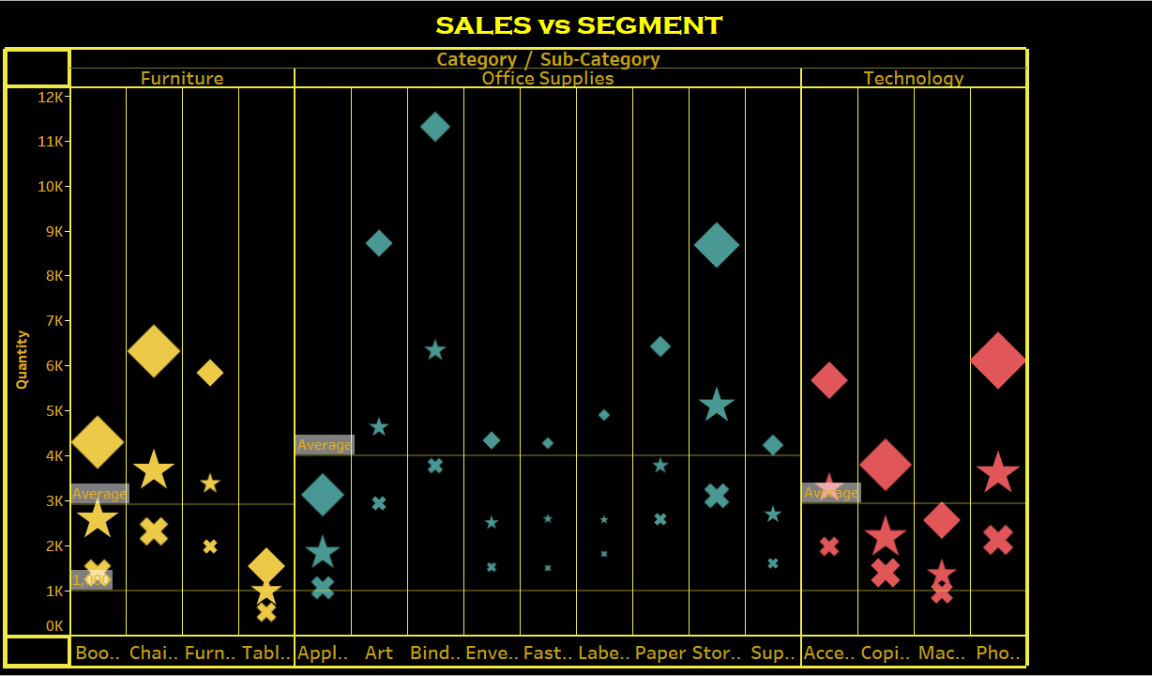

* **Bubble scatter plot** compares **product categories** (Furniture, Office Supplies, Technology) across **quantity sold**.
* **Larger bubbles** represent **higher sales volumes**.
* **Colors and shapes** differentiate **customer segments** (Consumer, Corporate, Home Office).
* **Technology items** like **Phones** and **Copiers** show **significant sales volumes**.
* **Furniture items** display **moderate quantities** sold.

Product Sales Analysis:

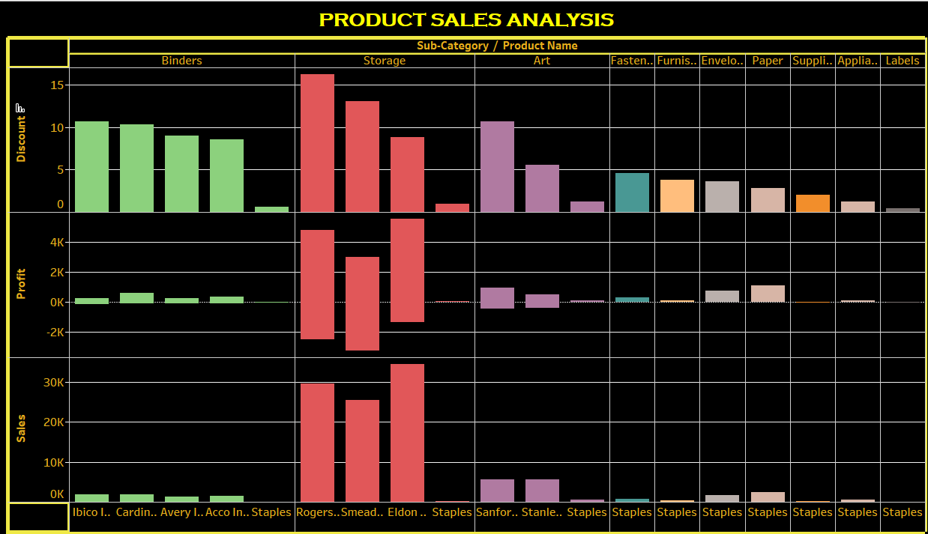

* **Chart shows** **Sales**, **Profit**, and **Discount** metrics by **Sub-Category** and **Product Name**.
* Each coloured group (like **Storage**, **Binders**, **Art**, etc.) represents a **Sub-Category**.
* **Positive profit and sales bars** show **successful products**, while **negative profits** highlight **loss-making items**.
* **Example**: In **Storage**, **"Smead File Cart, Single Width"** in **El Salvador** had a **profit of 236** and **sales of 514** with **no discount** offered.
* Categories like **Binders** and **Storage** show both **high sales** and some **losses**, indicating areas for better **discount control**.

Top Less Product:

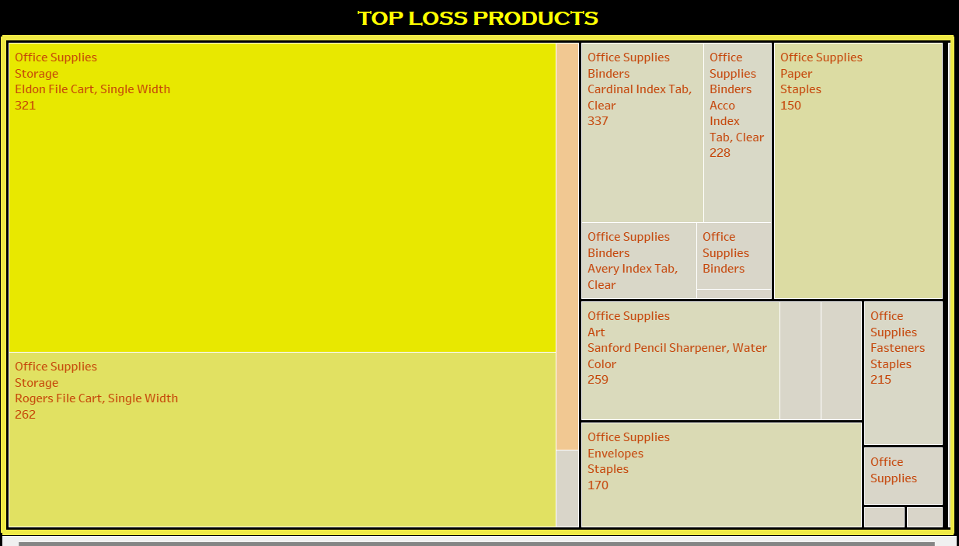

* **Tree map** highlights products causing the most **profit loss**.
* **Office Supplies** (especially **Storage items**) show major losses, with the largest block sizes.
* Products like **"Eldon File Cart"** and **"Rogers File Cart"** are top loss contributors.
* **Blocks are color-coded** by **profit range**, with more intense colours showing higher losses.
* **Hovering over blocks** reveals details like **quantity sold** and **profit per product** for deeper insight.

Customer Sales Trend:

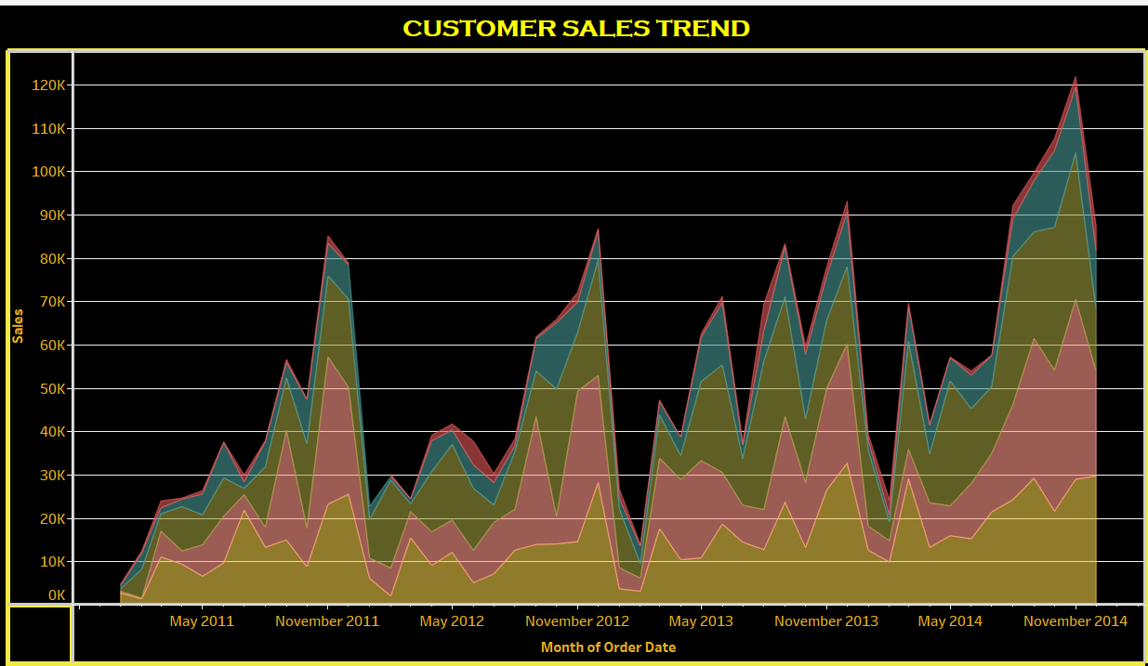

* **Area chart** tracks **monthly customer sales trends** across regions.
* **Seasonal patterns** visible, with peaks around **November** and **December** each year.
* **West region** dominates overall sales, compared to **Canada** and **Caribbean**.
* **Central Asia** shows **moderate, steady growth** over the years.
* **Colour layering** separates sales trends by **region** visually.

Segment vs Sales:

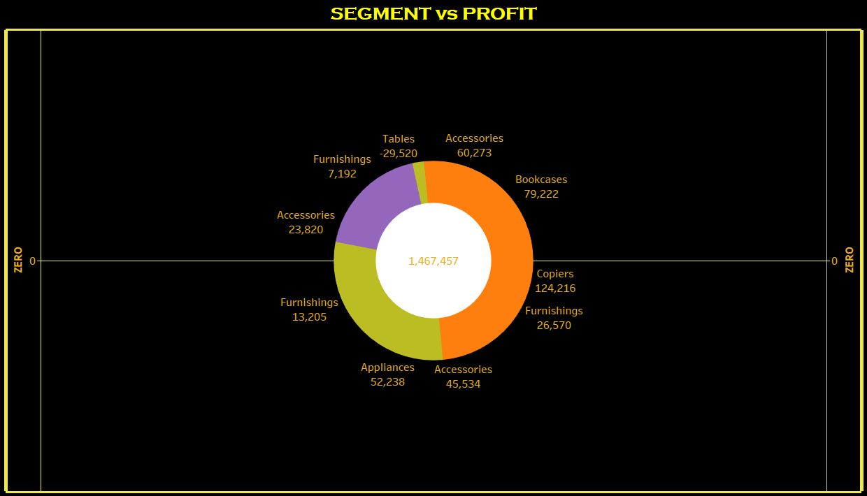

* **Donut chart** visualizes the relationship between **customer segments** (Consumer, Corporate, Home Office) and **total profit contribution**.
* **Consumer** segment shows the **highest profit** contribution overall.
* **Corporate** and **Home Office** contribute less compared to **Consumer**.
* The **inner circle** represents **total profit value**.
* **Colour coding** helps differentiate between **segments** clearly.

Global Superstore Story – Description:

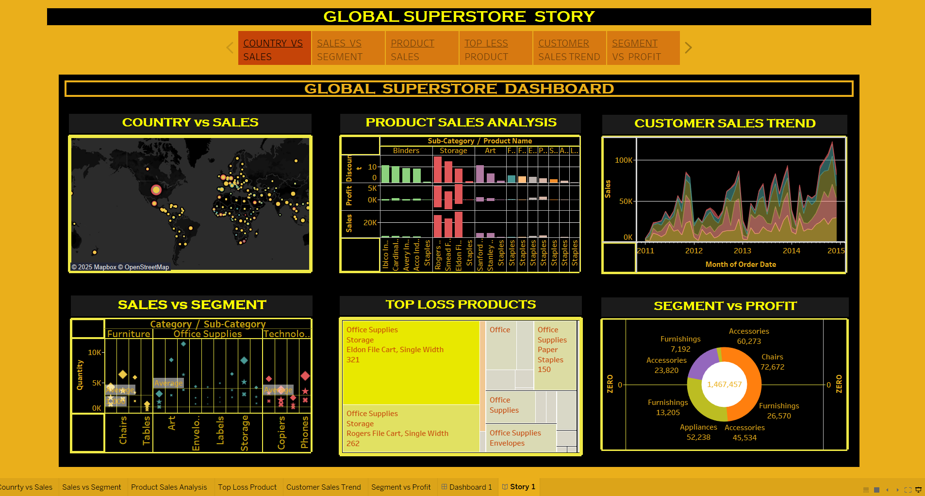

* This story combines different **visual analyses** to show the overall performance of the **Global Superstore**.
* It displays **sales across countries**, tracks **customer trends over time**, highlights **top-selling** and **loss-making products**, and compares **segment profitability**.
* The **map** shows **sales distribution globally**, while **charts and graphs** break down **product categories**, **quantities sold**, and **profits earned**.
* **Colour coding** and **interactive visuals** help quickly identify which **products**, **segments**, and **regions** are driving **success or losses**.

Conclusion:

* This story combines different **visual analyses** to showcase the overall performance of the **Global Superstore**.
* It presents **sales across countries**, tracks **customer trends over time**, highlights both **top-selling** and **loss-making products**, and compares **segment profitability**.
* The **world map** visualizes **global sales distribution**, while **charts and graphs** break down **product categories**, **quantities sold**, and **profits earned**.
* **Colour coding** and **interactive visuals** enable quick identification of **successful** and **underperforming** products, segments, and regions.