Zero Trust Network Access (ZTNA) with
Zsclaer : Securing User to Application
Connectivity

List of Teammates
S.No. | Name | Reg.no | Contact | College
1. | Anbarasu S P | 2328D0004 | anbarasusp23csa@vetias.ac.in | VET Institute of Arts and Science
2. | Navaneethan A | 2328D0033 | navaneethana23csa@vetias.ac.in | VET Institute of Arts and Science
3. | Sachinvishal S C S | 2328D0044 | Sachinvishalscs23csa@vetias.ac.in | VET Institute of Arts and Science
4. | Jeevankumar M | 2328D0023 | Jeevankumarm23csa@vetias.ac.in | VET Institute of Arts and Science
5. | Kanishka S | 2328D0025 | Kanishkas23csa@vetias.ac.in | VET Institute of Arts and Science

Title of the Project: -
Implement and manage Zero Trust Network Access (ZTNA) using Zscaler by enabling secure, identity-based user-to-application connectivity without exposing internal networks

Overview: -
Zero Trust Network Access (ZTNA) is a modern cybersecurity approach designed to secure access to applications by eliminating the traditional concept of a trusted internal network. Instead of automatically trusting users or devices inside a corporate network, the Zero Trust model operates on the principle of “never trust, always verify.” Every access request is continuously authenticated, authorized, and validated before granting access to applications or resources.
ZTNA ensures that users are connected only to specific applications they are authorized to use, rather than giving them access to the entire network. This significantly reduces the attack surface and helps prevent unauthorized access, data breaches, and lateral movement by attackers.
Zscaler is a leading cloud security platform that implements the Zero Trust architecture through its Zscaler Private Access (ZPA) solution. ZPA enables secure, direct connections between authenticated users and internal applications without exposing the applications to the public internet or requiring traditional VPN infrastructure. Unlike VPNs, which extend the network to the user, Zscaler connects the user directly to the application, ensuring a more secure and efficient access method.
With Zscaler’s ZTNA approach, users are authenticated through identity providers, and their devices are verified for security posture before access is granted. The platform continuously monitors user activity and enforces security policies in real time. This ensures that only legitimate users with compliant devices can access enterprise applications, whether they are hosted in on-premises data centers or cloud environments.
Additionally, Zscaler uses a cloud-native architecture that delivers secure connectivity through a global network of data centers. This architecture improves performance, scalability, and security while simplifying IT infrastructure by reducing dependency on traditional network hardware such as firewalls and VPN gateways.
Overall, Zero Trust Network Access with Zscaler provides organizations with a secure, scalable, and efficient method to protect sensitive applications and data. By verifying user identity, device health, and contextual information before granting access, ZTNA helps organizations strengthen their security posture while enabling seamless remote and hybrid workforce connectivity.

Abstract: -
Zero Trust Network Access (ZTNA) is an advanced security framework designed to protect organizational resources by enforcing strict identity verification for every user and device attempting to access applications. Unlike traditional security models that rely on perimeter-based defenses and Virtual Private Networks (VPNs), the Zero Trust model assumes that no user or device should be automatically trusted, regardless of whether they are inside or outside the corporate network. Instead, access is granted based on continuous authentication, authorization, and security policy enforcement.
This study focuses on the implementation of ZTNA using Zscaler, a cloud-based security platform that provides secure user-to-application connectivity without exposing internal networks to potential threats. Zscaler’s Zero Trust architecture, particularly through its Zscaler Private Access (ZPA) solution, enables direct and secure connections between authenticated users and specific applications rather than granting broad network access. This approach significantly reduces the attack surface, prevents lateral movement within networks, and enhances overall security.
The proposed system emphasizes secure remote access, identity-based authentication, device posture validation, and real-time policy enforcement. By leveraging cloud-native infrastructure, Zscaler delivers scalable, high-performance security services that support modern hybrid and remote work environments. The implementation of ZTNA with Zscaler improves organizational security by ensuring that only authorized users with verified devices can access critical applications and data.
Overall, adopting ZTNA with Zscaler provides a robust security solution that enhances user access control, minimizes cybersecurity risks, and simplifies network management while maintaining seamless connectivity between users and enterprise applications.

Use Case Scenarios: -
Use Case Scenario 1: Secure Contractor Access
A third-party contractor is hired to manage a specific set of development servers for a limited period. Instead of giving them broad network access, the organization assigns them to a “Contractor” group in the Identity Provider (IdP). Zscaler uses this group membership to restrict their access only to the required development infrastructure, ensuring that the rest of the network remains invisible to them.
Output:
- User identity verified: Contractor authenticated through IdP and assigned to Contractor Group.
- Connection restricted: Access limited exclusively to Development Servers (Dev Zone).
- Security enforcement: Continuous monitoring of session activity for audit and compliance.
- No lateral movement: Blocked from accessing other internal systems such as Finance, HR, or Admin networks.
- Access expiry: Automatic termination of access when the contractor account is deactivated in the IdP.

Use Case Scenario 2: Secure Remote Employee Access
A company employee working from home needs to access internal applications such as the project management system and company dashboard. Using Zscaler ZTNA, the employee connects securely to these applications without accessing the entire corporate network.
Output:
- User identity verified: Employee authenticated through Single Sign-On (SSO) using IdP.
- Connection restricted: Access allowed only to approved internal business applications.
- Security enforcement: Continuous verification of user session and security policies.
- No lateral movement: Employee cannot access other internal systems not assigned to their role.
- Device compliance: Access permitted only if the device meets organizational security requirements.

Use Case Scenario 3: Secure Vendor Application Access
A software vendor requires temporary access to a company’s internal maintenance system to perform system updates and troubleshooting. Zscaler ZTNA provides application-specific access without exposing the organization’s internal network.
Output:
- User identity verified: Vendor authenticated through IdP with vendor-specific role.
- Connection restricted: Access limited to the Maintenance Application only.
- Security enforcement: All vendor activities are logged and monitored for compliance.
- No lateral movement: Vendor cannot access other enterprise applications or databases.
- Access expiry: Access automatically revoked after the maintenance period ends.

Use Case Scenario 4: Secure Access to Cloud-Based Applications
An organization hosts important business applications on cloud infrastructure. Employees need secure access to these applications from different locations. Zscaler ZTNA ensures that only authorized users can access the applications securely.
Output:
- User identity verified: Authentication performed through cloud-integrated IdP.
- Connection restricted: Users can access only designated cloud applications.
- Security enforcement: Continuous inspection of application traffic and user activity.
- Application invisibility: Applications remain hidden from unauthorized users.
- Policy enforcement: Access controlled based on user role, device posture, and location.

Use Case Scenario 5: Secure Access from Managed Devices
Organizations often require employees to access sensitive applications only from trusted devices. Zscaler ZTNA verifies the device security posture before granting access to the application.
Output:
- User identity verified: Employee authenticated using IdP credentials.
- Device verification: Device checked for compliance (updated OS, antivirus enabled, security patches installed).
- Connection restricted: Access granted only to authorized enterprise applications.
- Security enforcement: Continuous monitoring to detect suspicious activity.
- Access denial: Non-compliant or unmanaged devices are blocked from accessing sensitive resources

Stage – 1

Title of the Project: -
Implement and manage Zero Trust Network Access (ZTNA) using Zscaler by enabling secure, identity-based user-to-application connectivity without exposing internal networks

List of Vulnerability Table: -

S.No. | Vulnerability Name | CWE/CVE - No
1. | Absolute Path Traversal | CWE-36
2. | Password in Configuration File | CWE-260
3. | Use of Obsolete Function | CWE-447
4. | Insufficient Entropy | CWE-331
5. | Missing XML Validation | CWE-112
6. | Incorrect Privilege Assignment | CWE-266
7. | Authentication Bypass by Alternate Name | CWE-289
8. | Deserialization of Untrusted Data | CWE-502
9. | Information Loss of Omission | CWE-221
10. | NULL Pointer Dereference | CWE-476

REPORT: -
- Vulnerability Name: - Absolute Path Traversal
CWE/CVE: - CWE-36
OWASP/SANS Category: - A01:2025 Broken Access Control
Description: -
Absolute Path Traversal is a type of web security vulnerability that occurs when an application allows a user to access files on a server using an absolute file path without proper validation or access control. An absolute path specifies the full location of a file starting from the root directory of the operating system.
In this vulnerability, an attacker can manipulate input parameters (such as file names or paths) to access sensitive files or directories on the server that should normally be restricted. Instead of limiting users to specific directories, the application mistakenly allows direct access to files using complete system paths.

Business Impact: -
Absolute Path Traversal can have serious impacts on a business if attackers exploit the vulnerability. It may allow unauthorized access to sensitive files such as configuration files, user data, and system information. This can lead to data breaches and exposure of confidential business information. Organizations may suffer financial losses due to recovery costs, legal penalties, and compensation. Such incidents can also damage the company’s reputation and reduce customer trust. Attackers may use the obtained information to perform further cyberattacks on the system. Overall, this vulnerability can affect business operations, security, and long-term reliability.
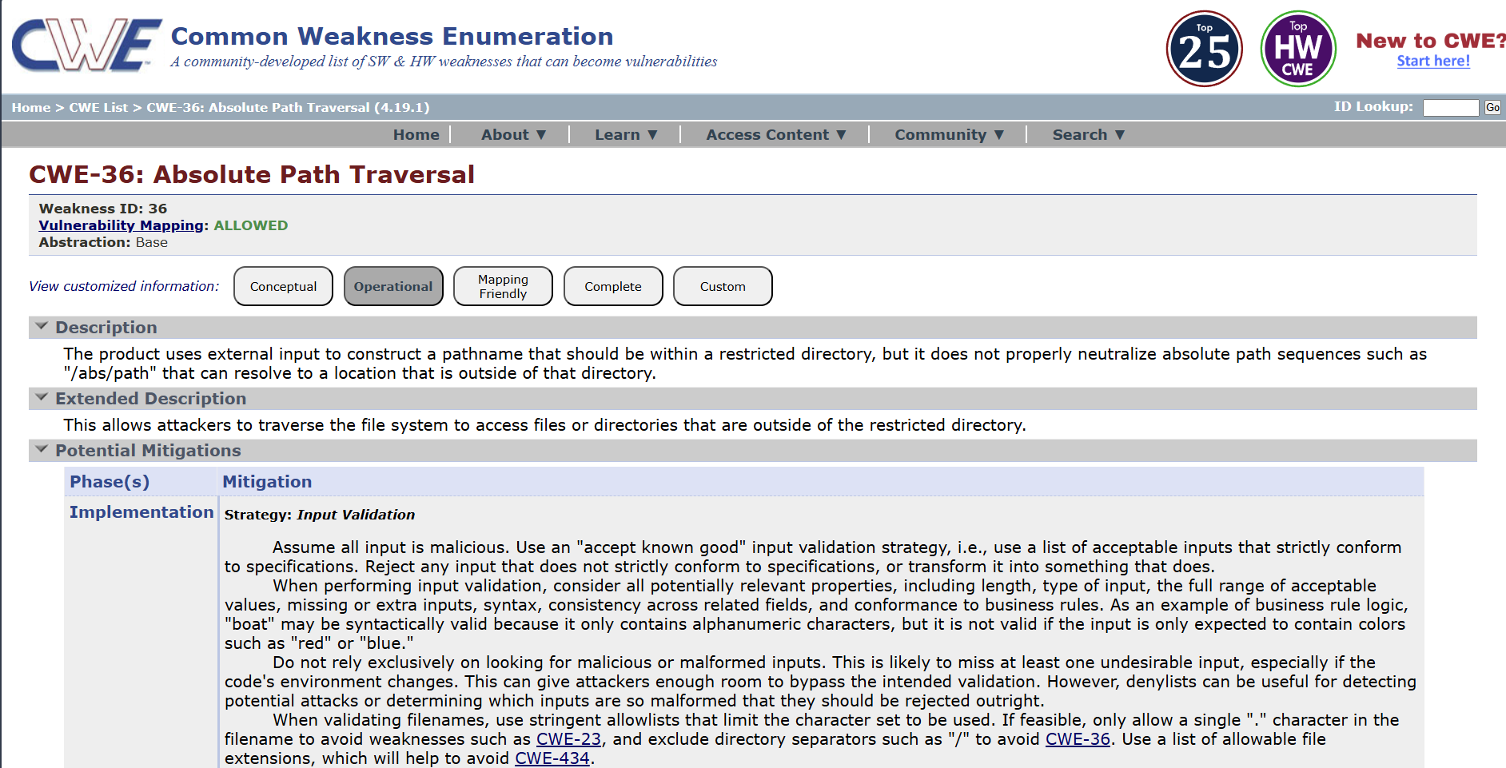

- Vulnerability Name: - Password in Configuration File
CWE/CVE: - CWE-260
OWASP/SANS Category: - A02:2025 Security Misconfiguration
Description: -
Password in Configuration File is a security vulnerability where passwords are stored directly in application configuration files in plain text. These files are often used to store system settings, database credentials, and authentication details. If the configuration file is accessed by unauthorized users, they can easily view the stored passwords. Attackers may obtain these files through system access, backups, or other vulnerabilities. Storing passwords in plain text increases the risk of credential theft and unauthorized access. This issue usually occurs due to poor security practices during application development. Using encryption or secure credential management systems can help prevent this vulnerability.
Business Impact: -
Storing passwords in configuration files can expose sensitive credentials if the files are accessed by attackers. This can allow unauthorized users to gain access to databases, servers, or applications. As a result, confidential business and customer data may be compromised. Organizations may experience financial losses due to security breaches and system recovery costs. It can also damage the company’s reputation and reduce customer confidence. Businesses may face legal and compliance issues for failing to protect sensitive information. Overall, this vulnerability can lead to serious security and operational risks.
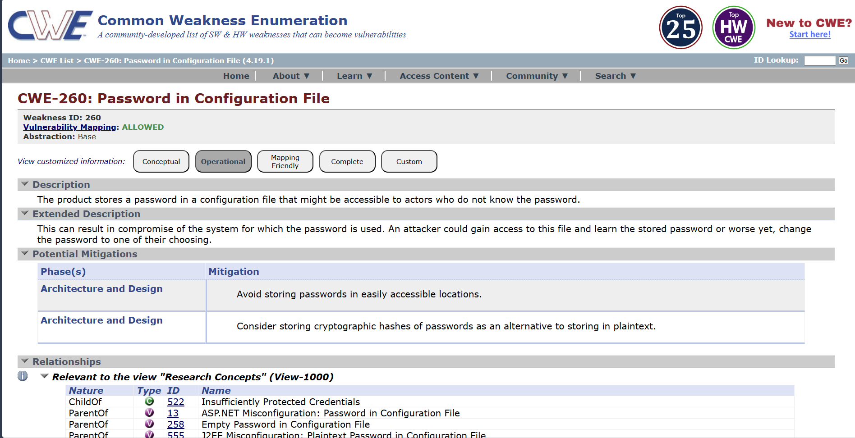

- Vulnerability Name: - Use of Obsolete Function
CWE/CVE: CWE-447
OWASP/SANS Category: - A03:2025 Software Supply Chain Failures
Description: -
Use of Obsolete Function is a security vulnerability that occurs when an application uses outdated or deprecated functions in its code. These functions are often no longer recommended because they may contain security weaknesses. Developers may continue using them due to legacy code or lack of updates. Obsolete functions may not follow modern security standards. Attackers can exploit weaknesses in these functions to compromise the system. This vulnerability is common in older software or poorly maintained applications. Regular code updates and using secure alternatives can help prevent this issue.

Business Impact: -
Using obsolete functions can expose applications to known security vulnerabilities. Attackers may exploit these weaknesses to gain unauthorized access to systems or data. This can lead to data breaches and system compromise. Organizations may face financial losses due to security incidents and system repairs. It can also damage the company's reputation and reduce customer trust. Businesses may experience operational disruptions if the system becomes unstable or compromised. Keeping software updated helps reduce these security risks.
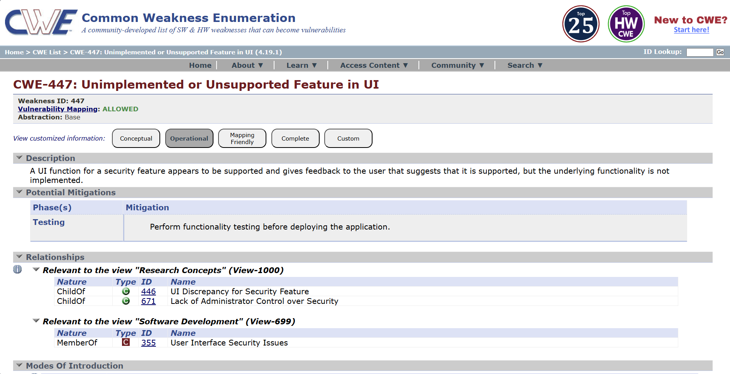

- Vulnerability Name: - Insufficient Entropy
CWE/CVE: CWE-331
OWASP/SANS Category: - A04:2025 Cryptographic Failures
Description: -
Insufficient Entropy is a security vulnerability that occurs when an application generates predictable random values. Entropy refers to the level of randomness used in generating data such as passwords, session IDs, or encryption keys. If the randomness is weak or predictable, attackers may be able to guess or reproduce these values. This can happen when insecure random number generators are used. As a result, attackers may hijack sessions or break authentication mechanisms..
Business Impact: -
Insufficient entropy can allow attackers to predict sensitive values such as session IDs or authentication tokens. This may lead to unauthorized access to user accounts or system resources. Attackers may also bypass security controls or encryption mechanisms. Organizations may experience data breaches and exposure of confidential information. This can result in financial losses due to recovery and security improvements. It may also damage the company’s reputation and reduce customer trust. Proper security practices are necessary to protect business systems from such risks.
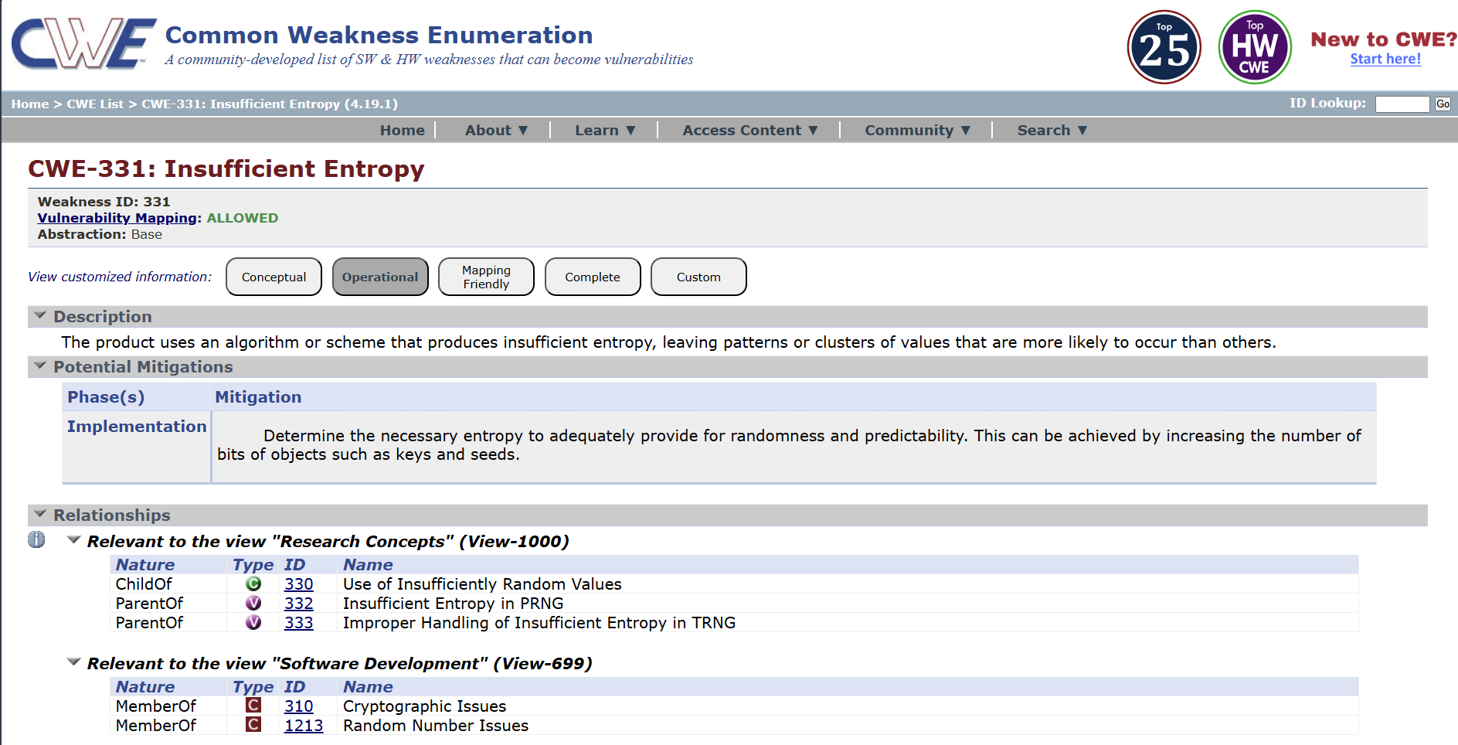

- Vulnerability Name: - Missing XML Validation
CWE/CVE: CWE-112
OWASP/SANS Category: - A05:2025 Injection
Description: -
Missing XML Validation is a security vulnerability that occurs when an application processes XML input without properly validating its structure and content. XML validation ensures that the data follows a defined format and schema. Without validation, attackers can send malicious or unexpected XML data to the system. This can lead to issues such as XML injection or XML External Entity (XXE) attacks. Improperly handled XML input may allow attackers to access sensitive files or disrupt application behavior. The vulnerability often occurs in applications that rely heavily on XML-based communication. Implementing proper XML schema validation and secure parsing helps prevent this issue.
Business Impact: -
Missing XML validation can allow attackers to send malicious XML data to the application. This may lead to unauthorized access to sensitive files or system information. Attackers could exploit the vulnerability to perform further attacks on the system. Organizations may experience data breaches and exposure of confidential information. This can result in financial losses due to recovery costs and legal penalties. It may also damage the organization’s reputation and reduce customer trust. Proper input validation is important to protect business systems from such threats.
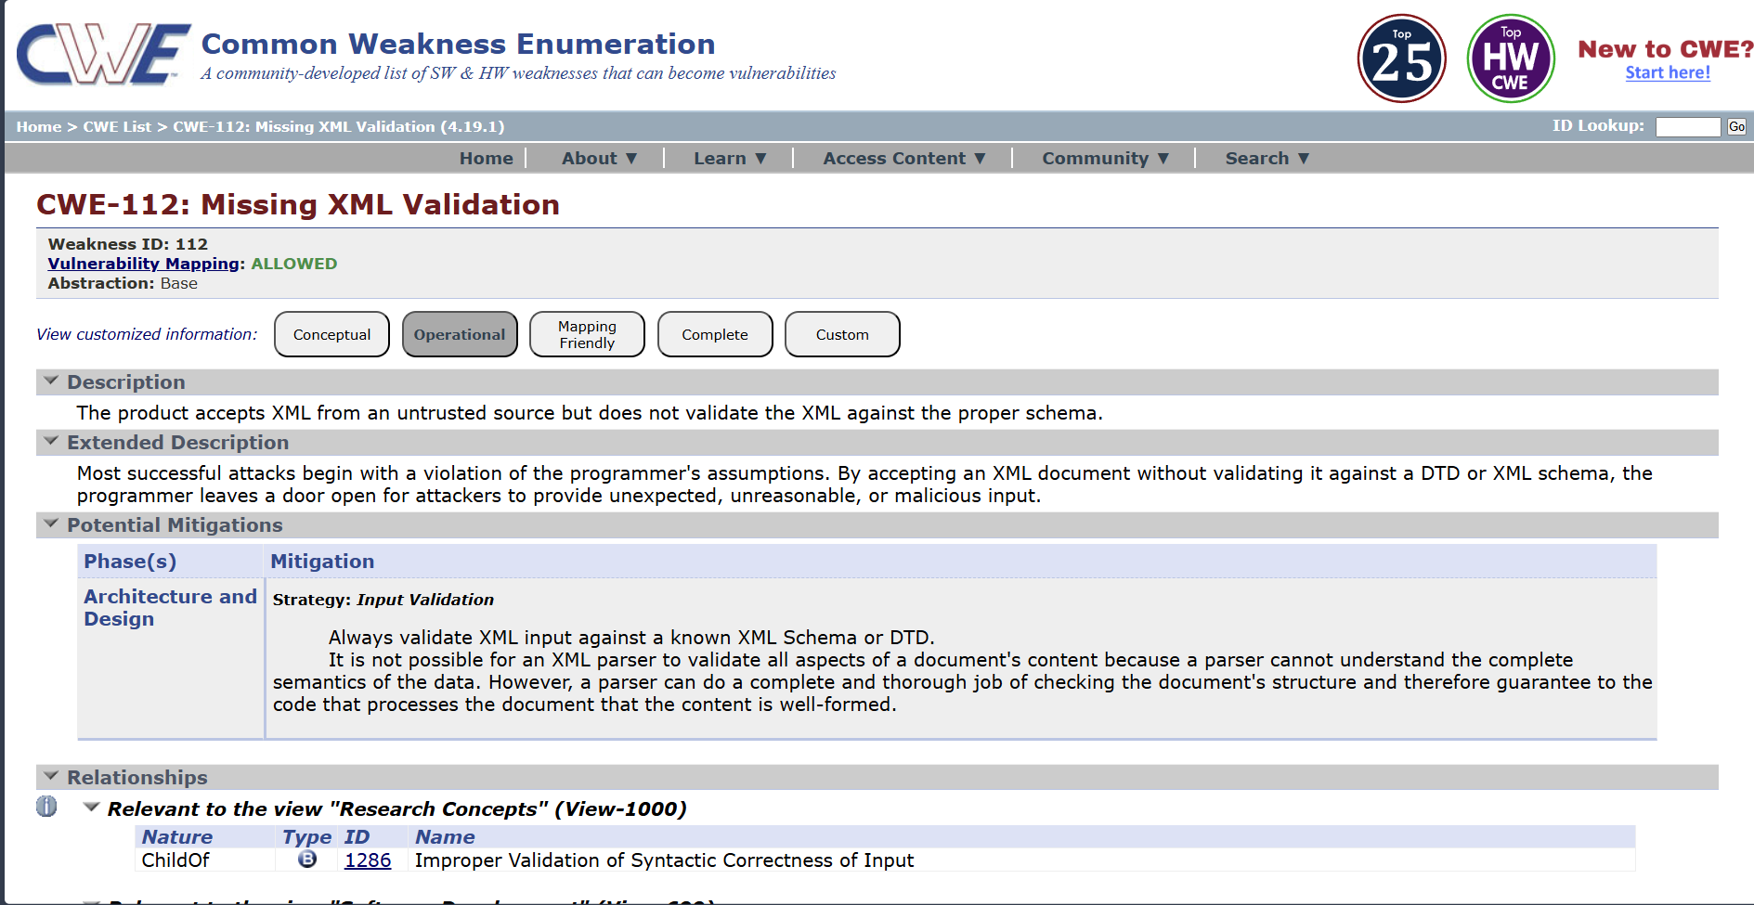

- Vulnerability Name: - Incorrect Privilege Assignment
CWE/CVE: CWE-266
OWASP/SANS Category: - A06:2025 Insecure Design
Description: -
Incorrect Privilege Assignment is a security vulnerability that occurs when users or processes are given more permissions than necessary. Access privileges should be limited based on the user’s role and responsibilities. When excessive privileges are assigned, unauthorized actions may become possible. For example, a normal user might gain administrative rights or access to restricted data. This usually happens due to poor access control policies or configuration errors. Attackers can exploit these privileges to modify, delete, or access sensitive information. Implementing the principle of least privilege helps prevent this vulnerability.
Business Impact: -
Incorrect privilege assignment can allow unauthorized users to access sensitive systems or data. Attackers may misuse elevated privileges to modify or steal important information. This can lead to data breaches and system compromise. Organizations may suffer financial losses due to security incidents and recovery costs. Such incidents can damage the company’s reputation and reduce customer trust. Businesses may also face legal or compliance issues for failing to enforce proper access control. Proper privilege management is essential to maintain system security and protect business operations.
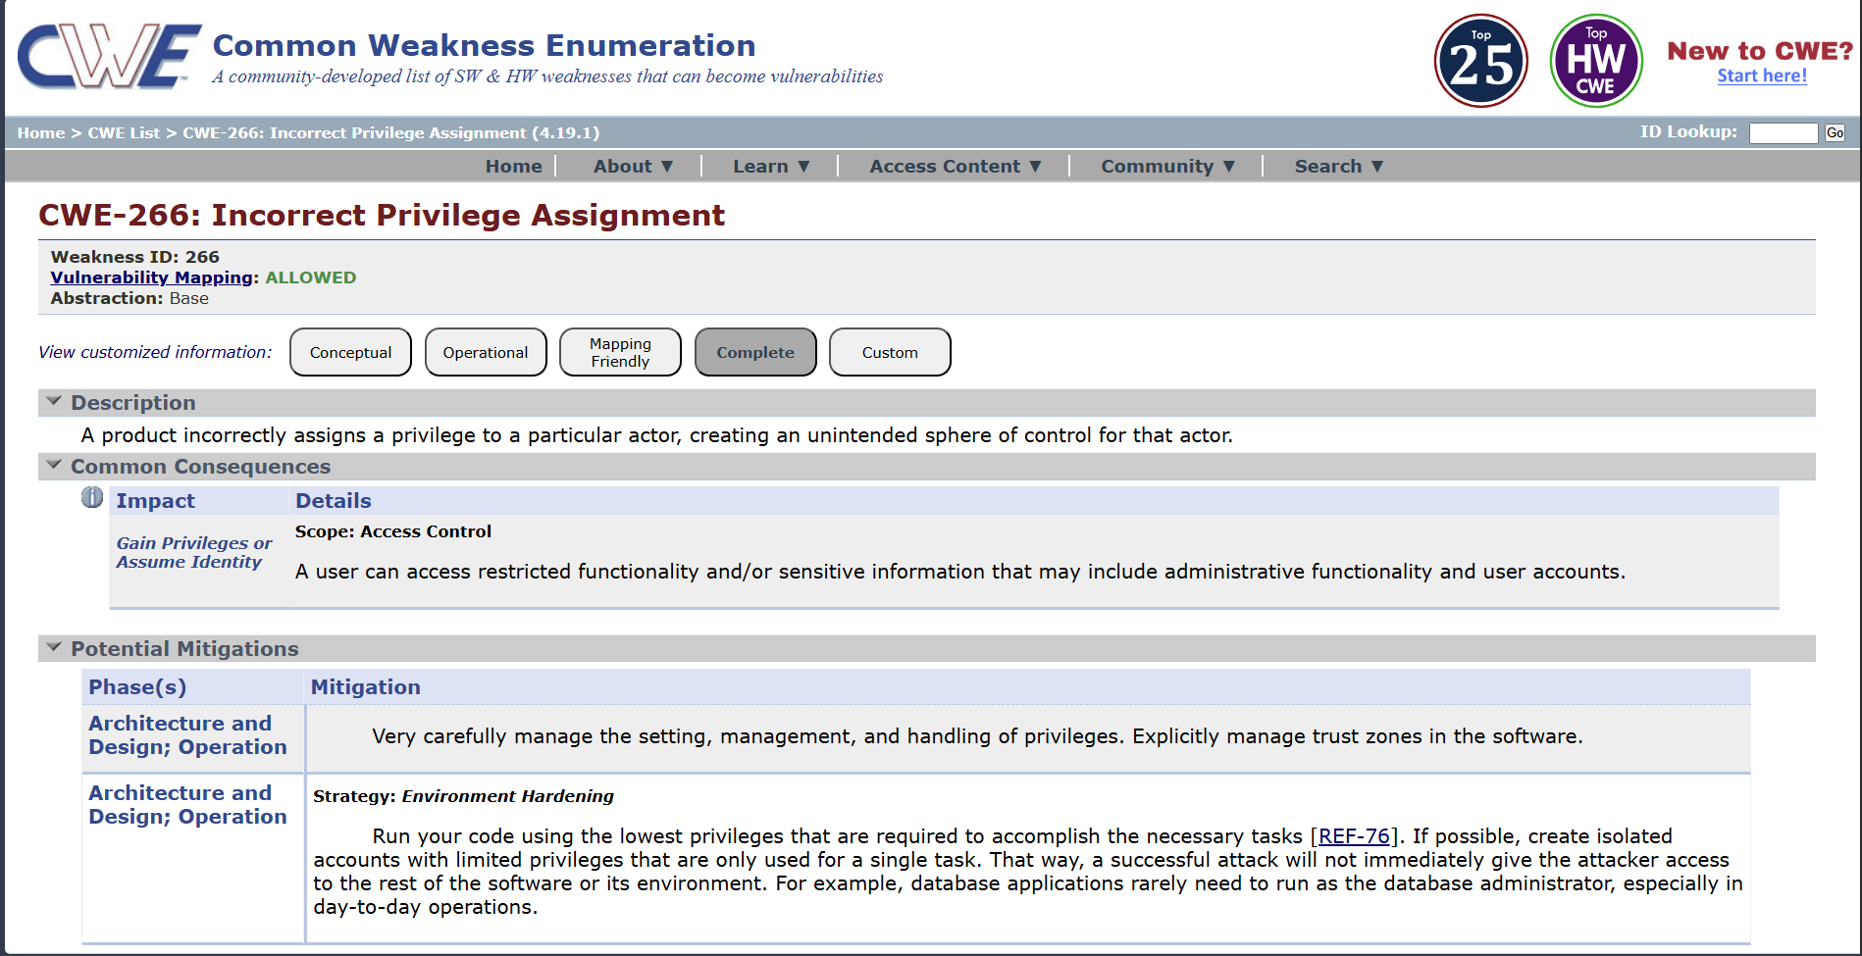

- Vulnerability Name: - Authentication Bypass by Alternate Name
CWE/CVE: CWE-289
OWASP/SANS Category: - A07:2025 Authentication Failures
Description: -
Authentication Bypass by Alternate Name is a security vulnerability where an attacker gains access to a protected resource using an alternative name or path. This happens when an application checks authentication only for specific file names or URLs. Attackers may use different representations of the same resource to bypass security checks. For example, accessing a file through an alternate path or encoded URL may avoid authentication controls. This occurs due to improper access validation in the application. As a result, attackers may gain unauthorized access to restricted pages or data. Proper authentication checks and path validation are necessary to prevent this vulnerability.

Business Impact: -
Authentication bypass can allow attackers to access restricted systems or sensitive information without proper login credentials. This may lead to unauthorized data access and system misuse. Confidential business or customer information could be exposed. Organizations may face financial losses due to data breaches and security incidents. Such vulnerabilities can damage the company’s reputation and reduce customer trust. Businesses may also face regulatory or compliance penalties. Strong authentication controls are essential to protect business systems and data.
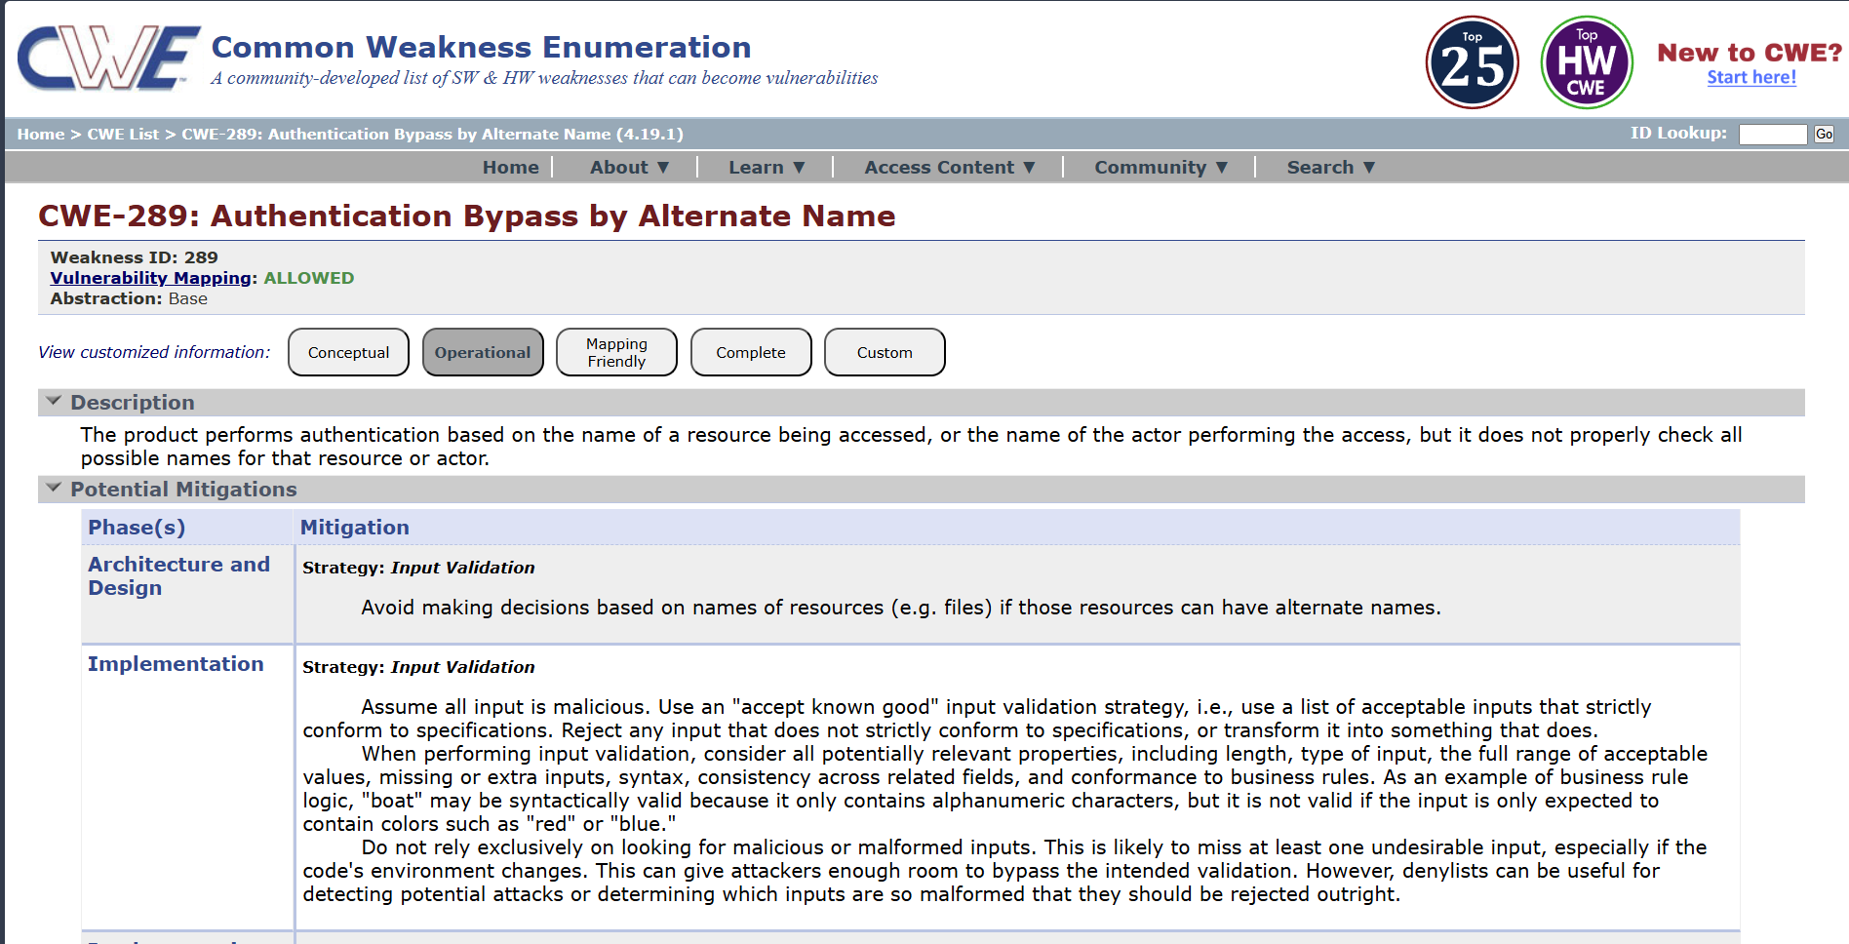

- Vulnerability Name: - Deserialization of Untrusted Data
CWE/CVE: CWE-502
OWASP/SANS Category: - A08:2025 Software or Data Integrity Failures
Description: -
Deserialization of Untrusted Data is a security vulnerability that occurs when an application processes serialized data from an untrusted source without proper validation. Serialization converts objects or data into a format that can be stored or transmitted. During deserialization, the data is converted back into objects used by the application. If the data is maliciously modified, it may execute harmful code during the process. Attackers can exploit this to perform unauthorized actions or gain control of the system. This vulnerability often occurs in applications that exchange serialized objects over networks. Proper validation and secure deserialization methods are required to prevent this issue.
Business Impact: -
Deserialization vulnerabilities can allow attackers to execute malicious code on the system. This may lead to unauthorized access, system compromise, or data manipulation. Sensitive business and customer information could be exposed or modified. Organizations may experience financial losses due to system damage and recovery efforts. It can also disrupt business operations if critical systems are affected.
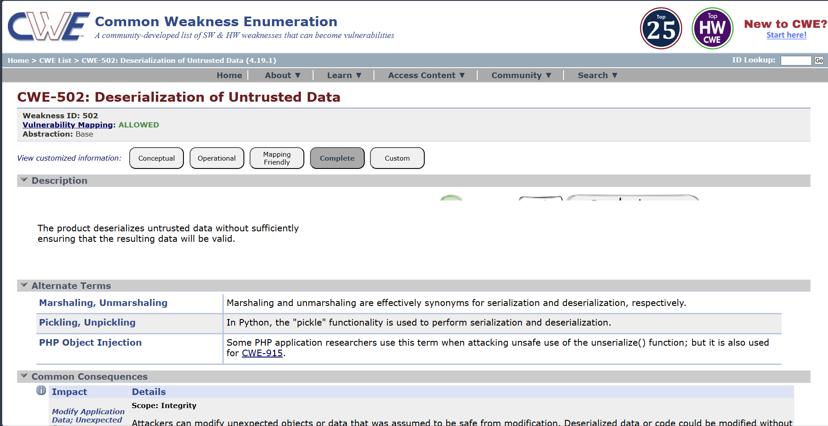

- Vulnerability Name: - Information Loss of Omission
CWE/CVE: CWE-221
OWASP/SANS Category: - A09:2025 Security Logging & Alerting Failures
Description: -
Information Loss of Omission is a security issue that occurs when important information is missing from data processing, reporting, or system communication. This can happen when an application fails to include critical details during logging, auditing, or data transmission. As a result, important events or actions may not be properly recorded or communicated. Attackers may exploit this weakness to hide malicious activities within the system. It may also cause inaccurate system behavior or incomplete data processing. This issue often occurs due to poor system design or insufficient validation. Proper logging, monitoring, and data validation help reduce this risk.
Business Impact: -
Information loss due to omission can lead to incomplete records and inaccurate system reports. Important security events may go unnoticed by administrators. This can allow attackers to perform malicious actions without detection. Organizations may face operational problems due to missing or incorrect information. It can also affect decision-making and system reliability. Businesses may suffer financial losses if errors or security issues are not properly tracked. Maintaining accurate logging and monitoring is essential for protecting business systems.
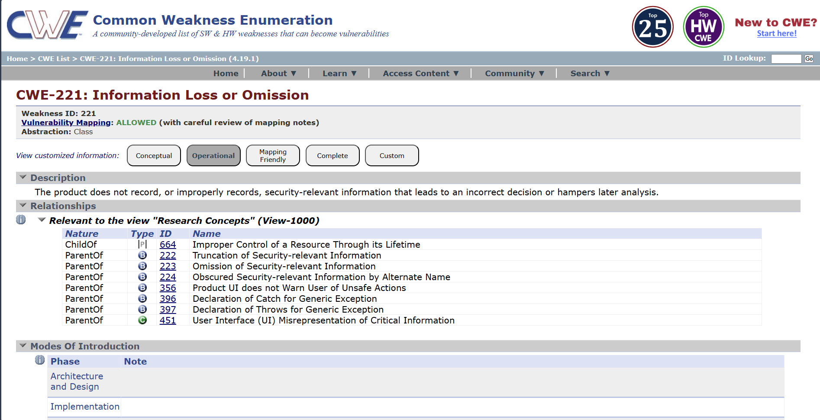

- Vulnerability Name: - NULL Pointer Dereference
CWE/CVE: CWE-476
OWASP/SANS Category: - A10:2025 Mishandling of Exceptional Conditions
Description: -
NULL Pointer Dereference is a software vulnerability that occurs when a program attempts to use a pointer that has not been assigned a valid memory address. A null pointer points to no location in memory. When the program tries to access or modify data using this pointer, it can cause the application to crash. This issue often occurs due to poor error handling or improper memory management. Attackers may exploit this vulnerability to cause denial of service by crashing the system. It is common in low-level programming languages such as C and C++. Proper validation and pointer checks can help prevent this vulnerability.
Business Impact: -
NULL pointer dereference can cause applications or systems to crash unexpectedly. This may lead to service interruptions or system downtime. Businesses may experience operational disruptions if critical systems stop functioning. Customers may be unable to access services during such failures. Repeated system crashes can reduce user trust in the application. Organizations may also incur costs for system recovery and maintenance. Proper coding practices and testing help prevent such reliability and security issues.
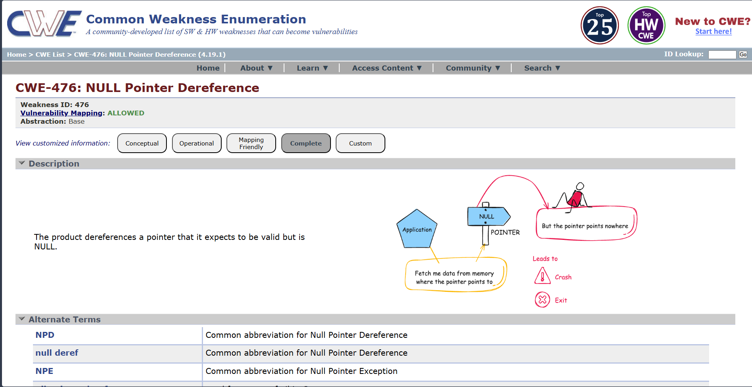

Stage 2

OVERVIEW :-

Nessus is a widely used vulnerability scanner that automates the detection of security weaknesses across networks, systems, and applications. From the screenshots you shared, I understand it as a comprehensive tool from Tenable that performed an informational scan on a remote web host, identifying configuration details like TLS support and missing headers rather than critical exploits.
Core Functionality
Nessus works by launching plugins—pre-built scripts that probe targets for known vulnerabilities, misconfigurations, and service details. In your scan (version 10.8.1), it ran checks in parallel on one host, fingerprinting the OS, detecting a Lua-based web service on a port, and noting informational items like supported TLS protocols (via plugin 10746) and additional DNS names (plugin 46180).​
It categorizes findings by severity: your results show low or info-level issues, such as HSTS missing (plugin 108098), which leaves HTTPS traffic vulnerable to interception, and TLS Next Protocol Negotiation enabled, advertising protocols like HTTP/2 that could signal outdated setups.
Key Features Observed
- Service Detection: Identifies web servers via banners or errors, as in your "NET Service Detection" output stating "A web is running on this port through Lua!" This helps map attack surfaces.​
- Protocol Checks: Enumerates TLS extensions (plugin 62564) and supported versions, flagging deprecated ones for remediation.​
- Fingerprinting: Gathers OS and host details without exploits, using methods like PCRE probes for high-confidence matches.​
- Compliance Auditing: Spots absences like HSTS headers or restricted methods disclosure, providing vendor fix guidance.​
Scan Workflow Insight
Your scan followed a standard flow: host discovery, port/service enum, vulnerability plugins, and reporting. Outputs include plugin IDs (e.g., 13524 for version leaks), risk factors (none high here), and remediation notes like adding Strict-Transport-Security headers. Reports export to formats like PDF/HTML for sharing security posture overviews.

Target website :- gin&juiceshop
Target ip address:- 34.246.169.176

List of vulnerability :-

s.no | Vulnerability name | Severity | plugins
1 | HSTS Missing From HTTPS Server | Medium | 142960
2 | Nessus SYN scanner | info | Unknown
3 | TLS Next Protocol Negotiation | Info | 62564
4 | Additional DNS Names | info | 46180.
5 | Nessus Scan Information | info | 11936
6 | OS Fingerprinting | info | 105558
7 | NET Service Detection | info | Unknown
8 | TLS Protocols  Supported | info | 10746
9 | HSTS Missing | info | 108098
10 | Web Server Restricted Methods/Version Info | info | 13524
REPORT:-

Vulnerability Name:- HSTS Missing From HTTPS Server
severity : - Medium
Plugin:- 142960
Port :- 0
Description:-
The remote web server is not enforcing HSTS, as defined by RFC 6797. HSTS is an optional response header that can be configured on the server to instruct the browser to only communicate via HTTPS. The lack of HSTS allows downgrade attacks, SSL-stripping man-in-the-middle attacks, and weakens cookie-hijacking protections.
solution:-
To remediate the HSTS (HTTP Strict Transport Security) missing vulnerability, the web server should be configured to include the HSTS response header in all HTTPS responses. This can be implemented by adding the Strict-Transport-Security header with appropriate parameters such as max-age, includeSubDomains, and optionally preload. For example:
Strict-Transport-Security: max-age=31536000; includeSubDomains; preload.
This configuration instructs browsers to access the website only through HTTPS for the specified time period and prevents fallback to HTTP connections
Business Impact::-
If HSTS is not enabled, users may be vulnerable to downgrade attacks such as SSL stripping, where attackers force the browser to connect through an insecure HTTP connection instead of HTTPS. This could allow attackers to intercept sensitive information including login credentials, session cookies, and personal data. Such attacks can lead to unauthorized access, data breaches, and compromise of user accounts. In a business environment, this may result in loss of customer trust, reputational damage, regulatory compliance issues, and potential financial losses. Implementing HSTS significantly improves the overall security posture of the web application by ensuring secure communication between the client and the server.

Vulnerability Name:-Nessus SYN scanner
severity : -info
Plugin:-unkown
Port :-0
Description:-
This plugin is a SYN 'half-open' port scanner. It shall be reasonably quick even against a firewalled target. Note that SYN scans are less intrusive than TCP (full connect) scans against broken services, but they might cause problems for less robust firewalls and also leave unclosed connections on the remote target, if the network is loaded.
solution:-
The Nessus SYN scanner is an information-gathering technique used during vulnerability assessment to identify open ports and running services on a target system. Since this is not a vulnerability but a scanning method, no direct remediation is required. However, organizations can reduce exposure by implementing proper network security controls. These include configuring firewalls and intrusion detection/prevention systems (IDS/IPS) to detect and block unauthorized port-scanning activities, restricting unnecessary open ports, and allowing access only to required services. Network administrators should also regularly review firewall rules, close unused ports, and implement network monitoring to detect suspicious scanning behavior from unknown sources. Proper logging and alerting mechanisms should be enabled so that security teams can quickly identify and respond to reconnaissance attempts.
Business Impact::-
Although the SYN scan itself does not represent a direct security vulnerability, it indicates that attackers or security tools may be performing reconnaissance on the network to discover open ports and active services. If sensitive services are exposed, attackers may use the gathered information to launch further attacks such as exploitation of vulnerabilities, brute-force attempts, or denial-of-service attacks. In addition, excessive scanning activity may affect poorly configured firewalls or network devices, potentially causing performance issues or leaving incomplete connections on the target system. Monitoring and controlling such activities helps organizations maintain better network security and prevent potential misuse of exposed services.

Vulnerability Name:- TLS Next Protocol Negotiation
severity : - info
Plugin:- 62564
Port :-8443
Description:-
This host supports TLS Next Protocol Negotiation. The remote host has the TLS Next Protocol Negotiation extension. This plugin enumerates the protocols supported by the remote service.
solution:-
TLS Next Protocol Negotiation (NPN) is a legacy TLS extension that allows a client and server to negotiate which application protocol will be used over a secure connection (for example, HTTP/1.1 or SPDY). This mechanism has largely been replaced by the more modern Application-Layer Protocol Negotiation (ALPN) extension, which is supported by newer versions of TLS. Since this finding is informational, it does not necessarily indicate a vulnerability. However, as a best security practice, organizations should review their TLS configuration and disable deprecated or unnecessary protocol negotiation mechanisms where possible. Administrators can update the web server or application server configuration to prioritize or exclusively use ALPN, upgrade TLS libraries to the latest supported versions, and ensure that only secure TLS protocols and cipher suites are enabled.
Business Impact::-
The presence of TLS Next Protocol Negotiation itself does not directly expose the system to immediate security risks. However, the use of outdated or legacy protocol negotiation methods may indicate that the server is running older TLS configurations or libraries. Over time, legacy features may become unsupported or may introduce compatibility and security concerns if they are not properly maintained. Attackers performing reconnaissance could use this information to understand the server’s TLS capabilities and identify potential weaknesses in the cryptographic configuration. Regularly reviewing and updating TLS settings helps organizations maintain strong encryption standards, improve compatibility with modern browsers, and ensure secure communication between clients and servers.

Vulnerability Name:- Additional DNS Names
severity : - info
Plugin:- 46180.
Port :-8443
Description:-
Additional hostnames were collected by Nessus. These are alternate names collected via misconfigurations. Versus generated a list of hostnames that point to different servers hosted on same virtual host. Solution: test with them using whole syntax
solution:-
The “Additional DNS Names” finding indicates that the scanning tool discovered multiple hostnames or alternate DNS records associated with the target server. These names may appear due to DNS configurations, virtual hosting setups, or shared hosting environments. Since this is an informational finding, it does not necessarily represent a direct vulnerability. However, administrators should review the discovered DNS names and verify whether they are legitimate and required for the organization’s infrastructure. Any unused, outdated, or misconfigured DNS records should be removed from the DNS server configuration. Security teams should also ensure that all identified hostnames are properly secured, configured with valid TLS certificates, and follow the same security policies as the primary domain. Additionally, penetration testing or validation can be performed on these alternate hostnames to ensure they do not expose unintended services or sensitive information.
Business Impact::-
The presence of additional DNS names may reveal information about the internal structure of the organization’s network or web infrastructure. Attackers can use this information for reconnaissance to identify hidden services, staging environments, or misconfigured systems that might not be intended for public access. If any of the discovered hostnames are improperly secured, they may provide an entry point for attackers to exploit vulnerabilities or gain unauthorized access. Regularly reviewing DNS configurations and ensuring proper security controls across all associated hostnames helps reduce the attack surface and protects the organization’s web infrastructure from potential threats.

Vulnerability Name:- Nessus Scan Information
severity : - info
Plugin:- 11936.
Port :-8443
Description:-
This plugin set holds information about the scan. The number of hosts (1). The Nessus version (10.8.1). The number of checks in parallel.
solution:-
The “Nessus Scan Information” finding provides general details about the vulnerability scan performed by the Nessus Vulnerability Scanner. It includes information such as the number of hosts scanned, the scanner version used, and the number of parallel checks executed during the scan. This plugin does not indicate a vulnerability but simply records metadata related to the scanning process. Therefore, no remediation action is required. However, organizations should ensure that vulnerability scans are conducted using updated scanning tools and configurations. Security teams should also maintain proper documentation of scan reports and review the results regularly to identify and address actual vulnerabilities detected during the assessment.
Business Impact::-
Since this finding only provides information about the scan itself, it does not pose any direct security risk to the system or network. The information is mainly useful for audit, reporting, and troubleshooting purposes. It helps security teams understand the scanning environment and verify that the assessment was conducted using a supported and up-to-date scanning tool. Properly documenting scan information also assists organizations in maintaining compliance records, tracking vulnerability management activities, and ensuring that security assessments are performed consistently across the infrastructure.

Vulnerability Name:- OS Fingerprinting
severity : -info
Plugin:- 105558
Port :-8448
Description:-
OS Fingerprints PCRE DoS was reported in plugin 10910. This is the highest confidence result reported in plugin 10910. The composite of fingerprints detected were reported in plugin 10910.
solution:-
The OS Fingerprinting finding indicates that the scanning tool was able to identify or estimate the operating system of the target host based on network responses and system behavior. This information is collected during the scanning process to help security teams understand the environment and identify potential vulnerabilities related to specific operating systems. Since this is an informational finding, it does not represent a direct vulnerability. However, organizations can reduce unnecessary exposure by limiting information disclosure through proper system hardening. This may include configuring firewalls to restrict unnecessary network responses, disabling unused services and ports, and ensuring that systems are updated with the latest security patches. Administrators should also implement intrusion detection and monitoring mechanisms to detect unauthorized scanning or reconnaissance attempts.
Business Impact::-
Although OS fingerprinting itself does not cause damage to the system, it may provide attackers with useful reconnaissance information about the underlying operating system and system configuration. If attackers can accurately determine the OS type and version, they may attempt to exploit known vulnerabilities specific to that platform. This can increase the risk of targeted attacks against the system. By reducing information exposure and maintaining secure system configurations, organizations can minimize the chances of attackers using reconnaissance data to plan further attacks.

Vulnerability Name:- NET Service Detection
severity : -info
Plugin:- Unknown
Port :-0
Description:-
Nessus is able to identify the service by banner or by looking at the error message it sends when it receives an HTTP request. Output: A web is running on this port through Lua!
solution:-
The “NET Service Detection” finding indicates that the vulnerability scanning tool was able to identify a network service running on the target system by analyzing the service banner or the response generated when an HTTP request was sent. In this case, the scan detected that a web service is running on the specified port and identified it through its response characteristics. This is an informational result and does not represent a direct vulnerability. However, administrators should review the detected services to ensure that only required services are running on the system. Unnecessary services should be disabled to reduce the attack surface. It is also recommended to limit banner information exposure, configure proper firewall rules, and ensure that the detected services are updated with the latest security patches.
Business Impact::-
Service detection results may reveal details about the services running on a server, including their type and sometimes their version. Attackers can use this information during reconnaissance to identify potential targets for exploitation. If outdated or vulnerable services are running, attackers may attempt to exploit known weaknesses associated with those services. Even though this finding is informational, exposing service information can increase the risk of targeted attacks. Regular monitoring, service hardening, and proper configuration management help organizations maintain a secure environment and reduce the likelihood of attackers using service identification information for malicious purposes.

Vulnerability Name:- TLS Protocols Supported
severity : -info
Plugin:- 10746
Port :-8448
Description:-
This script detects the protocols advertised by the remote service to be used in TLS connections. Note that failing to advertise other protocols does not mean the service does not support them.
solution:-
The “TLS Protocols Supported” finding indicates that the scanning tool identified which TLS (Transport Layer Security) protocol versions are supported by the remote service during secure communication. This check helps security teams understand the encryption protocols available on the server. Since this is an informational finding, it does not directly indicate a vulnerability. However, administrators should review the TLS configuration and ensure that only secure and modern protocols such as TLS 1.2 and TLS 1.3 are enabled. Older and insecure protocols like SSL 2.0, SSL 3.0, TLS 1.0, and TLS 1.1 should be disabled to prevent potential cryptographic attacks. Additionally, the server should be configured with strong cipher suites and updated TLS libraries to maintain secure encrypted communication.
Business Impact::-
If insecure or outdated TLS protocols are enabled on the server, attackers may exploit known weaknesses in those protocols to compromise secure communications. This could potentially allow attackers to intercept or decrypt sensitive data transmitted between the client and the server. Even though this finding is informational, it highlights the importance of reviewing and maintaining secure TLS configurations. Proper TLS configuration helps organizations protect sensitive information, maintain user trust, and comply with modern security standards and best practices for encrypted communication.

Vulnerability Name:- HSTS Missing
severity : -info
Plugin:- 108098
Port :-8443
Description:-
HTTP Strict Transport Security (HSTS) is an optional header that can be configured on the web server to instruct browsers to only communicate with the server over HTTPS. The lack of HSTS enables man-in-the-middle attacks.
solution:-
The “HSTS Missing” finding indicates that the web server does not include the HTTP Strict Transport Security (HSTS) header in its HTTPS responses. HSTS is a security feature that instructs web browsers to always connect to the server using HTTPS instead of HTTP. To address this issue, administrators should configure the web server to include the Strict-Transport-Security header in all HTTPS responses. A common configuration example is: Strict-Transport-Security: max-age=31536000; includeSubDomains. Before enabling HSTS, it is important to ensure that the website and all related resources are fully accessible over HTTPS and that HTTP requests are properly redirected to HTTPS. After configuration, the implementation should be tested to verify that the header is correctly applied across the web application.
Business Impact::-
If HSTS is not implemented, users may initially connect to the website through an unencrypted HTTP connection, which could be intercepted by attackers through man-in-the-middle attacks. This may allow attackers to manipulate or redirect traffic, potentially leading to data interception, session hijacking, or unauthorized access to sensitive information. Although this finding is informational, the absence of HSTS weakens the overall security of the web application. Implementing HSTS helps ensure that browsers always communicate securely with the server, thereby improving the protection of user data and maintaining trust in the organization’s online services.

Vulnerability Name:- Web Server Restricted Methods/Version Info
severity : -info
Plugin:- 13524
Port :-8443
Description:-
The web server running on the remote host appears to be hiding its version or name, which is a good thing. Using specially crafted requests, Nessus was able to gather the following information from the web server.
solution:-
The “Web Server Restricted Methods/Version Info” finding indicates that the web server is configured to hide its version or detailed server information from standard HTTP responses. This is generally considered a good security practice because it limits the amount of information exposed to external users. However, advanced scanning techniques can sometimes still retrieve certain details using specially crafted requests. To further improve security, administrators should ensure that unnecessary HTTP methods (such as TRACE, OPTIONS, PUT, or DELETE) are disabled if they are not required. Web server configurations should also be reviewed to confirm that server banners and version details are minimized or completely removed. Additionally, keeping the web server software updated with the latest security patches and implementing web application firewall (WAF) protection can further reduce the risk of information disclosure.
Business Impact::-
Although hiding server version information helps reduce information leakage, attackers may still attempt to gather details about the server through advanced probing techniques. If attackers successfully identify the server type or version, they may search for known vulnerabilities associated with that specific software and attempt targeted attacks. Even though this finding is informational, proper configuration and regular security updates are important to ensure that the web server remains protected against potential exploitation. Limiting exposed information helps reduce the attack surface and improves the overall security posture of the organization’s web infrastructure.keeping the web server software updated with the latest security patches and implementing web application firewall (WAF) protection can further reduce the risk of information disclosure.

Stage – 3
Report
Title of the Project: -
Implement and manage Zero Trust Network Access (ZTNA) using Zscaler by enabling secure, identity-based user-to-application connectivity without exposing internal networks

1. Centralized Identity Management
Centralized Identity Management is a key component in implementing Zero Trust Network Access (ZTNA) using Zscaler. In traditional network security models, access decisions are often based on the user’s network location, such as whether they are inside or outside the corporate network. However, in a Zero Trust model, access decisions are based primarily on verified user identity. Zscaler integrates with enterprise identity providers such as Active Directory, Azure Active Directory, Okta, and other Identity and Access Management (IAM) systems to create a centralized identity management framework.
Through centralized identity management, organizations can maintain a single source of truth for user identities, roles, and permissions. All user authentication and authorization processes are handled through the centralized identity system, ensuring consistency across different applications and services. This simplifies administrative tasks, as IT teams no longer need to manage multiple user accounts or access policies across different systems. Instead, identity information is synchronized and managed in one location.
Another major benefit is improved security. Since ZTNA relies on identity-based access rather than network access, every request to access an application is verified based on the user’s identity, device posture, and security policies. This ensures that only authenticated and authorized users can access specific resources. Centralized identity management also allows organizations to quickly update access privileges when employees change roles or leave the organization. By implementing centralized identity management within Zscaler ZTNA, organizations can achieve stronger security, simplified administration, and more efficient access control.

2. Single Sign-On (SSO) Authentication
Single Sign-On (SSO) authentication plays an important role in improving both security and user experience in a ZTNA environment. SSO allows users to authenticate once and gain access to multiple applications without repeatedly entering their credentials. When integrated with Zscaler ZTNA, SSO provides a seamless and secure method for accessing enterprise applications while maintaining strong authentication controls.
In a traditional environment, users often have to remember and manage multiple usernames and passwords for different applications. This can lead to password fatigue, where users reuse weak passwords or write them down, increasing security risks. SSO eliminates this problem by allowing users to log in once through a trusted identity provider and gain access to authorized applications. Once authenticated, Zscaler verifies the user’s identity and grants access according to predefined security policies.
From a security perspective, SSO reduces the number of authentication points and centralizes authentication processes. Administrators can enforce strong authentication policies through the identity provider, such as password complexity rules or multi-factor authentication. If a user’s account needs to be disabled or modified, administrators can update the identity provider, and the changes automatically apply to all connected applications. This simplifies identity management while maintaining high security standards.
Overall, SSO improves productivity by allowing users to quickly access the resources they need while ensuring that access remains secure and centrally controlled.

3. Enhanced Security and Access Control
One of the primary objectives of implementing ZTNA using Zscaler is to enhance security and strengthen access control mechanisms. Traditional network security approaches typically grant users access to an entire internal network once they successfully authenticate through a VPN. This model increases the risk of lateral movement within the network if an attacker compromises a user account. ZTNA eliminates this risk by providing application-level access rather than network-level access.
With Zscaler ZTNA, users are granted access only to specific applications they are authorized to use. This approach follows the principle of least privilege, which ensures that users receive only the minimum level of access necessary to perform their tasks. Access decisions are based on multiple factors, including user identity, device health, location, and security policies defined by administrators.
Additionally, Zscaler continuously evaluates access requests in real time. If any suspicious activity or security risk is detected, the system can automatically block or restrict access. This dynamic access control mechanism significantly reduces the attack surface and prevents unauthorized access to sensitive resources.
By restricting access to individual applications and continuously verifying security conditions, organizations can protect critical systems from cyber threats such as credential theft, insider attacks, and unauthorized access. This approach provides a stronger and more flexible security framework compared to traditional network security models.

4. Automated User Provisioning and Deprovisioning
Automated user provisioning and deprovisioning are essential features for efficiently managing user access in modern organizations. In a ZTNA environment implemented with Zscaler, automation ensures that users receive the appropriate level of access based on their roles within the organization. This process is typically integrated with identity management systems and directory services.
User provisioning refers to the process of granting access to applications and resources when a new employee joins the organization or when an existing employee requires additional access. Instead of manually configuring access for each user, administrators can define role-based policies that automatically assign permissions based on job roles or departments. This reduces administrative workload and ensures consistent access control policies across the organization.
Deprovisioning is equally important for maintaining security. When an employee leaves the organization or changes roles, their access to certain applications must be immediately revoked or modified. Automated deprovisioning ensures that these changes occur instantly through the identity management system. This prevents former employees or unauthorized users from retaining access to sensitive systems and data.
Automation also reduces the risk of human error, which is a common cause of security vulnerabilities in manual access management processes. By implementing automated provisioning and deprovisioning within Zscaler ZTNA, organizations can maintain accurate access controls while improving operational efficiency and security.

5. Multi-Factor Authentication (MFA) Support
Multi-Factor Authentication (MFA) is a critical security feature that strengthens the authentication process by requiring users to provide multiple forms of verification. In addition to entering a password, users must confirm their identity using an additional factor such as a mobile authentication app, a one-time password, biometric verification, or a hardware security token.
When Zscaler ZTNA is integrated with identity providers that support MFA, organizations can significantly enhance their security posture. Even if an attacker obtains a user’s password through phishing or other attacks, they would still need the additional authentication factor to gain access. This greatly reduces the likelihood of unauthorized access to enterprise applications.
MFA is particularly important in modern work environments where employees access corporate applications from various locations and devices. By requiring multiple forms of authentication, organizations can ensure that only legitimate users can access sensitive resources. Administrators can also configure MFA policies based on risk factors, such as requiring additional verification when users attempt to access applications from unfamiliar devices or locations.
Overall, MFA adds an essential layer of security to ZTNA deployments and helps organizations protect their systems from credential-based attacks.

6. Improved Monitoring, Logging, and Compliance
Effective monitoring and logging are essential for maintaining visibility into user activities and ensuring that security policies are being properly enforced. Zscaler ZTNA provides detailed monitoring and logging capabilities that allow administrators to track user access to applications in real time. These logs include information such as user identity, device details, access location, and the specific applications accessed.
This visibility enables security teams to detect suspicious behavior and respond quickly to potential security threats. For example, if a user attempts to access an application from an unusual location or device, administrators can investigate the activity and take appropriate action. Continuous monitoring also helps organizations identify potential vulnerabilities and improve their overall security posture.
In addition to improving security, logging and monitoring support regulatory compliance requirements. Many organizations must comply with industry regulations and standards that require detailed records of user access and security events. Zscaler’s reporting and logging capabilities provide the necessary documentation to demonstrate compliance with these requirements.
By providing comprehensive monitoring, logging, and reporting features, Zscaler ZTNA helps organizations maintain strong security governance, quickly detect threats, and ensure compliance with regulatory standards.

