As a Team



As a team we have come up with the procedure to follow REQUIREMET MANAGEMENT . Requirements management is about keeping your team in-sync and providing visibility to what is going on within a project.It is critical to the success of your projects for your whole team to understand what you are building and why .As the question of “Why” arises . All that we could think about is our current situation as students. What would be the main application programming that a student finds more useful and cost efficient ? Then we came up with the idea, we always look forward to the new year and a chance to start anew, wipe our financial slates clean, set new goals, and rededicate ourselves to keeping a budget..A plan to save the budget is cool idea isn’t it ? Why do we need a budget planner and what difference is our budget planner different from the other money managing app.

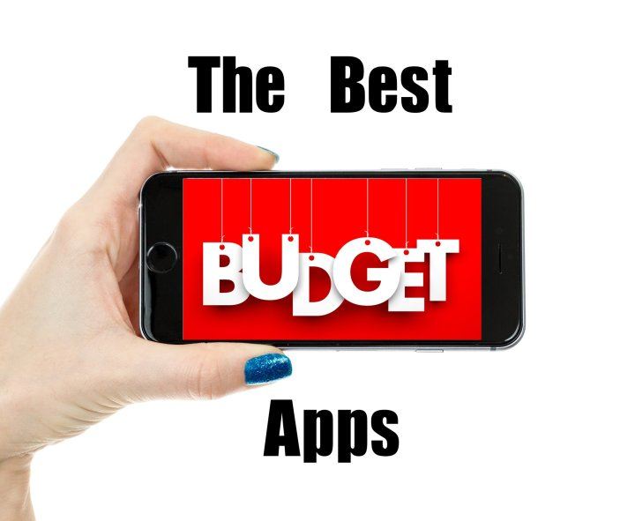

So without further ado, we wanted to create the best budgeting and saving apps.With these thoughts we realisedthat the app should be something that can actually save you money. Hence we needed to approach our client on his basic requirements.

**Our Clients Requirements** **and Our analysis**



“I want to categorise my expenses, so that I will be able to track my expenses”

Budgeting your money is very important as well as categorising them. We live in an era where subscription services are common. You’ve got your usual stuff along with stuff Netflix. Plus, money is just tighter than it used to be. There is no shame in needing some extra help managing the categories of your finances. In order to categorise the requirements we needed to know the basic expense that the client will have in a month and use them as default values to fulfil what the client has asked for. Hence we had asked the client for certain categories and we had also added a few such that initially the client will be able to enter for 10 categories provided by us .As the client had exceptionally mentioned that he should have the ability to add an extra field ,it is necessary to add an option to fill in the default values

“I want to have expense or income option on the start screen, so that I will select precisely”

The team had gathered the information on how the user likes to view his expense and income tab. The income and the expense tab has to be in the home page . it is necessary in this manner so that , the user could have flexible management of the his income and expense .we needed to analyse how and where each page leads to after selecting the buttons .

“I want to secure my budget planner by having a password protection enabled whenever I want to, so that only I would be able to access it or view it “

Budget apps can help spendthrifts track and control spending. They also carry a security risk, as they require users to hand over sensitive information such as credit card and bank account numbers, then allow the apps access to that information.

In this era of headline-grabbing security breaches, just how safe is this apps? And what would happen to users if their sensitive information fell into the wrong hands? Hence, in order to protect the  users' finances, assembling information from checking, savings, credit card and even retirement accounts.

“I want the default option for my currency to be EURO, so that when I enter other currencies the whole of previous entries should be erased”

The user had particularly mentioned this, hence the default value entered by the user should be in euro, so that there would be no possibility of entering any other currency. The question arises here, what if the user wants to make an entry in other currencies or he has spent his money in the other country? The only way to avoid this, is to erase all the data’s that the user has entered.

“I want to save my daily expenses for which I would want to have date options, so that I could keep a track on my daily expenditures”

Looking for a sheet that you can both easily read AND update on your phone much easier than printing out your workbook and making notes throughout the day or saving all of your receipts and tallying up your purchases at the end of the day, week, or month was much expected from our client . So as a basic monthly planner app we did not have to go over our heads to think about this particular expectation from our client.

“I want to have default categories e.g. Clothing, rent, electricity, so that I could categorise each of my expenses accordingly” the client also had an additional criterion saying ”I want an option to have additional field with respect to the categories, so that I could add other expenses also”

As this requirement was from our client we also were asked to add an extra field where templates built in Excel are incredibly challenging to change and update. Between wonky formulas and old file formats, we are not set up for an easy start. Making any adjustments or changes to the Excel templates out there is a pain in the neck – and that’s just when we were getting started.That reminded us that Successful money management is rooted in small steps and lifestyle changes, so look for the ability to adjust our sheets as our habits change.Rather than an offline Excel sheet, we had to look for a web-based template that is built to be flexible and is easy to adjust.



Gathering and Analysing where important challenges in our project.We believe that Projects succeed or fail due to poor requirements at any time throughout the project lifecycle. The continuously evolving baseline of requirements needs to be managed effectively. We need to assess and understand the uniqueness of the requirements gathering process for the project.