RESUME

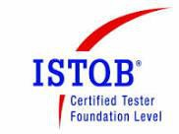

**ANBARASAN A**

C-92, Mayuraas Nest, Flat A4, E-mail: [anbuadonis2010@gmail.com](mailto:anbuadonis2010@gmail.com)

Crescent Road, Thiruvengadam Nagar,

Ambattur, Chennai – 600053 Mobile: +91-8667487219

**E X P E R I E N C E**

1. DESIGNATION: **Software Test Analyst Senior** COMPANY**:** FIS & WorldPay India Pvt Ltd. PERIOD: April 2022 – Till Date

2. DESIGNATION: **Test Specialist - Automation**

COMPANY**: IBM INDIA PVT LTD & IBM UK LTD** (April 2016-Mar 2017, Oct 2017 – Dec 2019) PERIOD: Dec 2013 – April 2022

**C A R E E R S U M M A R Y :**

1. 10.0 years of experience in software functional testing (Banking/ Payments Domain) process which include **Business Requirement Analysis**, **Understanding Functional Specification, Test Planning, Stage Estimation, Test Cases Design, Test Environment Setup, Test Data Setup, Defect Management, Test log, Test results, Test Traceability & Status Reporting**.

2. **3.2years of onsite experience in U.K** working directly with Nationwide Building Society clients on various banking Payment applications.

3. 3+ years of experience in Salesforce domain Testing.

4. 2.5 years of experience in Java Selenium Automation, TestNG, BDD-Cucumber Framework.

5. Worked on Agile methodology and have been actively participating in Scrum ceremonies (Scrum call, Sprint planning, Reviews and Retro and Backlog refinement sessions).

6. Proficient in System Testing, SIT, UAT, Regression and Smoke Testing.

**D o m a i n S k i l l s e t :** Salesforce Application, Oracle CPQ, DocuSign e-signing, Java-Selenium, BDD- Cucumber- TestNG Framework.

**T o o l s :** Eclipse, GIT, Jira and Confluence, Iliad T3 V7, HP ALM, Agile Requirement Designer, SOAP UI.

**P R O J E C T S I N V O L V E D :**

**1. I N A S A – C O R E & I N T L R A I L : ( S A L E S F O R C E / C P Q / D O C U S I G N / O N B O A R D I N G )**

➢ 3+ years of experience in Salesforce domain Testing. Have handled Key projects in CORE, OLA

Decommissioning (Onboarding Project), MLOC & INTL rail.

➢ 2.5 years of experience in Java Selenium Automation. After moving from TOSCA to Selenium, we have automated from scratch for Smoke & Regression suites of Salesforce iNASA - Core & INTL rail, Smoke Suite of Onboarding rail.

➢ Experience in BDD Cucumber & TestNG framework.

➢ Responsible for owning the User story, analyze the requirements, plan & prepare the tests, test data, validate as per test schedule, raise any issues/bugs with Business and Developers for the fix, Test Execution & Sign off the changes in QA & UAT environment before Prod release.

➢ Experience in supporting different downstream systems for E2E testing in both Core & INTL rail.

➢ Salesforce – Have experience in Lead creation to opportunity conversion, CPQ quote handling, Contract wizard back in Salesforce, DocuSign contract esigning process and onboarding of deals downstream.

➢ Experience using GIT workflows in the team and effectively manage code repositories.

**2. F I R C O S O F T U P G R A D E - H O T L I S T S C A N N I N G :**

➢ The Fircosoft filtering was required to be upgraded from existing version to latest version in order to be up to date with the filtering services as per the industry standard. The following is the high level scope delivered with the work package.

➢ Upgrade of Fircosoft solution including all components; Ability to do add new scanning rules

➢ I was involved in System Testing of changes and support to SIT Team for the Project and UAT

Testing as the team didn’t had the test capability.

**3. P G M S ( P A Y M E N T G A T E W A Y M A N A G E D S E R V I C E ) & S Y S T E M T E S T I N G :**

➢ The Gateway used by payments platform was going to be out of support from VPS, the gateway

provider. Hence, NBS decided to move gateway from VPS to Payport (Third party who manages gateways for different banks).

➢ I was the only resource in onshore who worked closely with clients with PayPort (third party) & FP

Scheme for SIT.

➢ Involved in 4 cycles of testing. (Internal, PMTS, Payport & Scheme certification testing)

➢ The significant achievement was certification testing with scheme was completed in 8-man days which were planned for 20-man days. The delay here will incur costs to NBS as tests need to be re- planned with Payport & scheme. This was widely appreciated by stakeholders as I was the only tester from client and one from scheme between whom we coordinated and completed the tests.

**4. S E P A P A Y M E N T S S O L U T I O N :**

➢ Involved in End to End SEPA payments testing, creation of new payment type in Chaps Swift UI, with team size of 10.

➢ MT103/202 file processing, SEPA Pain format messages, reconciliation, MT902 Statements processing with HSBC.

➢ HSBC Testing for SEPA files and Reporting. (FPAR & EOD Reject/Return reports)

**A C C O L A D E S :**

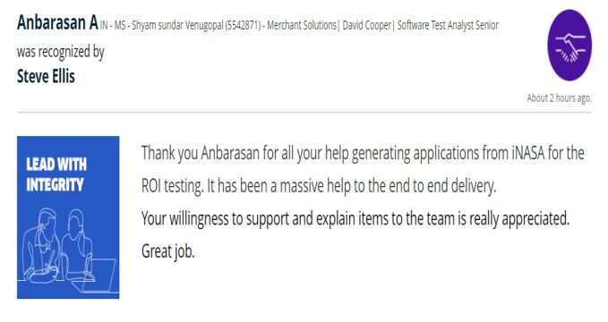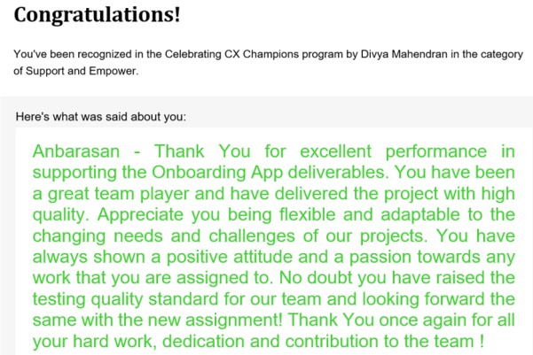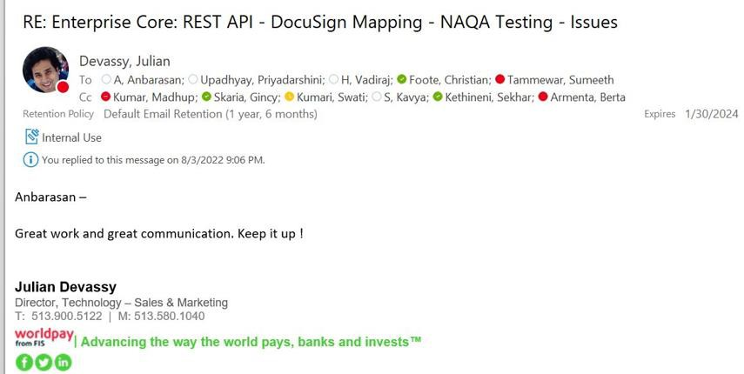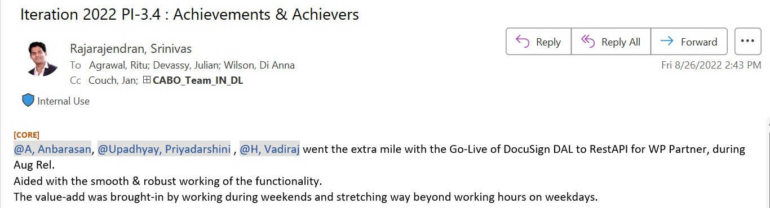

I hereby declare that the information furnished above are true and correct to the best of my knowledge and belief.

DATE: 23-Nov-2024 SIGNATURE PLACE: Chennai (ANBARASAN A)