**how it works:**

* so make esp_cam and esp8266 to make the server on my home wifi so that I'm able to control it with my laptop(python) and with my phone.
* then I programmed esp-cam to print camera data on the webserver I added a flash button so that I can use the flash on it I also added a bottom for the solenoid to open the door lock and I can also control it with a voice command.
* then I programmed esp8266 to create a server in which I added buttons to control light and fan relay controls and I can also control lights and fan with my voice.
* then I programmed in python to recognize my voice commands so to understand it example: so if I say light then python will recognize it and write 192.168.43.29/R1 then node MCU will switch on the first relay.

**ESP_CAM CONNECTIONS;**

* so to send notification we need to do these procedures first
* open [IFTTT](https://ifttt.com/)

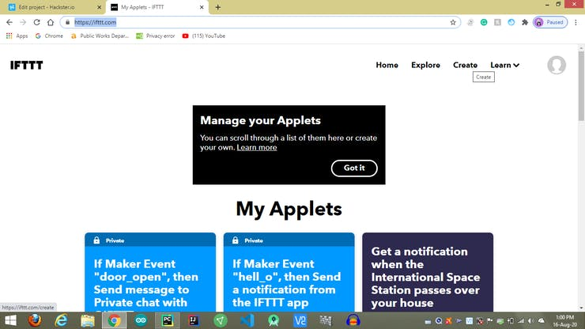

* click on create.

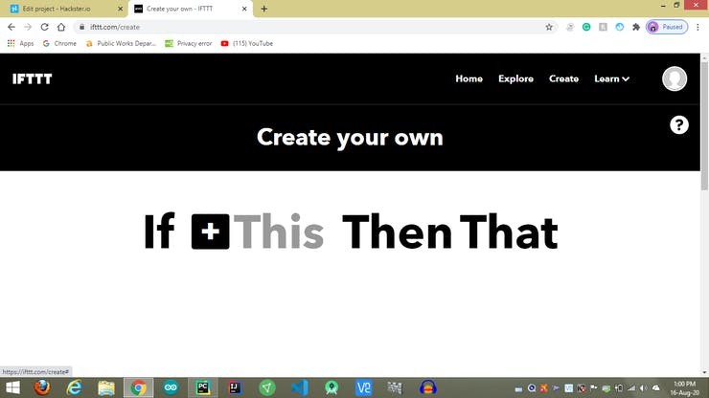

* Click on this

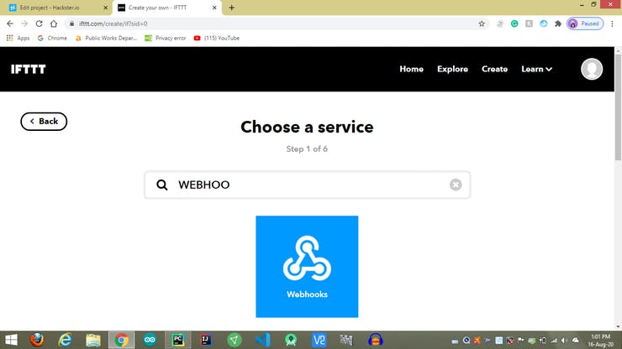

* search for webhooks and click on it.

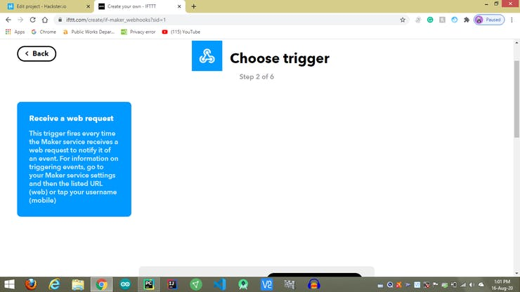

* Click on Receive a web request.

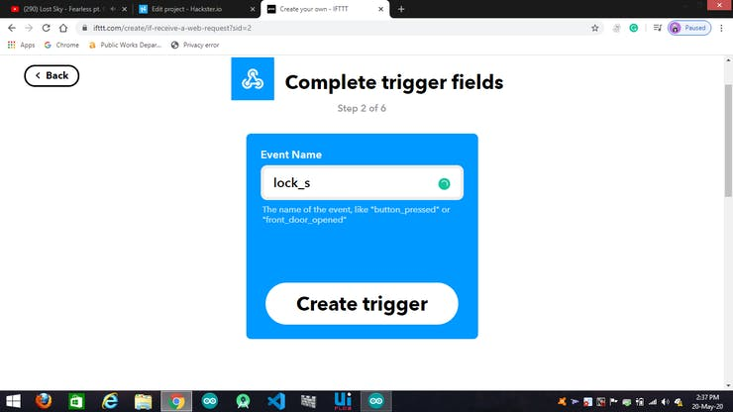

* write your event name here and then click on CREATE TRIGGER

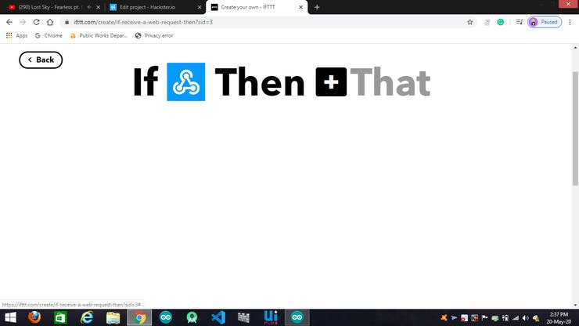

* Click on THAT

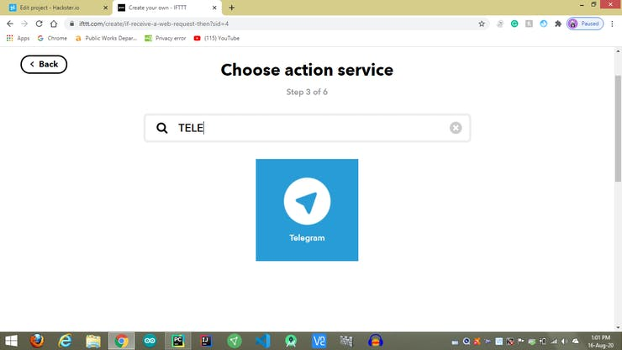

* search for telegram so to use this feature you need telegram app in your phone then do the linking procedure with IFTTT Channel

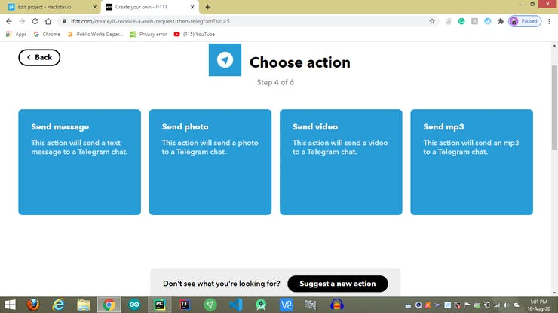

* after completion of linking, you're able to see this then click on send msg.

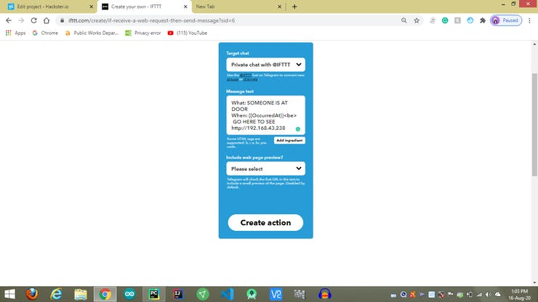

* write what you want to see in the message when the door button pressed also add the IP of esp so that you can see the live stream from esp_cam then click on CREATE ACTION.

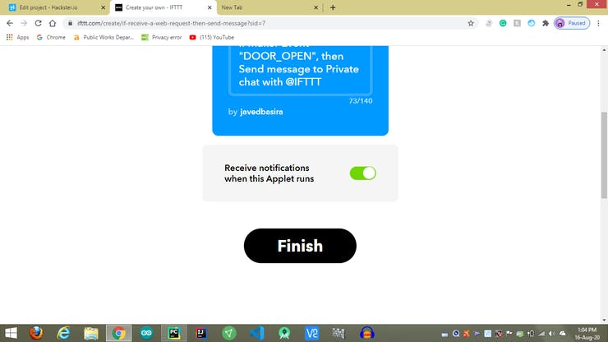

* click on finish

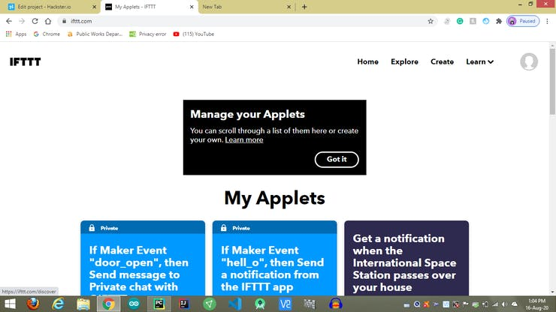

* then click on explore

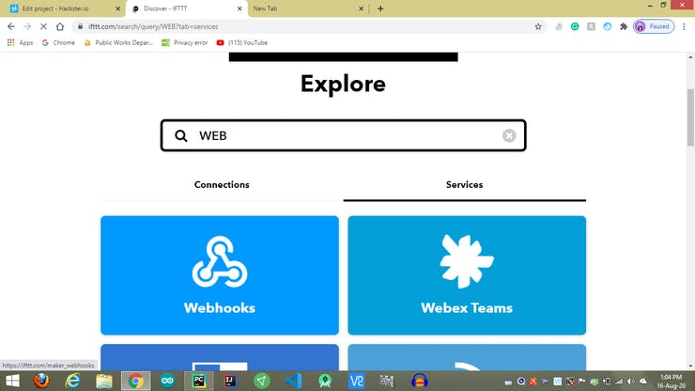

* Search for webhooks

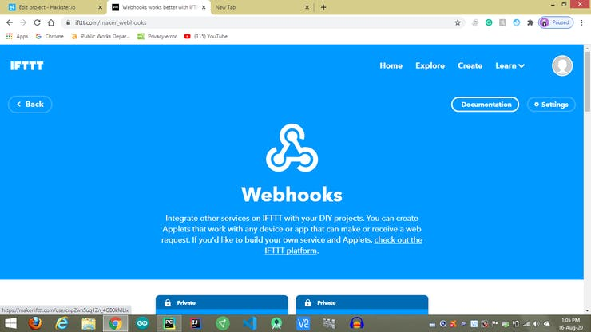

* click on documentation

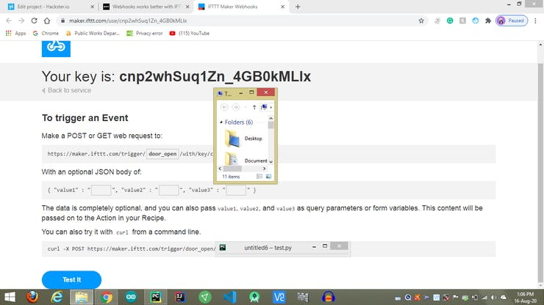

* write the event name in my case it's door-open and then copy the URL from /trigger

String url = "/trigger/door_open/with/key/cnp2whSuq1Zn_4GB0kMLlx";

* paste the URL here
* then it's time for connections

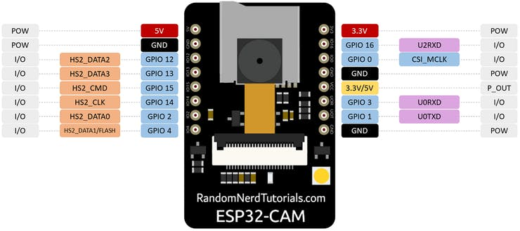

* take a tactile button and connect it to
* VCC AND GND
* CONNECT LED/SOLENOID RELAY ON GPIO12

**esp8266 connections:**

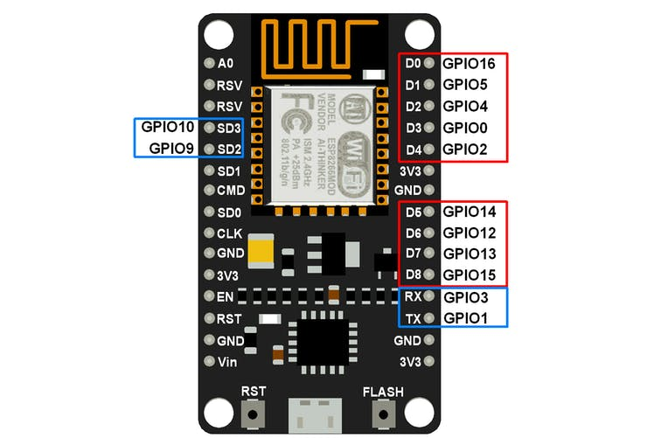

* connect FAN AND LIGHT RELAY ON GPIO 5(D1) AND GPIO 4(D2).

**PYTHON Libraries:**

* speech-recognition
* pyttsx3
* pyautogui

**HOW TO USE IT:**

* UPLOAD CODES TO ESP-CAM ANS NODEMCU BOTH.
* CONNECT TO YOUR WIFI AND RUN PYTHON PROGRAM
* to turn on light say *light*
* to turn off light say *dark*
* to turn on fan say *fan on*
* to turn off fan say *fan off*
* to turn on camera say *camera*
* to open door lock say *open door*
* to open google voice search say *google*
* for music say *music*
* you can also control it from the webpage