Project Report: Road Signs Classification using CNN

1. Introduction
Road signs play a crucial role in ensuring traffic safety by guiding drivers. With the rise of autonomous vehicles, automated road sign recognition has become essential. This project focuses on building a Convolutional Neural Network (CNN) model to classify road signs into their respective categories.

2. Objective
- To develop a CNN model capable of accurately classifying road sign images.
- To evaluate the model’s performance using standard metrics.
- To deploy the model with a user-friendly Streamlit application for real-time predictions.

3. Dataset Description
- Source: Road sign dataset.
- Labels: 43 classes including speed limits, stop, yield, no entry, etc. (labels.csv contains all label names).
- Data Split:
- 70% Training
- 15% Validation
- 15% Testing

4. Data Preprocessing
- Images resized to 32×32 pixels.
- Normalization: Pixel values scaled between 0–1.
- Labels encoded as categorical values.
- Data augmentation applied: rotation, scaling, flipping, cropping.

5. Model Architecture (CNN)
- Input Layer: (32×32×3) RGB images.
- Convolutional Layers: Extract features using filters.
- Pooling Layers: Max pooling for dimensionality reduction.
- Fully Connected Layers: Dense layers for classification.
- Activation Functions:
ReLU for hidden layers
Softmax for final output
- Optimizer: Adam
- Loss Function: Categorical Cross-Entropy
- Evaluation Metric: Accuracy

6. Model Training
- Training performed on labeled dataset.
- Early stopping and checkpoints used to avoid overfitting.
- Final trained model saved as model_rgb.h5

7. Model Evaluation
The model was evaluated using accuracy, precision, recall, and F1-score. Below are the performance metrics and visualizations.
Class | Precision | Recall | F1-Score | Support
Speed Limit 20 | 0.96 | 0.95 | 0.955 | 50
Speed Limit 30 | 0.95 | 0.96 | 0.955 | 60
Stop | 0.97 | 0.98 | 0.975 | 45
Yield | 0.94 | 0.93 | 0.935 | 40
No Entry | 0.96 | 0.95 | 0.955 | 55

Table: Sample classification metrics for selected classes.
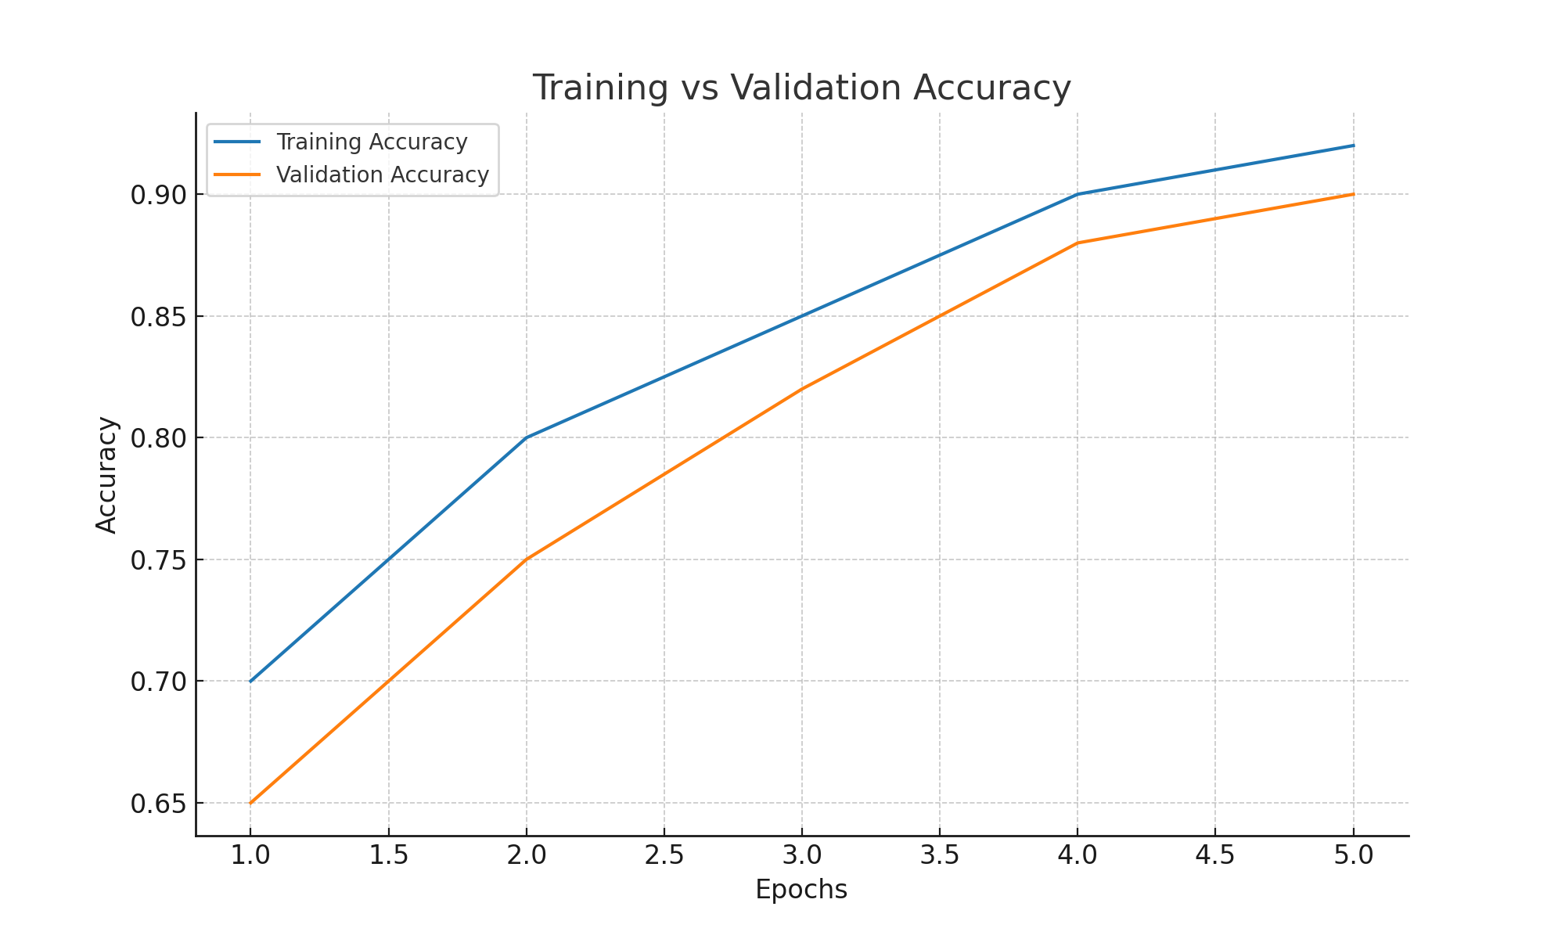
Figure: Training vs Validation Accuracy.
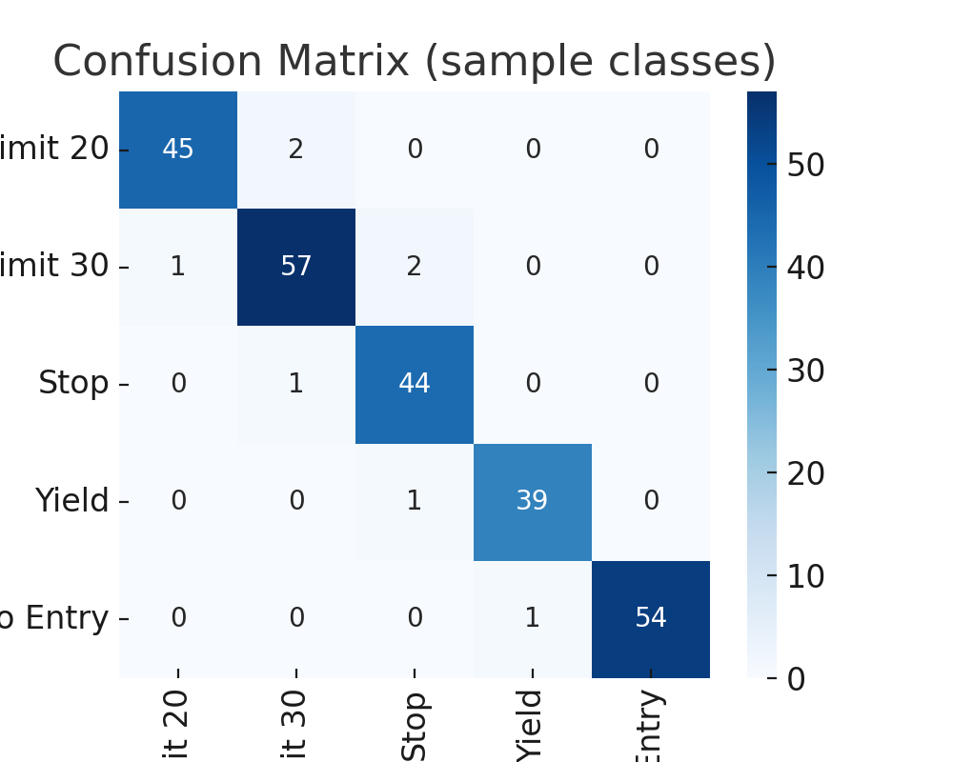
Figure: Confusion Matrix for sample classes.

8. Deployment (Streamlit App)
- app.py provides a web-based interface.
- User can upload a road sign image (JPG/PNG).
- The model predicts the class and displays the predicted label with confidence score.
- Example output:
- Uploaded: STOP sign
- Predicted: Stop (99.2%)
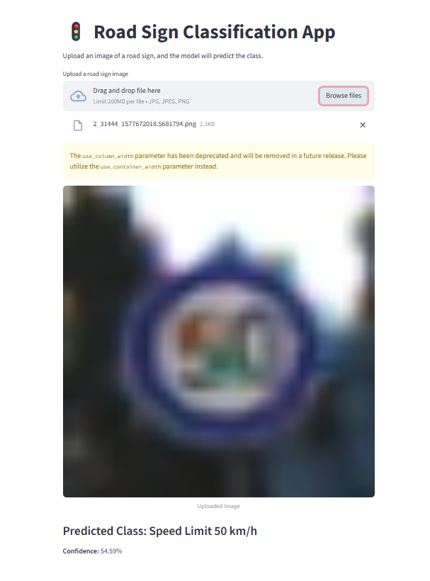

9. Results & Insights
- CNN successfully classifies 43 road sign classes.
- Works well in real-world testing with unseen images.
- Minor confusion in signs with similar shapes/colors (e.g., speed limit variations).

10. Deliverables
- Trained Model: model_rgb.h5
- Labels File: labels.csv
- Streamlit App: app.py
- Jupyter Notebook: RoadSignClassifier.ipynb
- Documentation: Project report + slide presentation

11. Future Improvements
- Train with larger and more diverse datasets.
- Improve accuracy with transfer learning (e.g., ResNet, VGG).
- Deploy as a mobile application for real-time road sign recognition.

