Objective:
Flipkart Smartphone Product Analysis

To analyse the smartphone listings on Flipkart to extract meaningful insights about product features, pricing trends, customer preferences, and brand performance using Power BI.
Tools & Technologies Used:
- Python: For web scraping, data cleaning, and exploratory data analysis (EDA).
- MySQL: For storing and querying structured product data.
- Power BI: For creating an interactive dashboard and visual analytics.
- Jupyter Notebook: For scripting and documenting Python code.
Methodology:
- Data Collection: Web scraping Flipkart smartphone listings using Python and BeautifulSoup.
- Data Cleaning: Removing missing values, standardizing formats (e.g., price, RAM, ROM), and extracting product attributes.
- Data Storage: Cleaned data was stored in a MySQL database.
- EDA: Performed statistical summaries, distributions, and feature relationships.
- Dashboard: Visualized key metrics using Power BI (e.g., most-reviewed brands, price vs. rating, specs distribution).
Data Cleaning & Preparation:
- Converted string features like "16 GB RAM" and "512 GB ROM" into numerical values.
- Extracted display size, battery capacity, and brand name from the product description.
- Removed duplicates and null entries.
- Final dataset columns included:
Product_Name, Product_Description, Product_Reviews, Product_Price, RAM, ROM, Display_Size, Battery, Brand.
Exploratory Data Analysis (EDA):
- Conducted in Jupyter using Python.
- Analyzed price distributions, review scores, and average specs across brands.
- Found outliers in pricing and identified top-performing brands based on average ratings.
Insights from Power BI Dashboard:
- Top Brands by Product Count: OnePlus, Samsung, and Apple dominate listings.
- Most Reviewed Brands: OnePlus and Apple have the highest number of reviews.
- Price Distribution: Most smartphones fall in the ₹30,000–₹50,000 range.
- RAM & ROM Trends: Increasing preference for phones with ≥8 GB RAM and ≥256 GB ROM.
- Battery vs Display: Larger battery phones (>5000 mAh) often come with 6.6+ inch displays.
- Interactive Filters: Slicers for brand, price, rating, etc. for granular analysis
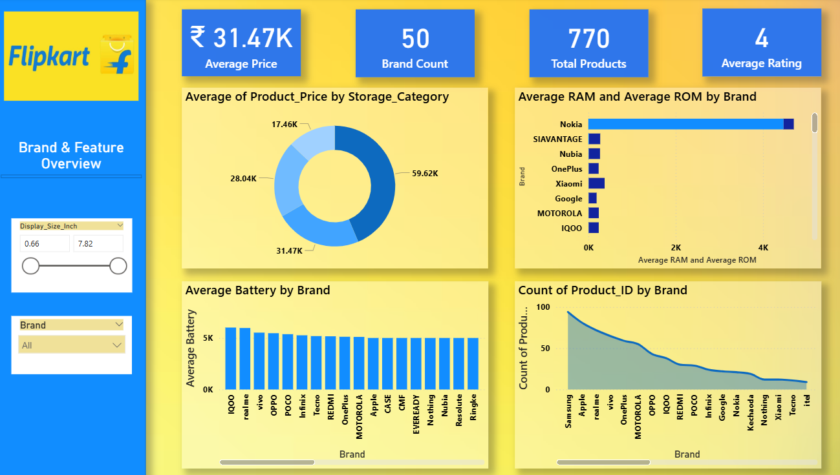
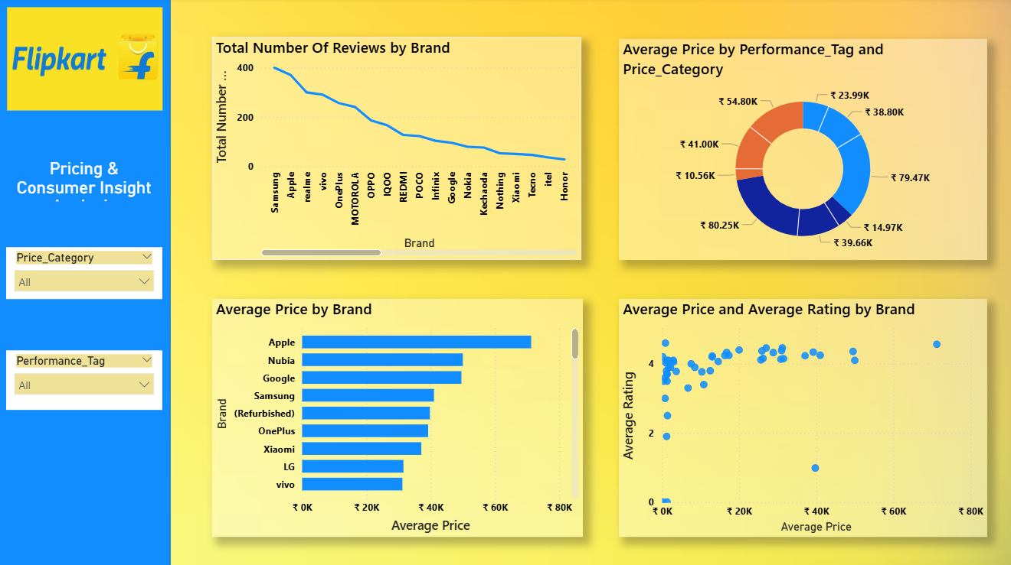
DAX Measures and Calculated Columns:
Basic Statistical Measures
- Average Battery = AVERAGE('flipkart_products'[Battery_mAh])
- Average Price = AVERAGE('flipkart_products'[Product_Price])
- Average RAM = AVERAGE('flipkart_products'[RAM_GB])
- Average ROM = AVERAGE('flipkart_products'[ROM_GB])
- Average Rating = AVERAGE('flipkart_products'[Product_Reviews])

Aggregated Insights
- Total Products = COUNTROWS (flipkart_products)
- Total Number of Reviews = SUM('flipkart_products'[Product_Reviews])
- Brand Count = DISTINCTCOUNT (flipkart_products[Brand])
- Battery_to_Price_Ratio = DIVIDE(SUM('flipkart_products'[Battery_mAh]), SUM('flipkart_products'[Product_Price]), 0)
- Price_per_GB_ROM = DIVIDE('flipkart_products'[Product_Price], 'flipkart_products'[ROM_GB], 0)
- Weighted Reviews = SUMX ('flipkart_products', 'flipkart_products'[Product_Reviews] * flipkart_products[Product_Price])
Business Logic and Tagging (DAX):
Storage_Category
SWITCH(TRUE(),
'flipkart_products'[ROM_GB] >= 512, "Ultra",
'flipkart_products'[ROM_GB] >= 256, "High",
'flipkart_products'[ROM_GB] >= 128, "Medium", "Low")
Price_Category
SWITCH(TRUE(),
'flipkart_products'[Product_Price] >= 50000, "Premium",
'flipkart_products'[Product_Price] >= 30000, "Mid-range",
"Budget")
Performance_Tag
SWITCH(TRUE(),
'flipkart_products'[RAM_GB] >= 12 && 'flipkart_products'[Battery_mAh] >= 5000, "High Performer",
'flipkart_products'[RAM_GB] >= 8, "Moderate","Basic")
SQL Queries and Database Operations:
CREATE TABLE flipkart_products (
Product_ID INT AUTO_INCREMENT PRIMARY KEY,
Product_Name VARCHAR(255),
Product_Description TEXT,
Product_Reviews FLOAT,
Product_Price INT,
RAM_GB INT,
ROM_GB INT,
Display_Size_Inch FLOAT,
Battery_mAh INT,
Brand VARCHAR(100)
);
Conclusion & Business Recommendations:
- Customer Preference: High storage, large displays, strong batteries.
- Brand Strategy: OnePlus should continue targeting mid-high range with strong specs.
- Inventory Planning: Focus on stocking 8GB/256GB variants, which are in high demand.
- Improvement Opportunity: Analyze lower-rated products for potential enhancements.
Project Deliverables:
- Python scripts – Web scraping, cleaning, Microsoft SQL Server integration
- SQL scripts – Flipkart database schema
- Power BI Dashboard – Full interactive visuals
- DAX measures and calculated columns for logic and KPIs
- Final Report – This insights and analysis document
- PPT – To summarize findings visually

