**Feedback**

1. When trying to access <https://www.videoslots.com/> I am being redirected automatically on <https://www.videoslots.com/sv/> . Even when I try to go to <https://www.videoslots.com/en/> the result is the same.

I am being redirected because my location in retrieved automatically, but being located in Sweden does not mean necessarily that I know Swedish.

1. I was investigating a possible bug, but my IP got blocked. I will try to write the steps:
   1. Go to <https://www.videoslots.com/>
   2. Click Open account button
   3. Enter e-mail address and phone number
   4. Select UK as country
   5. Check the 2 checkboxes
   6. Click on open account button
   7. Page with step 2 of 2 is displayed – select English
   8. Click Change e-mail address link
   9. The page with step 1 of 2 is displayed, but even if UK is still selected, the button for opening an account is named Open account with bank id, which is specific for Sweden.

The name of the button will remain unchanged even if the e-mail address/ phone number is changed.

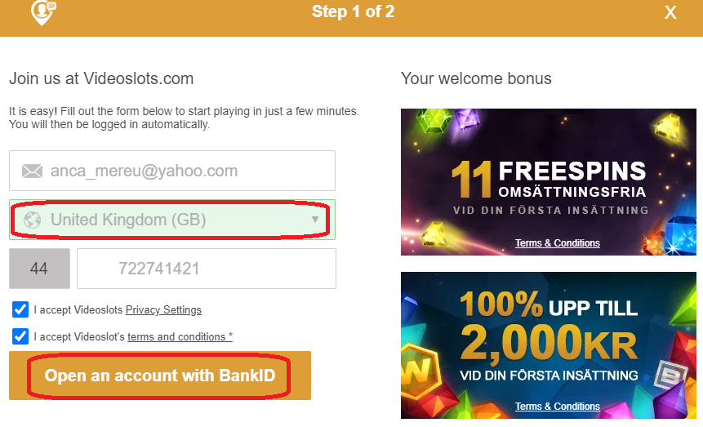

1. On the Italian version of the website (<https://www.videoslots.it/> ), the regulation regarding minimal age appear several times in more visible places (even when you are not logged in). Should this be the case for <https://www.videoslots.com/> , too?

Homepage:



Every page:



1. When trying to make a deposit, this message appears. In order to see if this is or isn’t a bug, the requirements should be read. Should this appear in my case pr not? If not, this is a CRITICAL bug, because prevents users to make a deposit and hinders their experience on the website.



1. When trying to create a new account some countries are not in the list (Romania among others), but I did not find a list with countries that do not allow players from specific countries. Maybe it can be useful.

When trying to access videoslots.com from a Romanian VPN, a message is indeed received (that players from my country are not accepted).