Documentație PS

Ilicea Anca / Sava Daniel / Gherasim Mihai

2/4/2020

### Problema 1

## Exercitiul 1

Calcularea mediei si a variantei cu ajutorul functiilor din R mean(), respectiv var() Am generat repartitiile cu ajutorul urmatoarelor functii:

* rpois()
* rbinom()
* rexp()
* rnorm()

## function ()   
## {  
## pois = rpois(1000, 50)  
## print(var(pois))  
## print(mean(pois))  
## binom = rbinom(1000, 15, 0.2)  
## print(var(binom))  
## print(mean(binom))  
## exp = rexp(1000, 5)  
## print(var(exp))  
## print(mean(exp))  
## norm = rnorm(1000, 20)  
## print(var(norm))  
## print(mean(norm))  
## }

Rezultate:

## [1] 48.21619  
## [1] 49.905  
## [1] 2.292644  
## [1] 3.093  
## [1] 0.04382053  
## [1] 0.2056995  
## [1] 0.9976532  
## [1] 19.91671

## Exercitiul 2

Graficele pentru functiile de densitate si functiile de masa

## Exercitiul 3

Graficele pentru functiile de repartitie pentru fiecare repartitie

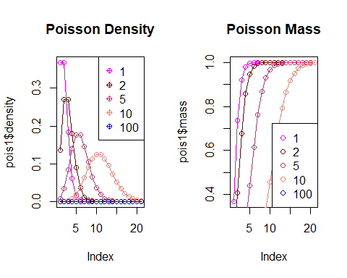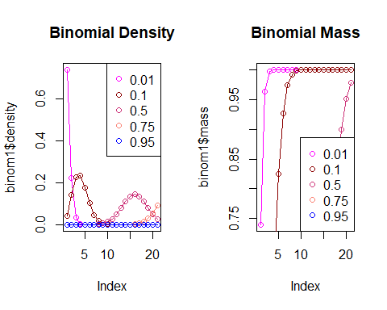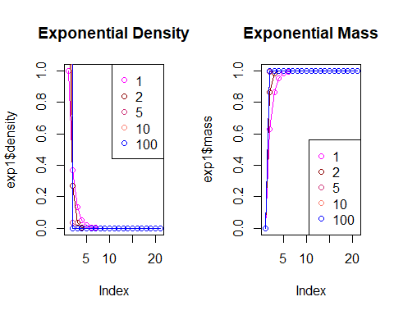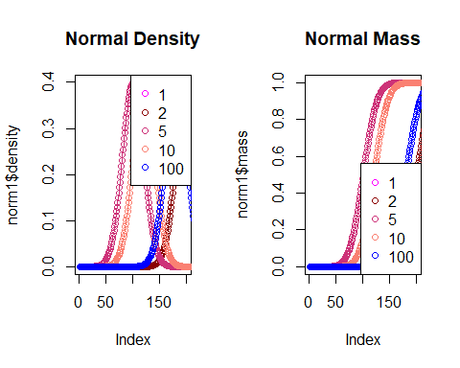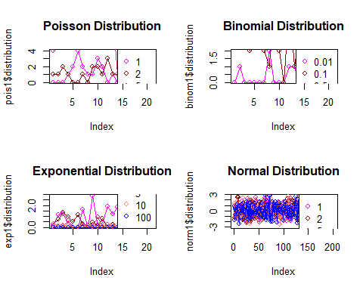

### Problema 1.4

## Implementare aproximari

## function (n, p)   
## {  
## aproximarePoisson <- function(k, lambda) {  
## suma <- 0  
## for (x in 0:k) suma <- suma + exp(-lambda) * (lambda^x)/factorial(x)  
## return(suma)  
## }  
## aproximareNormalaTLC <- function(k, n, p) {  
## return(pnorm((k - n * p)/sqrt(n * p * (1 - p)), mean = 0,   
## sd = 1))  
## }  
## aproximareNormalaFactorCorectie <- function(k, n, p) {  
## return(pnorm((k - 0.5 - n * p)/sqrt(n * p * (1 - p)),   
## mean = 0, sd = 1))  
## }  
## aproximareCampPaulson <- function(c, miu, sigma) {  
## return(pnorm((c - miu)/sigma, mean = 0, sd = 1))  
## }  
## raspunsuri <- matrix(ncol = 6, nrow = 10)  
## for (k in 1:10) {  
## a <- 1/(9 * (n - k))  
## b <- 1/(9 * (k + 1))  
## r <- ((k + 1) * (1 - p))/(p * (n - k))  
## sigmaPatrat <- a + b * r^(2/3)  
## c <- (1 - b) * r^(1/3)  
## miu <- 1 - a  
## lambda <- n * p  
## aprox_a <- aproximarePoisson(k, lambda)  
## aprox_b <- aproximareNormalaTLC(k, n, p)  
## aprox_c <- aproximareNormalaFactorCorectie(k, n, p)  
## aprox_d <- aproximareCampPaulson(c, miu, sqrt(sigmaPatrat))  
## raspunsuri[k, 1] <- k  
## raspunsuri[k, 2] <- dbinom(k, n, p)  
## raspunsuri[k, 3] <- aprox_a  
## raspunsuri[k, 4] <- aprox_b  
## raspunsuri[k, 5] <- aprox_c  
## raspunsuri[k, 6] <- aprox_d  
## }  
## return(raspunsuri)  
## }  
## <bytecode: 0x0000000018331e30>

Tabele:

n = 25, p = 0.05

|  |  |  |  |  |  |
| --- | --- | --- | --- | --- | --- |
| k | Binomiala | Poisson | Normala | Normala Corectie | Camp-Paulson |
| 1 | 0.3649863 | 0.6446358 | 0.4092729 | 0.2456486 | 0.6452200 |
| 2 | 0.2305177 | 0.8684677 | 0.7543514 | 0.5907271 | 0.8733858 |
| 3 | 0.0930159 | 0.9617309 | 0.9458532 | 0.8743254 | 0.9651268 |
| 4 | 0.0269257 | 0.9908757 | 0.9941916 | 0.9805263 | 0.9922684 |
| 5 | 0.0059520 | 0.9981619 | 0.9997105 | 0.9985700 | 0.9985791 |
| 6 | 0.0010442 | 0.9996799 | 0.9999935 | 0.9999519 | 0.9997790 |
| 7 | 0.0001492 | 0.9999509 | 0.9999999 | 0.9999993 | 0.9999705 |
| 8 | 0.0000177 | 0.9999933 | 1.0000000 | 1.0000000 | 0.9999966 |
| 9 | 0.0000018 | 0.9999992 | 1.0000000 | 1.0000000 | 0.9999997 |
| 10 | 0.0000001 | 0.9999999 | 1.0000000 | 1.0000000 | 1.0000000 |

n = 25, p = 0.1

|  |  |  |  |  |  |
| --- | --- | --- | --- | --- | --- |
| k | Binomiala | Poisson | Normala | Normala Corectie | Camp-Paulson |
| 1 | 0.1994161 | 0.2872975 | 0.1586553 | 0.0912112 | 0.2706080 |
| 2 | 0.2658881 | 0.5438131 | 0.3694413 | 0.2524925 | 0.5383546 |
| 3 | 0.2264973 | 0.7575761 | 0.6305587 | 0.5000000 | 0.7647348 |
| 4 | 0.1384150 | 0.8911780 | 0.8413447 | 0.7475075 | 0.9021393 |
| 5 | 0.0645937 | 0.9579790 | 0.9522096 | 0.9087888 | 0.9662328 |
| 6 | 0.0239236 | 0.9858127 | 0.9901847 | 0.9772499 | 0.9901932 |
| 7 | 0.0072150 | 0.9957533 | 0.9986501 | 0.9961696 | 0.9975741 |
| 8 | 0.0018038 | 0.9988597 | 0.9998771 | 0.9995709 | 0.9994841 |
| 9 | 0.0003786 | 0.9997226 | 0.9999927 | 0.9999683 | 0.9999050 |
| 10 | 0.0000673 | 0.9999384 | 0.9999997 | 0.9999985 | 0.9999848 |

n = 50, p = 0.05

|  |  |  |  |  |  |
| --- | --- | --- | --- | --- | --- |
| k | Binomiala | Poisson | Normala | Normala Corectie | Camp-Paulson |
| 1 | 0.2024868 | 0.2872975 | 0.1651950 | 0.0971830 | 0.2787915 |
| 2 | 0.2611014 | 0.5438131 | 0.3728014 | 0.2582061 | 0.5419320 |
| 3 | 0.2198748 | 0.7575761 | 0.6271986 | 0.5000000 | 0.7617348 |
| 4 | 0.1359752 | 0.8911780 | 0.8348050 | 0.7417939 | 0.8966284 |
| 5 | 0.0658406 | 0.9579790 | 0.9476213 | 0.9028170 | 0.9618574 |
| 6 | 0.0259897 | 0.9858127 | 0.9884295 | 0.9742121 | 0.9878222 |
| 7 | 0.0085981 | 0.9957533 | 0.9982498 | 0.9952779 | 0.9965871 |
| 8 | 0.0024324 | 0.9988597 | 0.9998207 | 0.9994116 | 0.9991503 |
| 9 | 0.0005974 | 0.9997226 | 0.9999877 | 0.9999506 | 0.9998103 |
| 10 | 0.0001289 | 0.9999384 | 0.9999994 | 0.9999972 | 0.9999617 |

n = 50, p = 0.1

|  |  |  |  |  |  |
| --- | --- | --- | --- | --- | --- |
| k | Binomiala | Poisson | Normala | Normala Corectie | Camp-Paulson |
| 1 | 0.0286321 | 0.0404277 | 0.0296732 | 0.0169474 | 0.0334704 |
| 2 | 0.0779429 | 0.1246520 | 0.0786496 | 0.0494801 | 0.1109253 |
| 3 | 0.1385651 | 0.2650259 | 0.1728893 | 0.1192964 | 0.2497303 |
| 4 | 0.1809045 | 0.4404933 | 0.3186759 | 0.2397501 | 0.4314063 |
| 5 | 0.1849246 | 0.6159607 | 0.5000000 | 0.4068319 | 0.6168541 |
| 6 | 0.1541038 | 0.7621835 | 0.6813241 | 0.5931681 | 0.7708904 |
| 7 | 0.1076281 | 0.8666283 | 0.8271107 | 0.7602499 | 0.8781270 |
| 8 | 0.0642779 | 0.9319064 | 0.9213504 | 0.8807036 | 0.9420684 |
| 9 | 0.0333293 | 0.9681719 | 0.9703268 | 0.9505199 | 0.9752641 |
| 10 | 0.0151833 | 0.9863047 | 0.9907889 | 0.9830526 | 0.9904630 |

n = 100, p = 0.05

|  |  |  |  |  |  |
| --- | --- | --- | --- | --- | --- |
| k | Binomiala | Poisson | Normala | Normala Corectie | Camp-Paulson |
| 1 | 0.0311607 | 0.0404277 | 0.0332287 | 0.0194737 | 0.0366911 |
| 2 | 0.0811818 | 0.1246520 | 0.0843343 | 0.0541468 | 0.1173545 |
| 3 | 0.1395757 | 0.2650259 | 0.1793977 | 0.1256746 | 0.2572236 |
| 4 | 0.1781426 | 0.4404933 | 0.3231776 | 0.2456486 | 0.4362128 |
| 5 | 0.1800178 | 0.6159607 | 0.5000000 | 0.4092729 | 0.6168067 |
| 6 | 0.1500149 | 0.7621835 | 0.6768224 | 0.5907271 | 0.7667729 |
| 7 | 0.1060255 | 0.8666283 | 0.8206023 | 0.7543514 | 0.8723891 |
| 8 | 0.0648709 | 0.9319064 | 0.9156657 | 0.8743254 | 0.9368812 |
| 9 | 0.0349013 | 0.9681719 | 0.9667713 | 0.9458532 | 0.9716068 |
| 10 | 0.0167159 | 0.9863047 | 0.9891093 | 0.9805263 | 0.9883152 |

n = 100, p = 0.1

|  |  |  |  |  |  |
| --- | --- | --- | --- | --- | --- |
| k | Binomiala | Poisson | Normala | Normala Corectie | Camp-Paulson |
| 1 | 0.0002951 | 0.0004994 | 0.0013499 | 0.0007710 | 0.0003769 |
| 2 | 0.0016232 | 0.0027694 | 0.0038304 | 0.0023033 | 0.0020473 |
| 3 | 0.0058916 | 0.0103361 | 0.0098153 | 0.0062097 | 0.0079372 |
| 4 | 0.0158746 | 0.0292527 | 0.0227501 | 0.0151301 | 0.0237017 |
| 5 | 0.0338658 | 0.0670860 | 0.0477904 | 0.0333765 | 0.0573670 |
| 6 | 0.0595787 | 0.1301414 | 0.0912112 | 0.0668072 | 0.1167730 |
| 7 | 0.0888952 | 0.2202206 | 0.1586553 | 0.1216725 | 0.2056576 |
| 8 | 0.1148230 | 0.3328197 | 0.2524925 | 0.2023284 | 0.3206667 |
| 9 | 0.1304163 | 0.4579297 | 0.3694413 | 0.3085375 | 0.4513689 |
| 10 | 0.1318653 | 0.5830398 | 0.5000000 | 0.4338162 | 0.5834688 |

### Problema 5

### Problema 6

Repartitiile normalei asimetrice 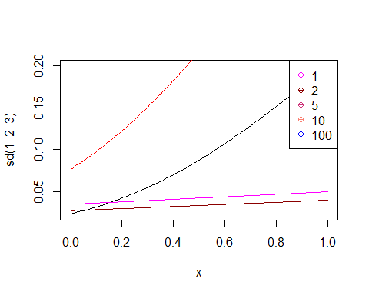

### Problema 7

Calculul ecuatiei:

p1ex7

## function (n, p)   
## {  
## ecuatie <- function(n, p) {  
## return(Vectorize(function(lambda) {  
## argUp1 <- (1 - ((2/pi) * ((lambda^2)/(1 + lambda^2))))^3  
## argDown1 <- (2/pi) * (4/pi - 1)^2 * ((lambda^2)/(1 +   
## lambda^2))^3  
## argUp2 <- n * p * (1 - p)  
## argDown2 <- (1 - 2 * p)^2  
## return(argUp1/argDown1 - argUp2/argDown2)  
## }))  
## }  
## functie <- ecuatie(n, p)  
## solution <- uniroot(f = functie, interval = c(0, 1000))  
## solutie <- solution$root  
## print(solutie)  
## lambda <- sign(1 - (2 * p)) * sqrt(solutie)  
## print(lambda)  
## sigmaPatrat <- n * p * (1 - p)/(1 - ((2/pi) * (solutie/(1 +   
## solutie))))  
## print(sigmaPatrat)  
## sigma <- sqrt(sigmaPatrat)  
## miu <- n * p - sigma * sqrt((2/pi) * (solutie/(1 + solutie)))  
## print(miu)  
## result <- c(lambda, sigma, miu)  
## library(sn)  
## barplot(pbinom(q = 0:n, size = n, prob = 0.05), col = "salmon")  
## barplot(pbinom(q = 0:n, size = n, prob = 0.1), col = "green",   
## add = TRUE)  
## barplot(dsn(x = 0:n, dp = c(miu, sigma, lambda)), col = "dark red",   
## add = TRUE)  
## return(result)  
## }

Graficul:

p1ex7(25, 0.05)

## [1] 4.558586  
## [1] 2.135085  
## [1] 2.484781  
## [1] 0.1110175

## Warning: package 'sn' was built under R version 3.6.2

## Loading required package: stats4

##   
## Attaching package: 'sn'

## The following object is masked from 'package:stats':  
##   
## sd

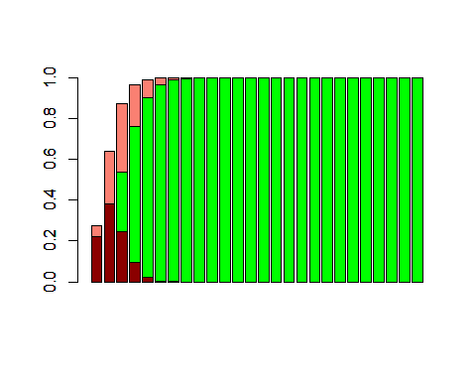

## [1] 2.1350846 1.5763188 0.1110175

### Problema 8

Calculul integralei si construirea tabelului

p1ex8

## function (n, p)   
## {  
## vector <- p1ex7(25, 0.05)  
## print(vector)  
## lambda <- vector[1]  
## sigma <- vector[2]  
## miu <- vector[3]  
## raspunsuri <- matrix(ncol = 3, nrow = 10)  
## aproximareNormalaSimetrica <- function(k, n, p) {  
## return(Vectorize(function(x) {  
## D <- function(t) {  
## 2 * dnorm(t) * pnorm(t * lambda)  
## }  
## return(integral(D, -Inf, x))  
## }))  
## for (k in 1:10) {  
## aproxNS <- aproximareNormalaSimetrica(k, n, p)  
## raspunsuri[k, 1] <- k  
## raspunsuri[k, 2] <- dbinom(k, n, p)  
## raspunsuri[k, 3] <- aproxNS(k, n, p)(x)  
## }  
## return(raspunsuri)  
## }  
## }