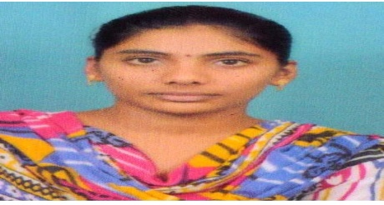
ANCHA ROHINI

Phone num: +91_9963483909
Gmail: rohiniancha21@gmail.com
CAREER objective
To pursue a challenging career and be a part of progressive organization that gives a scope to enhance my knowledge and utilizing my skills towards the growth of the organization
Educational qualifications
 | School/college | board | C G P A | Year of passing
B Tech | Malineni Lakshmaiah Women’s Engineering College | JNTUK | 7.5 | 2022
Intermediate | St Ann’s College | Board Of Intermediate Education | 8.9 | 2018
SSC | N Z P High School | Board Of Secondary Education | 8.0 | 2016

Technical skills
Programming languages known : C , UI TECHNOLOGIES, PYTHON, ORACLE
Software known : MS word ,MS Excel
projects
- Comparative Analysis Of Low Power Wallace Tree Encoders With Modified Full Adders.
- Tomato Plant Disease Detection Using Artificial Intelligence(AI)
ACHIEVEMENTS CERTIFICATION
- I am a part of COGNIGENT DIGITAL NATURE.
- I CAN INCLUDE THAT ARE BEING TRAINED BY TCS UNDER TCS YEP(YOUTH EMPLOYMENT PROGRAM) .
Extra curricular activities
1)I had participated in C -programming quiz from the RICE KRISHNA GROUP OF INSTITUTE
PERSONALITY TRAITS:
1)CREATIVITY
2)HONESTY
3)LEADERSHIP
Hobbies:
1)MEDITATION
2)PUZZLE solving
3)art & CRAFT
Personal info :
D O B :21/12/2000
Father name :A.Srinivasa Rao
Address for communication :2-853,near Ramalayam temple
kakumanu(m),kakumanu(v),guntur(dt).
Languages known: 1. English
2.Telugu
Declaration:
I hereby declare that the above furnished information is fully true to the best of my knowledge.


Place: Kakumanu.
ANCHA ROHINI

