**Inshorts**

**Inshorts** (previously known as **News in Shorts**) aggregates news and other content such as videos, infographics, and blogs, and summarizes them in 60 words or less.

**Installation:**

First open URL <https://www.inshorts.com> on mobile and download **Inshorts** app or by using play store you can direct download this app.

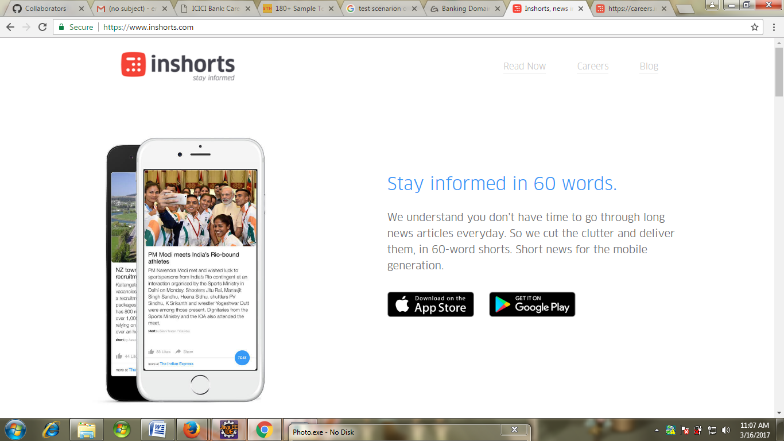

Here you have to first create your account; and you have to fill your basic information so that next time you can directly get log in. Add information (Personal, educational, experience) and have to upload resume etc.

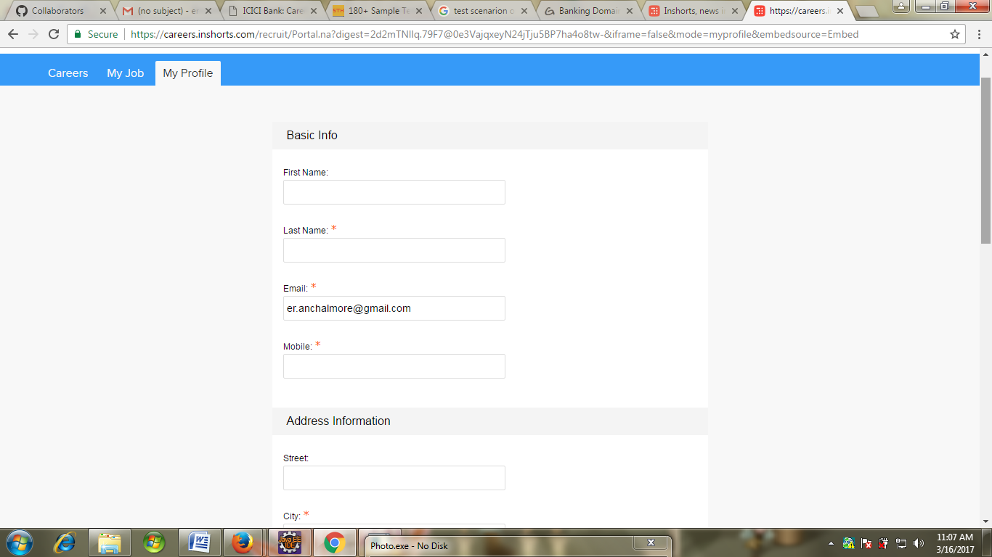

**Features:**

* In this app you will get latest update of news i.e. what’s going on your surrounding within short news you will get connected with the world.
* Here provided many options blog,career,news so that you can choose any one according to your requirements.
* There is also provided help option so that it guide user about how to handle application.
* You can redirect to gmail, fb, and twitter page directly by this app.

**Functionality:**

* Menu bar option is properly working
* All the options are properly shown
* Languages option is given so that user can select according to their need.
* All news are provided section wise(sport,education,science,technology etc) .

**Improvements:**

* Application is not compatible with blackberry, windows mobiles
* More language options should be provided other than English and Hindi.