**Experiment - 01**

Objective :

Study of the following network devices in detail.

Apparatus Required :

1. NIC
2. Hub
3. Switch
4. Repeater
5. Modem
6. Router
7. Firewall
8. Gateway
9. POE (Power Over Ethernet)
10. POP Switch

Theory :

* NIC (Network Interface Card) :

A NIC provides a computer with a dedicated, full-time connection to a network. It implements the physical layer circuitry necessary for communicating with a data link layer standard, such as Ethernet or Wi-Fi. Fig. 1.1 shows NIC.

Fig. 1.1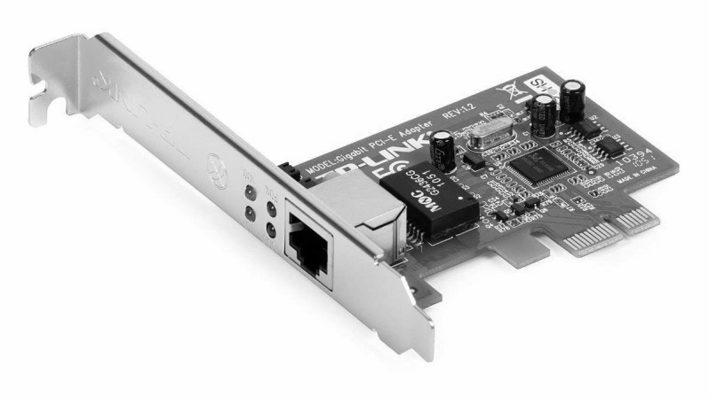

* Hub :

In networking, a hub is a device that links multiple computers and devices together. Hubs can also be referred to as repeaters or concentrators, and they serve as the center of a local area network (LAN). In a hub, each connected device is on the same subnet and receives all data sent to the hub. Fig. 1.2 shows Hub.

Fig. 1.2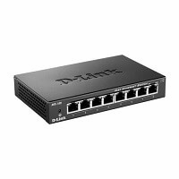

* Switch :

The Switch is a network device that is used to segment the networks into different subnetworks called subnets or LAN segments. It is responsible for filtering and forwarding the packets between LAN segments based on [MAC address](https://www.geeksforgeeks.org/introduction-of-mac-address-in-computer-network/). Switches have many ports, and when data arrives at any port, the destination address is examined first and some checks are also done and then it is processed to the devices. Fig. 1.3 shows Switch.

Fig. 1.3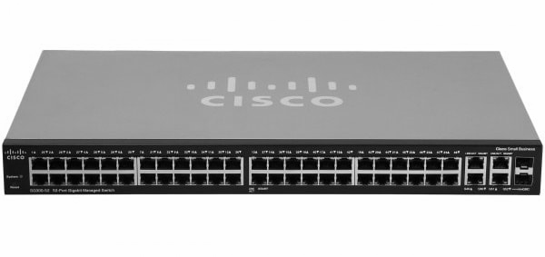

* Repeater :

A computer network is made up of various devices such as the hub, repeater, modem, switch, computer devices, etc. Each device plays a vital role in networking. Repeaters are used in order to extend the network and provide security, strength, and no data loss. The below article describes in detail a networking device known as a repeater. Fig. 1.4 shows Repeater.

Fig. 1.4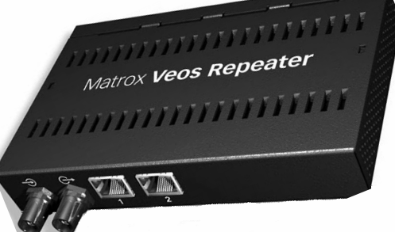

* Modem :

A modem is a hardware which connects to a computer, broadband network or wireless router. Modem converts information between analogue and digital formats in real time making seamless two-way network communication. The full form of Modem or modem stands for modulator–demodulator. Fig. 1.5 shows Modem.

Fig. 1.5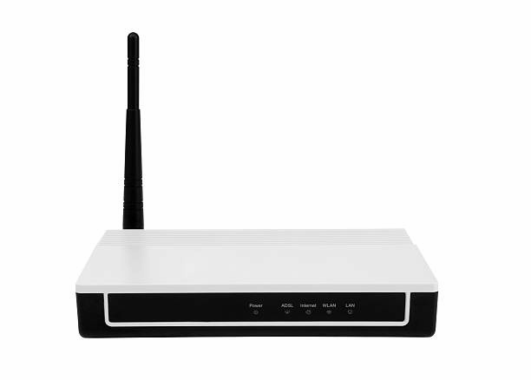

* Router :

A Router is a networking device that forwards data packets between computer networks. One or more [packet-switched networks](https://www.geeksforgeeks.org/packet-switched-network-psn-in-networking/) or subnetworks can be connected using a router. By sending data packets to their intended [IP addresses](https://www.geeksforgeeks.org/what-is-an-ip-address/), it manages traffic between different networks and permits several devices to share an [Internet connection](https://www.geeksforgeeks.org/types-of-internet-connection/). Fig. 1.6 shows Router

Fig. 1.6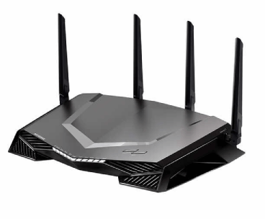

* Firewall :

A firewall is a network security device, either hardware or software-based, which monitors all incoming and outgoing traffic and based on a defined set of security rules it accepts, rejects or drops that specific traffic. Accept : allow the traffic Reject : block the traffic but reply with an “unreachable error” Drop : block the traffic with no reply A firewall establishes a barrier between secured internal networks and outside untrusted network , such as the Internet. Fig. 1.7 shows Hardware Firewall.

Fig. 1.7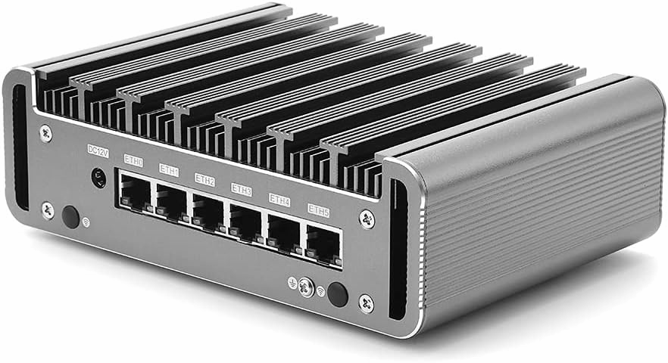

* Gateway :

A gateway is a network node used in telecommunications that connects two networks with different transmission protocols together. Gateways serve as an entry and exit point for a network as all data must pass through or communicate with the gateway prior to being routed. Fig. 1.8 shows Gateway.

Fig. 1.8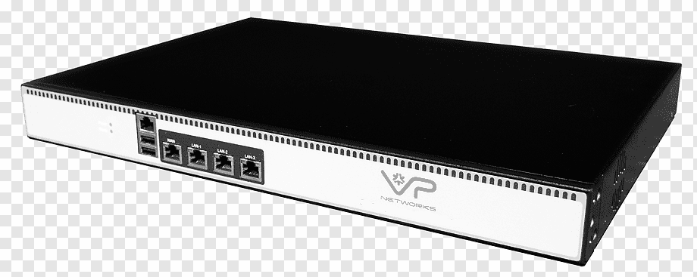

* POE (Power Over Ethernet) :

Power Over Ethernet (POE) is a technique used for building wired Ethernet local area networks (LANs) which use Ethernet data cables instead of normal electrical power cords and wiring to carry the electrical current required to operate each device. The transfer of power through network cabling is possible because of the coupling of data transmission and power-providing hardware on the same RJ45 Ethernet connection. Fig. 1.9 shows POE

Fig. 1.9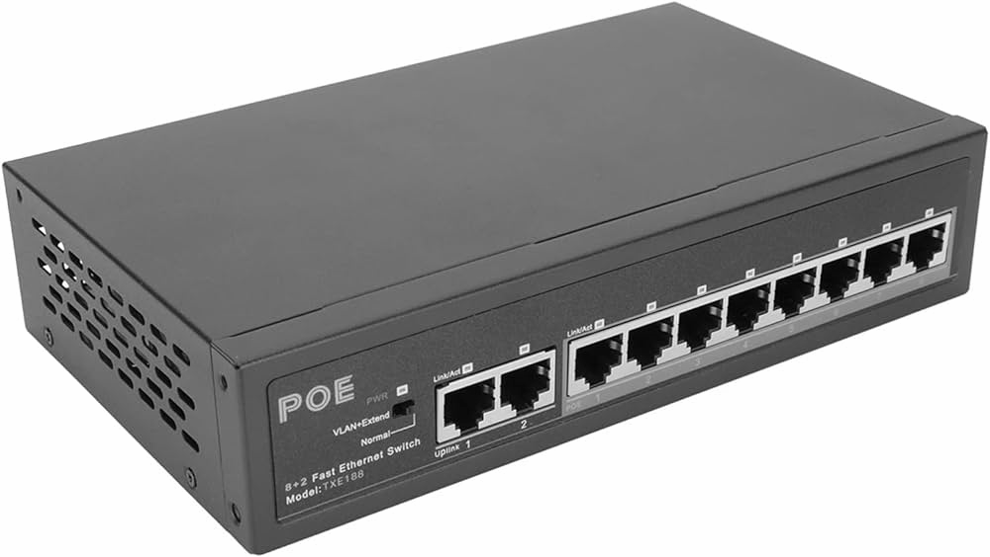

* POP Switch :

A "pop switch" typically refers to a switch (a network device used for connecting devices together within a local area network) located at a Point of Presence (POP). A POP is a location within a network where multiple connections come together, often serving as an access point for users to connect to the wider network, such as the internet. In a computer network context, a POP switch would be a switch located at a POP, facilitating connections between devices within that

location or network segment. Fig 1.10 shows POP Switch.

Fig. 1.10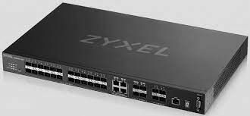

Result :

We have studied about the working of various network devices which typically involves understanding their functionalities, configuration and roles within a network

Precautions :

* Handle Carefully.
* Do not use long wires.
* Use POE to reduce cost.
* Physical Security.
* Training and Awareness.
* Secure Configuration.

***