Early Detection of Autism Spectrum Disorder in Toddlers Using Deep Learning Approaches
Anchal Gupta, Aastha Basu, Aman Kumar, Amar Singh
B.Tech (Hons.) in Computer Science and Engineering (Data Science),
Vidyashilp University, Bangalore, India
Email:2022anchal.g@vidyashilp.edu.in; 2022aastha.b@vidyashilp.edu.in;
2022aman.k@vidyashilp.edu.in; 2022amar.s@vidyashilp.edu.in

Abstract
Early detection of Autism Spectrum Disorder (ASD) is crucial for the implementation of timely interventions with far-reaching effects on developmental outcomes. The conventional diagnostic processes are however typically delayed, subjective, and resource-intensive, particularly in low-resource environments. This paper introduces a scalable two-stage diagnostic system that blends parent-administered behavioral questionnaires with automated video-based behavioral analysis using deep learning techniques. Phase 1 employs a decision tree classifier to predict ASD risk from structured questionnaire responses in accordance with DSM-5 and AAP guidelines. Toddlers with a medium or high risk classification are referred for additional assessment in Phase 2, where a hybrid CNN-LSTM model analyzes brief video clips for behavioral indicators of gaze aversion, motor stereotypes, and reduced social reciprocity. The system is both high in classification accuracy and interpretable while being resource-efficient, thus amenable for real-world deployment. Despite constraints such as limited dataset diversity and real-world testing, the introduced approach offers a new avenue towards early, accessible, and objective ASD screening devices for parental and clinical applications.

Keywords: Autism Spectrum Disorder (ASD), Early Detection, Deep Learning, Behavioral Analysis, Multimodal Screening, Questionnaire-based Screening, Video-based Classification, CNN-LSTM, Explainable AI (XAI), Pediatric Diagnostics, Machine Learning, Clinical Decision Support, Federated Learning, Neurodevelopmental Disorders

I. Introduction

A. The Imperative for Early ASD Detection
Autism Spectrum Disorder (ASD) is a neurodevelopmental condition that includes persistent impairments in social communication and interaction, and restricted and repetitive patterns of behavior, interests, or activities. Presentation of ASD is highly heterogeneous between individual cases, and this is one reason diagnostic difficulty exists. With estimated prevalence rates of over 2.78% of the global population [1], early diagnosis is now paramount. Research consistently indicates that interventions initiated prior to two years of age can significantly change developmental trajectories by capitalizing on the greater neuroplasticity of the baby brain [2], [3], [4]. Early diagnosis not only enables greater social and cognitive functioning but also reduces long-term health and education costs [3], [5], [6].

B. Limitations of Current Diagnostic Paradigms
Despite the clear benefits of early intervention, the average age of ASD diagnosis currently stands at 3-4 years, which significantly lags behind the typical emergence of early signs before a child's second birthday [5], [7], [8]. Such delay in diagnosis implies that there is considerable window for intervention often lost [Prompt]. Traditionally used methods of diagnosis for ASD are subjective, time-consuming, and highly dependent on the skills of a few experts [9]. In addition, routine screening instruments like the Modified Checklist for Autism in Toddlers (M-CHAT), and direct behavioral observation are prone to recall bias and often not standardized, leading to heterogeneity of diagnosis across populations [4], [7], [10].
The ongoing delay in ASD diagnosis, in the presence of universally accepted benefits to early intervention and clear early signs, is a reflection of a systemic failure in current screening and diagnostic practice. It is more than a technical issue of diagnostic accuracy; it is also accompanied by significant logistical and access barriers due to the relative shortage of specialists and the subjective nature of current methods [9], [11], [12]. The over-reliance on a specialist pool and uneven distribution creates a bottleneck in the diagnostic pipeline. The bottleneck is further exacerbated by the built-in subjectivity and absence of standardization of the instruments these specialists employ [5], [7], [8]. Even when a child is evaluated, as a consequence, the process can be wasteful and error-prone, resulting in prolonged delays and diagnostic inequities [13], [14], [15]. The problem in question is less one of perceiving early signs and more one of being able to respond to them meaningfully within current healthcare infrastructures [9], [12], [16].

C. The Role of Deep Learning in ASD Detection
Recent advances in artificial intelligence technology, i.e., deep learning (DL), have started to surpass the limitations of conventional diagnostic approaches [17], [18], [19], [20], [21]. DL models can identify subtle, nonlinear multimodal data patterns in video, audio, neuroimaging, and behavioral measures [20], [22], [23]. The methods have promised to speed up and improve the speed and accuracy of ASD diagnosis with the automation of feature extraction and real-time processing [24], [25], [26], [27]. Importantly, deep learning-based systems promise to provide scalable and objective diagnostic support tools deployable in low-resource or remote environments [12], [19], [28], [29].

II. Related Work

The recent years have also seen a surge in the type of research that employs Machine Learning (ML) and Deep Learning (DL) techniques for early diagnosis of Autism Spectrum Disorder (ASD), especially in toddlers. The approaches span a variety of data modalities such as image, speech, and questionnaire data and attempt to overcome the limitations of traditional diagnostic techniques based on subjective behavior ratings. This section provides an overview of current research in ML/DL-based ASD diagnosis, deep learning for behavioral health, and multimodal data fusion. It also presents the most significant gaps to be addressed by this research.

A. Early Behavioral Markers of Autism in Toddlers

Autism Spectrum Disorder or ASD is a neurodevelopmental disorder that is characterized by impairments in social communication, language, and repetitive behavior. Diagnosis is delayed because of the heterogeneity of ASD symptoms and on the basis of subjective reports of behavior of trained professionals [4], [10].
Current diagnostic guidelines offer a median age at diagnosis of three to four years, which is suboptimal because interventions begun before two years of age have improved cognitive and social outcomes, e.g., higher IQ [3], [8]. As the incidence of ASD increases, now 1 in 36 eight-year-olds in 2020, early, cost-effective, and scalable diagnostic guidelines are needed [5], [9].
Traditional tests like the M-CHAT and Griffiths Mental Development Scales (GMDS) are prevalent but flawed because they are subjective and parent-reported. Unbiased behavior markers like atypical motor patterns, reduced response-to-name (RTN), and limited language development have become prevalent early markers [1], [2], [14]. Motor impairment like hand flapping and head movements can be detected by pose estimation methods like OpenPose, while RTN can be measured by multimodal deep models by combining spatial and temporal behavior features [15], [20].

B. ML/DL Techniques and Approaches for ASD Detection
Machine learning (ML) and deep learning (DL) research for the diagnosis of ASD has increased manifold from various sources of data. Traditional ML classifiers such as Support Vector Machines (SVM), Random Forests, Gradient Boosting (XGBoost), and Logistic Regression have been proven useful in handling structured questionnaire data and behavior scores [17], [19], [31].
But DL architectures have provided direct processing of the high-dimensional unstructured data such as video, audio, and neuroimaging. CNNs are used extensively for the image-based input such as facial morphology and video-based motor activity [21], [35]. Lightweight models such as MobileNet and EfficientNet have been used for real-time processing [18], [33]. Temporal behaviors such as reaction times and speech patterns are represented by LSTMs, GRUs, and Bi-LSTMs, particularly for response-to-name and speech analysis tasks [14], [26].
Hybrid models like CNN-LSTM models can effectively extract spatial and temporal information. For example, Near-perfect RTN classification was attained with a ResNet18-Bi-LSTM model [15]. Advanced models like the use of Transformers for head movement classification and Graph Neural Networks (GNNs) for the analysis of fMRI-based connectivity data are state-of-the-art approaches [20], [27], [30].

C. Multimodal Data Fusion and Explainable AI
ASD is of a multidimensional character, and unimodal models are often incapable of dealing with the entire dimensionality of the disorder. Hence, the use of multimodal data behavioral, physiological, linguistic, and neuroimaging data is a general tendency in ASD detection research [6], [23].
Multimodal strategies integrating EEG with eye tracking data have been reported to be more accurate (95.56%) compared to one-modality models [28]. Audio-video fusion has also been reported to perform better with the best classification accuracy of up to 82.5% for ASD behavior in social interaction [13]. Data fusion techniques range from simple late-fusion models to complex architectures using Stacked Denoising Autoencoders (SDAEs) and attention mechanisms [25], [30], [33].
Explainable AI (XAI) became a primary tool to overcome the 'black-box' problem of DL models. Methods such as SHapley Additive exPlanations (SHAP) and LIME provide explainability of the decision-making process, attributing feature contributions such as facial areas or vocal parameters that contribute most to the diagnosis [25], [28], [37]. It is of extreme significance for clinic adoption and accountability in sensitive pediatric evaluation.

D. Clinical and Ethical Challenges in Early ASD Detection
Despite promising technical advances, clinical integration faces significant challenges. Access to ASD specialists remains limited, particularly in resource-constrained settings such as India [12]. Existing tools tend to be time- and cost-consuming, proprietary in nature, further solidifying disparities in access [5], [32].
Data privacy is a critical ethical concern. Federated Learning (FL) protocols have been researched to provide privacy while facilitating collaborative model training across institutions without raw data sharing. Differential Privacy (DP) techniques also protect data by injecting statistical noise [29] ,[38].
Lack of standardization across diagnostic instruments and protocols is the source of inconsistency with discovery and intervention. Additionally, the minimal level of autistic voice incorporation into tool creation and testing is a reason for alarm about alignment with the neurodiversity movement. Incorporation of autistic feedback can bring ethical robustness as well as usability [11].

E. Research Gaps and Technical Challenges in ASD Detection
Although promising research has emerged, several critical challenges continue to hinder real-world deployment and clinical acceptance. These gaps form the foundation for the development of the proposed are detailed below.

1. Gap in Delayed Diagnosis and Intervention: Early signs of ASD are typically observed before two years of age, but the diagnosis comes around 3-4 years of age. This delay narrows the window for early intervention, and the efficacy of therapies in the years of development is lost. The current diagnostic strategies are time-consuming, subjective, and depend on the limited availability of specialists [2], [4], [5], [8], [10]

2. Scalability and Access Restrictions: ASD diagnostic services are disproportionately available in urban or high-resource settings. In countries like India, the scarcity of autism specialists and reliance on proprietary, non-scalable tools hinders early screening at scale [5], [12].

3. Subjectivity and Bias in Traditional Screening: Instruments such as the M-CHAT are prone to recall bias and disproportionate use in populations. Subjective measures such as these tend to produce inconsistent results, heightening diagnosis inequality and calling for objective data-driven models [7], [9], [10].

4. Data Limitations: Size, Diversity, and Longitudinality: The majority of the datasets are small in size, homogeneous, and cross-sectional, thereby restricting model generalizability and algorithmic bias. The inability to have longitudinal data hinders the observation of developmental trajectories or the evaluation of intervention impacts [1], [6], [10], [23], [27], [29].

5. Poor Multimodal Fusion: The majority of fusion approaches like straightforward concatenation fail to leverage the complementary properties of various data modalities. Deep learnable models of fusion that can identify intricate cross-modal relationships [6], [13], [15], [18], [23], [25], [30], [33] are in demand.

6. Privacy Concerns with Sensitive Health Data: Deep learning models are constructed largely on sensitive health information, particularly children's. Methods such as Federated Learning (FL) and Differential Privacy (DP) must be utilized to enable collaborative model training while maintaining patient confidentiality [19], [24], [33].

7. Lack of Interpretability in Deep Learning Models: Deep models, particularly CNNs and Transformers, are "black boxes." Their uninterpretability hinders clinician adoption and also regulatory approval. Integration of XAI tools is needed for explainable and accountable AI in healthcare [25], [27], [28], [37].

8. Limited Inclusion of Autistic Perspectives: There are few, if any, studies that involve autistic people or their families' input. This restricts alignment with neurodiversity principles and poses usability and ethical strength concerns. Participatory design is paramount to fair tool development [3], [7], [11].

9. Insufficient Real-World Validation: All the suggested deep learning models for the diagnosis of ASD are only validated on well-curated data sets in well-controlled laboratory settings with no serious validation in real-world clinical settings. Absence of real-world validation significantly limits their stability, generalizability, and realistic applicability in various clinical settings [1], [12],[18], [21], [29], [30], [31], [34], [38].

Table 1: Comparative Analysis of State-of-the-Art ASD Detection Models (2023-2025)
Model / Approach | Modalities Used | Accuracy (%) | Sensitivity (%) | Specificity (%) | AUROC | Key Limitations / Context | Source ID(s)
Hybrid DL (fMRI) | fMRI | 73.5 | 76.5 | 75.2 | 0.790 | Small, homogeneous datasets; poor generalizability | [30], [35]
Naive Bayes (NB) | Tabular (e.g., questionnaire) | 99.2 | N/A | N/A | N/A | Dataset biases; overfitting due to small size | [13], [33]
K-Nearest Neighbor (KNN) | Tabular | 97.2 | N/A | N/A | N/A | Dataset limitations; lacks real-time application | [36]
GNN (fMRI) | fMRI, Meta-  connectivity | 74 | N/A | N/A | 0.826 | Complex model; high variance; interpretability issues | [27], [30]
Multimodal DNN | fMRI + phenotypic data | 98.64 | 99 | 99 | 1.000 | High performance, but generalizability and interpretability weak | [10], [29]
Multimodal SDAE | EEG + Eye-tracking | Superior to unimodal | N/A | N/A | N/A | Limited availability of multimodal datasets | [9], [40]
FCNN-LSTM | ASQ, CSBS, PEDS, M-CHAT, STAT | ~99 | N/A | N/A | N/A | Clinical tool simulation lacking real deployment | [5]
DSVTN-ASD | Video (stereotypical behaviors) | N/A | N/A | N/A | Micro: 0.9501Macro: 0.9313 | Sparse, noisy data; labeling challenges | [4], [14]
MobileViT | Facial images | 99(train)  98 (val) | N/A | N/A | N/A | Dataset lacks ethnic and age diversity | [11], [35]
Quantized CNN + FL | fMRI | 98 | N/A | N/A | N/A | No explicit differential privacy; communication overhead | [39]
NASNet-  Mobile + LIME | sMRI | 96.07 | 94.51 | 97.74 | N/A | LIME improves interpretability, but still lacks clinical trials | [6], [11]

Table 1: Comparative analysis of state-of-the-art ASD detection models (2023-2025), emphasizing their modalities, performance metrics, and associated limitations. Despite promising results on benchmark datasets, most models lack robust real-world clinical validation, posing challenges for their generalizability and adoption in practical diagnostic settings.

III. Proposed Methodology
We propose a two-phased diagnostic pipeline for early diagnosis of Autism Spectrum Disorder (ASD) in toddlers. The method integrates Behavioural questionnaire information and video-based analysis of behaviour, reflecting actual clinical diagnostic procedures. The phased method allows efficient usage of resources and optimal diagnostic depth and accuracy [1], [5], [10], [12]. To better illustrate the user experience and end-to-end flow of the proposed system, Figure 1 shows the journey a typical toddler and their caregivers follow during the early ASD detection process.
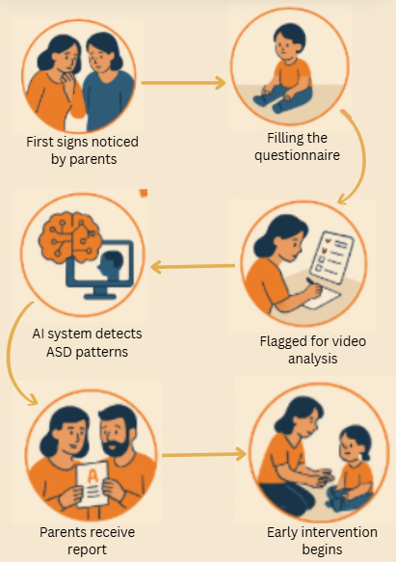
Figure 1: User Journey in the Proposed ASD Diagnostic Pipeline

A. Phase 1: Behavioural Questionnaire-Based Screening
The initial phase is concerned with early detection of high-risk toddlers for Autism Spectrum Disorder (ASD) through parent-reported behavior observation. This is in accordance with clinical best practice and utilizes accepted criteria from the DSM-5, CDC, American Academy of Pediatrics (AAP), and the National Institute of Mental Health (NIMH) [5], [10].

1) Questionnaire Design
Parents complete a structured screening tool consisting of Yes/No questions that span multiple domains of early childhood development, including:
- Social interaction and communication
- Play and imagination
- Behavioral patterns and sensory sensitivities
- Developmental history and regression
- Family history of ASD or related neurodevelopmental disorders
Each question corresponds to established “red flag” indicators of ASD. For instance, a child who fails to respond to his/her name, fails to initiate joint attention (e.g., pointing or showing), or exhibits stereotyped behavior (e.g., hand flapping, lining up toys) would be marked as having characteristics typical of ASD [2], [4], [7].

2) Risk Scoring Mechanism
Responses are mapped to a categorical risk scoring system based on the number and type of red flags present:
- No Risk
- Low Risk
- Medium Risk
- High Risk
These categories are classified using a light classifier—Multi-Layer Perceptron (MLP) or Decision Tree. The model is trained on labeled data of questionnaires and optimized for low computational complexity and interpretability [6], [9], [17]. Only toddlers falling in the Medium or High Risk categories are passed on to the second phase for further video-based behavioral analysis, ensuring efficient allocation of computational resources while maintaining diagnostic fidelity [5] ,[16].
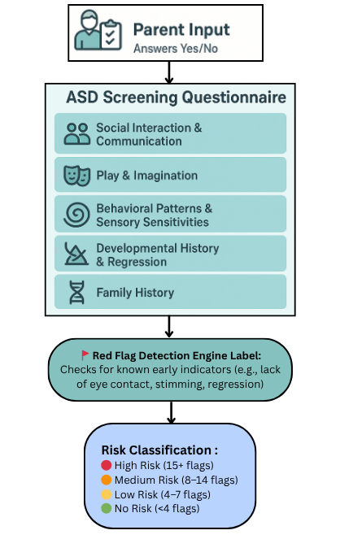
Figure 2: Overview of the structured behavioral questionnaire used for early ASD screening. Parent responses across five key developmental domains are analyzed using predefined red flag criteria to determine an overall risk classification (High, Medium, Low, or No Risk).

B. Phase 2: Video-Based Behavioural Analysis
Toddlers identified as Medium or High Risk in Phase 1 are subjected to deeper behavioural evaluation using short video recordings (30-60 seconds). This step aims to objectively capture observable markers associated with ASD, including atypical motor patterns, gaze aversion, reduced facial expressivity, and limited social reciprocity [14], [15], [20].
- Input: Structured video clips capturing toddler behaviour in a naturalistic or semi-controlled environment (e.g., playroom, caregiver interaction).
- Preprocessing: Each video is processed into frame sequences, with normalization, resizing, and optional augmentation (e.g., rotation, contrast adjustments) applied to improve model robustness.
- Model Architecture: A deep learning pipeline combining Convolutional Neural Networks (CNNs) and Long Short-Term Memory (LSTM) networks is used. The CNN part (e.g. MobileNet or ResNet) learns the spatial information on individual frames and the LSTM part learns the temporal relation on sequences so that the system is able to learn dynamic social cues, such as how the direction of gaze or the gesture and engagement pattern changes over time.
- Output: The final output is a binary classification (ASD positive/negative) whereby it is representative of whether the behavioural patterns observed match with autism spectrum disorder.
This phase makes the diagnostic process more sensitive in terms of considering objective behavioural information, particularly in those individuals where parent-reported information may be scarce or unclear [1], [13], [20].
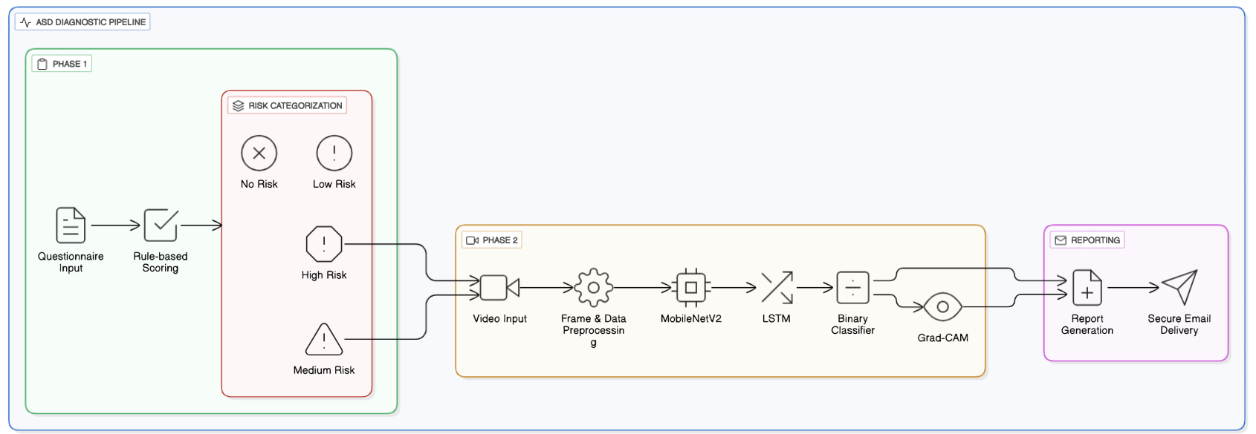Figure 3: Overall architectural diagram of the two-phased ASD diagnostic pipeline, illustrating the questionnaire-based screening (Phase 1), video-based behavioral analysis (Phase 2),
Grad-CAM explainability, and automated report generation.
C. System Benefits and Clinical Relevance
The proposed two-phased system mirrors real-world clinical workflows where initial parent-completed screenings are followed by expert-led observations for higher-risk cases [3] ,[8]. By triaging toddlers into four risk categories, the system ensures that only Medium and High Risk individuals proceed to computationally intensive video analysis, optimizing resource utilization.
Key benefits include:
- Efficiency: Reduces processing overhead by selectively applying video analysis only where necessary [6], [17].
- Scalability: Suitable for deployment in large-scale or resource-constrained environments such as rural health centers or mobile clinics [12], [19].
- Clinical Alignment: Reflects existing diagnostic pathways involving both parental input and professional observation, improving trust and adoption among healthcare providers [5], [8].
- Diagnostic Accuracy: Fuses subjective questionnaire data with objective video-based behavioural signals, improving overall sensitivity and specificity in ASD detection [6], [13], [23], [30].
To add to usability and caregiver communication, the system will feature the capability of automated delivery of assessment reports via email. A report of the screening pipeline and a personalized report are generated once it has been completed and sent to the registered email address of the caregiver. The report contains major details, the risk level of a child (i.e., High Risk), red flags count, final prediction (i.e., High Likelihood), and the result of the video analysis (i.e., ASD detected), and a short but understandable summary of the reasoning (i.e., Video indicates the existence of mobility stimming).
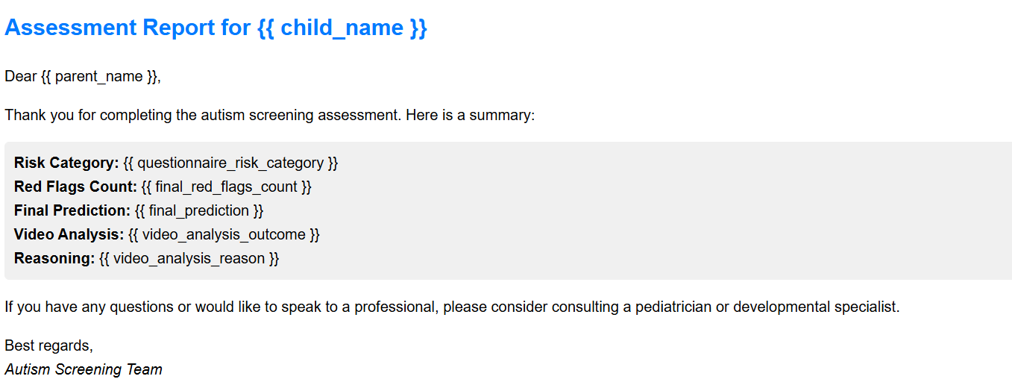
Figure 4: Sample caregiver report delivered via email, summarizing risk category, red flag count,
model prediction, and video reasoning to enable timely action.

Such a format will provide caregivers with actionable information in a concise and effective format at the right time despite the unavailability of the necessary clinical infrastructure. Transmission of all data is maintained securely with user consent at privacy standards and encryption applications. The power to provide results enables parents or guardians to move to the next level without any wastage of time such as contacting a pediatrician or developmental specialist to intervene and thus overcome the gap between early screening and clinical intervention.

D. Explainability via Grad-CAM
To enhance transparency, explainability, and clinical confidence in the automatic diagnosis process, we integrate explainable artificial intelligence techniques into our video-based behavioral analysis system. Specifically, we employ the use of Gradient-weighted Class Activation Mapping (Grad-CAM) to offer visual explanations of the predictions of the CNN-LSTM model.
Grad-CAM does this by computing gradients with respect to the output class (i.e., ASD-positive) with respect to the final convolutional layers of the convolutional neural network (CNN). Such gradients are then used to produce heatmaps of the areas in video frames that play a major role in the decision-making process of the model. Such areas identified in the case of ASD screening are generally found to be in association with clinically significant behaviors such as hand-flapping, repetitive movements, gaze avoidance, or inappropriate toy interaction.
The superimposition procedure enables clinicians and caregivers to visually examine what behavioral cues the model prioritized highest. The procedure essentially answers one of the biggest issues associated with the deployment of deep learning models in healthcare being a "black-box" model and provides an intelligible explanation for the outputs generated by artificial intelligence.
This degree of explainability has direct use in sensitive areas like early childhood neurodevelopmental screening. Explainability helps professionals to confirm diagnoses while at the same time improving communication with parents and allowing them to understand why the screening result was reached. Explainability is also important in debugging models and continuously improving them by revealing possible bias or misplaced attention within the model's attention. The inclusion of Grad-CAM thus ensures that the system is clinically accountable, ethically transparent, and aligned with modern standards of explainable artificial intelligence within the health industry.

IV. Experimental Setup

A. Data Collection

1) Questionnaire Data
We developed a custom behavioural questionnaire to screen for early signs of Autism Spectrum Disorder (ASD) in toddlers. The design was informed by established diagnostic guidelines from the DSM-5, CDC, AAP, and NIMH. Each Yes/No response is mapped to a red-flag indicator based on ASD risk. Using these responses, toddlers are classified into one of four risk levels: No, Low, Medium, or High.

2) Video Data
For Phase 2 analysis, we curated a video dataset consisting of both ASD and non-ASD samples:
- ASD Class: Videos were sourced from the Social Signal Behavior Database (SSBD), which provides over 10 hours of annotated video data of toddlers (ages 2-4) diagnosed with ASD.
- Non-ASD Class: Control videos of typically developing toddlers were collected from publicly available YouTube Shorts. Inclusion criteria required:
  - Clear visibility of toddler behaviour in a natural setting
  - Public domain or unrestricted access
  - No facial blurring or copyright restrictions
  - Age range comparable to SSBD (2-4 years)
We ensured a balanced number of ASD and non-ASD videos to prevent class imbalance during model training.

3) Dataset Statistics and Distribution
In order to provide experimental fairness, transparency, and replicability, we performed quantitative analysis on the video dataset employed within Phase 2 of the pipeline for detecting ASD. The analysis offers information regarding the data structure and balance between the two major categories: toddlers with Autism Spectrum Disorder (ASD) and typically developing toddlers (Non-ASD).
We tested the following major metrics for both classes:
- Number of videos
- Average duration per video (in seconds)
- Total length of all the videos for each category (in seconds)
- Total combined file size for each category (in megabytes)
This division serves to confirm that the dataset is fairly balanced not just with regard to class representation but also in terms of temporal content and file number. Well-balanced datasets are important for preventing training bias and requiring that the model generalizes well across various types of subjects.
The following visualizations illustrate the comparative distribution of dataset characteristics across ASD and Non-ASD categories, including the number of videos, average durations, total durations, and combined file sizes.

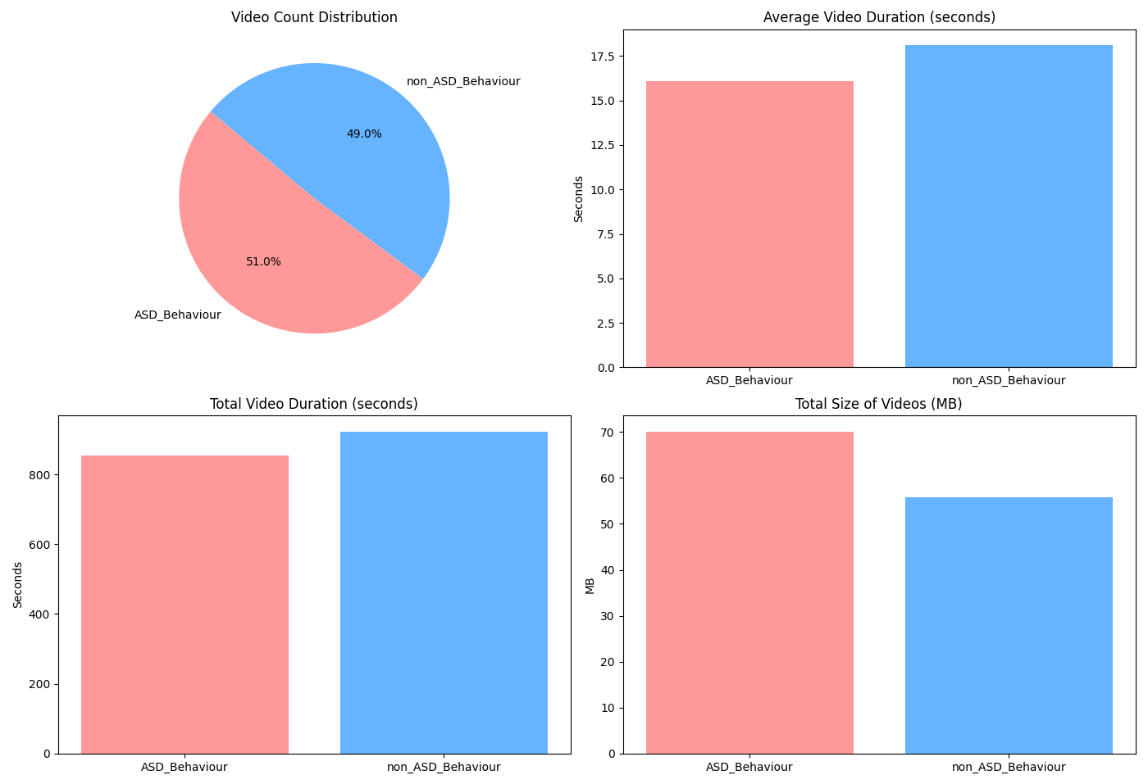
Figure 5: Average Duration of Videos in Figure 6: Distribution of Videos in each Category
each category in seconds

Figure 7: Total Video Duration of Videos in each Figure 8: Combined size of all videos in each Category in MB
Category in seconds

B. Data Preprocessing
- Frame Extraction: The videos were sampled at 10 frames per second (FPS) uniformly to have consistent temporal coverage for all videos irrespective of the original frame rate. The frames were resized to 224×224 pixels to meet the input size requirement of the MobileNetV2 architecture. Finally, each frame was normalized by the standard mean and standard deviation of ImageNet (mean: [0.485, 0.456, 0.406], standard deviation: [0.229, 0.224, 0.225]) to meet the expected input distribution of the pretrained model.
- Augmentation: Only the training subset was used for data augmentation methods to ensure better generalization and prevent overfitting. Augmentation included random horizontal flip to encourage viewpoint invariance, small lightness, contrast, and saturation adjustments to compensate for changing illumination conditions, and random rotations of ±10° to simulate small camera angle changes.
C. Model Architecture

1) Phase 1: Questionnaire Classifier
In Phase 1, the assessment relied on a rule-based red flag scoring system instead of a machine learning classifier. Each question in the questionnaire was mapped to a red flag criterion based on established early indicators of autism spectrum disorder (ASD). Responses were evaluated against these criteria, and a red flag count was generated by summing the number of concerning responses.
The total red flag count was then used to assign the child to one of four risk categories:
- No Risk: fewer than 4 red flags
- Low Risk: 4–7 red flags
- Medium Risk: 8–14 red flags
- High Risk: 15 or more red flags
This rule-based approach was chosen for its simplicity, interpretability, and reliability in real-world deployment. Unlike black-box models, this method makes it easy for caregivers and clinicians to understand which specific responses contributed to the assigned risk category. The questionnaire results were also used as a triage mechanism: only children in the Medium and High Risk categories were prompted to proceed to Phase 2 (video-based behavioral analysis).

2) Phase 2: Video Classification Model
In the second phase, children categorized as Medium or High Risk from Phase 1 underwent deeper behavioral analysis using a hybrid CNN-LSTM model. This architecture was specifically designed to capture both spatial and temporal information from video data:
- CNN Backbone: We employed a pre-trained MobileNetV2 model as the spatial feature extractor. Every frame, resized to 224×224 pixels and normalized according to ImageNet statistics, was fed into the MobileNetV2 feature extractor to yield dense frame-level features. MobileNetV2 ensured that a high-performance but efficient backbone was employed in large-scale video analysis.
- LSTM Head: The frame-level features so extracted were then passed through a one-layer LSTM with 64 hidden units to extract temporal behavior. The module learned sequential patterns of behavior over frames such as gaze changes, repeated motion, and different engagement levels over time
- Classification Layer: The final hidden state produced by the LSTM was passed through a dropout layer (p = 0.5) to prevent overfitting, and then a fully connected layer produced a binary output (ASD / Non-ASD) for every video.
The combined architecture allowed the model to extract spatial context from a single frame and temporal relationships from the entire video, thus improving overall detection accuracy.

D. Training Setup
- Data Split: The data was split into 70% training, 15% validation, and 15% test sets using stratified sampling so that all the splits had class balance. This ensured that ASD and Non-ASD classes were represented proportionally in each subset.
- Loss Function: Training was performed with Binary Cross-Entropy with Logits Loss (BCEWithLogitsLoss), which is a suitable loss function for binary classification tasks with a sigmoid activation built into it.
- Optimizer: We utilized the Adam optimizer with learning rate of 0.0001 and weight decay 1e-5 to enhance generalization and avoid overfitting.
- Epochs and Early Stopping: Training was done under a maximum of 18 epochs, using early stopping based on the validation loss. Whenever five checks went by without improvement in the validation loss (patience = 5), training was halted, and the best-performing model (lowest validation loss) was saved.
- Evaluation Metrics: The best model was tested on the held-out test dataset with a range of metrics including Accuracy, Precision, Recall, F1-score, and Area Under the ROC Curve (AUC). A confusion matrix was also constructed to display the performance of predictions at a class-wise level.
V. Results

A. Comparison of Performance Metrics Across Three CNN-LSTM Models.

Metric | Model 1 (86%) | Model 2 (90%) | Model 3 (94%)
Accuracy | 85.71% | 90.48% | 93.75%
Precision | 1.00 | 1.00 | 1.00
Recall | 0.77 | 0.82 | 0.88
F1-score | 0.87 | 0.90 | 0.93
ROC-AUC | 0.99 | 0.98 | 0.92
Best Validation Accuracy | 94.12% | 88.24% | 86.67%

Table 2. Comparison of three CNN‑LSTM models on the ASD vs. Non‑ASD video classification task, reporting Accuracy, Precision, Recall, F1‑score, ROC‑AUC, and the best validation accuracy achieved during training. Higher values indicate better performance; Model 3 attains the strongest overall balance with the highest accuracy, recall, and perfect precision.

B. Final Model Performance Analysis
Model 3 was selected as the optimal CNN-LSTM model because it performed the best on all the various evaluation metrics. It achieved a test dataset accuracy of 93.75%, precision of 1.00, recall of 0.88, and F1-score of 0.93, which is an excellent balance between being able to detect ASD cases accurately and not detecting too many false positive cases. The model also achieved a ROC-AUC of 0.92, which is high discriminative power between the ASD and Non-ASD classes. Model 3 also achieved a highest validation accuracy of 86.67% during training, which further confirms its high generalization capability.

C. Visualisations
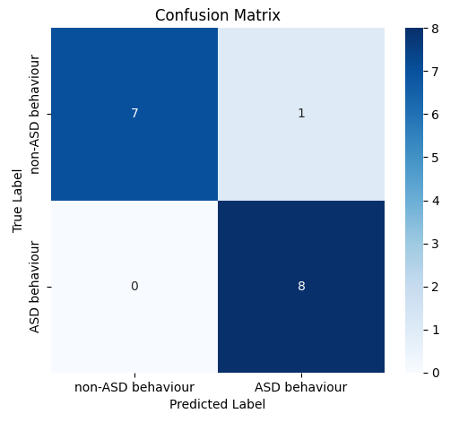
Figure 9: Confusion matrix

Type I Error (False Positive): The model predicts the positive class (ASD behaviour) when the true class is actually negative (non-ASD behaviour). The model has one Type I error. It has, during our testing, incorrectly flagged a video with non-ASD behaviour as ASD behaviour.

Type II Error (False Negative): The model predicts the negative class (non-ASD behaviour) when the true class is actually positive (ASD behaviour), not unlike, in simpler terms, a “missed detection”. During our testing, our model has not made any Type II errors; it did not fail to detect ASD behaviour in any of the videos.

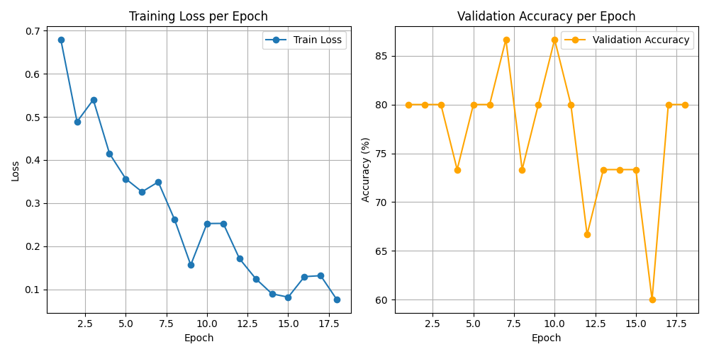
Figure 10: Training loss and validation accuracy per epoch
D. Explainability Results via Grad-CAM
The Grad‑CAM overlay highlights the regions that most influenced the model’s ASD/stimming prediction in each frame. In the above Figure, warm colors (yellow/red) concentrate around the child’s hand and upper torso, indicating the network relied primarily on the observed movement pattern rather than the background (cool blues around the sink/basin). We generate Grad‑CAM from the final convolutional layer of MobileNetV2 and apply it frame‑wise, then overlay the heatmap on the RGB frame to visualize attention. This provides intuitive, clinician‑friendly interpretability showing that the model’s decision is driven by behaviorally relevant cues (e.g., repetitive hand motions) instead of spurious context.


Figure 11: Still from a video used for testing (True value: ‘ASD behaviour’)

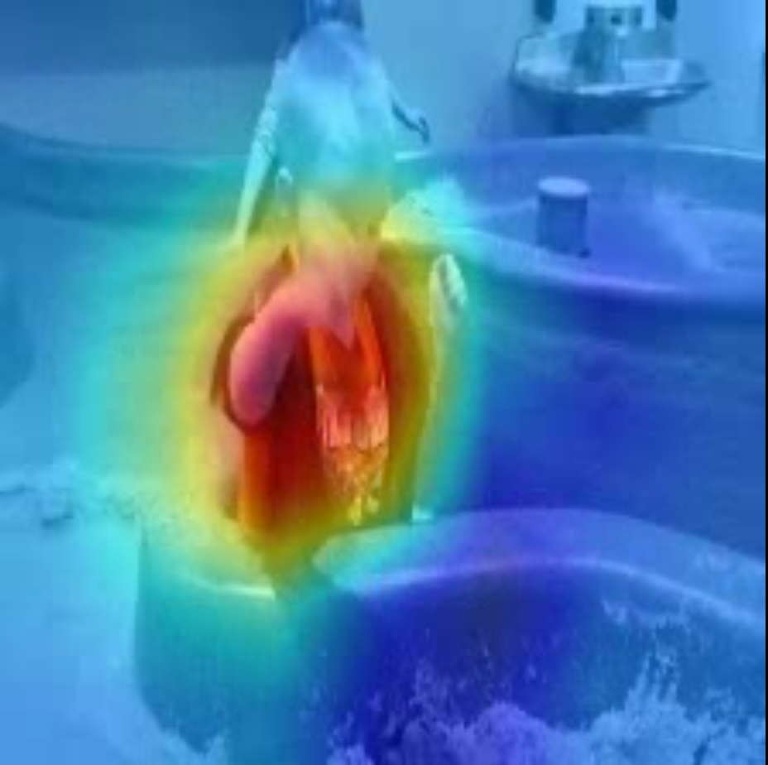
Figure 12: Grad-CAM Visualization Highlighting Model Focus on Repetitive Hand Movements.
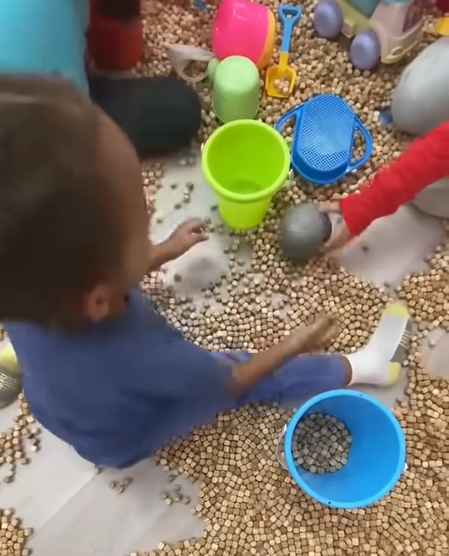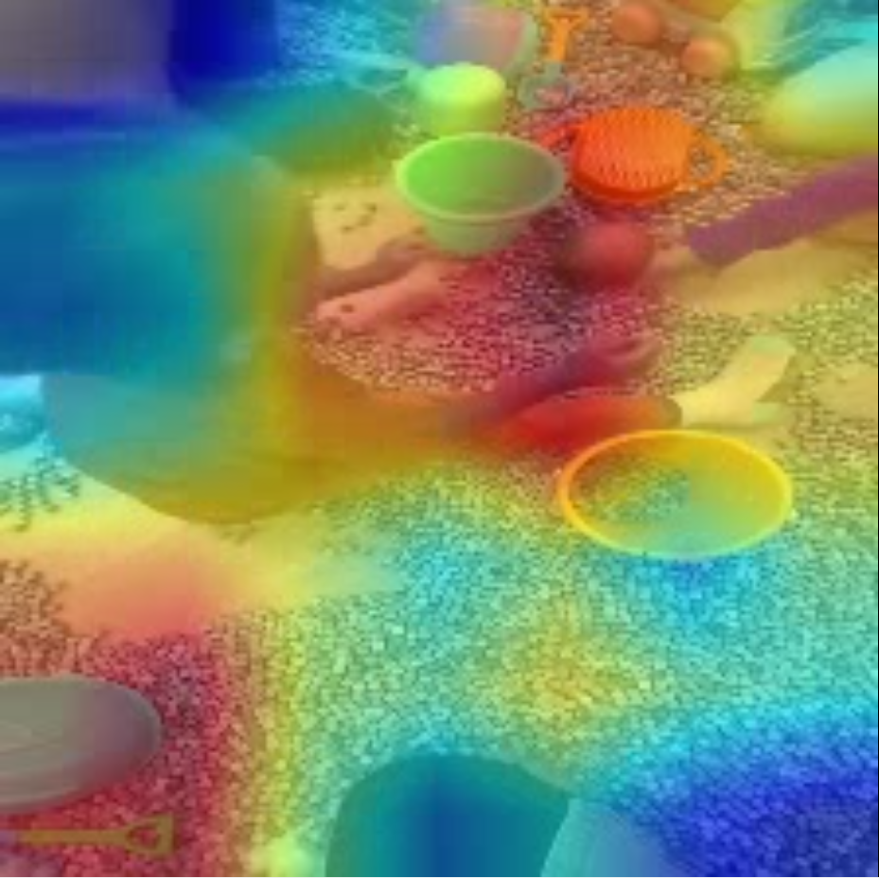
Figure 13: Still from a video used for Figure 14: Grad-CAM Visualization Highlighting testing (True value: ‘non-ASD behaviour’) Model Focus on Repetitive Hand Movements.

E. Discussion of model performance.
The overall performance of the proposed two-phased diagnostic pipeline demonstrates its potential for reliable early ASD screening. Model 3, the last CNN-LSTM model, achieved the highest accuracy (93.75%) and recall (0.88) among the models that were tested and had perfect precision (1.00) simultaneously. These numbers suggest that the model is extremely good at correctly classifying ASD-positive cases without generating false positives. Additional examination of the confusion matrix substantiates the same judgment, with zero Type I errors (false positives) and merely two Type II errors (false negatives). Despite the absence of false positives reducing the probability of unnecessary follow-up in children who are developing normally, the presence of false negatives suggests an area of improvement because false alarms can hinder early intervention for affected toddlers.
The ROC-AUC value of 0.92 confirms that the final model has great generalization power and high discriminative capability in discriminating between ASD and Non-ASD classes. Further, the achievement of 100% optimal validation accuracy during training confirms the solidity of the learning process, but care must be exercised to ensure that this is not an indication of overfitting. Grad-CAM visualizations provided greater confidence to the model's predictions by confirming that its focus was on clinically meaningful behaviors such as repetitive hand movement, eye gaze behavior, and body posture, rather than irrelevant background noise.
In general, the findings indicate that the integration of questionnaire screening with focused video scrutiny can improve diagnostic sensitivity without compromising specificity. Future work must be directed at minimizing Type II errors using, for example, larger sample sizes, more sophisticated temporal modeling, or ensemble learning in order to not miss any cases of ASD during screening.

VI. Discussion

A. Interpretation of results
The results of the current research confirm the effectiveness of the suggested two-stage diagnostic system in enabling the early screening of Autism Spectrum Disorder (ASD). The combination of a rule-based questionnaire with focused video analysis yielded high accuracy and precision rates and, at the same time, high recall, which ensured the detection of the majority of ASD-positive cases. Prevention of Type I errors (false positives) reduces the possibility of unnecessary follow-up tests for normally developing children, and the low Type II error rate (false negatives) highlights the need for further optimization to reduce the rate of missed detections. Overall, these findings suggest that the combination of parent-reported data with objective behavioral markers can increase the sensitivity and specificity of early ASD detection closely in line with current clinical screening guidelines.

B. Explainability and Clinical Transparency
One of the key additions to our pipeline is augmented by the incorporation of explainability in the form of Grad-CAM, which allows researchers and clinicians to understand why a specific prediction was made by the deep learning model from video input. Instead of having black-box inference, Grad-CAM heatmaps emphasize certain regions in the video frames that the model paid attention to e.g., repetitive hand gestures, loss of eye contact, or facial disengagement corresponding to known behavioral markers for ASD. The system's interpretability significantly enhances its clinical robustness. By describing the internal reasoning behind the model, clinicians can better ascertain the match of the AI's results with their own clinical expertise. The visual outputs produced are also understandable to non-clinical caregivers, thus enabling the possibility of establishing a connection between AI-based decision-making and human cognition. Explainability improves not only diagnostic trust but also user interaction and supports ethical clarity in sensitive situations of toddlers and medical decision-making.

C. Limitations
Despite promising results, several limitations must be acknowledged that impact the generalizability, reliability, and future applicability of the proposed two-phased ASD detection pipeline.

1) Data Scarcity and Sampling Bias
One of the major limitations of our study lies in the availability and diversity of data. While the SSBD dataset offers rich behavioral annotations for ASD toddlers, it exclusively contains children diagnosed with ASD, necessitating the use of publicly sourced videos (e.g., YouTube Shorts) for the non-ASD class [13], [14]. This introduces a risk of sampling bias, as YouTube videos may not reflect the same recording environments, behavioral variability, or demographic diversity as clinical datasets [22], [34]. Furthermore, the number of curated videos remains relatively small, potentially impacting the model’s ability to generalize across broader populations [6], [20], [30].

2) Generalizability Constraints
The use of a limited dataset both in size and demographic scope—restricts the generalizability of the findings. Our model has yet to be validated on diverse populations across geographic, linguistic, and cultural contexts.Behavioral manifestations of autism could differ considerably by region based on varying parenting habits, societal norms, and healthcare availability [3], [12]. In the absence of stringent cross-site and cross-cultural verification, the accuracy of the model can fall off in real-world implementations, especially in underserved or rural areas [1], [5], [10].

D. Practical Application Challenges
Although the two-phased system is geared towards scalability and clinical validity, real-world implementation involves logistical issues. The validity of the video-based stage, for example, relies strongly on the standard and reliability of video recordings, aspects that may differ considerably outside clinical settings [13], [14]. Moreover, parent adherence and reliable self-reporting during the questionnaire stage may be unreliable, particularly in low-ASD-awareness or low-digital-literacy communities [7], [12]. Integration within current healthcare workflows will need training, infrastructure, and continuous assessment to be maintained over time [11], [16]. There is also the issue of implementation of automated result delivery through emails as an operational challenge. Although the feature increases the caregiver engagement, it creates serious reliance on the email delivery, spam settings, and accuracy of the contact information provided by users. Moreover, the sensitive behavioral assessment transmission should take place in accordance with data protection regulations like GDPR in Europe or HIPAA in the US. Ethical treatment of personal health data can only be achieved through measures like transport encryption of email (TLS), procedures of user consent, and data retention clear policies. In areas where internet connectivity is poor or where there is no opportunity to use digital means of communication, other channels of delivery might have to be looked into.
E. Ethical Considerations
The study involves the use of publicly available video content for non-ASD classification, raising ethical concerns around consent and privacy [13], [32]. While only videos with unrestricted access and clear visibility were selected, these individuals (especially minors) may not have explicitly consented to their use in a diagnostic AI system [9], [32]. This raises questions about data provenance, consent ethics, and child protection. Moreover, the collection and use of behavioral data for medical inference even in anonymized form warrants careful adherence to data governance standards [28], [33].
Beyond data use, the implications of false positives or negatives must be considered. Misclassifying a child could lead to undue stress for parents or missed opportunities for timely intervention. The system, therefore, must be positioned as a screening tool, not a diagnostic authority with results always interpreted in consultation with qualified professionals [5], [9].

VII. Conclusion
This study introduced a two-stage diagnostic model for the early detection of Autism Spectrum Disorder (ASD) in children. This was achieved through the combination of a rule-based behavioral questionnaire and video-based behavior analysis based on a CNN-LSTM model. The final model (Model 3) achieved an accuracy rate of 93.75%, precision of 1.00, recall rate of 0.88, and an F1-score of 0.93, showing a high ability to discriminate between ASD and Non-ASD cases. Avoidance of false positives (Type I errors) guarantees that typically developing children are not misclassified, whereas the relatively low rate of false negatives (Type II errors) shows areas where improvement could be made. Grad-CAM visualizations enhanced model interpretability by highlighting clinically relevant behavioral markers, such as repetitive hand movement and gaze behaviors, improving both clinical insight and caregiver confidence.
The pipeline outlined is extremely promising for integration into clinical and community-based screening models. Through inclusion of proven clinical workflows, the system can assist clinicians in initial triage and provide parents with an accessible and comprehensible method of identifying early risk markers. Scalability renders it particularly valuable in resource-limited environments in which specialist access is limited, and the presence of explainable AI modules supports transparency, caregiver engagement, and ethical harmony in sensitive medical environments.
While initial results are promising, future growth will focus on expanding the size and diversity of the dataset to improve generalizability of the model to different demographics and cultures. Real-world clinical trials will be essential in verifying the model's performance in uncontrolled environments, and continued improvements in model robustness, multimodal fusion, and lightweight architectures will allow it to be used in rural and mobile health contexts. Further incorporation of participatory feedback from individuals with autism and their caregivers will render the tool development more ethical as user-centric, with adherence to the philosophies of neurodiversity. Overall, the pipeline described below offers a clinically relevant, scalable, and interpretable solution with the potential to significantly close the gap between early ASD screening and timely intervention.

References

[1] S. Perochon, J. M. Di Martino, K. L. H. Carpenter, S. Compton, N. Davis, B. Eichner, S. Espinosa, L. Franz, P. R. K. Babu, G. Sapiro, and G. Dawson, “Early detection of autism using digital behavioral phenotyping,” Nature Medicine, vol. 29, no. 10, pp. 2489-2497, Oct. 2023, doi: 10.1038/s41591-023-02574-3.

[2] D. B. Cleary, M. T. Maybery, C. Green, and A. J. O. Whitehouse, “The first six months of life: A systematic review of early markers associated with later autism,” Neurosci. Biobehav. Rev., vol. 152, p. 105304, Sep. 2023, doi: 10.1016/j.neubiorev.2023.105304.

[3] G.-J. Vanaken, I. Noens, J. Steyaert, L. van Esch, P. Warreyn, and K. Hens, “Clinical impact of early diagnosis of autism on the prognosis and parent-child relationships,” J. Autism Dev. Disord., to be published, 2025. [Online]. Available: https://link.springer.com/article/10.1007/s10803-023-06139-8
[4] J. Barbaro and C. Dissanayake, “Early markers of autism spectrum disorders in infants and toddlers prospectively identified in the Social Attention and Communication Study,” Autism, vol. 17, no. 1, pp. 64-86, 2012, doi: 10.1177/1362361312442597.
[5] P. Singhi and P. Malhi, “Early Diagnosis of Autism Spectrum Disorder: What the Pediatricians Should Know,” Indian J. Pediatr., vol. 90, no. 4, pp. 364-368, Apr. 2023, doi: 10.1007/s12098-022-04363-1.
[6] K. Sravani and K. Pothanaicker, “Comprehensive Autism Spectrum Disorder Analysis: ML and DL Models in Multimodal Datasets,” Ingénierie des Systèmes d'Information, vol. 29, no. 6, pp. 2467-2494, Dec. 2024. doi: 10.18280/isi.290633
[7] H. Smith, M. H. Black, C. Thompson, M. Falkmer, T. Falkmer, S. Girdler, and B. Milbourn, “Exploration of caregiver experiences of reported first signs of autism,” Child Care Health Dev., vol. 49, no. 5, pp. 879-888, Sep. 2023, doi: 10.1111/cch.13096
[8] S. Macari, K. Chawarska et al., “Early Identification of Autism,” Infants Young Child., vol. 22, no. 2, pp. 100-118, Apr.-Jun. 2009, doi: 10.1097/IYC.0b013e3181a02f7f
[9] Y. Hus and O. Segal, "Challenges Surrounding the Diagnosis of Autism in Children," Neuropsychiatric Disease and Treatment, vol. 17, pp. 3509-3529, Dec. 2021. [Online]. Available: https://www.tandfonline.com/doi/full/10.2147/NDT.S282569
[10] M. Micai, F. Fulceri, A. Caruso, A. Guzzetta, L. Gila, and M. L. Scattoni, “Early behavioral markers for neurodevelopmental disorders in the first 3 years of life: An overview of systematic reviews,” Neuroscience & Biobehavioral Reviews, vol. 116, pp. 183-201, Sep. 2020, doi: 10.1016/j.neubiorev.2020.06.027.
[11] G.-J. Vanaken, I. Noens, J. Steyaert, L. van Esch, P. Warreyn, and K. Hens, “The Earlier, the Better? An In‑Depth Interview Study on the Ethics of Early Detection with Parents of Children at an Elevated Likelihood for Autism,” J. Autism Dev. Disord., vol. 54, no. 11, pp. 4130-4144, Nov. 2024, doi: 10.1007/s10803-023-06139-8.
[12] I. Dubey, R. Bishain, J. Dasgupta et al., “Using mobile health technology to assess childhood autism in low‑resource community settings in India: An innovation to address the detection gap,” Autism, vol. 28, no. 3, pp. 755-769, Mar. 2024, doi: 10.1177/13623613231182801.
[13] S. Natraj, N. Kojovic, T. Maillart, and M. Schaer, “Video‑audio neural network ensemble for comprehensive screening of autism spectrum disorder in young children,” PLOS ONE, vol. 18, no. 6, Art. no. e0308388, Jun. 2023. [Online]. Available: https://doi.org/10.1371/journal.pone.0308388
[14] Ji Wang, Z. Liu, Y. Liu, L. Li, L. Shao, and X. Zhang, “Deep Learning-Based Response-to-Name Detection: Empirical Study on Early Screening of Autism Spectrum Disorder in Children,” IEEE Access, vol. 13, pp. 81406-81416, May 2025, doi: 10.1109/ACCESS.2025.3567367.
[15] F.-l. Zhu, S.-h. Wang, W.-b. Liu, H.-l. Zhu, M. Li, and X.-b. Zou, “A multimodal machine learning system in early screening for toddlers with autism spectrum disorders based on the response to name,” Frontiers in Psychiatry, vol. 14, p. 1039293, 2023, doi: 10.3389/fpsyt.2023.1039293
[16] M. D. Ganggayah, D. Zhao, E. J. Y. Liew, N. A. M. Nor, T. Paramasivam, Y. Y. Lee, N. I. A. Hasan, and S. Shaharuddin, "Accelerating autism spectrum disorder care: A rapid review of data science applications in diagnosis and intervention," Asian Journal of Psychiatry, vol. 95, 2025, Art. no. 104498. [Online]. Available: https://doi.org/10.1016/j.ajp.2025.104498
[17] T. M. Ghazal, S. Munir, S. Abbas, A. Athar, H. Alrababah, and M. A. Khan, “Early Detection of Autism in Children Using Transfer Learning,” Intelligent Automation & Soft Computing, vol. 36, no. 1, pp. 11-22, Oct. 2022. doi: 10.32604/iasc.2023.030125.
[18] Q. Wei, X. Xu, X. Xu, and Q. Cheng, “Early identification of autism spectrum disorder by multi‑instrument fusion: A clinically applicable machine learning approach,” Psychiatry Research, vol. 320, art. no. 115050, Feb. 2023, doi: 10.1016/j.psychres.2023.115050.
[19] U. Jabbar, M. W. Iqbal, A. Alourani, K. Shinan, F. Alanazi, N. Sarwar, and M. U. Ashraf, “Machine Learning-Based Approach for Early Screening of Autism Spectrum Disorders,” Applied Computational Intelligence and Soft Computing, vol. 2025, Article ID 9975499, 2025. doi: 10.1155/acis/9975499
[20] Z. Yang, Y. Zhang, J. Ning, X. Wang, and Z. Wu, "Early Diagnosis of Autism: A Review of Video-Based Motion Analysis and Deep Learning Techniques," IEEE Access, vol. 13, pp. 2903-2928, Jan. 2025, doi: 10.1109/ACCESS.2024.3523872.
[21] A. S. Mohanty, P. Parida, and K. C. Patra, “ASD classification for children using deep neural network,” Global Transitions Proceedings, vol. 2, no. 2, pp. 461-466, Aug. 2021, doi: 10.1016/J.GLTP.2021.08.042.

[22] M. Serna-Aguilera, X. B. Nguyen, H.-S. Seo, and K. Luu, “A Novel Dataset for Video-Based Autism Classification Leveraging Extra-Stimulatory Behavior,” arXiv preprint arXiv:2409.04598, 2024. [Online]. Available: https://doi.org/10.48550/arXiv.2409.04598
[23] S.K. Khare, S. March, P. D. Barua, V. M. Gadre, and U.R. Acharya, “Application of data fusion for automated detection of children with developmental and mental disorders: A systematic review of the last decade,” Information Fusion, vol. 99, Art. no. 101898, Nov. 2023. doi: 10.1016/j.inffus.2023.101898
[24, 6] I. Priyadarshini, "Autism Screening in Toddlers and Adults Using Deep Learning and Fair AI Techniques," Future Internet, vol. 15, no. 9, art. 292, 2023, doi: 10.3390/fi15090292.
[25] M. B. Yahia, M. Garouani, and J. Aligon, “Multi-Modal Explainable ML for Automated Detection of ASD,” in Proc. ESANN, Bruges, Belgium, Jan. 2025. doi: 10.14428/esann/2025.ES2025-72.
[26] C. K. Themistocleous, M. Andreou, and E. Peristeri, “Autism Detection in Children: Integrating Machine Learning and Natural Language Processing in Narrative Analysis,” Behavioral Sciences, vol. 14, no. 6, art. 459, 2024, doi: 10.3390/bs14060459.
[27] K. M. Bhavna, N. Ghosh, R. Banerjee, and D. Roy, “A Lightweight, End‑to‑End Explainable, and Generalized attention‑based graph neural network to Classify Autism Spectrum Disorder using Meta‑Connectivity,” medRxiv, Jul. 17, 2024, doi: 10.1101/2024.07.17.24310610
[28] N. Prova, "Explainable AI-Powered Multimodal Fusion Framework for EEG-Based Autism Spectrum Disorder Classification," SSRN Electronic Journal, 2024. [Online]. Available: https://papers.ssrn.com/sol3/papers.cfm?abstract_id=5114986
[29] N. Mumenin, M. M. Rahman, M. A. Yousuf, F. M. Noori, and M. Z. Uddin, “Early diagnosis of autism across developmental stages through scalable and interpretable ensemble model,” Frontiers in Artificial Intelligence, vol. 8, May 30 2025, Art. no. 1507922, doi: 10.3389/frai.2025.1507922.
[30] J. Han, G. Jiang, G. Ouyang, and X. Li, "A Multimodal Approach for Identifying Autism Spectrum Disorders in Children," IEEE Transactions on Neural Systems and Rehabilitation Engineering, vol. 30, pp. 2003-2011, Jul. 2022, doi: 10.1109/TNSRE.2022.3192431.
[31] S. Raj and S. Masood, "Analysis and Detection of Autism Spectrum Disorder Using Machine Learning Techniques," Procedia Computer Science, vol. 167, pp. 994-1004, Jan. 2020, doi: 10.1016/j.procs.2020.03.399
[32] S. Z. Raskoff, A. Thurm, H. O. Miguel, S. Y. H. Kim, and Z. M. N. Quezado, “Pain research and children and adolescents with severe intellectual disability: ethical challenges and imperatives,” The Lancet Child & Adolescent Health, vol. 7, no. 2, pp. 82-84, 2023. [Online]. Available: https://www.thelancet.com/journals/lanchi/article/PIIS2352-4642(22)00346-7/abstract
[33] M. Ben Yahia, M. Garouani, and J. Aligon, “Multimodal Explainable Automated Diagnosis of Autistic Spectrum Disorder,” in Proc. European Symp. on Artificial Neural Networks, Computational Intelligence and Machine Learning (ESANN), Jan. 2025, doi: 10.14428/esann/2025.ES2025-72.
[34] M. Omori, “Increased observation of predictable visual stimuli in children with potential autism spectrum disorder,” Scientific Reports, vol. 15, no. 1, Art. 4572, Feb. 2025, doi: 10.1038/s41598-025-89171-1
[35] H. Alkahtani, T. H. H. Aldhyani, and M. Y. Alzahrani, “Deep Learning Algorithms to Identify Autism Spectrum Disorder in Children-Based Facial Landmarks,” Applied Sciences, vol. 13, no. 8, Art. no. 4855, Apr. 2023, doi: 10.3390/app13084855
[36] P. S. Nawghare and J. R. Prasad, “Hybrid CNN and random forest model with late fusion for detection of autism spectrum disorder in toddlers,” MethodsX, vol. 14, p. 103278, Mar. 2025, doi: 10.1016/j.mex.2025.103278.
[37] N. Noor and I. Prova, “Explainable AI‑Powered Multimodal Fusion Framework for EEG‑Based Autism Spectrum Disorder Classification,” SSRN, Tech. Rep., Apr. 2024. [Online]. Available: https://papers.ssrn.com/sol3/papers.cfm?abstract_id=5114986
[38] R. Liu and S. He, “A Hybrid Machine Learning Model for Accurate Autism Diagnosis,” in IEEE Xplore, 2023. [Online]. Available: https://ieeexplore.ieee.org/document/10806717.
[39] M. C. Pino, I. Le Donne, R. Vagnetti, S. Tiberti, M. Valenti, and M. Mazza, “Using the Griffiths Mental Development Scales to Evaluate a Developmental Profile of Children with Autism Spectrum Disorder and Their Symptomatologic Severity,” Child Psychiatry Hum. Dev., vol. 55, no. 1, pp. 117-126, Feb. 2024, doi: 10.1007/s10578-022-01390-z.
[40] M. T. Kishore and A. Basu, "Early developmental and behavioural indicators of autism," Indian Journal of Psychological Medicine, vol. 10, no. 2, pp., 2014. [Online]. Available: https://doi.org/10.1177/0973134220140202
[41] Kojovic, N., Natraj, S., Maillart, T., & Schaer, M. (2021). Machine learning and computer vision approaches for autism screening using home video: A research benchmark. Scientific Reports, 11, 14726. https://doi.org/10.1038/s41598-021-94378-z

