ShuttleSync – Backend Testing Documentation
- User Registration
A.Topic: Register a new user
Purpose: Verify that a new user can create an account successfully.
API:
POST /api/auth/register
Request Body:
{
"username": "MockUser",
"email": "Mock@example.com",
"password": "password123"
}
Expected Result:
- Registration succeeds.
- User is stored in MySQL.
- Password is stored as a hashed password, not plain text.
Actual Result:
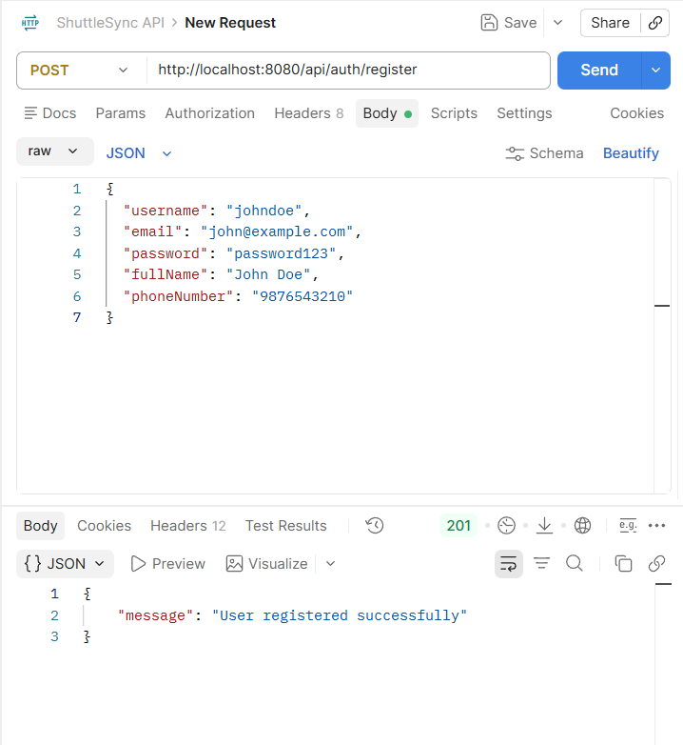

Result :SUCCESS

B. Topic: Register an already existing user
Purpose: Verify that a already user needs to login not re register (Preventing from Redundant Values) .
API:
POST /api/auth/register
Request Body:
{
"username": "MockUser",
"email": "Mock@example.com",
"password": "password123"
}
Expected Result:
- Fail Registration.

- Actual Result:
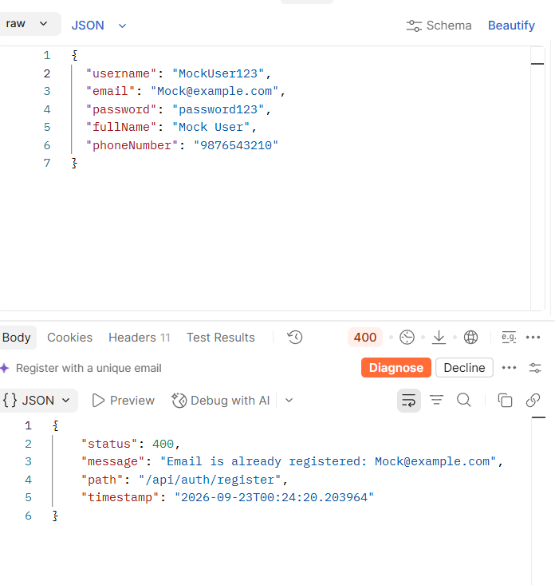
Result :SUCCESS
- User Login
Topic: Authenticate registered user
Purpose: Verify that a registered user can log in and receive a JWT token.
API:
POST /api/auth/login
Request Body:
{
"usernameOrEmail": "Mock@example.com",
"password": "password123"
}
Expected Result:
- Login succeeds.
- JWT token is returned.
- Token can be used for protected APIs
Actual Result:

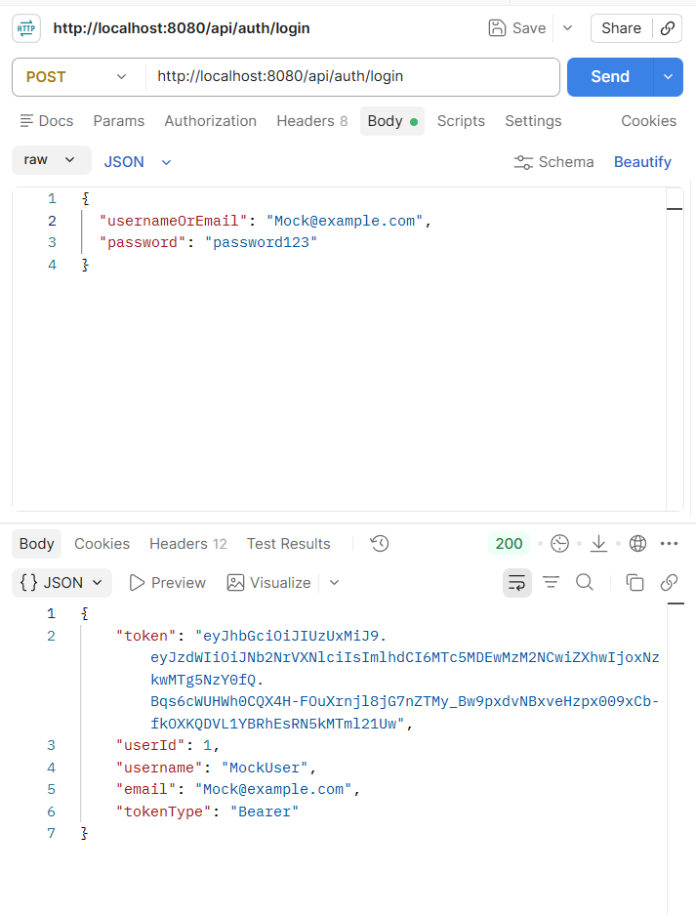
Status: SUCCESS

- Route Creation
You said you tested this before booking validation, so this should definitely be included.
Topic: Create route with ordered stops
Purpose: Verify that a route and its ordered stops can be created.
API:
POST /api/routes
Request Body:
{
"name": "Office Route 1",
"origin": "Office",
"destination": "City Center",
"distanceKm": 12.5,
"estimatedDurationMinutes": 45,
"stops": [
{
"name": "A",
"location": "Office",
"sequenceOrder": 1,
"arrivalTime": "10:00"
},
{
"name": "B",
"location": "Market",
"sequenceOrder": 2,
"arrivalTime": "10:15"
},
{
"name": "C",
"location": "Mall",
"sequenceOrder": 3,
"arrivalTime": "10:30"
},
{
"name": "D",
"location": "City Center",
"sequenceOrder": 4,
"arrivalTime": "10:45"
}
]
}
Expected Result:
- Route is created.
- Stops are associated with the route.
- Stops maintain their sequence order.
Actual Result:
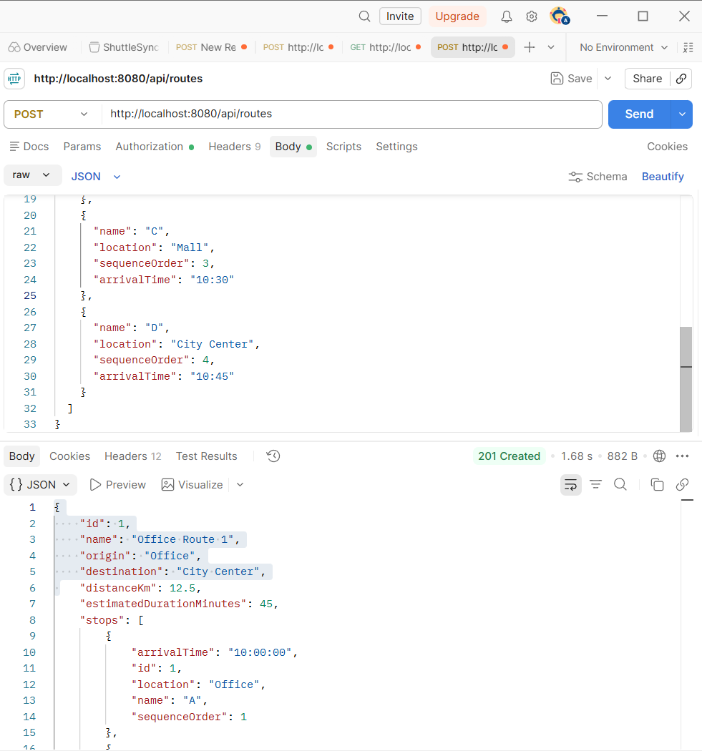

Status: SUCCESS

- Trip Creation
Topic: Create a trip from a route
Purpose: Verify that an actual trip can be created using an existing route and that seats are automatically created.
API:
POST /api/trips
Request Body:
{
"routeId": 1,
"departureTime": "2026-09-23T10:00:00",
"arrivalTime": "2026-09-23T10:45:00",
"totalSeats": 5
}
Expected Result:
- Trip is created.
- Status is SCHEDULED.
- 5 seats are created.
- Available seats initially equal 5.
Actual Result:
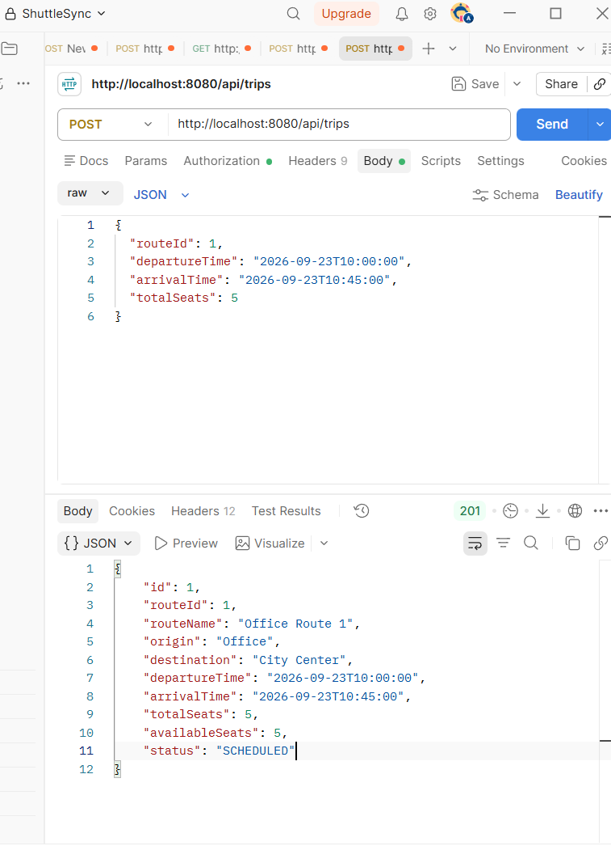
Result: PASS
- Booking Validation
This is where your booking-specific validation tests start.
5.1 Valid Segment Booking
Topic: Book a valid segment
{
"tripId": 1,
"pickupStopId": 1,
"dropoffStopId": 2
}
Expected: A → B Booking succeeds.
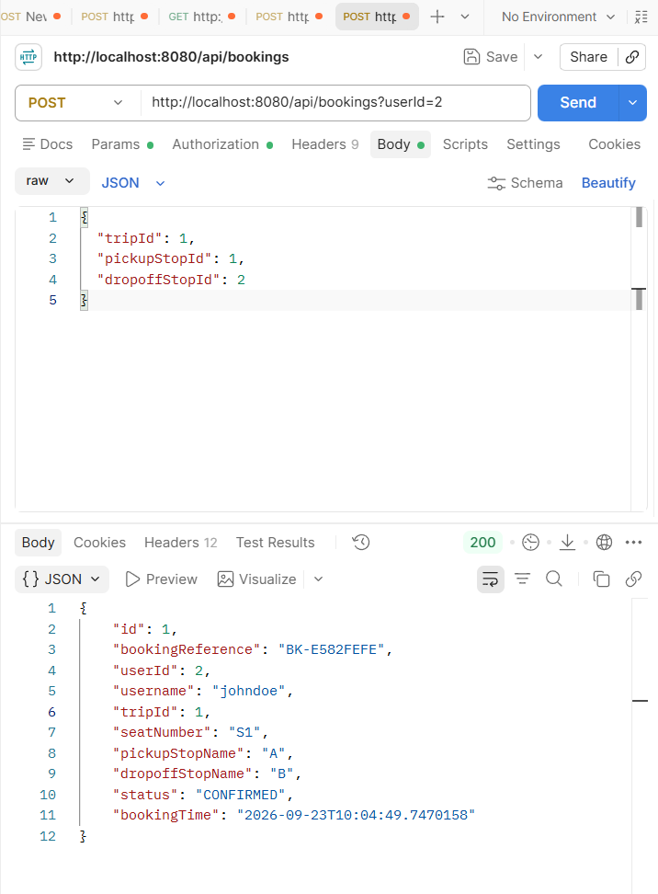
Result: SUCCESS.

5.2 Same Pickup and Dropoff
Topic: Reject zero-length segment
{
"tripId": 1,
"pickupStopId": 2,
"dropoffStopId": 2
}

Expected:B → B is rejected.
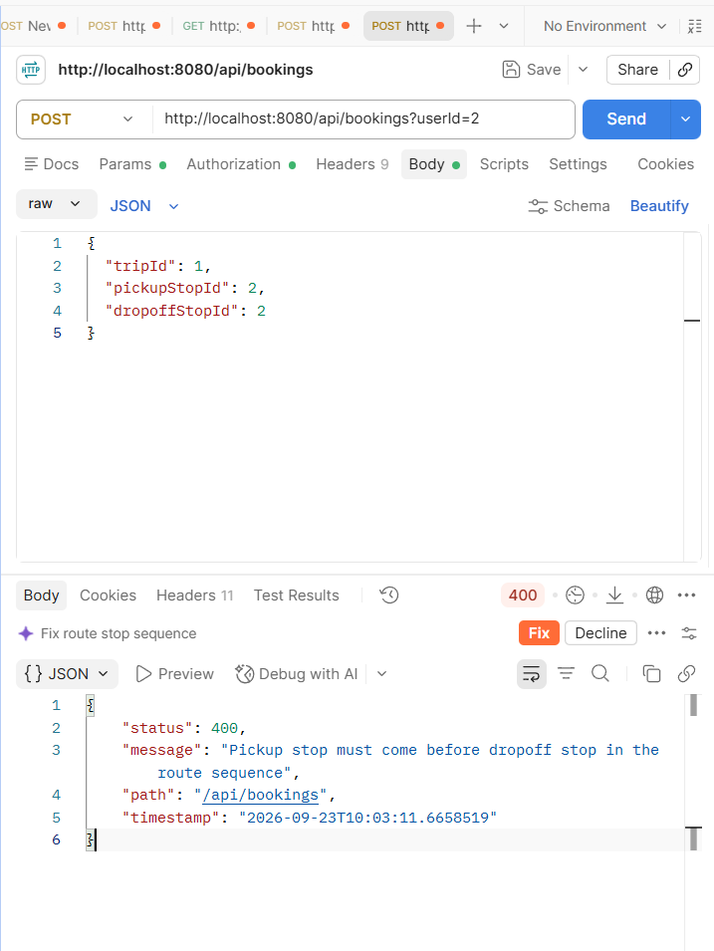
Result: SUCCESS

5.3 Pickup After Dropoff
Topic: Reject invalid stop order
{
"tripId": 1,
"pickupStopId": 3,
"dropoffStopId": 1
}
Expected: C → A is rejected
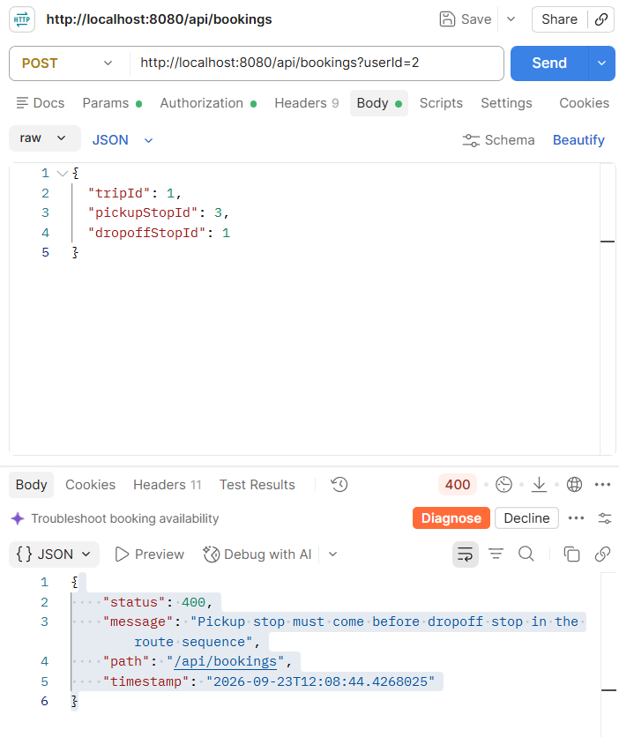.
Result: SUCCESS

5.4 Non-existent Stop
Topic: Validate Stop ID
{
"tripId": 1,
"pickupStopId": 999,
"dropoffStopId": 2
}
Expected: 404 Stop not found

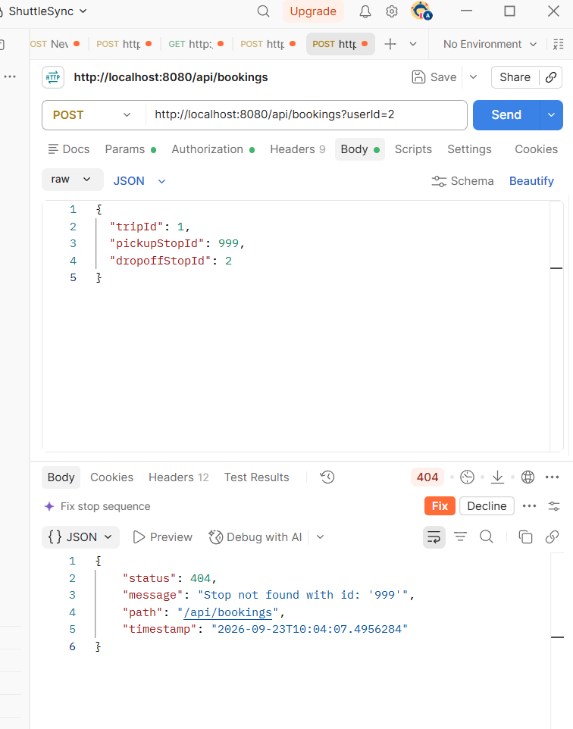
Result: SUCCESS

5.5 Non-existent Trip
Topic: Validate Trip ID
{
"tripId": 999,
"pickupStopId": 1,
"dropoffStopId": 2
}
Expected: 404 Trip not found

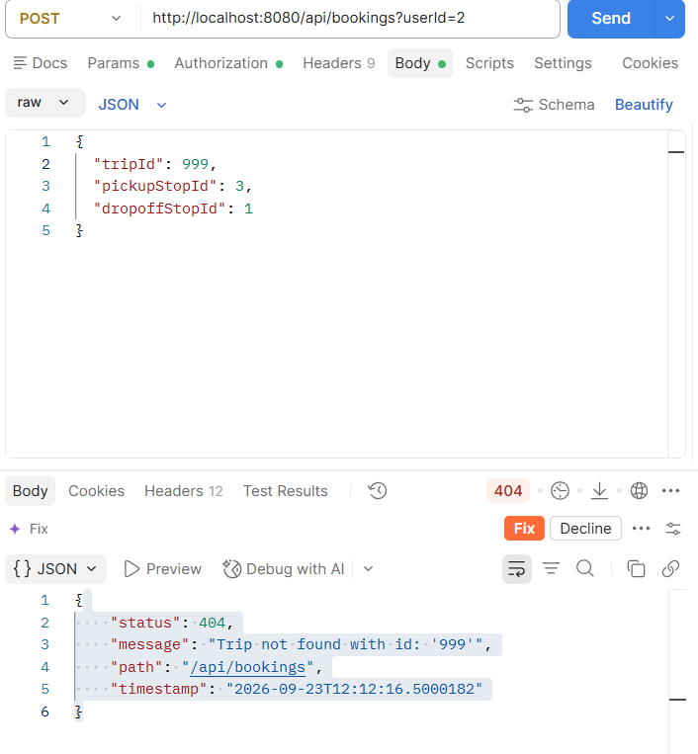
7. Segment-Based Seat Allocation
Topic: Reuse a seat for non-overlapping segments.
First:
Seat 1 → A→B
Then request:
{
"tripId": 1,
"pickupStopId": 2,
"dropoffStopId": 4,
"seatId": 1
}
Expected:
Seat 1 → A→B
Seat 1 → B→D
Both bookings are allowed because they only touch at B.
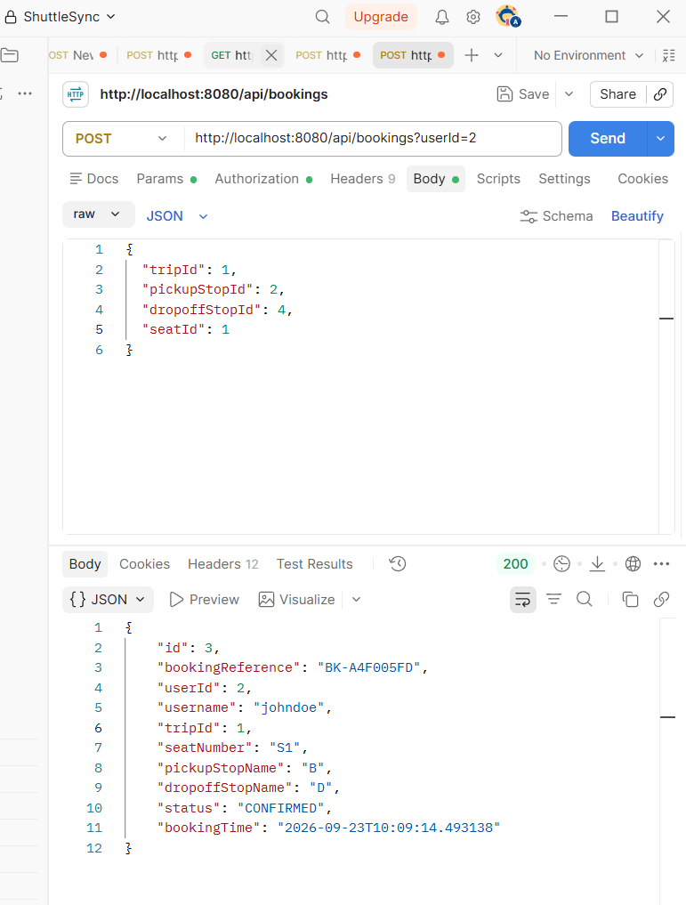

Result :
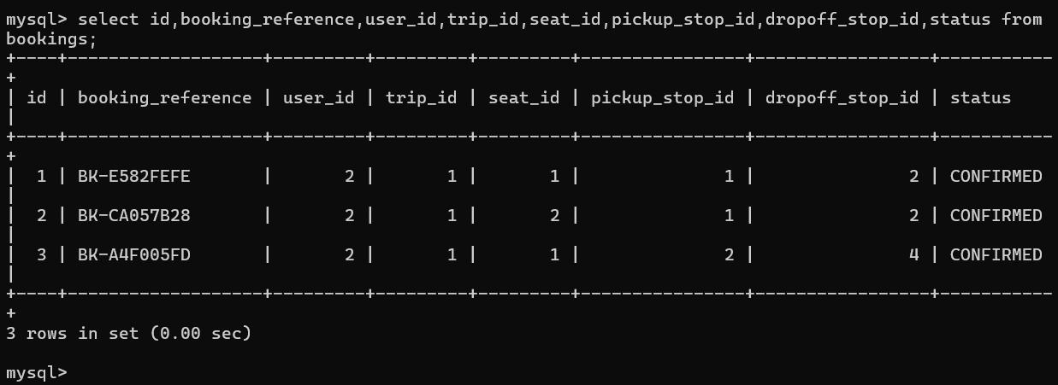

Result :SUCCESS

8. Overlapping Seat Booking
Topic: Prevent overlapping bookings on the same seat.
Request:
{
"tripId": 1,
"pickupStopId": 1,
"dropoffStopId": 3,
"seatId": 1
}
If Seat 1 already has:
A→B
B→D
then:A→C
overlaps an existing booking and must be rejected.
Expected Result:
400 Seat is not available for the requested segment

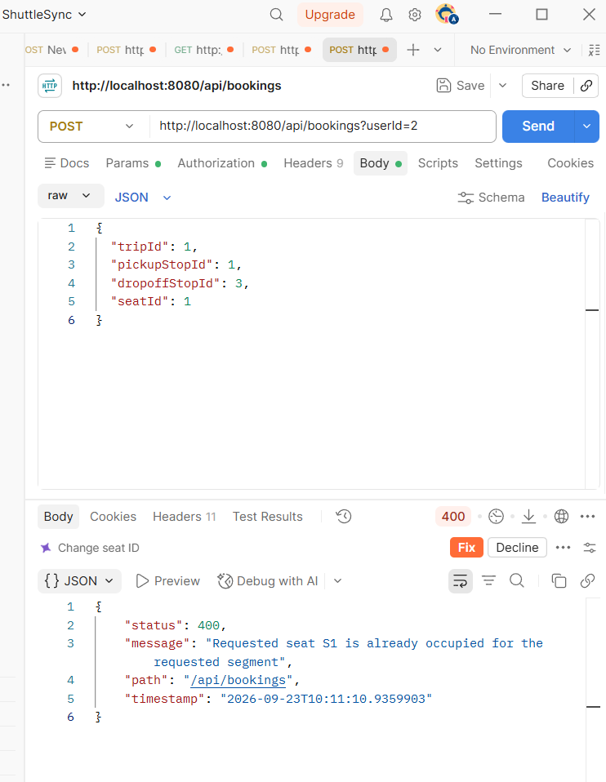
Result :SUCCESS
9. Automatic Segment-Based Seat Allocation
Topic: Automatically select a suitable seat.
Request:
{
"tripId": 1,
"pickupStopId": 1,
"dropoffStopId": 3
}
No seatId is supplied.
The system checks the seats and selects the first seat whose existing bookings do not overlap A→C.
Expected Result:
A suitable seat is automatically allocated.
Actual Result:

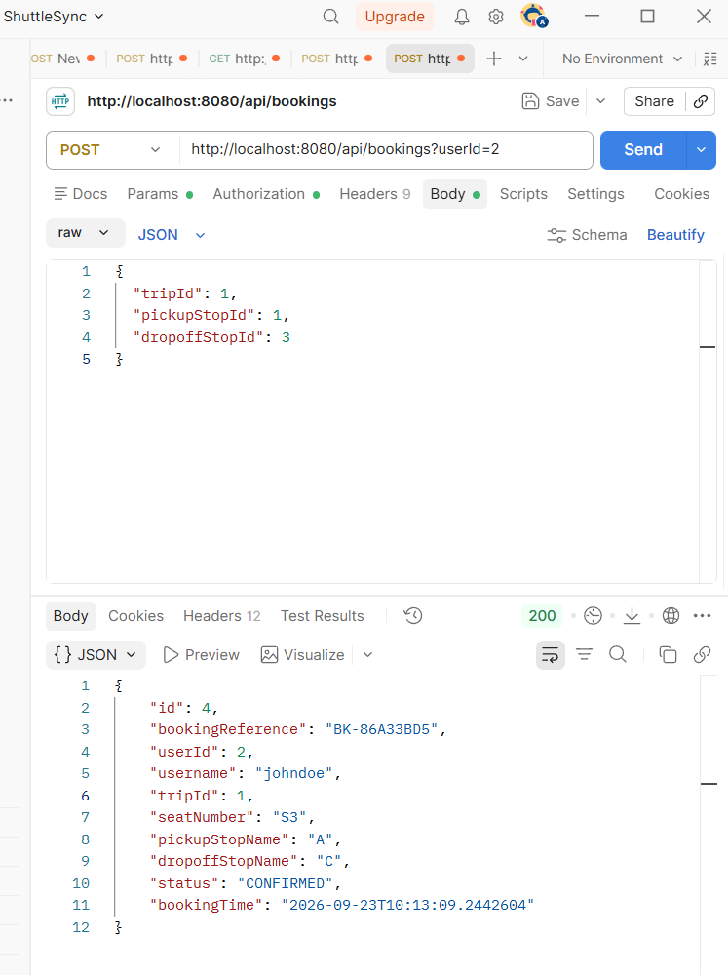

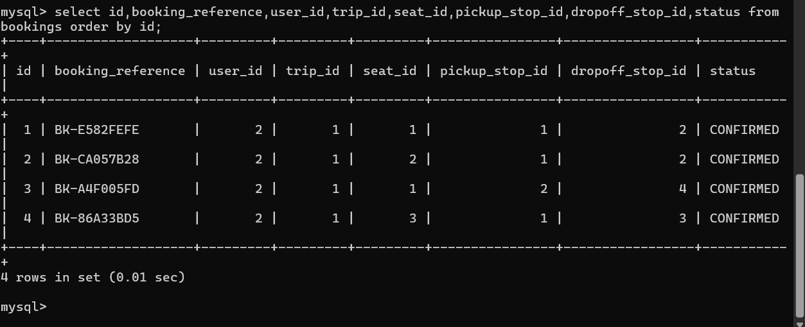

Result: SUCCESS

10. Last-Seat Race / Concurrent Booking
Topic: Atomic booking under concurrent requests
Purpose: Verify that two requests cannot both obtain the last usable seat.
Request:
{
"tripId": 1,
"pickupStopId": 1,
"dropoffStopId": 3
}
Two requests were sent without waiting for the first response.
Expected Result:
Request 1:
200 OK
Seat S5
CONFIRMED
Request 2:
400 Bad Request
No seats available for the requested segment: A -> C
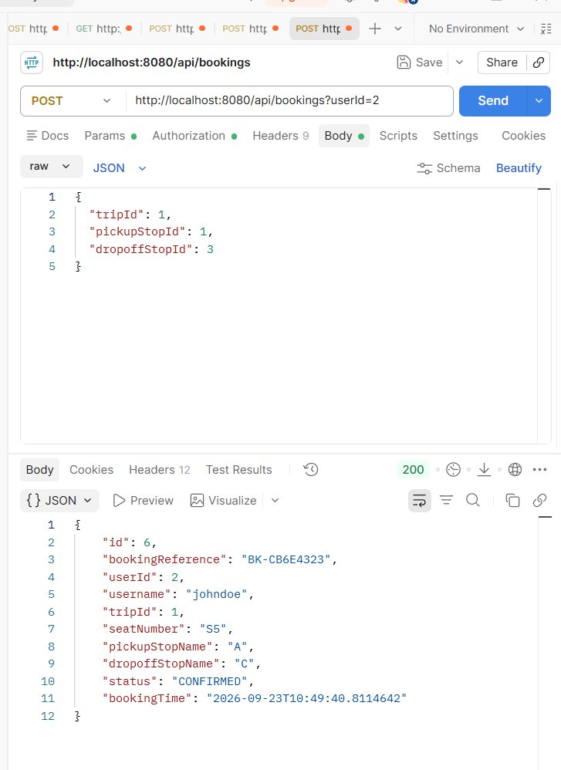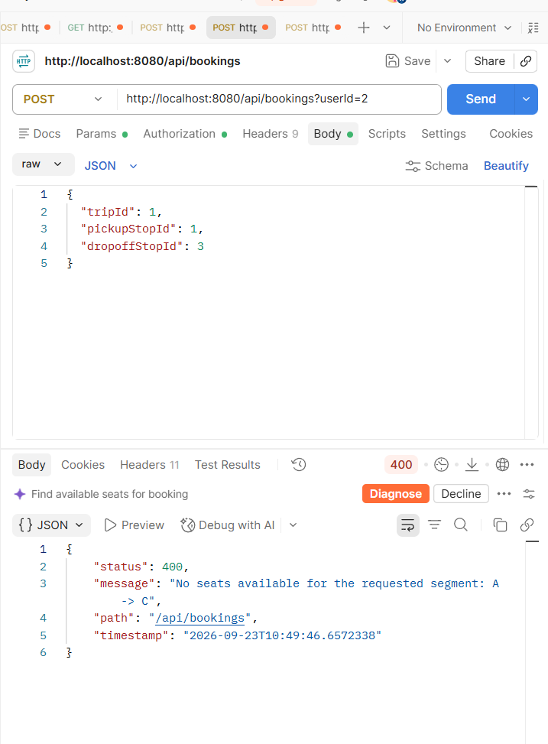

Result: SUCCESS
11. Waitlist and Promotion Validation
Topic:
Validate waitlist creation and promotion after booking cancellation
Purpose: Verify that a passenger joins the waitlist and is automatically promoted when a suitable seat segment becomes available.
API:
POST /api/waitlist/join?userId=2&tripId=1&pickupStopId=1&dropoffStopId=4
Expected Result:
- Waitlist entry is created successfully with PENDING status.
- After a suitable booking is cancelled, the eligible waitlisted passenger is automatically promoted.
- The waitlist entry changes to ALLOCATED.
- A new confirmed booking is created for the promoted passenger.
Actual Result:
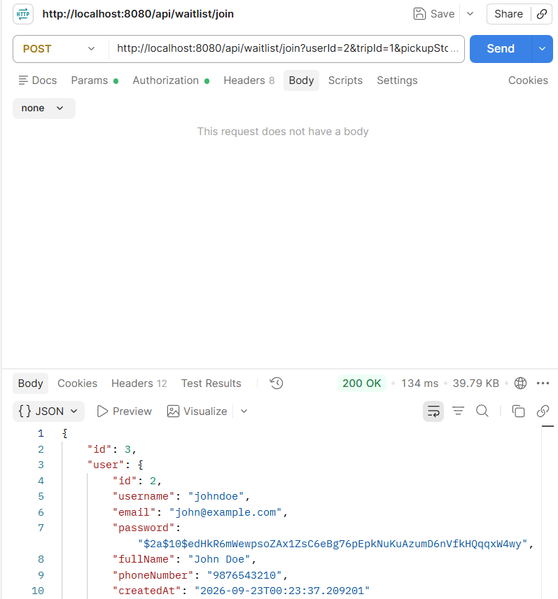
Wait list Join
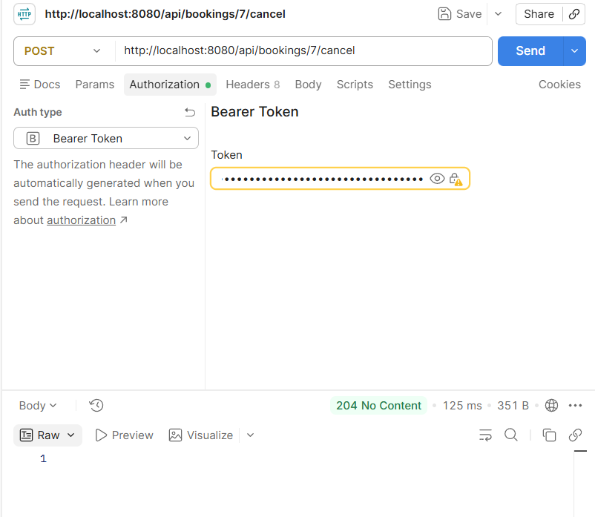
A booking getting cancelled
Waiting One got Allocated
