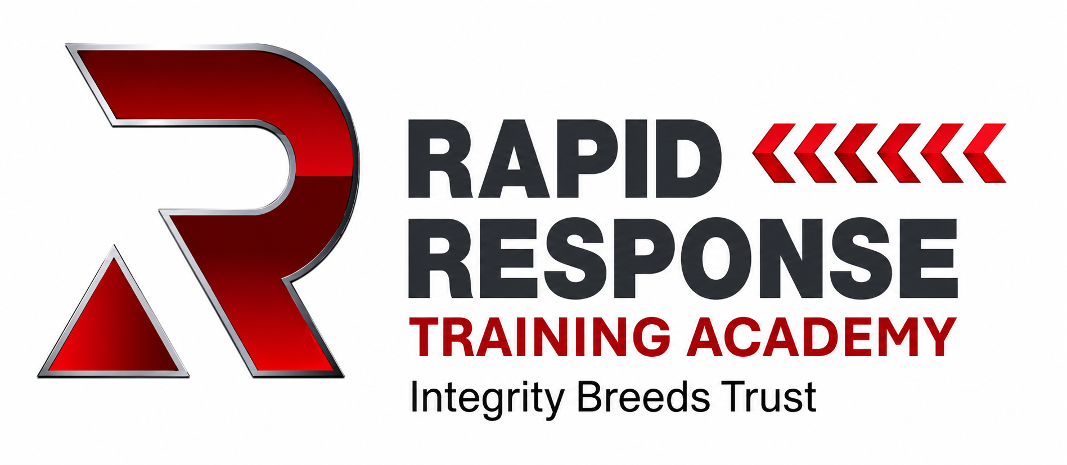
COURSE SPECIFICATION
Customer Service & Professional Conduct
Face-to-Face Course for Field Engineers
Course Owner | Rapid Response Training Academy
Course Duration | 2 Hours
Delivery Method | Face-to-face classroom and scenario-based delivery
Maximum Trainer / Assessor Ratio | 1:6 - one trainer/assessor to six operatives
Target Audience | Field engineers, operatives, new starters, existing engineers and supply-chain operatives
Summative Assessment | 20-minute multiple-choice and situational-judgement assessment
Pass Mark | 80% - minimum 16/20
Certification | RRTA Customer Service & Professional Conduct Certificate / Record of Achievement
Recommended Refresher | As determined by company policy, client requirements or identified performance concerns

Document Control
Version | 1.0 | Issue Date | 27 August 2026
Approved By | ________________________ | Review Date | ________________________

1. Purpose of the Course
The purpose of the Customer Service & Professional Conduct course is to establish a clear, consistent and measurable standard of behaviour for engineers and operatives attending customer premises.
The course develops the knowledge, judgement and communication skills required to represent the company professionally, protect customers and property, communicate effectively, recognise unsafe or inappropriate situations and understand when work should continue, stop or be escalated.
Delivery is practical and scenario-led, allowing operatives to apply the standard to realistic situations they may encounter while carrying out field-based telecoms work.

2. Target Audience
The course is suitable for:
- Field engineers and operatives.
- New starters prior to customer-facing work.
- Existing engineers requiring standardisation or refresher training.
- Installation and maintenance engineers.
- Supply-chain and subcontract operatives representing Rapid Response or its clients.
- Other personnel who regularly attend customer premises as part of their role.
No previous formal customer-service qualification is required.

3. Course Duration and Delivery Ratio
The course shall be delivered over a minimum period of 2 hours, inclusive of the summative assessment.
MAXIMUM DELIVERY RATIO: 1 TRAINER / ASSESSOR : 6 OPERATIVES
The 1:6 ratio is intended to ensure that each learner can actively participate in discussion, role-play, scenario exercises and formative assessment and that the trainer/assessor can adequately observe individual participation and understanding.
The planned course structure comprises approximately 100 minutes of teaching, discussion and practical/scenario activities followed by 20 minutes of protected summative assessment.

4. Course Aim
To establish a clear and consistent customer-service and professional-conduct standard for engineers working at customer premises and enable them to apply that standard throughout the complete customer journey.

5. Learning Outcomes
On successful completion of the course, operatives will be able to:
- Represent the company professionally when arriving at and attending a customer's premises.
- Complete appropriate customer, property and site checks before starting work.
- Explain proposed work clearly and gain customer agreement before starting or changing the scope of work.
- Protect customers, themselves, property, privacy and the company's reputation.
- Communicate effectively when delays, complaints, changes or unexpected situations occur.
- Recognise unsafe, inappropriate or unauthorised situations.
- Determine when work can CONTINUE, when it must STOP, and when the situation must be ESCALATED.
- Respond professionally to challenging customer situations.
- Complete the customer visit professionally and leave the work area in an appropriate condition.

6. Course Content
ARRIVE -> CHECK -> AGREE -> PROTECT -> COMMUNICATE -> COMPLETE
The course shall follow the RRTA customer journey above. Delivery should include customer first impressions, professional appearance and identification, responsible adults and vulnerable customers, safe access, pets and hazards, agreeing installation routes, property protection, customer privacy, managing changes and delays, complaints, aggressive behaviour, lone-working risks, unsafe environments, inappropriate requests and professional completion of the visit.
Scenarios should include realistic field situations such as exposed needles or drug paraphernalia, customer furniture obstructing access, loose animals, existing property damage, unauthorised route changes, aggressive customers, personal safety concerns and offers of private work.

7. Training Methodology
The course shall not be delivered solely through presentation or lecture. Approved delivery methods include trainer presentation, guided group discussion, questioning, photographs and visual prompts, paired role-play, realistic customer scenarios and the STOP / CONTINUE / ESCALATE decision-making activity.
For scenarios, learners should be challenged to answer:
- What do you DO?
- What do you SAY to the customer?
- Do you CONTINUE, STOP or ESCALATE?

8. Trainer / Assessor Requirements
The course must be delivered by a trainer/assessor approved by Rapid Response Training Academy.
The trainer/assessor should have appropriate knowledge and experience of customer-facing field operations and sufficient occupational understanding to discuss realistic situations encountered by engineers.
The trainer/assessor must understand the approved Course Specification, Scheme of Work, presentation, scenarios and assessment requirements before delivering the course. Where the trainer is responsible for assessment, they must maintain impartiality and apply the approved assessment standard consistently to all learners.

9. Formative Assessment
Formative assessment shall take place throughout delivery. This will include trainer questioning, observation, learner participation, scenario responses, paired role-play and STOP / CONTINUE / ESCALATE decision-making.
The purpose of formative assessment is to identify misunderstandings and allow further teaching or clarification before the learner attempts the summative assessment.

10. Summative Assessment
All learners must complete the approved RRTA Customer Service & Professional Conduct summative assessment.
- Assessment: 20 multiple-choice and situational-judgement questions.
- Time allowed: 20 minutes.
- Maximum marks: 20.
- Pass mark: 80%.
- Minimum passing score: 16/20.
- Assessment must be completed individually without tutor coaching or assistance.
Assessment questions shall relate directly to the course learning outcomes and realistic situations an operative may encounter.

11. Assessment Conditions
The trainer/assessor shall ensure that appropriate assessment conditions are maintained. Learners should complete their own work independently and communication between learners during the summative assessment should not be permitted.
Where a paper assessment is used, completed answer sheets shall be retained in accordance with RRTA quality-assurance and record-retention procedures. Where an online assessment is used, an appropriate electronic record of the result shall be retained.

12. Reassessment
Where an operative does not achieve the required 80% pass mark, the trainer/assessor should review the areas of misunderstanding with the learner. Appropriate further teaching should take place before reassessment.
A reassessment should provide sufficient assurance that the learner now understands the required standard rather than simply remembering previously supplied answers. The original result and reassessment result should both be retained as part of the assessment record.

13. Required Course Resources
- Approved RRTA Customer Service & Professional Conduct PowerPoint.
- Current Course Specification.
- Current Scheme of Work.
- Trainer guidance / lesson plan.
- Scenario cards and materials.
- STOP / CONTINUE / ESCALATE activity resources.
- Relevant photographs or visual prompts.
- Approved 20-question summative assessment.
- Candidate answer sheets or approved online assessment system.
- Assessment answer key.
- Attendance record.
- Assessment results record.

14. Course Evidence and Records
For each course, RRTA should retain appropriate evidence including the attendance register, course date and location, trainer/assessor details, learner names, assessment results and any reassessment records. Where applicable, practical/formative observation evidence should also be retained.
Only learners who have attended the required course content and successfully achieved the summative assessment should be recorded as having successfully completed the course.

15. Quality Assurance
Course delivery and assessment may be subject to internal quality assurance by Rapid Response Training Academy. IQA activity may include observation of delivery, sampling of completed assessment records, review of assessment decisions, learner feedback, review of course materials and confirmation that the required 1:6 ratio has been maintained.
Any identified actions should be recorded and addressed through the RRTA quality-assurance process.

16. Course Review
The Course Specification, Scheme of Work, presentation, scenarios and assessment question bank should be reviewed periodically and following significant changes to company procedures, client requirements, operational practices or identified customer-service trends.
Feedback from trainers, operatives, operational management, customers and quality-assurance activity should be considered as part of the review process.

17. Associated Course Documents
- RRTA Customer Service & Professional Conduct - Scheme of Work.
- RRTA Customer Service & Professional Conduct - Trainer Presentation.
- RRTA Customer Service & Professional Conduct - Summative Assessment.
- RRTA Customer Service & Professional Conduct - Operative Answer Sheet.
- RRTA Customer Service & Professional Conduct - Assessor Answer Key.

