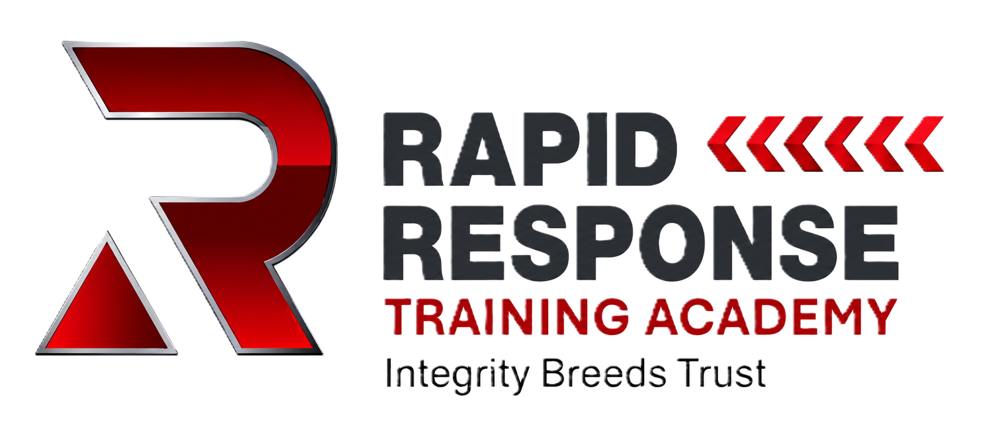
SCHEME OF WORK
Customer Service & Professional Conduct
Face-to-Face Course for Field Engineers

Course Duration | 2 Hours
Delivery Method | Face-to-face, small group delivery
Target Audience | Field engineers, operatives, new starters, existing engineers and supply-chain operatives
Assessment | Formative activities throughout plus 20-minute online summative assessment
Summative Pass Mark | 80%

1. Course Aim
To establish a clear and consistent customer-service and professional-conduct standard for engineers working at customer premises. The course uses realistic field situations, discussion and practical activities so engineers can apply the standard from arrival through to completion of the visit.

2. Learning Outcomes
- Represent the company professionally at the customer's door.
- Complete appropriate customer, property and site checks before starting work.
- Explain the proposed work clearly and gain agreement before starting or changing scope.
- Protect people, property, privacy and the company's reputation.
- Communicate effectively when delays, complaints or unexpected situations occur.
- Recognise when work should continue, stop or be escalated to a supervisor.
- Complete the customer visit professionally and leave the work area in an appropriate condition.

3. Engineer Journey Framework
ARRIVE → CHECK → AGREE → PROTECT → COMMUNICATE → COMPLETE
This framework runs throughout the course and provides a consistent mental model for every customer visit.

4. Scenario Method
For each scenario, learners are required to consider the same three questions:
- What do you DO?
- What do you SAY to the customer?
- Do you CONTINUE, STOP or ESCALATE?

5. Detailed Scheme of Work
Time | Duration | Section / Outcome | Tutor Activity & Key Content | Learner Activity | Assessment / Evidence
0-10 | 10 min | Introduction & Standards | Welcome learners, explain course aims and the customer-facing standard. Discuss how the engineer represents the business and how conduct can affect trust, complaints and reputation. | Opening discussion: What makes a good or bad customer visit? Share examples and identify behaviours. | Tutor questioning and participation.
10-20 | 10 min | ARRIVE | Cover parking, appearance, identification, introduction, confirming the customer and confirming the purpose of the visit. | First Impression activity: identify positive and negative behaviours from example arrivals. | Formative observation and questioning.
20-35 | 15 min | CHECK | Cover responsible adult, vulnerable customers, safe access, pets, hazards, existing property defects and pre-work checks. | Scenario discussion: only a 15-year-old is present / unsafe access or customer issue. Decide what to do and say. | Scenario response: Continue, Stop or Escalate.
35-50 | 15 min | AGREE | Explain the importance of plain language, proposed cable routes, equipment locations, permissions and customer expectations before starting. | Paired role-play: engineer explains the proposed installation and gains customer agreement. | Tutor observation and peer feedback.
50-60 | 10 min | PROTECT | Cover existing damage, floors, furniture, belongings, photographs, privacy, passwords/codes and protection of the customer's property. | Existing Damage scenario: damage is identified beside the proposed drilling location. Learners explain their response. | Scenario response and tutor questioning.
60-65 | 5 min | Comfort Break | Short break and reset for the second half of the session. | Break. | N/A
65-80 | 15 min | COMMUNICATE | Cover progress updates, delays, unexpected problems, route changes and managing customer expectations. | Route Change / Delay scenario. Learners practise explaining the issue and re-agreeing work where appropriate. | Formative role-play and questioning.
80-95 | 15 min | Difficult Situations & Escalation | Cover complaints, angry customers, loose animals, accidental damage, inappropriate requests, ethics, stop-work authority and escalation. | STOP / CONTINUE / ESCALATE activity using realistic scenario cards, including angry customer, dog loose and cash offered for private work. | Formative decision-making assessment.
95-100 | 5 min | COMPLETE | Cover tidying the work area, demonstrating completed work, confirming the customer understands, final checks and professional departure. | Quick closing-visit discussion / role-play. Learners identify the key steps before leaving. | Tutor questioning and observation.
100-120 | 20 min | SUMMATIVE ASSESSMENT | Set up and invigilate the individual online summative assessment. No coaching during the assessment. Review outcomes in line with the assessment process. | Complete online multiple-choice and situational-judgement assessment independently. | Summative assessment. Pass mark: 80%. Result recorded as course evidence.

6. Assessment Strategy

Formative Assessment
Formative assessment is embedded throughout the session through tutor questioning, discussion, paired role-play, scenario responses and the STOP / CONTINUE / ESCALATE activity. The trainer should correct misunderstandings before the learner progresses to the summative assessment.

Summative Assessment
- Duration: 20 minutes protected within the two-hour course.
- Method: Individual online assessment.
- Question style: Multiple-choice and situational-judgement questions based on realistic field situations.
- Pass mark: 80%.
- Assessment should be completed independently without tutor coaching.
- Incorrect responses should be reviewed in accordance with the approved assessment and feedback process.

7. Resources Required
- Customer Service & Professional Conduct trainer PowerPoint.
- Scenario cards.
- STOP / CONTINUE / ESCALATE activity materials.
- Example field photographs or visual prompts.
- Internet-enabled device for each learner, or suitable shared IT arrangement, for the online summative assessment.
- Attendance record and assessment-result record.
- Trainer guidance / lesson plan.

8. Course Evidence
- Attendance record.
- Online summative assessment result.
- Formative activity / practical observation evidence where required.
- Trainer lesson plan and PowerPoint.
- Learner handout and scenario materials.
- Approved assessment question bank.

9. Trainer Notes
The course should remain practical and discussion-led. Tutors should draw on genuine field experiences while maintaining the agreed company standard. Scenario discussions should focus not only on the correct action, but also on the language the engineer uses with the customer. Where a learner is uncertain, reinforce the principle that engineers should not make unauthorised decisions simply to satisfy the customer: stop and escalate where required.

