ROADWATCH / VISION SYSTEMS
AI-Based Ego-Lane
Pothole Detection and
Road Safety Monitoring System
  - Technical implementation report

PROJECT PROFILE | DETAIL
Purpose | Detect potholes in road video and prioritize events in the vehicle camera’s current lane.
Technology | Python · FastAPI · OpenCV · PyTorch/Ultralytics YOLOv8 · React · Vite · FFmpeg
Model artifact | models/best.pt · existing trained Pothole detector
Report version | 1.0 · 23 September 2026
Execution target | Local macOS · CPU inference

Prepared from the source files, configuration, and sample-video processing output present in the existing project. No personal names, institution, or unverified training claims are included.
This report describes the implemented system as inspected and run. Reported measurements are sample-run observations, not general performance guarantees.

Contents
- 1. Abstract
- 2. Introduction
- 3. Project Objectives
- 4. System Architecture
- 5. Technology Stack
- 6. YOLO Model
- 7. Pothole Detection Pipeline
- 8. Ego-Lane Detection
- 9. Pothole-to-Ego-Lane Association
- 10. Video Processing
- 11. Vehicle Speed
- 12. Day/Night Detection
- 13. Frontend Dashboard
- 14. Backend API
- 15. Project Directory Structure
- 16. Code Explanation
- 17. Data Flow
- 18. Performance
- 19. Limitations
- 20. Future Improvements
- 21. Conclusion
- 22. Validation Record
Reading note: Sections describe code in the checked-out repository. “Ego-lane” means the lane polygon estimated around the calibrated camera path; it is not a semantic lane identity supplied by a learned lane model.

1. Abstract
Road potholes can damage vehicles and create a safety hazard. A forward-facing video may show defects in several road lanes, while the immediate monitoring objective is to identify defects located in the lane followed by the recording vehicle. This project combines an existing YOLOv8 Pothole detector with OpenCV lane-marking estimation, a lightweight event tracker, and a local web dashboard.
For each video frame, the backend estimates left and right lane-marking curves around a configured camera optical path. A detected pothole is associated with the estimated ego lane using the bottom-center of its bounding box. Detections outside that polygon are separated into adjacent drivable roadway or outside-road regions using a low-chroma road mask. Lane confidence and temporal boundary history help the application describe periods in which the lane estimate is uncertain.
The system keeps the trained weights in models/best.pt, processes video locally on CPU, writes an annotated H.264 MP4, and returns JSON statistics through FastAPI to a React/Vite dashboard. The video marks potholes with red boxes and retains a green ego-lane visualization. Risk is explicitly a visual heuristic, physical pothole depth is unavailable, and speed is shown as N/A because there is no calibrated speed source.
The delivered demo run processed 240 frames from assets/final.mp4. It detected 571 raw frame detections and associated 51 unique tracks in counted categories: 25 ego-lane, 14 adjacent-lane, and 12 outside-road events; six further uncertain-lane tracks are reported separately and excluded from the 51 counted-category total. These are results from one clip and one run, not a validated accuracy study.

2. Introduction
Road-surface defects such as potholes are a practical road-safety and maintenance concern. A forward-facing camera offers a low-cost way to record visible surface conditions, and an object detector can localize candidate potholes in those frames. A frame-level detector alone, however, can report every visible road lane. For a vehicle-centered warning or inspection workflow, the lane occupied by the camera vehicle is the relevant context.
This implementation therefore associates detections with a frame-derived road lane. It uses conventional computer vision to estimate visible marking curves and creates a polygon between the boundaries nearest the configured camera path. This geometric estimate is separate from the learned pothole detection model: lane lines are not inferred by YOLO and are not semantic segmentation output.
The dashboard is designed for an academic or technical demonstration. It provides a processed-video view, lane status and confidence, counts, event confidence and risk levels, adjacent/outside classifications, and vehicle-status fields. The design is local-first: uploaded video is processed by the project backend and no cloud service is required.
The application does not measure pothole depth or calibrated vehicle velocity. Severity is a visual prioritization score. Lighting is summarized as DAY or NIGHT from brightness samples, and “Forward” describes the forward-looking video view rather than a compass heading.

3. Project Objectives
- Detect Pothole-class objects in road video using the existing trained weights.
- Estimate the lane around the camera optical path from observed road-marking evidence.
- Associate potholes with the ego-lane polygon and distinguish adjacent roadway, outside road, and uncertain lane status.
- Track repeated detections across frames so a visible object can form a persistent event ID.
- Render detected potholes in red while retaining the separate lane overlay and debug visualization.
- Generate severity/risk estimates, confidence summaries, and lane counts without claiming physical depth.
- Provide a browser dashboard for demo processing, MP4 upload, video playback, and event statistics.
- Report vehicle speed honestly as unavailable unless an actual calibrated source exists.
- Summarize scene lighting as DAY or NIGHT using a lightweight image statistic.
Scope boundary: this task adds visualization, vehicle-status fields, playback controls, dashboard styling, and this report. It preserves the existing model, lane estimator, tracker, API architecture, and video workflow.

4. System Architecture
The frontend starts an upload or the built-in demo as an asynchronous FastAPI job. The processor probes source-video dimensions and frame rate, decodes raw frames through FFmpeg, estimates lane geometry with OpenCV, runs the existing YOLO weights on each untouched decoded frame, associates each box with lane/road state, tracks detections, calculates ego-lane severity, draws annotations, and encodes the result. The API stores a JSON result and serves the completed video to the browser.
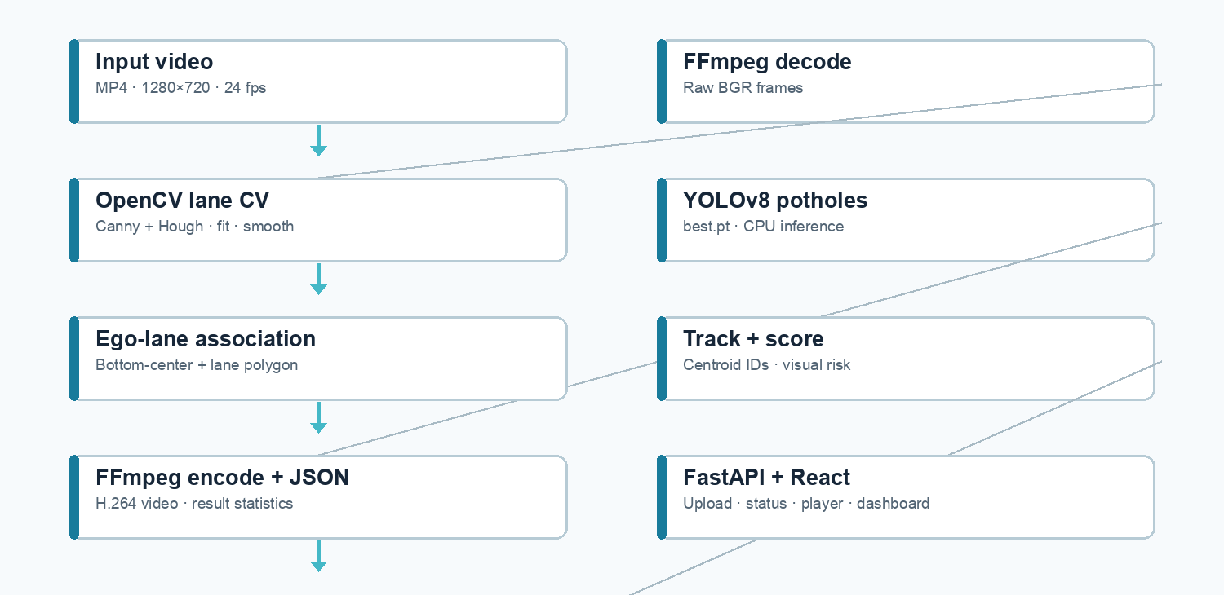
Figure 1. Implemented application path. YOLO inference and lane estimation run on the same decoded road frame; the existing weights remain unchanged.
The job manager uses a daemon thread and in-memory job dictionary protected by a lock. This is adequate for one local demonstration process; it is not a durable queue or multi-worker job store. Results and media are written beneath runs/dashboard/<job-id>/.

5. Technology Stack
Layer | Observed implementation
Backend runtime | Python 3.11 project virtual environment; FastAPI 0.141.1; Uvicorn; python-multipart for uploads.
Detection | PyTorch 2.2.2; Ultralytics 8.0.200; existing YOLO weights models/best.pt.
Image/video CV | OpenCV 5.0.0 and NumPy 1.26.4. FFmpeg and FFprobe decode, probe, and encode video.
Frontend | React 18.3.1; Vite 6.4.3; JavaScript JSX; lucide-react icons; local CSS.
Output | H.264 MP4 (libx264, ultrafast, yuv420p, faststart) and JSON statistics.

The backend requirements file adds FastAPI, Uvicorn, and multipart parsing. The requested visual/status work introduced no additional Python or JavaScript packages. The existing PyTorch, NumPy, and Ultralytics environment was preserved.
The reported local environment versions were observed from the project virtual environment. The project should be run from that environment; recreating it or changing the numerical stack is outside the implementation scope.

6. YOLO Model
YOLO (You Only Look Once) is a family of single-stage object detectors. It predicts object locations and class scores from an image in one model inference pass. In this application the detector returns candidate bounding boxes, confidence values, and class IDs; application code retains detections identified as the Pothole class.
The active loader is backend/detector.py::load_model(). It resolves the repository’s models/best.pt and loads it through Ultralytics YOLO. The inspected checkpoint metadata reports task=detect and names={0: Pothole}; its underlying class is Ultralytics DetectionModel. The checkpoint is approximately 21 MB. An exact architecture YAML variant or training history was not available in inspected metadata, so this report does not state one.
model.predict(frame, conf=0.25, imgsz=640, device="cpu", verbose=False)
The model receives the original decoded BGR frame. The inference call uses confidence threshold 0.25, inference image size 640, and CPU execution. Lane and pothole annotations are drawn only after inference, avoiding overlay pixels influencing the detector input. The trained weights are neither altered nor retrained.
YOLO confidence is a model score for a candidate detection, not a calibrated probability of correctness. In the dashboard, average confidence is calculated across unique ego-lane event records created on first association, rather than across every repeated frame detection.

7. Pothole Detection Pipeline

1. Probe and decode
backend/video_processor.py::_probe reads width, height, average frame rate, and frame count through ffprobe. FFmpeg then emits raw BGR frames to the processor.

2. Lane analysis
LaneDetector.update(frame) produces the smoothed boundary geometry, confidence, road mask, and current-lane polygon for the frame.

3. YOLO inference
The unchanged YOLO model is called on the decoded frame using CPU, 640 input size, and confidence 0.25. is_pothole_class filters for the Pothole label.

4. Association and tracking
Each box yields coordinates, confidence, center, and bottom-center road-contact point. Lane category is assigned; CentroidTracker links detections over short time gaps.

5. Risk and drawing
Only current ego-lane objects are given the LOW/MEDIUM/HIGH visual score. Each detection is drawn with a red rectangle and concise category, ID, and confidence label.

6. Aggregate and encode
Counters and event records form the result JSON. Annotated frames are piped to FFmpeg for H.264 MP4 output.
The detection path is frame-wise rather than a separate detector service. This keeps the working YOLO integration in the existing processor while adding context and presentation around its detections.

8. Ego-Lane Detection
Lane detection is algorithmic OpenCV geometry, not a learned lane-segmentation network. backend/lane_detector.py converts a road region to edge evidence with Canny, extracts candidate segments using probabilistic Hough transform, filters segments by slope, length, position, and candidate grouping, and fits left/right boundary curves. The fit is evaluated across normalized y samples and smoothed temporally.
The estimator selects the nearest plausible marking on each side of the configured camera path. The lane polygon between the fitted boundaries is a dynamic geometric representation of the observed lane for a frame. The configured camera_x is an optical-path calibration anchor; it does not encode “always select the left lane” or a permanently centered lane identity. Current implementation settings include ROI top 0.32, ROI bottom 0.86, 12 curve samples, Hough threshold 36, minimum segment length 38 px, maximum gap 72 px, smoothing factor 0.42, 18-frame boundary hold, and confidence threshold 0.32.
Configuration family | Current default | Purpose
Image region | roi_top=.32; roi_bottom=.86 | Limit line search to road-facing vertical band.
Camera anchor | camera_x=.50; anchor_y=.72 | Approximate calibrated camera path at a reference image height.
Edge/Hough | Canny 42/132; Hough 36; line 38 px; gap 72 px | Tune line evidence and segment continuity.
Temporal | smoothing .42; hold 18 frames; decay .90 | Retain/smooth recent reliable boundaries through brief misses.
Reliability | confidence threshold .32 | Mark weak lane geometry uncertain rather than claiming relevance.

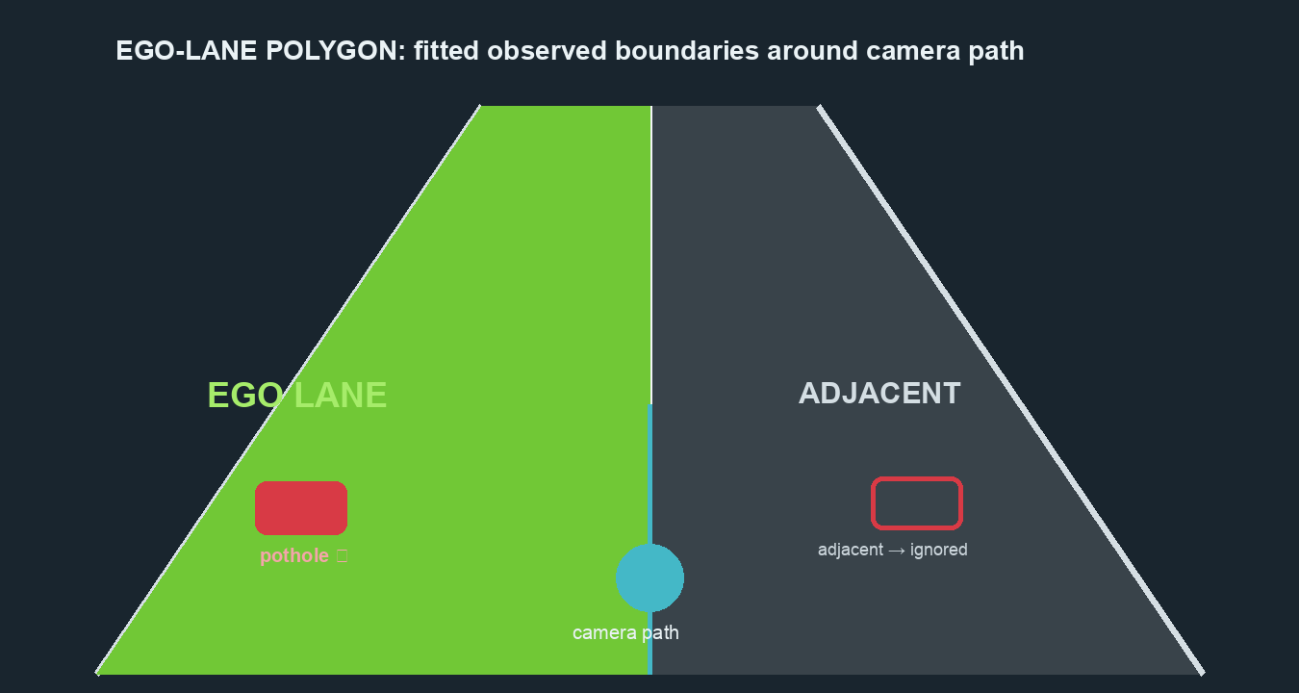
Figure 2. Conceptual association: green indicates the polygon between observed boundaries surrounding the configured camera path. The actual frame illustration follows fitted geometry.
Lane confidence is a heuristic based on line support/coverage and temporal state; it is not a statistical probability. With weak boundaries, previous estimates are held briefly and confidence decays. When geometry is no longer reliable, potholes are labeled uncertain and excluded from primary ego-lane severity counts. DEBUG_LANES=true adds edge/candidate/camera-path/road-mask diagnostics.

9. Pothole-to-Ego-Lane Association
For a YOLO box (x1,y1,x2,y2), the representative road point is the bottom-center: x=(x1+x2)/2 and y=y2. This approximates the point where the pothole meets the road and avoids using the box’s upper region as the lane location.
if not lane_geometry.reliable: lane = "uncertain"
elif point_inside(bottom_center, ego_lane_polygon): lane = "current"
elif road_surface_mask(bottom_center): lane = "adjacent"
else: lane = "outside_road"
The current polygon is tested first. A point outside the polygon but supported by the road mask is classified as adjacent roadway; otherwise it is outside road. The road mask uses HSV saturation/value bounds and samples a 9×9 patch around the road-contact point, requiring at least 30% accepted pixels. It is a pavement heuristic, not semantic road segmentation.
For the completed sample run, current-lane potholes contribute to ego totals and severity. Adjacent, outside-road, and uncertain categories are visually labeled and separated; uncertain tracks are not treated as current-lane events. The counts should not be interpreted as detector precision/recall or independently verified ground truth.

10. Video Processing
The sample file assets/final.mp4 was probed as H.264, 1280×720, 24 frames per second, and 10 seconds. The processor reads FFmpeg raw BGR frames, applies per-frame OpenCV lane/detection drawing, and writes raw BGR frames to an FFmpeg H.264 encoder. Output settings use libx264, ultrafast preset, yuv420p pixel format, faststart metadata, and the source frame rate. Audio is not copied (-an).
Completed job artifacts are stored at runs/dashboard/<job-id>/processed.mp4 and results.json. Uploaded jobs also keep input.mp4. The API provides the processed file through a video/mp4 FileResponse, and the browser uses that URL as the HTML video source.
The application currently reports source frame count and statistics. Temporary raw frame data is streamed between processes rather than materialized as a directory of images. FFmpeg/FFprobe must be available on PATH. The output duration observed for the sample remains 10 seconds and the output is browser-oriented H.264 MP4.

11. Vehicle Speed
There is no usable calibrated speed source in the supplied video. The inspected source metadata did not provide GPS/CAN speed, and the project has no calibrated camera geometry or validated visual-odometry scale that would convert pixel displacement to metres per second. Therefore the implementation returns speed_kmh=null and speed_label="N/A".
The dashboard explicitly displays N/A with a note that no calibrated source is present. This avoids fabricating a real-world vehicle velocity from apparent motion. The current “Forward” label indicates the forward-facing road-camera orientation, not an inferred compass bearing or independently measured travel direction.
Future speed estimation would require a trusted metric scale and camera-motion model or vehicle telemetry. Optical flow alone measures image displacement and cannot produce reliable km/h without calibration and assumptions about scene depth and camera motion.

12. Day/Night Detection
Lighting is estimated with a lightweight luminance statistic. Once each second, the backend resizes a frame to 160×90 pixels, converts it to grayscale, and records mean intensity. The median of these samples is compared with LIGHTING_NIGHT_THRESHOLD=58 in backend/vehicle_status.py. A median below 58 yields NIGHT; otherwise the output is DAY.
lighting_condition = "NIGHT" if median_luminance < 58.0 else "DAY"
The supplied sample measured median grayscale luminance 139.3 and was classified DAY. This single scene-level label is not frame-by-frame exposure metadata, weather recognition, or a calibrated lux measurement. Headlights, tunnels, shadows, overexposure, and nighttime street lighting can affect it; the threshold is configurable and should be tuned to target clips.
No rain, fog, or snow classification is implemented. The UI displays the requested day/night indication only.

13. Frontend Dashboard
The frontend is a React single-page application built with Vite. The main dashboard is implemented in frontend/src/App.jsx and styled in frontend/src/style.css. It checks backend/model availability, starts demo or upload jobs, polls status, fetches result JSON, and switches the video source to the processed media URL.
The layout retains the existing video, current-lane event table, YOLO raw count, ego-lane status and confidence, high/medium/low risk totals, adjacent and outside-road counts, processing feedback, and upload/demo actions. The vehicle-status card adds speed (N/A when unavailable), lighting state, and forward-facing direction. Physical depth is explicitly shown as not available.
Pothole bounding boxes use restrained red hazard color in the encoded video. Lane visualization continues in its separate green lane color. The video element has native controls, playsInline, metadata preload, and no autoplay attribute. A compact control row adds restart, elapsed/total time, and playback speed (0.5× through 2×). Native browser controls supply play/pause, seeking, volume, and fullscreen.
The styling uses a dark slate professional palette, restrained cyan/blue system accents, and red only for pothole hazards. Responsive CSS breakpoints reorganize the dashboard for narrower widths. No heavy animation or additional frontend framework is introduced.

14. Backend API
Method and route | Request / response | Purpose
GET / | No body; service, dashboard, health and docs paths. | Small API information response.
GET /api/health | JSON status; model_available; demo_available. | Check backend, model file, and demo file.
POST /api/process | Multipart file field; MP4 only, <=500 MB. Returns job_id/status. | Save and asynchronously process uploaded video.
POST /api/process/demo | No body; returns job_id/status. | Process assets/final.mp4.
GET /api/status/{job_id} | Job ID in path; status/progress/message and optional error. | Poll queued/running/completed/failed state.
GET /api/results/{job_id} | Job ID in path; completed statistics and event list. | Retrieve processing JSON (409 while in progress).
GET /api/video/{job_id} | Job ID in path; video/mp4 body. | Serve annotated output when complete.

FastAPI endpoints live in backend/main.py. CORS allows the local Vite origins on ports 5173. Upload validation rejects non-MP4, empty, and >500 MB inputs. Per-job failures are logged and reported through status. The API stores job state in memory, while media/results are saved under runs/dashboard/.

15. Project Directory Structure
Pothole_Detection_YOLOv8/
├── backend/ FastAPI and processing modules
│ ├── main.py Routes, jobs, upload validation
│ ├── detector.py Loads existing YOLO weights
│ ├── lane_detector.py OpenCV lane geometry and overlays
│ ├── video_processor.py Frame pipeline, result aggregation
│ ├── tracker.py Centroid event association
│ ├── severity.py Visual risk score
│ └── vehicle_status.py Lighting and honest speed status
├── frontend/ Vite/React application
│ └── src/App.jsx Dashboard and API interactions
├── models/best.pt Existing trained pothole model
├── assets/final.mp4 Local demo input
├── runs/dashboard/ Job output videos and JSON
├── Pothole_Detection.py Original direct inference script
├── Pothole_Detection.ipynb Historical notebook/reference
├── test_lane_pipeline.py CPU/model/lane/status smoke checks
└── README.md Setup and implementation notes
The root also contains historical dataset and experiment directories and a project virtual environment. They are not used as active dashboard services. The Colab/Drive/Roboflow notebook is retained as historical material; the local web application uses neither Google Drive nor Roboflow.

16. Code Explanation

Backend modules

backend/main.py
Defines the FastAPI app, CORS policy, health and processing endpoints. _create_job starts a daemon worker; _run_job updates in-memory progress, calls process_video, writes results.json, and records terminal state.

backend/detector.py
Provides load_model() for the repository model and a class helper that recognizes the Pothole class. It is the single model-loading point for dashboard inference.

backend/video_processor.py
Probes input, streams frame decode/encode through FFmpeg, initializes LaneDetector and CentroidTracker, samples luminance, calls YOLO on the undecorated frame, associates each result, records new tracked events, draws red boxes/labels, and returns result statistics.

backend/lane_detector.py
Defines LANE_CONFIG, LaneGeometry and LaneDetector. Edge extraction and Hough line candidates are filtered and fitted into left/right curves; confidence and boundary history support temporal smoothing. Polygon and road-mask helpers provide point association; draw_lane_overlay renders the geometry and optional diagnostics.

backend/tracker.py
CentroidTracker associates same-category detections by centroid proximity across a short frame gap. It preserves IDs through brief missed detections; it is not a learned appearance tracker.

backend/severity.py
score_severity normalizes bbox area, confidence, and image vertical proximity, then applies configurable LOW/MEDIUM/HIGH thresholds.

backend/vehicle_status.py
classify_lighting applies a median grayscale threshold; vehicle_speed_status returns unavailable speed fields and explanatory metadata.
Severity calculation detail (backend/severity.py): normalized box area saturates at 8% of the frame; proximity increases toward the lower image region. The score is 0.50 × normalized area + 0.25 × YOLO confidence + 0.25 × proximity. Scores below 0.38 are LOW, below 0.67 are MEDIUM, and 0.67 or above are HIGH. This is a configurable visual ranking heuristic and is calculated for ego-lane events only; it is not a physical depth measurement or a validated safety standard.

Frontend and configuration
frontend/src/App.jsx owns dashboard state and API requests. It renders upload/drop handling, demo processing, progress/error state, video URL, native playback, custom restart/rate controls, event table, and statistic/status cards. frontend/src/style.css holds the visual system and responsive breakpoints. backend/requirements.txt contains API additions only; frontend/package.json lists the existing React/Vite/icon toolchain. DEBUG_LANES is an environment configuration switch for visual diagnostics.

17. Data Flow
MP4 source
↓ ffprobe metadata + FFmpeg raw frame stream
BGR frame ──→ OpenCV lane candidates → fitted/smoothed boundaries → ego polygon
└────────→ YOLO best.pt → pothole boxes + confidence
↓ bottom-center association
current / adjacent / outside-road / uncertain
↓
centroid tracking + ego severity
↓
lane and red-box overlays → FFmpeg H.264 output
+ JSON statistics/results
↓
FastAPI status/results/video → React dashboard
Per-frame data includes box coordinates, confidence, lane category, score/severity, representative road contact, and tracker association. New ego events record stable display ID, first frame, confidence, severity, lane confidence, position, center, road contact, dimensions, and box. The API returns these event rows alongside aggregate counts and ignored-detection summaries.
Lighting and speed are video-level status fields. Lighting aggregates 1 Hz samples; speed is unavailable. These fields do not alter pothole lane association.

18. Performance
Metric | Observed value | Context
Source | 1280×720, 24 fps, 10 s | assets/final.mp4; 240 frames.
Model inference | CPU, imgsz 640, conf .25 | Existing best.pt and local project stack.
Run time | 64.23 seconds | One full sample processing run; system load can vary.
Effective throughput | ≈3.7 frames/s | 240 frames divided by observed processing time.
Raw detections | 571 | Frame-level YOLO results after Pothole class filtering.
Tracked totals | 51 counted-category events | 25 ego, 14 adjacent, 12 outside; six uncertain separately excluded.
Lighting | DAY; median 139.3 | 1 Hz thumbnail luminance aggregation.
Speed | N/A | No calibrated telemetry or validated metric visual odometry.

No controlled benchmark, memory profile, thermal profile, or accuracy evaluation was run. Throughput is a single observed local CPU result; it is not a guarantee for different hardware, video codec, scene complexity, or concurrent workload.

19. Limitations
- Lane boundaries depend on visible markings and Canny/Hough evidence. Faded paint, curves, intersections, shadows, camera vibration, lane changes, or poor contrast can reduce confidence. Camera-path calibration and thresholds may need tuning for a different recording setup.
- The lane confidence is a heuristic, not a calibrated probability. During low confidence, the system reports uncertain rather than claiming an ego-lane association.
- The road mask uses low-chroma HSV thresholds and a local patch vote. Pavement color, wet road, gravel, concrete, shadows, and road-side surfaces can confuse adjacent-road versus outside-road labels.
- Pothole lane association uses a bounding-box bottom-center. Partial occlusion, oversized boxes, or detector localization error can move the representative point across a lane boundary.
- Centroid tracking is lightweight. Dense detections, occlusion, large camera motion, close potholes, or long gaps can split/merge event IDs.
- Severity is an estimated visual risk score and is not validated against measured depth, repair urgency, vehicle impact, or a road authority standard. No depth is available.
- Speed cannot be recovered in real units from this sample without a metric reference or valid vehicle telemetry. N/A is the correct current output.
- DAY/NIGHT is a whole-clip brightness threshold and does not infer weather, illuminance, or a precise lighting state for every frame.
- The local job store is in memory and resets on backend restart. The current API is designed for a single-user demonstration, not durable multi-user deployment.
- The observed sample run is not an accuracy benchmark; no labeled test set or ground-truth lane/pothole event evaluation is included.

20. Future Improvements
The following are possible research and engineering extensions; they are not current features.
- Evaluate an efficient lane-segmentation network against the OpenCV baseline, keeping a CPU budget and explicit confidence fallback.
- Use calibrated camera intrinsics/extrinsics and road-plane geometry to improve lane/path and distance reasoning.
- Add stereo/depth sensing or validated monocular depth with independent calibration if physical depth estimation is required.
- Integrate GPS, IMU, or vehicle CAN speed and direction, with source validity and timestamps exposed to the UI.
- Validate lane association, tracking, and severity on a labeled multi-road, multi-lighting, multi-country dataset.
- Calibrate severity thresholds against an explicitly selected road-maintenance or safety protocol.
- Consider a durable job queue and persistent metadata store if processing multiple users or restarting the server must preserve job history.
- Measure inference throughput, latency distribution, CPU/memory/thermal behavior, and optimize frame sampling/model image size only after quality is assessed.
- Add weather classification only with a suitable validated data source/model and clear confidence semantics.

21. Conclusion
The current repository implements a local video-based pothole monitoring pipeline combining the existing YOLOv8 Pothole detector with OpenCV lane-boundary estimation, ego-lane association, centroid event tracking, heuristic visual severity, a FastAPI API, and a React/Vite dashboard. The requested presentation changes use red hazard boxes, retain the working ego-lane overlay and statistics, add honest speed status and lightweight day/night reporting, and provide native no-autoplay playback plus restart and rate controls.
The project was run against its existing assets/final.mp4 and models/best.pt. The resulting video remains playable as H.264 MP4 and the JSON result distinguishes ego, adjacent, outside-road, and uncertain events. The key interpretation limits remain explicit: the lane fit is geometric CV, risk is visual rather than physical depth, speed is unavailable, and observed counts represent one demo run.
The source project architecture and trained weights remain in place. The report is intended to document the inspected implementation and should be updated if the processing behavior, thresholds, API, model, or frontend are subsequently changed.

22. Validation Record
Validation was explicitly requested and was performed against the local project and sample video. The following results describe the completed run inspected for this report.
Check | Result
Existing model and environment | Existing models/best.pt loaded and ran on CPU; PyTorch 2.2.2, NumPy 1.26.4, Ultralytics 8.0.200 preserved.
Lane smoke checks | Dynamic lane geometry and road mask valid on assets/final.mp4; point-in-ego-lane association checked.
Tracking smoke check | 40 repeated detections retained one tracker ID.
Failure handling | Lane loss decays to uncertain without crashing or fixed-polygon fallback.
Vehicle status | Luminance classifier exercised; absent speed source yields N/A.
Demo API | POST demo processing completed; GET status/results returned completed JSON.
Demo run | 240 frames; 571 raw detections; 25 ego, 14 adjacent, 12 outside, 6 uncertain unique tracks.
Severity summary | 0 HIGH, 4 MEDIUM, 21 LOW ego-lane unique events.
Lane confidence | Mean heuristic confidence 0.7242; not a probability.
Average ego confidence | 0.3746, based on unique ego events.
Lighting/speed | DAY at median 139.3 grayscale; speed_kmh null / N/A.
Processed video | H.264, 1280×720, 24 fps, 10 s. Frame inspected: lane polygon visible; pothole boxes red.
Frontend build | Vite production build completed successfully.

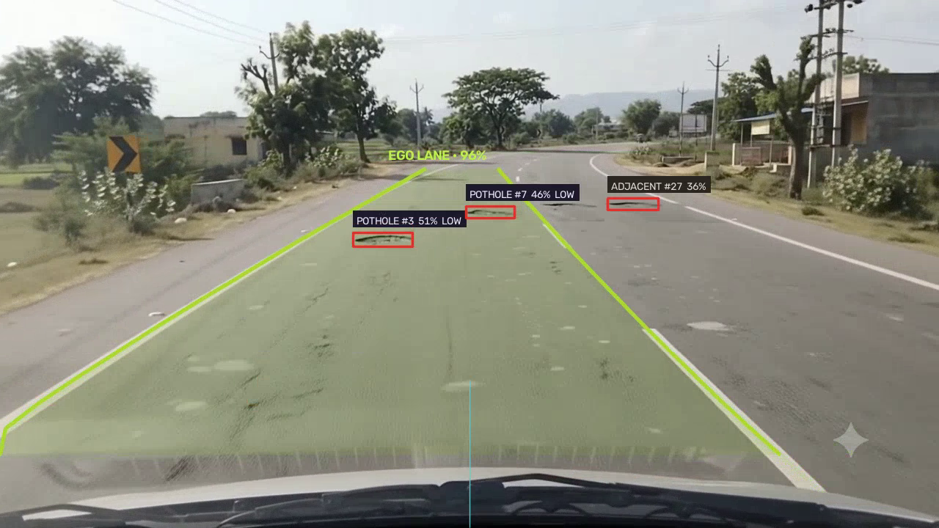
Figure 3. Processed sample frame inspected at approximately 4 s. Green region/boundaries show ego-lane visualization; pothole boxes are red; an adjacent event is labeled separately.
Test command used: MPLCONFIGDIR=/tmp/mpl-cache YOLO_CONFIG_DIR=/tmp/yolo-config .venv/bin/python test_lane_pipeline.py. Frontend validation used npm run build from frontend/. End-to-end backend verification used the existing local service on port 8000 and the demo processing endpoint.

