**Jerrys Quick Mart Exercise – Code Explanation**

My chosen programming language for this exercise was python. As required, I did not use any 3rd party modules or frameworks for the exercise. The python file can be found at the GitHub repository as **QuickMart_Code.py**.

From code line 1 to 5, I imported the required 1st party (built-in) modules I required. Also, I defined a global variable I would need in order to keep track of the number of transactions executed.

From code line 7 to 159, I proceeded to build two classes: “Point of Sale”, and “Customer Shopping Cart”.

The “Point of Sale” is composed only by its constructor, which is where the inventory is read from the **Inventory.txt** file (which has to be located at the same directory as the python file in order to be read) and stored into a python dictionary (after being cleaned-up in the process).

The “Customer Shopping Cart” is composed by its constructor (which includes point of sale and customer’s reward level as attributes) and the methods used to allow the shopping process (add to cart, remove from cart, empty cart, checkout, print receipt, update inventory). Here is an object design diagram/workflow in order to observe all these elements and the way they interact between each other more clearly:

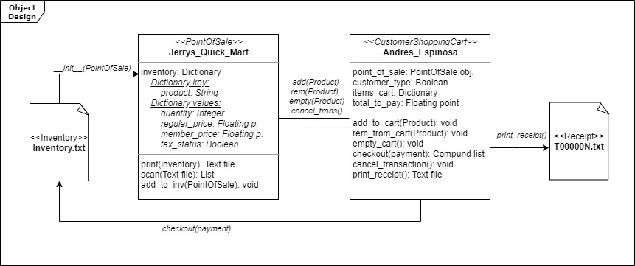

Finally, from code line 160 to 204, a demonstration of how the code works is provided. On it, “Point of Sale” and “Customer Shopping Cart” objects are created, items are added and removed from the cart, and the checkout, print receipt and update inventory are called.

**PD:** I was on the process of developing an end-user interface for controlling the program more easily, but I ran out of time and I was not able to finish it. Nevertheless, in case you want to review the work on process, you can download and open the **QuickMart_DRAFT_EndUserInterface.py** file, which is also uploaded in the GitHub repository.