**MERN stack Video chat app**

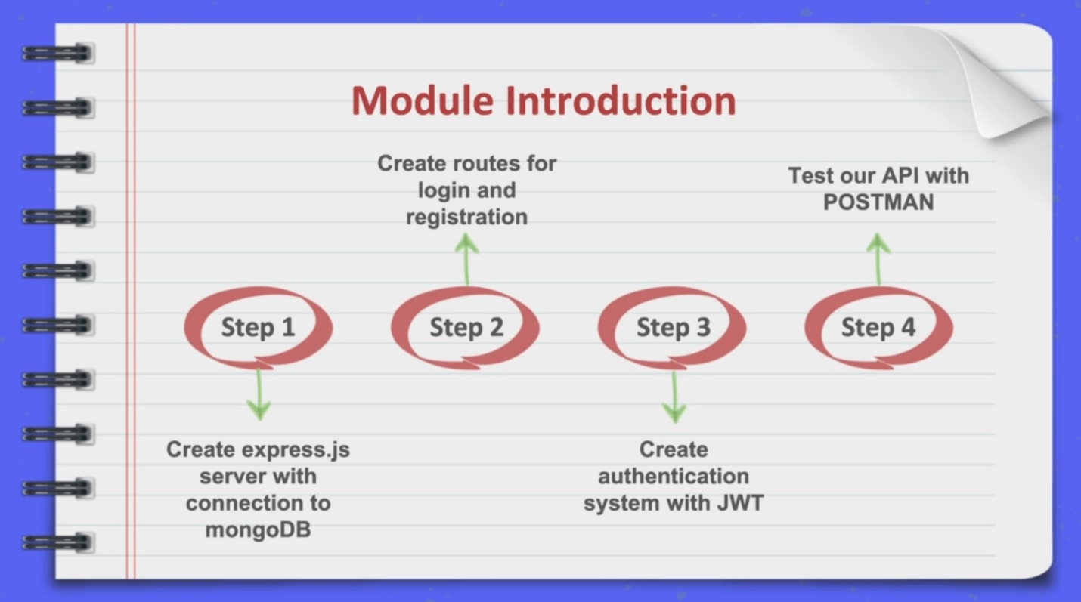

**Step1:** We will be creating an **Express server** and we will also connect that to MongoDB and we’ll be storing all of the information about the users and all of the messages which will be created and on everything in our application in database and will be going for the **MongoDB in cloud**.

**Step2:** We’ll take care about creating **routes** for login and registration because first thing which we will be creating when we start creating our React app will be **a form**, which will allow us to **login or register**.

**Step3:** We’ll create the **authentication system with JWT token** that if the user will login or register successfully, the token will be returned to client site app and client will be able to access the **protected resources** at the server side.

**Step4:** We’ll be **testing** our API with Postman.

/****/

Module 4: Dashboard

