TECHNICAL WRITE UP FOR BITWISE PATTERN GENEARTION IN ARM

BUFFER LAYOUT AND ADDRESSING MATH

BUFFER LAYOUT
To facilitate the storage and manipulation of a 48-by-48 black and white GUI, the project uses a 288 byte long (48 bits * 48 bits = 2304 bits = 288 bytes) bit-packed frame buffer in which every bit corresponds to one pixel. As a 48-bit row corresponds to a row of 6 bytes the frame buffer stores the first row in the first 6 bytes, stores the second row in the next 6 bytes, etc. The frame buffer stores the bits in such an order that a byte of bits corresponding to 8 bits/pixels on the same row will have the leftmost pixel of that 8-pixel group stored in the MSB whilst the rightmost pixel of the 8-pixel group is stored in the LSB (this means that the 0th/first bit read when reading from left to write will correspond to the first pixel of that bytes 8 defined pixels).

ADDRESSING MATH
In the context of ARM, where load and store operation are done through addresses corresponding to the memory location of bytes, a frame buffer can be thought of as a 288-byte long list with 288 indexes (starting from 0 to 287) corresponding to the 288 bytes. Once a byte has been retrieved, we can read from MSB to LSB to read the bits corresponding to the leftmost to rightmost pixels defined by the byte. Bitmasks are not calculated from row or col addresses but instead are loaded during start.
Row: 0 – 47
Col: 0 – 5
numOfByteInRow = 6
frameBufferMemoryAddress = The memory address of the first byte of the frame buffer
byteIndex = (row * 6) + byteCol
memoryAddress = byteIndex + frameBufferMemoryAddress

PATTERNS AND BITWISE LOGIC

Zebra Pattern:

DESCRIPTION
A zebra stripe pattern in which the leftmost column is fully black, the next column of pixels is fully white, and then the pattern repeats, black-white-black-white, until reaching the end of the image.

IMAGE
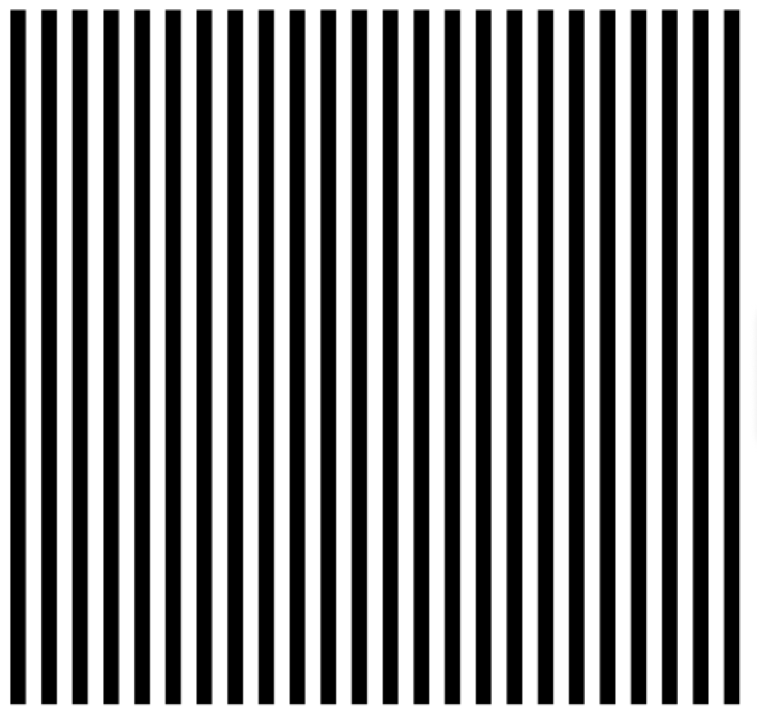

BITWISE LOGIC
Starting/Parameter Bitmask (already loaded) in Binary: 01010101…01010101
Bitwise Logic:
For every 8 bytes of the frame buffer, load the 8 bytes into a register.
On the 8 bytes perform a logical AND with the parameter bitmask.
On the 8 bytes then preform a logical ORR with the parameter bitmask.
Store the 8 bytes back to the frame buffer.

EXPLANATION:
To create a zebra pattern, we can realize that all bytes of the frame buffer of a zebra pattern are all 01010101 meaning that if we can find a way to assign all 288 bytes to 01010101 we will have successfully created the zebra pattern. One way to do this is to have a precomputed bitmask of 8 bytes of 01010101 and for every 8 bytes of the frame buffer we will set the bits of the frame buffer’s 8 bytes to have the same zero’s locations as the precomputed bitmask (this is what the AND instruction does), then set the bits of the frame buffer’s 8 bytes to have the same one’s locations as the precomputed bitmask (this is what the ORR instruction does), and store the updated bits to the frame buffer before moving to the next 8 bytes of the frame buffer.

Checkerboard Pattern:

DESCRIPTION
The classic checkerboard pattern in which the top left corner of the GUI is a black pixel and every adjacent pixel is the opposite color whilst every diagonal pixel is the same color.

IMAGE
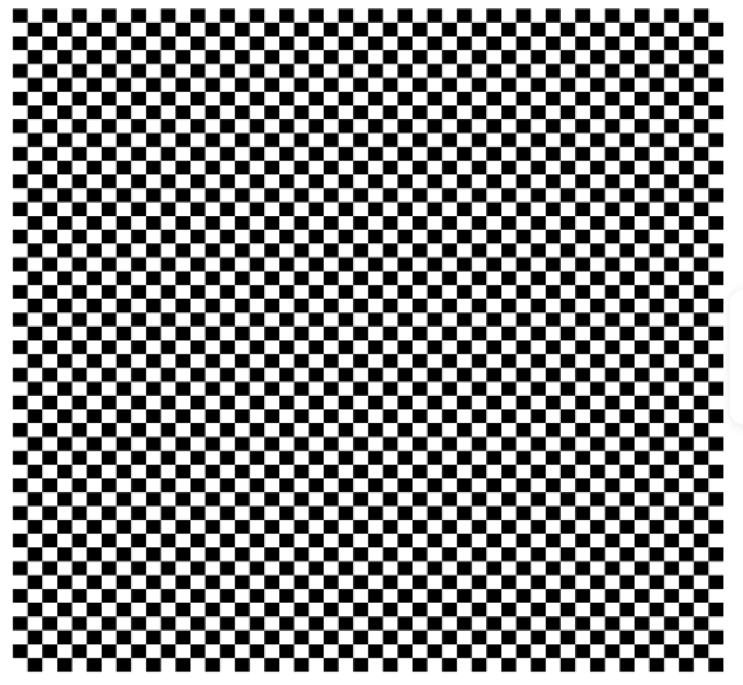

BITWISE LOGIC
Starting/Parameter Bitmask (already loaded) in Binary: 01010101…01010101
Bitwise Logic:
For every 6 bytes (row) of the frame buffer.
Store the first 6 bytes of the parameter bitmask.
XOR the bitmask against register of 64 bits one’s (flips all bits of bitmask).
The result of the XOR is saved as the current bitmask we’ll be working with.

EXPLANATION:
For a checkerboard pattern we start with a precomputed bitmask in which the first 6 bytes of the 8-byte register holding the bitmask has the same bits as what would be needed for the first row (first 6 bytes) of the checkerboard pattern. We thus will store these 6 bytes before flipping the bits of the bitmask, this is done by XOR-ing the bitmask by a 64-bit register of all one (which will lead to all zeros becoming ones and all ones becoming zeros). By flipping the bitmask, the first 6 bytes of the bitmask now corresponds to the second rows bits needed for a checkerboard pattern, thus we can now store those 6 bytes into the frame buffer to achieve a second row of the checkerboard pattern. We can keep storing and flipping the bitmasks bits until we’ve written to the entire frame buffer to successfully achieve a checkerboard pattern.

Horizontal Stripes:

DESCRIPTION
A rotated zebra stripe pattern in which the topmost row is fully black, the next row of pixels is fully white, and then the pattern repeats, black-white-black-white, until reaching the end row of the image.

IMAGE
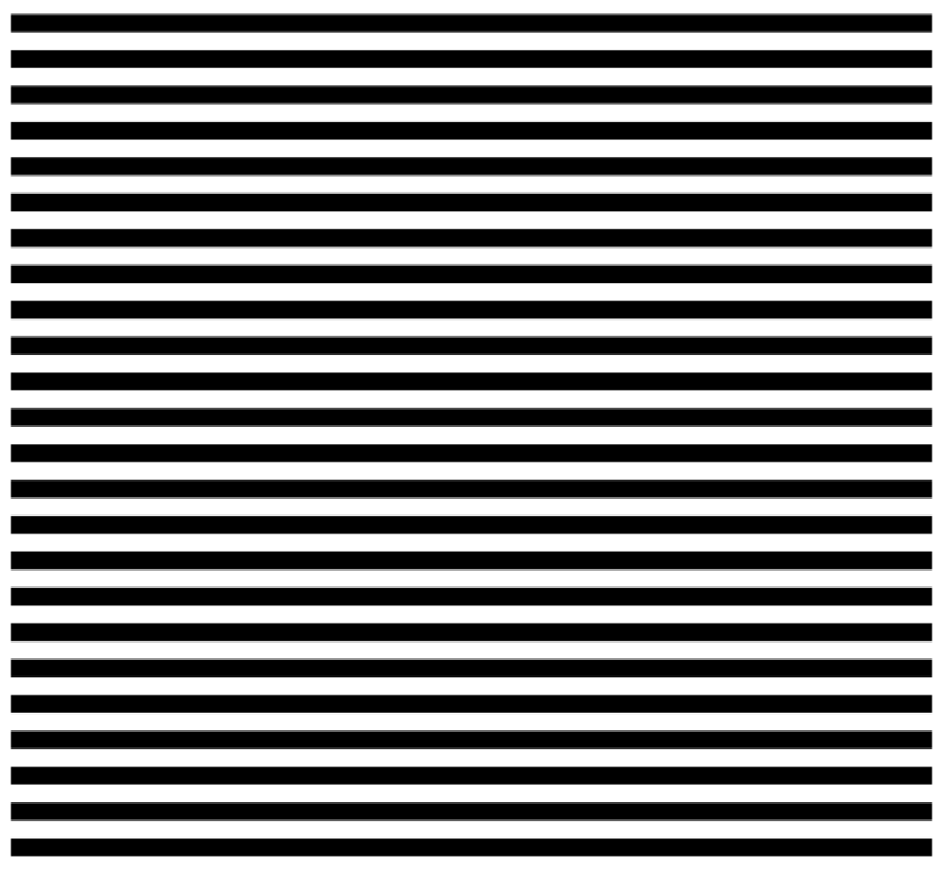

BITWISE LOGIC
Starting/Parameter Bitmask (already loaded) in Binary: 00000000…00000000
Bitwise Logic:
For every 6 bytes (row) of the frame buffer.
Store the first 6 bytes of the parameter bitmask.
XOR the bitmask against register of 64 bits one’s (flips all bits of bitmask).
The result of the XOR is saved as the current bitmask we’ll be working with.

EXPLANATION:
The horizontal stripes bitwise logic follows the same process as the checkerboard pattern but with a differing initial precomputed bitmask. In the case of the horizontal stripes pattern the initial bitmask which we will be flipping the bits of will be 6 bytes of all zeros (this will be stored in an 8 byte register but the last 2 bytes of the register are ignored/irrelevant).

Diagonal-Half Pattern:

DESCRIPTION
A pattern in which every jth pixel of the nth row is white if j > n and is black if otherwise.

IMAGE


BITWISE LOGIC
Starting/Parameter Bitmask (already loaded) in Binary: 10000000…00000000
Bitwise Logic:
For every 6 bytes (row) of the frame buffer.
Store the first 6 bytes of the parameter bitmask.
Shift the bitmask to the right by one bit (save the original, non-shifted mask).
ORR the shifted bitmask and the non-shifted mask.
The result of the ORR is saved as the current bitmask we’ll be working with.

EXPLANATION:
For this pattern we start with a precomputed 6-byte bitmask stored in an 8-byte register in which the MSB (the leftmost bit of the 8-bytes) is one and all other bits are zero. As can be guessed, these first 6-bytes of the bitmask match the first row of the pattern, so the first step is to store these 6 bytes to the frame buffer. We can then alter this bitmask so as to create the next row of the pattern by copying the bitmask shifted one bit to the right into a scratch register and then assigning the bitmask to the output of ORR-ing the current bitmask and the shifted bitmask in the scratch register. This will lead to a change in the bitmask in which the leftmost zero gets flipped to one. By storing this bitmask and then altering the bitmask using the same bitwise operation we can write the correct pattern into the frame buffer.

Steps Animation:

DESCRIPTION
The animation will start with a pattern as indicated below which I am going to refer to as a collection of stairs. The top left corner will be set to black; the bottom of this black pixel will then be set to black, then the pixel to the right of this newly set pixel will be set to black, and then the bottom of this newly set pixel will be set to black, and so on until we create a black staircase from the top left to the bottom right. We then will sandwich this black staircase against two oppositely colored staircases. We then will continuously “sandwich” a colored staircase with two oppositely colored staircases (again the example does a better job of explaining the visual). This is just the initial image of the animation, when it is time for a new frame the stairs will get moved to the right by one pixel (the pixels which are emptied and not assigned new pixel values will be reassigned to keep the pattern the same).
Example: Initial Image
0 | 1 | 1 | 0
0 | 0 | 1 | 1
1 | 0 | 0 | 1
1 | 1 | 0 | 0
Example: Frame 1
0 | 0 | 1 | 1
1 | 0 | 0 | 1
1 | 1 | 0 | 0
0 | 1 | 1 | 0

GIF


INTIAL PATTERN BITWISE LOGIC
Starting/Parameter Bitmask (already loaded) in Binary: 01100110…01100110
Bitwise Logic:
For every 6 bytes (row) of the frame buffer.
Store the first 6 bytes of the parameter bitmask.
Get the state of the 48th bit in the bitmask by running an AND against the bitmask and a register which is all zeros except for a 1 at the 48th bit (save the results).
Shift the saved results of the AND operation 47 bits to the left so the 48th bit is now the 1st bit.
Shift the bitmask to the right by one bit.
ORR the bitmask and the register with the left shifted bits.
The result of the ORR is saved as the current bitmask we’ll be working with.

ANIMATION BITWISE LOGIC
Setting Start/Parameter Bitmask:
Load the first 6 bytes of the frame buffer.
Get the state of the 48th bit in the 6 bytes loaded by running an AND against the bytes and a register which is all zeros except for a 1 at the 48th bit (save the results).
Shift the saved results of the AND operation 47 bits to the left so the 48th bit is now the 1st bit.
Shift the 6 bytes to the right by one bit.
ORR the shifted 6-bytes and the register with the left shifted bits.
The result of the ORR is saved as the current bitmask we’ll be working with.
Bitwise Logic:
For every 6 bytes (row) of the frame buffer.
Store the first 6 bytes of the parameter bitmask.
Get the state of the 48th bit in the bitmask by running an AND against the bitmask and a register which is all zeros except for a 1 at the 48th bit (save the results).
Shift the saved results of the AND operation 47 bits to the left so the 48th bit is now the 1st bit.
Shift the bitmask to the right by one bit.
ORR the bitmask and the register with the left shifted bits.
The result of the ORR is saved as the current bitmask we’ll be working with.

EXPLANATION:
To create the walking steps animation, we utilize bitwise operations such that a row is shifted to the right by one bit and the bit which was shifted out of the LSB of the bits making that row are then wrapped to the MSB of the row’s bits. This bitwise operation is of course done on a bitmask whose 6-bytes equate to the first row of the stairs pattern we are going for (thus the bitmask’s 6-bytes are written to the first row as the first step). To then alter the bitmask such that it has the next rows bytes to be written requires us extracting the 48th bit in the bitmask by AND-ing the bitmask by 0x0000000000010000 and then shifting the extracted bit 47 bits to the left so that we either have 0x8000000000000000 or 0x0000000000000000. Once we have extracted this bit, we then shift the bitmask by one bit to the right before then adding the extracted bit and bitmask together through an ORR instruction. This then results in us shifting the bitmask to the right by one bit, but with the 48th bit being wrapped back to the first bit. For the generation of the initial stairs pattern, we use a precomputed bitmask that is stored in a global variable but for the create of the animation frames we actually will take the last frame’s first row (the first 6 bytes of the current unedited framebuffer) and will preform the same operation to shift and wrap the 6-bytes, the resulting bitmask is now the starting bitmask for the iteration.

SUBROUTINES AND THEIR CALLING CONVENTION

Branch Diagram
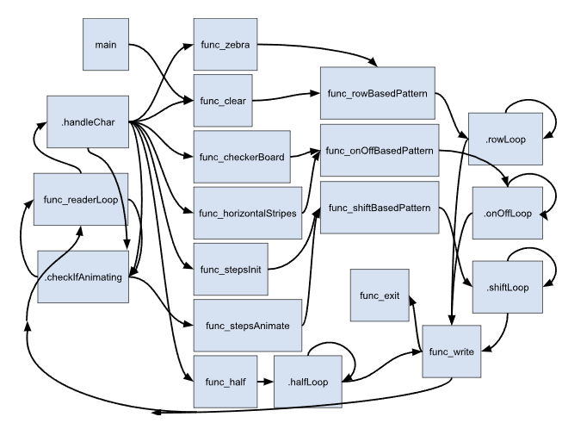

REGISTERS RESPONSIBILITIES
It is standard practice in ARM64 that registers X0-X7 are parameter/return variables, that registers X0-X15 are caller-saved/volatile and that registers X19-X28 are callee-saved/non-volatile. I attempted to follow the same standard by keeping parameters in the range of X0-X7, keeping scratch/temporarily used registers in the range of X9 to X11 and keeping values which are either unchanged and global or are changed, but are saved by the callee, to the register range of X19-X28.
The following list shows the responsibilities assigned to the different registers:
- X1-X4 : Used for SYSCALLS (parameters) (changes)
- X5: Used to pass the current address to read from frame buffer (parameter) (changes)
- X6: Used to pass the current bitmask (parameter) (changes)
- X7: Used to pass the current ending byte of the frame buffer (parameter) (changes)
- X8: Used to pass the current user inputted character (parameter)
- X9-X11: Scratch registers (local scope) (changes)
- X19: Current mode (0 = not animate, 1 = animate) (global) (changes but callee saved)
- X20: Bitmask for diagonal-half pattern (global) (static)
- X21: Bitmask for stairs animation (global) (static)
- X22: Bitmask for zebra pattern (global) (static)
- X23: Memory address of last byte of frame buffer (global) (static)
- X24: #288 (global) (static)
- X25: Memory address of binary file’s name (global) (static)
- X26: Memory address of use input byte (global) (static)
- X27: Memory address of timespec (global) (static)
- X28 : Memory address of first byte of frame buffer (global) (static)

Calling Conventions

main():
Initializes the global registers, sets terminal and file settings and clears the GUI via calling func_clear.
- Syscall registers clobbered: X0, X1, X2, X8
- Scratch registers clobbered: X9-X11
- Parameters set/changed: X7 set to 0 (indicates we aren’t exiting)
- Parameters used/read: X7
- Global variables/registers set: X19-X28
- Global variables/registers read: NONE
- Calls: func_clear(X7 userInput)

func_readerLoop():
Will continuously read the user’s typed characters and will run .handleChar and .checkIfAnimating to determine the if a pattern generation method should be called.
- Syscall registers clobbered: X0, X1, X2, X8
- Scratch registers clobbered: NONE
- Parameters set/changed: NONE
- Parameters used/read: NONE
- Global variables set/changed: NONE
- Global variables/registers read: X26 (chacter memory address)
- Calls: .checkIfAnimating() or .handleChar()

.handleChar():
Compares the user inputted character and calls the corresponding pattern generation method. If there’s no corresponding hotkey to the users input then we will jump to .checkIfAnimate method.
- Syscall registers clobbered: NONE
- Scratch registers clobbered: NONE
- Parameters set/changed: X7 (user’s most recently typed character)
- Parameters used/read: NONE
- Global variables set/changed: NONE
- Global variables/registers read: X26 (character memory address)
- Calls: func_clear(X7 userInput), func_zebra(X7 userInput), func_horizontalStripes(X7 userInput), func_checkerBoard(X7 userInput), func_stepsInit(X7 userInput), func_half(X7 userInput), or .checkIfAnimating()

.checkIfAnimating():
Check to see if we are in animate mode or non-animate mode, if in animate mode call the stepsAnimate method, otherwise read the next users input by calling func_readerLoop.
- Syscall registers clobbered: NONE
- Scratch registers clobbered: NONE
- Parameters set/changed: NONE
- Parameters used/read: NONE
- Global variables set/changed: NONE
- Global variables/registers read: X19 (animate/non-animate mode)
- Calls: func_stepsAnimate(X7 userInput) or func_readerLoop()

func_write(X7 userInput):
In charge of writing the frame buffer to a binary file to be read by JavaFX program to handle opening the GUI. Also checks the userInput and run the func_exit method if we are trying to exit and will wait 0.25 seconds if the current mode in X19 is animate mode (X19 = 1).
- Syscall registers clobbered: X0, X1, X2, X3, X8
- Scratch registers clobbered: X9
- Parameters set/changed: NONE
- Parameters used/read: X7
- Global variables set/changed: NONE
- Global variables/registers read: X19 (animating/non-animating mode), X24 (#288), X25 (file name address), X27 (timespec memory address), X28 (frame buffer memory address)
- Calls: func_exit() or func_readerLoop()

func_exit():
Resets terminal and file settings before running the syscall to exit the program execution.
- Syscall registers clobbered: X0, X1, X2, X8
- Scratch registers clobbered: NONE
- Parameters set/changed: NONE
- Parameters used/read: NONE
- Global variables set/changed: NONE
- Global variables/registers read: NONE
- Calls: NONE

func_checkerBoard(X7 userInput):
- Set parameters and call the func_onOffBasedPattern method to create/write the checkerboard pattern to the framebuffer.
- Syscall registers clobbered: NONE
- Scratch registers clobbered: NONE
- Parameters set/changed: X5 (checkerboard bitmask)
- Parameters used/read: NONE
- Global variables set/changed: NONE
- Global variables/registers read: X22 (zebra pattern bitmask)
- Calls: func_onOffBasedPattern(X5 bitmask, X7 userInput)

func_horizontalStripes(X7 userInput):
Set parameters and call the func_onOffBasedPattern method to create/write the horizontal stripes pattern to the framebuffer.
- Syscall registers clobbered: NONE
- Scratch registers clobbered: NONE
- Parameters set/changed: X5 (horizontal stripes bitmask)
- Parameters used/read: NONE
- Global variables set/changed: NONE
- Global variables/registers read: NONE
- Calls: func_onOffBasedPattern(X5 bitmask, X7 userInput)

func_onOffBasedPattern(X5 bitmask, X7 userInput):
Set parameters and loop through and create a pattern in the frame buffer through calling .onOFFLoop.
- Syscall registers clobbered: NONE
- Scratch registers clobbered: NONE
- Parameters set/changed: X4 (address of 1st byte in framebuffer), X6 (address following the last byte in framebuffer)
- Parameters used/read: NONE
- Global variables set/changed: X19 (set to 0/non-animate mode)
- Global variables/registers read: X28 (frame buffer address), X23 (end memory address of frame buffer)
- Calls: .onOffLoop(X4 address, X5 bitmask, X6 upperBound, X7 userInput)

.onOffLoop(X4 address, X5 bitmask, X6 upperBound, X7 userInput):
In charge of writing to frame buffer, bitwise operations, and iterations for func_onOffBasedPattern.
- Syscall registers clobbered: NONE
- Scratch registers clobbered: X9
- Parameters set/changed: X4 (address incremented), X5 (bitwise operations on bitmask)
- Parameters used/read: X4 (address), X5 (btimask), X6 (upperbound)
- Global variables set/changed: NONE
- Global variables/registers read: NONE
- Calls: .onOffLoop(X4 address, X5 bitmask, X6 upperBound, X7 userInput) or func_write(X7 userInput)

func_clear(X7 userInput):
Set parameters and call the func_rowBasedPattern method to create/write the cleared pattern to the framebuffer.
- Syscall registers clobbered: NONE
- Scratch registers clobbered: NONE
- Parameters set/changed: X5 (cleared bitmask)
- Parameters used/read: NONE
- Global variables set/changed: NONE
- Global variables/registers read: NONE
- Calls: func_onOffBasedPattern(X5 bitmask, X7 userInput)

func_zebra(X7 userInput):
Set parameters and call the func_rowBasedPattern method to create/write the zebra pattern to the framebuffer.
- Syscall registers clobbered: NONE
- Scratch registers clobbered: NONE
- Parameters set/changed: X5 (zebra stripes bitmask)
- Parameters used/read: NONE
- Global variables set/changed: NONE
- Global variables/registers read: X22 (zebra pattern bitmask)
- Calls: func_onOffBasedPattern(X5 bitmask, X7 userInput)

func_rowBasedPattern(X5 bitmask, X7 userInput):
Set parameters and loop through and create a pattern in the frame buffer through calling .rowLoop.
- Syscall registers clobbered: NONE
- Scratch registers clobbered: NONE
- Parameters set/changed: X4 (address of 1st byte in framebuffer), X6 (address following the last byte in framebuffer)
- Parameters used/read: NONE
- Global variables set/changed: X19 (set to 0/non-animate mode)
- Global variables/registers read: X28 (frame buffer address), X23 (last address of frame buffer)
- Calls: .rowLoop(X4 address, X5 bitmask, X6 upperBound, X7 userInput)

.rowLoop(X4 address, X5 bitmask, X6 upperBound, X7 userInput):
In charge of writing to frame buffer, bitwise operations, and iterations for func_rowBasedPattern.
- Syscall registers clobbered: NONE
- Scratch registers clobbered: X9
- Parameters set/changed: X4 (address incremented)
- Parameters used/read: X4 (address), X5 (btimask), X6 (upperbound)
- Global variables set/changed: NONE
- Global variables/registers read: NONE
- Calls: .rowLoop(X4 address, X5 bitmask, X6 upperBound, X7 userInput) or func_write(X7 userInput)

func_stepsInit(X7 userInput):
Set parameters and call the func_shiftBasedPattern method to create/write the intitial stairs pattern to the framebuffer.
- Syscall registers clobbered: NONE
- Scratch registers clobbered: NONE
- Parameters set/changed: X5 (stairs bitmask)
- Parameters used/read: NONE
- Global variables set/changed: X19 (set mode to 1/animating mode)
- Global variables/registers read: X21 (stairs pattern btimask)
- Calls: func_shiftBasedPattern(X5 bitmask, X7 userInput)

func_stepsAnimate(X7 userInput):
Set parameters and call the func_shiftBasedPattern method to create/write the next frame of the stairs animation to the framebuffer.
- Syscall registers clobbered: NONE
- Scratch registers clobbered: X9
- Parameters set/changed: X5 (shifted stairs bitmask)
- Parameters used/read: X5 (bitmask)
- Global variables set/changed: X19 (set mode to 1/animating mode)
- Global variables/registers read: X28 (address of 1st byte in frame buffer)
- Calls: func_shiftBasedPattern(X5 bitmask, X7 userInput)

func_shiftBasedPattern(X5 bitmask, X7 userInput):
Set parameters and loop through and create a pattern in the frame buffer through calling .shiftLoop.
- Syscall registers clobbered: NONE
- Scratch registers clobbered: NONE
- Parameters set/changed: X4 (address of 1st byte in framebuffer), X6 (address following the last byte in framebuffer)
- Parameters used/read: NONE
- Global variables set/changed: NONE
- Global variables/registers read: X23 (last address of frame buffer), X28 (address of 1st byte in frame buffer)
- Calls: .onOffLoop(X4 address, X5 bitmask, X6 upperBound, X7 userInput)

.shiftLoop(X4 address, X5 bitmask, X6 upperBound, X7 userInput):
In charge of writing to frame buffer, bitwise operations, and iterations for func_shiftBasedPattern.
- Syscall registers clobbered: NONE
- Scratch registers clobbered: X9
- Parameters set/changed: X4 (address incremented), X5 (bitwise operations on bitmask)
- Parameters used/read: X4 (address), X5 (btimask), X6 (upperbound)
- Global variables set/changed: NONE
- Global variables/registers read: NONE
- Calls: .shiftLoop(X4 address, X5 bitmask, X6 upperBound, X7 userInput) or func_write(X7 userInput)

func_half(X7 userInput):
Set parameters and loop through and create a pattern in the frame buffer through calling .halfLoop.
- Syscall registers clobbered: NONE
- Scratch registers clobbered: NONE
- Parameters set/changed: X4 (frame buffer address), X5 (diagonal-half bitmask), X6 (address after last byte in framebuffer)
- Parameters used/read: NONE
- Global variables set/changed: X19 (set mode to 0/non-animate mode)
- Global variables/registers read: X23 (last address of frame buffer), X28 (address of 1st byte in frame buffer), X20 (diagonal-half bitmask)
- Calls: .halfLoop(X4 address, X5 bitmask, X6 upperBound, X7 userInput) or func_write(X7 userInput)

.halfLoop(X4 address, X5 bitmask, X6 upperBound, X7 userInput):
In charge of writing to frame buffer, bitwise operations, and iterations for the func_half.
- Syscall registers clobbered: NONE
- Scratch registers clobbered: X9
- Parameters set/changed: X4 (address incremented), X5 (bitwise operations on bitmask)
- Parameters used/read: X4 (address), X5 (btimask), X6 (upperbound)
- Global variables set/changed: NONE
- Global variables/registers read: NONE
- Calls: .halfLoop(X4 address, X5 bitmask, X6 upperBound, X7 userInput) or func_write(X7 userInput)

DISPLAY AND TIMING LOGISTICS
The _write function is responsible for “displaying” the frame buffer and inducing a 0.25 second delay between when the next frame will be drawn if we are running an animation. I write display in quotations as due to technical limitations and restraints in regards to my working on an x86 architecture and using QEMU user-mode emulation I had to shift the responsibility of creating and updating the GUI to a higher language script, in this case a JavaFX project which continuously checks a framebuffer.bin binary file and makes the relevant changes to the GUI depending on if the binary files framebuffer has changed. Due to this the arm doesn’t display the frame buffer but instead “displays” the frame buffer by writing the updated frame buffer to the framebuffer binary file which the JavaFX script will then read and display onto the screen. To induce a 0.25 second timing delay I am using a Linux system call to run the nanosleep command which will suspend the current programs thread for 0.25 seconds and will then resume after the 0.25 seconds.

PERFORMANCE ORIENTED DESIGN CHOICES

KNOWN LIMITATIONS

