Jazzmon Canty-Lane

September 13, 2025

Module 1.3 Assignment

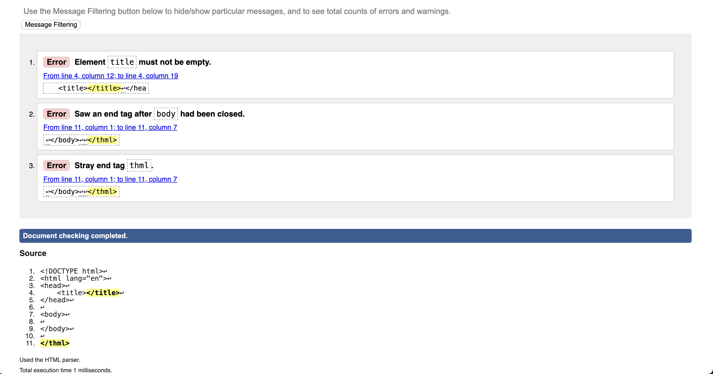Starter Code with Errors:

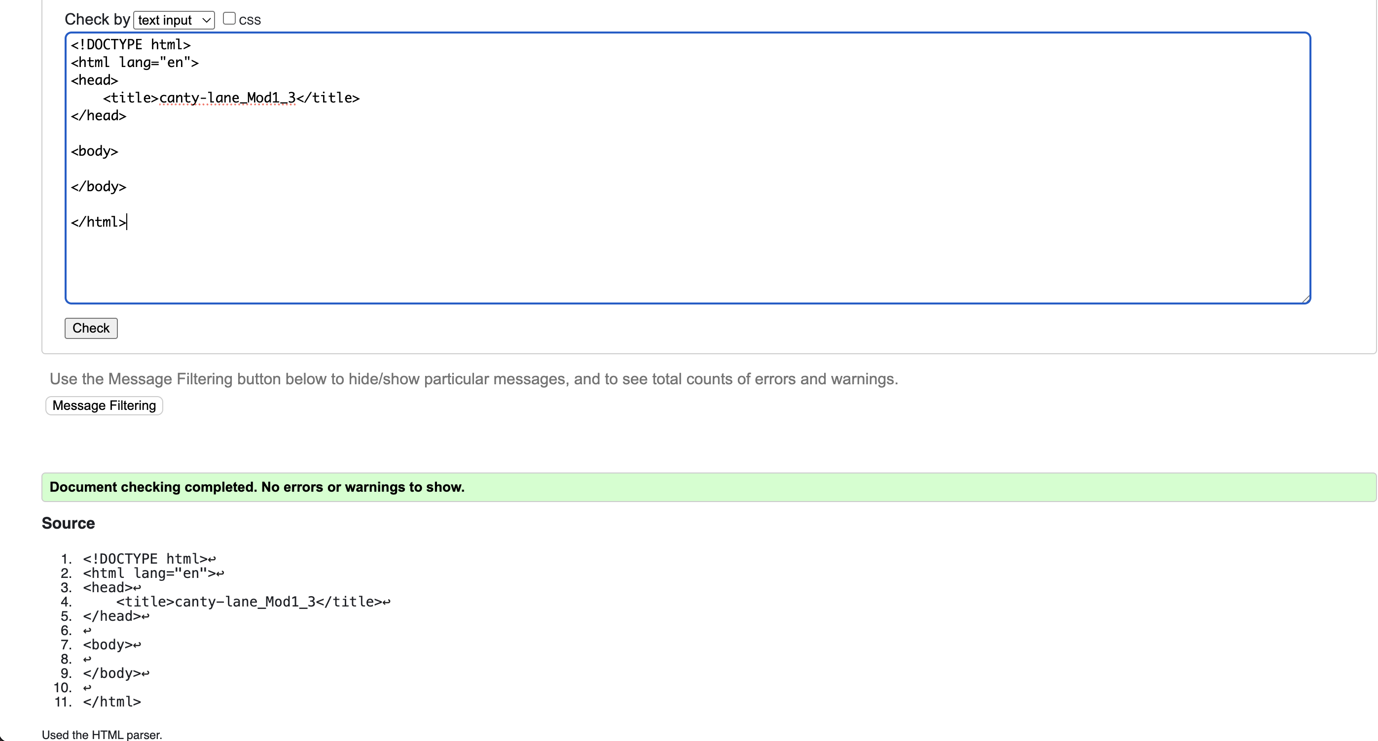Starter Code with Corrections

Starter Code with Instructor Provided Edits:

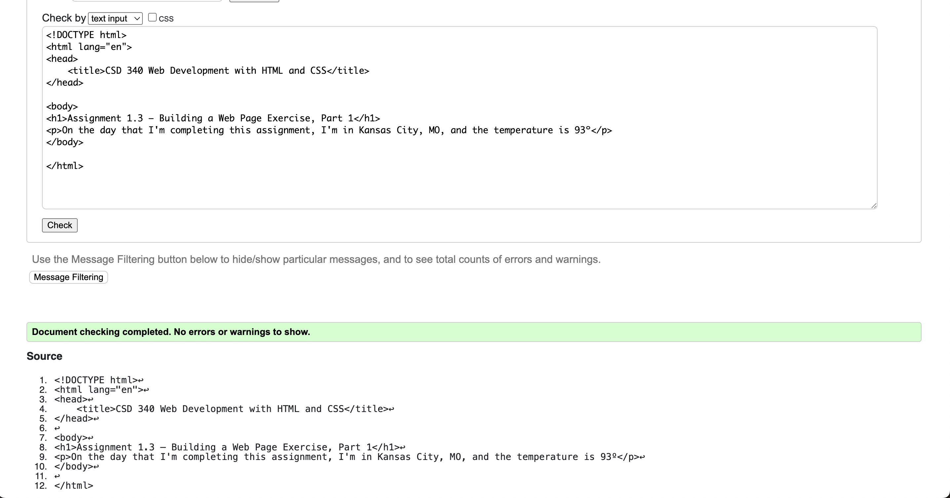

Web rendering of starter code: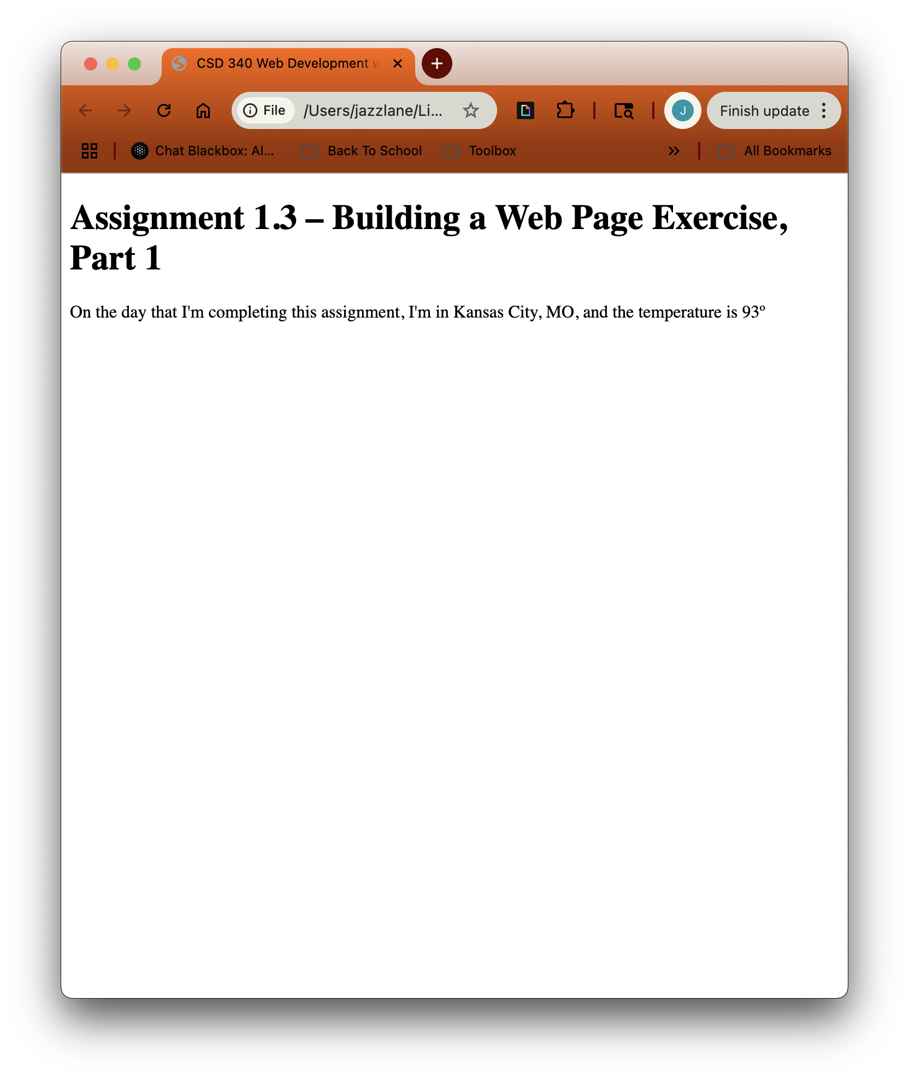

Git Hub commit issues (https://github.com/AndAwllThatJazz/csd-340)

The staging seems to be working, but upon being prompted to commit changes, username and password are requested, but the terminal cmd line does not allow me to type any characters at the password request so it can’t authenticate and commit the changes. I’m not sure what the issue is here.

