Jazz Canty-Lane

9/21/2025

CSD340-T301 Web Development with HTML and (2261-1)

Assignment 3.1

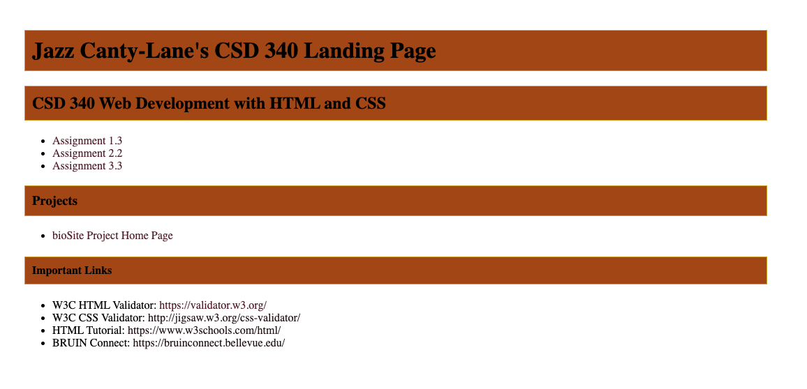

<!DOCTYPE html>

<html lang="en">

<head>

<title>Jazz Canty-Lane's CSD 340 Landing Page</title>

<meta name="author" content="Jazz Canty-Lane">

<meta name="description" content="Assignment: Module3, Assignment 3.2">

<meta name="keywords" content="bellevue, html, css, web, development">

<meta name="robots" content="nofollow">

<link rel="stylesheet" href="site.css">

</head>

<body>

<div id="container">

<h1>Jazz Canty-Lane's CSD 340 Landing Page</h1>

<h2>CSD 340 Web Development with HTML and CSS</h2>

<ul>

<li><a href="module-1/canty-lane_Mod1_3.html" aria-label="Assignment 1.3" target="_blank">Assignment 1.3</a></li>

<li><a href="module-2/Canty-Lane_Mod2_2html.html" aria-label="Assignment 2.2" target="_blank">Assignment 2.2</a></li>

<li><a href="#" aria-label="Assignment 3.3" target="_blank">Assignment 3.3</a></li>

</ul>

<h3>Projects</h3>

<ul>

<li>

<a href="#">bioSite Project Home Page</a>

</li>

</ul>

<h4>Important <span style="font-weight: bold;">Links</span></h4>

<ul>

<li>W3C HTML Validator: <a href="https://validator.w3.org/" target="_blank">https://validator.w3.org/</a></li>

<li>W3C CSS Validator: <a href="http://jigsaw.w3.org/css-validator/" target="_blank">http://jigsaw.w3.org/css-validator/</a></li>

<li>HTML Tutorial: <a href="https://www.w3schools.com/html/" target="_blank">https://www.w3schools.com/html/</a></li>

<li>BRUIN Connect: <a href="https://bruinconnect.bellevue.edu/" target="_blank">https://bruinconnect.bellevue.edu/</a></li>

</ul>

</div>

</body>

</html>

/* This is the main css file for Module 3 Assignment */

/* Jazz Canty-Lane */

/* 9/21/2025 */

#container {

margin: 50px 100px 0 100px;

}

h1, h2, h3, h4 {

background-color: #ad4f01!important;

color: black;

border: 1px solid #D6A800;

padding: 10px;

}

a, li a {

color: #281518;

text-decoration: none;

transition: .3s all;

}

a:visited, li a:visited {

color: #5b2030;

}

a:hover, li a:hover {

color: #a37870;

}