network_analyses

2025-05-19

knitr::opts_chunk$set(  
 echo = FALSE, # Hide code  
 message = FALSE, # Hide messages  
 warning = FALSE ) # Increase plot

## Analyses networks

## Finding R package dependencies ... Done!

### network properties from the edgelist.csv dataset

#### Good friends

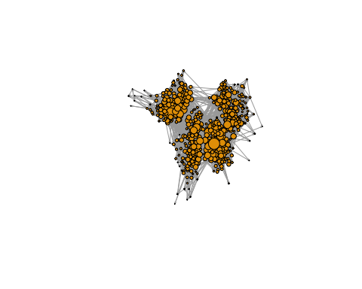

#### Best friends

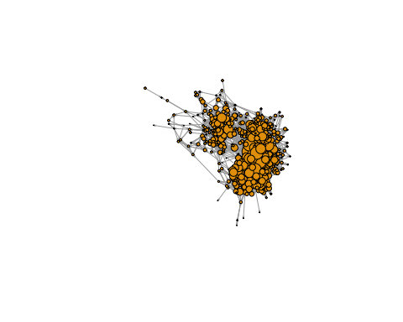

Network Summary

| Metric | GoodFriend | BestFriend |
| --- | --- | --- |
| Average degree | 29.06 | 16.99 |
| Average path length (largest component) | 3.25 | 8.76 |
| Degree (min - max) | 2 - 134 | 1 - 89 |
| Degree SD | 15.6 | 11.91 |
| Density | 0.026 | 0.015 |
| Diameter (largest component) | 7 | 26 |
| Largest component size | 562 | 555 |
| Number of components | 1 | 1 |
| Number of edges | 8165 | 4714 |
| Number of nodes | 562 | 555 |
| Reciprocity | 0.315 | 0.473 |

### Distribution of network properties

## [1] 8.043636

