TP2 – RSA

Exercice 1 :

1/

(a)

In the following capture you will see two implementations for totient function. The first one I did myself, and the second one using sympy library.

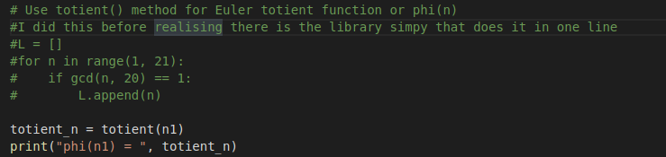
You can see results by using sage with my python code (‘../SageMath/sage ./tp2-rsa_material.sage.py’ for example).

(b)

As for the previous question, I used the sympy library.

(c)

In order to recover plaintext from C1, I used previous computation (private Key), a sage function (power_mod) and another one to translate int into ascii caracters. After decrypting, the plaintext is : ‘There is a reason we use two primes and not just one !’

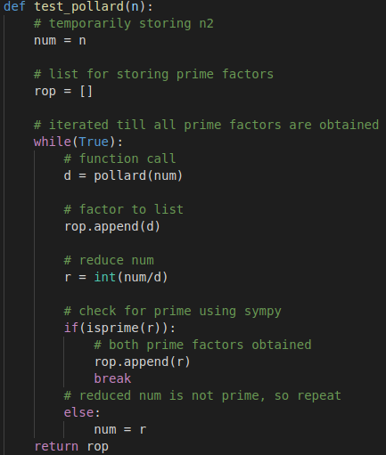
2/

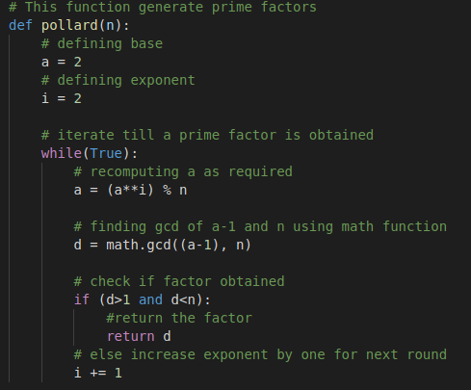

In order to implement the pollard p-1 function, I used two functions. One for pollard p-1 itself which iterates until it finds a suitable prime, and the second one to test and find the second prime. At the end, we have at least two primes for one given ‘n’. These primes are such that p*p’=n.

3/

After decrypting C2, we get : « In practice, we often choose safe-primes : p=2*p’ + 1, with p’ prime. This ensure tat p-1 has a big prime factor, and avoid such problems ».

Exercice 2 :

Here we use an LSB oracle server that returns the last significant bit of a plaintext p corresponding to a cyphertext c (0 or 1). Knowing that c=p^e[n] and that n is composed of two primes, the goal is locate the interval for p from all returned parity bits.

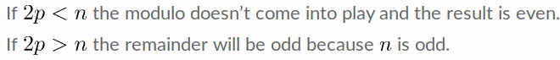
For example, If you send the cyphertext of 2p and the result is odd, you’ll know that the interval must be within (n/2)<p<n . Now restarts the process in order to further restrict the interval for p. After a few steps, we can get back the plaintext. This method is similar to the dichotomic method and allow us to fully recover p in log2(n) steps.

