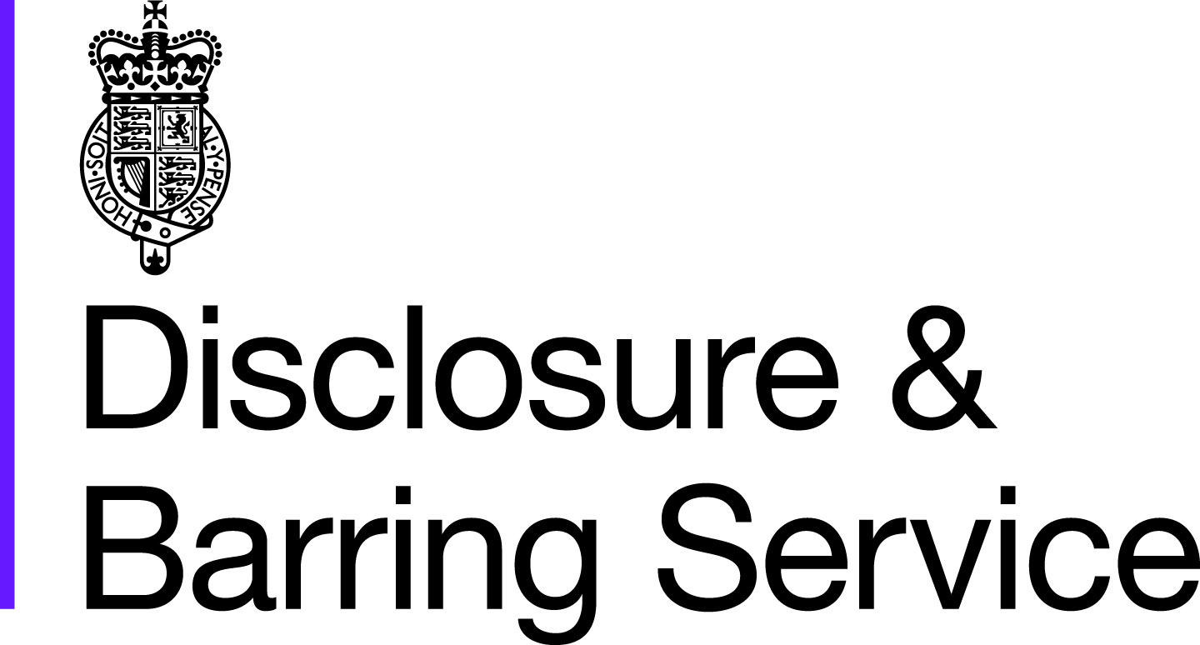

DBS basic checks - Responsible Organisation ID Guidance
Identity checking guidance for Responsible Organisations submitting basic checks to DBS

Introduction
This guidance explains what Responsible Organisations need to do in order to verify the identity of individuals applying through them for DBS basic checks. Different guidance exists for checking the identity of applicants for standard and enhanced checks.
The person (applicant) must provide original documents (not copies) to prove their identity.
The applicant must provide a range of ID documents as part of the basic check application process. The documents needed depend on the route the application takes.

As a Responsible Organisation you must:

• follow the ID checking process, as outlined in our guidance, using the lists of documents in groups 1, 1a, 2a and 2b

• check and validate the information provided by the applicant on the application form

• establish the true identity of the applicant through the face to face examination of a range of documents as set out in this guidance

• make sure the applicant provides details of all names by which they have been known

• make sure the applicant provides details of all addresses where they have lived in the last 5 years

• check that the application form is fully completed and the information it contains is accurate. Failing to do this can result in delays

If there are any discrepancies in the information provided by the applicant and/or the identity documents supplied, and fraud is not suspected, please ask the applicant to clarify before the application is submitted.

What you must do as part of the ID checking process

• you must only accept valid, current and original documentation

• you must not accept photocopies

• you must not accept documentation printed from the internet, for example internet bank statements

• identity information for the applicant’s name, date of birth and address must be validated

• you should, in the first instance, seek documents with photographic identity (e.g. passport, new style driving licence, etc.) and compare this against the applicant’s likeness

• all documents must be in the applicant’s current name as recorded on the application form

• you must ensure that the applicant declares all previous name changes, and provides documentary proof to support the change of name. If the applicant is unable to provide proof to support the change of name, you should hold a probing discussion with the applicant about the reasons why, before validating their identity

• you should cross-match the applicant’s address history with any other information you have been given, such as their CV. This can highlight if an address has not been given. For example, if the applicant’s CV shows that they have worked in Liverpool in the last 5 years, but the application form shows only London addresses, you may wish to question the applicant

•a document from each of the groups should be included only once in the document count. As one example, don’t accept two bank statements as two of the required documents, if they are from the same bank

• you should not accept the foreign equivalent of an identity document if that document is listed as ‘(UK)’ on the list of valid identity documents

A DBS check does not provide evidence of a person’s right to work in the UK. You may also need to complete a right to work check on the person to make sure they can work in the UK.

All applicants (except non-EEA national applicants applying for paid work in the UK)
The applicant can have their identity validated through Route 1. The applicant should have their identity validated using Route 1 If an applicant can’t provide Route 1 documents, Route 2 may be used once the ID checker is satisfied there’s a valid reason following a discussion with the applicant.
If an applicant is unable to provide this documentation they can’t submit a DBS basic check.
Non-EEA nationals needing a DBS check for paid work in the UK
The applicant must have their identity validated through Route 1a only.
If an applicant is unable to provide this documentation they can’t submit a DBS basic check. This is because the right to work in the UK can’t be established.

Two routes of ID checking

Route 1 (For all applicants except non-EEA national applicants needing a DBS check for paid work in the UK)
The applicant must be able to show the following:
- 1 document from Group 1, below; and
- 1 further document from either Group 1, or Group 2a or 2b, below

The combination of documents presented must confirm the applicant’s name, address and date of birth. If this can’t be achieved within 2 documents a third can be selected.

The applicant should have their identity validated using Route 1. If an applicant can’t provide Route 1 documents, Route 2 may be used once the ID checker is satisfied there’s a valid reason following a discussion with the applicant.

Route 1a (For non-EEA national applicants needing a DBS check for paid work in the UK)
The applicant must be able to show the following:
- 1 document from Group 1a, below; and
- 1 further document from either Group 1, Group 2a or 2b, below

The combination of documents presented must confirm the applicant’s name, address and date of birth. If this can’t be achieved within 2 documents a third can be selected.
If an applicant is unable to provide this documentation they can’t submit an application for DBS basic check. This is because the right to work in the UK can’t be established.

Route 2 (For all applicants except non-EEA national applicants needing a DBS check for paid work in the UK)
If the applicant doesn’t have any of the documents in Group 1, they must be able to show:
- 1 document from Group 2a
- 2 further documents from either Group 2a or 2b

The combination of documents presented must confirm the applicant’s name, address and date of birth.
If an applicant is unable to provide this documentation they can’t submit an application for a DBS basic check.

Identity Documents:

Group 1: Primary identity documents
Document | Notes
Passport | Any current and valid passport
Current biometric residence permit | UK
Current driving licence photocard - (full or provisional) | UK, Isle of Man, Channel Islands and EEA
Birth certificate - issued within 12 months of birth | UK, Isle of Man and Channel Islands - including those issued by UK authorities overseas, e.g. embassies, High Commissions and HM Forces
Adoption certificate | UK and Channel Islands

Group 1a: Primary identity documents for non-EEA nationals
Document | Notes
A current Biometric Immigration Document (Biometric Residence Permit) issued by the Home Office to the holder indicating that the person named is allowed to stay indefinitely in the UK, or has no time limit on their stay in the UK. | UK
A current Biometric Immigration Document (Biometric Residence Permit) issued by the Home Office to the holder which indicates that the named person can currently stay in the UK and is allowed to do the work in question.  A current passport endorsed to show that the holder is exempt from immigration control, is allowed to stay indefinitely in the UK, has the right of abode in the UK, or has no time limit on their stay in the UK. | UK  Any current and valid Passport
A current passport endorsed to show that the holder is allowed to stay in the UK and is currently allowed to do the type of work in question. | Any current and valid Passport
A Certificate of Application issued by the Home Office under regulation 17(3) or 18A (2) of the Immigration (European Economic Area) Regulations 2006, to a family member of a national of a European Economic Area country or Switzerland stating that the holder is permitted to take employment which is less than 6 months old together with a Positive Verification Notice from the Home Office Employer Checking Service.  An Application Registration Card issued by the Home Office stating that the holder is permitted to take the employment in question, together with a Positive Verification Notice from the Home Office Employer Checking Service.  Applicants providing one of the following documents must also provide a current valid Passport:  A current Residence Card (including an Accession Residence Card or a Derivative Residence Card) issued by the Home Office to a non-European Economic Area national who is a family member of a national of a European Economic Area country or Switzerland or who has a derivative right of residence. | UK  UK  UK
A current Immigration Status Document containing a photograph issued by the Home Office to the holder with a valid endorsement indicating that the named person may stay in the UK, and is allowed to do the type of work in question, together with an official document giving the person’s permanent National Insurance number and their name issued by a Government agency or a previous employer. | UK
A current Immigration Status Document issued by the Home Office to the holder with an endorsement indicating that the named person is allowed to stay indefinitely in the UK or has no time limit on their stay in the UK, together with an official document giving the person’s permanent National Insurance number and their name issued by a Government agency or a previous employer. | UK

Group 2a: Trusted government documents
Document | Notes
Current driving licence photo-card - (full or provisional) | All countries outside the EEA (excluding Isle of Man and Channel Islands)
Current driving licence (full or provisional) - paper version (if issued before 1998) | UK, Isle of Man, Channel Islands and EEA
Birth certificate - issued after time of birth | UK, Isle of Man and Channel Islands
Marriage/civil partnership certificate | UK and Channel Islands
HM Forces ID card | UK
Firearms licence | UK, Channel Islands and Isle of Man
Non EEA Immigration Document/Visa/Work permit | Valid only for roles whereby the applicant is living and working outside of the UK. Visa/permit must relate to the non EEA country in which the role is based

Group 2b: Financial and social history documents
Document | Notes | Issue date and validity
Mortgage statement | UK or EEA | Issued in last 12 months
Bank or building society statement | UK and Channel Islands or EEA | Issued in last 3 months
Bank or building society account opening confirmation letter | UK | Issued in last 3 months
Credit card statement | UK or EEA | Issued in last 3 months
Financial statement, eg pension or endowment | UK | Issued in last 12 months
P45 or P60 statement | UK and Channel Islands | Issued in last 12 months
Council Tax statement | UK and Channel Islands | Issued in last 12 months
Letter of sponsorship from future employment provider | Non-UK or non-EEA only - valid only for applicants residing outside of the UK at time of application | Must still be valid
Utility bill | UK - not mobile telephone bill | Issued in last 3 months
Benefit statement, eg Child Benefit, Pension | UK | Issued in last 3 months
Central or local government, government agency, or local council document giving entitlement, eg from the Department for Work and Pensions, the Employment Service, HMRC | UK and Channel Islands | Issued in last 3 months
EEA National ID card | - | Must still be valid
Cards carrying the PASS accreditation logo | UK, Isle of Man and Channel Islands | Must still be valid
Letter from head teacher or college principal | UK - for 16 to 19 year olds in full time education - only used in exceptional circumstances if other documents cannot be provided | Must still be valid

Non EEA Bank or building society  statement | Valid only for roles whereby the applicant is  living and working outside of the UK.  Statement must relate to a bank or building  society from the non EEA country in which  the role is based.

Applicants who have been adopted

If they were adopted before the age of 10, they do not need to provide their surname at birth. This is because the age of criminal responsibility is deemed to be 10 years, under the Children and Young Persons Act 1933, Chapter 12, Section 50. This means that there is no possibility that an individual could have a criminal record in a name that was used until the age of 10.

Checking driving licences

Do not accept licences, other than those stated in the list of valid identity documents.

English, Welsh and Scottish driving licence numbers contain information about the applicant’s name, sex and date of birth. This information is written in a special format but can be gleaned and matched against the information provided by the applicant.

Please note that the date of birth on English, Welsh and Scottish driving licences, issued before 1977, is not recorded as a separate entry on the licence. The date of birth can be deciphered from the driving licence number and checked against the date of birth field on the application form.

For example, the format of the number for Christine Josephine Robinson, born 2 July 1975

R O B I N 7 5 7 0 2 5 C J 9 9 9 0 1

N N N N N Y M M D D Y I I C C C C C

N = 1st five letters of the surname (if the surname begins MAC or MC it is treated as MC for all).

Y = YEAR of birth.

M = MONTH of birth (In the case of a female, the number represented by the first M will have the value 5 added to the first digit e.g. a female born in November (i.e. 11) would display ‘61’ in the MM boxes or if born in February (i.e. 02) would display ‘52’).

D = DAY of month of birth.

I = Initial letter of the first two forenames - if only one, then 9 will replace the second letter. If the licence indicates that the applicant has a middle name, ensure that one has been provided in Section A.

C = Computer generated.

For Northern Ireland; Isle of Man and Jersey driving licences the licence number is in a different format. The licence number is unique to the driver and the ‘name’ or ‘date of birth’ validation, as shown above, cannot be used.

How do I check for indicators of fraud?

Always check for signs of tampering when checking identity documents. Documents should be queried if they display any signs of damage, especially in the areas of personal details such as the name and the photograph. The following guidelines should help you look out for any suspicious signs when authenticating documents. The National Document Fraud Unit (NDFU) in the Home Office has published guidance on examining identity documents to detect basic forgeries.

Checking a passport

Check the general quality and condition of the passport. Treat it with suspicion if it is excessively damaged; accidental damage is often used to conceal tampering.

Photographs should be examined closely for signs of damage to the laminate or for excessive glue or slitting of the laminate; these signs would indicate photo substitution. If the photograph appears excessively large, this might indicate an attempt to hide another photograph underneath. There should also be an embossed strip embedded into the laminate, which will catch a portion of the photograph.

Check there is no damage to this area. If the passport is from a foreign national, you can still follow the same procedures as above.

Her Majesty’s Passport Office has produced a guide to be used when checking passports for identification.

Checking a photo driving licence

Examine the licence for evidence of photo tampering or any amendment of the printed details.

Checking an old style driving licence (no photograph)

Remove the document from the plastic wallet and check that it is printed on both sides.

It should have a watermark visible by holding the licence up to the light and there should be no punctuation marks in the name or address.

The ‘Valid To’ date should be the day before the bearer’s 70th birthday (unless the bearer is already over 70). The ‘Valid To’ date can therefore be cross-referenced with the applicant’s date of birth detailed in Section A.

Checking a birth certificate

Birth certificates are not evidence of identity, and are easily obtained. Although certificates issued at the time of birth may give more confidence that it belongs to the individual, unlike a recently issued certificate, they will not show if any information has been corrected or superseded by a new registration.

Check the quality of paper used; genuine certificates use a high grade. There should be a watermark visible when the document is held up to the light. Any signs of smoothness on the surface would indicate that original text might have been washed or rubbed away. There should be no signs of tampering, changes using liquid paper, overwriting or spelling mistakes.

The following list provides some general information about certificate completion which may help to establish whether the certificate and/or the details have been falsified. This is provided solely as a guide and is not exhaustive:

•the certificate format used should be appropriate for the year of registration.

•only the surname should be entered in upper case, not the forename(s).

•dates of birth should be shown with the day and month in words and the year in figures.

The following information might indicate that the certificate has been altered:

•spacing between falsely added particulars might be irregular compared to original information. ‘Thick’ or ‘thin’ spacing might infer particulars have been added.

•false particulars might not have been aligned with other words.

•characters may not be of the same size or shape with the rest of the particulars.

•movement of handwriting may look mechanical and does not flow with the rest of the particulars.

•changes might not be consistent e.g. parents’ surnames might be altered, but not the signatures.

•the area around falsely added or removed particulars may react differently under an ultra violet light i.e. show signs of staining. In addition, such areas of paper may appear thinner where the paper fibres have been disturbed by abrasion.

For more information on checking birth certificates, please refer to Her Majesty’s Passport Office document General Register Office guide to birth certificates.

Checking an EEA photo identity card

Examine the card for evidence of photo tampering or any amendment of the printed details.

Checking an HM Forces ID card

Examine the card for evidence of photo tampering or any amendment of the printed details.

Checking a firearms licence

Check the licence is printed on blue security paper with a Royal crest watermark and a faint pattern stating the words ‘Home Office’.

Examine the licence for evidence of photo tampering or any amendment of the printed details, which should include home address and date of birth.

The licence should be signed by the holder and bear the authorising signature of the chief of police for the area in which they live, or normally a person to whom his authority has been delegated.

Checking a biometric residence permit
View the features of a permit and how to check a job applicant’s biometric residence permit to see if they have a right to work in the UK.

Other types of ID

Ensure all letters and statements are recent, i.e. within a three month period. Do not accept documentation printed from the internet.

Check letter headed paper is used, bank headers are correct and all documentation looks genuine. The address should be cross-referenced with that provided by the applicant.

What should you do if you suspect false identity or documents?

If you suspect that you have been presented with a false identity or documents at the time of application, do not proceed with the application process.

• report suspected identity fraud through the Action Fraud website

• further information on identity fraud can be found on the Metropolitan police website

• if you suspect identity fraud once a DBS check has been submitted, you must call us on 03000 200 190

You are also advised that under Section 8 of the Asylum and Immigration Act 1996 all employers in the United Kingdom are required to make basic document checks to help prevent anyone from working illegally.

By carrying out checks employers will be able to establish a defence for themselves if any of their employees are found to be working illegally at a later date.

Further details are available on the UK visas and immigration website or by calling the employer helpline on 0845 010 6677.

Where to go for help to check non-UK issued identity and travel documents

You can go to the public register of authentic identity and travel documents online on the PRADO website to identify the basic safeguards contained in European documents and a few more other nationality documents.

The PRADO website is provided by the Council of European Union.

