|  |  |
| --- | --- |
| **agh_znk_wbr_rgb_150ppi** | **AKADEMIA GÓRNICZO-HUTNICZA**  **im. Stanisława Staszica w Krakowie**  **WYDZIAŁ INŻYNIERII MECHANICZNEJ I ROBOTYKI** |

**Praca dyplomowa**

**magisterska**

|  |
| --- |
| **Andrzej Szewczyk** |
| *Imię i nazwisko* |
| **Inżynieria Mechatroniczna** |
| *Kierunek studiów* |
| **Narzędzie wspierające proces ciągłej integracji poprzez dobór optymalnego zestawu testów.** |

*Temat pracy dyplomowej*

|  |
| --- |
| **Continuous integration tool that supports the process by an optimal test suite selection.** |
| *Subject of master diploma thesis* |

|  |  |  |
| --- | --- | --- |
| **dr inż. Lucjan Miękina** |  | ………………….. |
| *Promotor pracy* |  | *Ocena* |

Kraków, rok 20...../20.....

Kraków, ……………..

|  |  |
| --- | --- |
| Imię i nazwisko: | Andrzej Szewczyk |
| Nr albumu: | 270039 |
| Kierunek studiów: | Inżynieria Mechatroniczna |
| Specjalność: | Projektowanie Mechatroniczne |

**OŚWIADCZENIE**

Uprzedzony o odpowiedzialności karnej na podstawie art. 115 ust 1 i 2 ustawy z dnia 4 lutego 1994 r. o prawie autorskim i prawach pokrewnych (tj. Dz.U.z 2006 r. Nr 90, poz. 631 z późn.zm.) : „Kto przywłaszcza sobie autorstwo albo wprowadza w błąd co do autorstwa całości lub części cudzego utworu albo artystycznego wykonania, podlega grzywnie, karze ograniczenia wolności albo pozbawienia wolności do lat 3. Tej samej karze podlega, kto rozpowszechnia bez podania nazwiska lub pseudonimu twórcy cudzy utwór w wersji oryginalnej albo w postaci opracowania, artystyczne wykonanie albo publicznie zniekształca taki utwór, artystyczne wykonanie, fonogram, wideogram lub nadanie”, a także uprzedzony o odpowiedzialności dyscyplinarnej na podstawie art. 211 ust.1 ustawy z dnia 27 lip[ca 2005 r. Prawo o szkolnictwie wyższym (tj. Dz.U. z 2012 r. poz. 572, z późn.zm.) „Za naruszenie przepisów obowiązujących w uczelni oraz za czyny uchybiające godności student ponosi odpowiedzialność dyscyplinarną przed komisją dyscyplinarną albo przed sądem koleżeńskim samorządu studenckiego, zwanym dalej „sądem koleżeńskim”, oświadczam, że niniejszą pracę dyplomową wykonałem(-am) osobiście i samodzielnie i że nie korzystałem (-am) ze źródeł innych niż wymienione w pracy”.

.....................................................

*podpis dyplomanta*

Kraków, ……………..

|  |  |
| --- | --- |
| Imię i nazwisko: | Andrzej Szewczyk |
| Nr albumu: | 270039 |
| Kierunek studiów: | Inżynieria Mechatroniczna |
| Specjalność: | Projektowanie Mechatroniczne |

**OŚWIADCZENIE**

Świadomy/a odpowiedzialności karnej za poświadczanie nieprawdy oświadczam, że niniejszą inżynierską pracę dyplomową wykonałem/łam osobiście i samodzielnie oraz nie korzystałem/łam ze źródeł innych niż wymienione w pracy.

Jednocześnie oświadczam, że dokumentacja praca nie narusza praw autorskich   
w rozumieniu ustawy z dnia 4 lutego 1994 roku o prawie autorskim i prawach pokrewnych (Dz. U. z 2006 r. Nr 90 poz. 631 z późniejszymi zmianami) oraz dóbr osobistych chronionych prawem cywilnym. Nie zawiera ona również danych i informacji, które uzyskałem/łam w sposób niedozwolony. Wersja dokumentacji dołączona przeze mnie na nośniku elektronicznym jest w pełni zgodna z wydrukiem przedstawionym do recenzji.

Zaświadczam także, że niniejsza inżynierska praca dyplomowa nie była wcześniej podstawą żadnej innej urzędowej procedury związanej z nadawaniem dyplomów wyższej uczelni lub tytułów zawodowych.

………………………………..

*podpis dyplomanta*

Kraków, ……………..

Imię i nazwisko: Andrzej Szewczyk

Adres korespondencyjny: 42-100 Kłobuck, ul. Kościuszki 37

Temat pracy dyplomowej inżynierskiej: Narzędzie wspierające proces ciągłej integracji poprzez dobór optymalnego zestawu testów.

Subject of engineer diploma thesis: Continuous integration tool that supports the process by an optimal test suite selection.

Rok ukończenia: 2018

Nr albumu: 270039

Kierunek studiów: Inżynieria Mechatroniczna

Profil dyplomowania: Projektowanie Mechatroniczne

**OŚWIADCZENIE**

Niniejszym oświadczam, że zachowując moje prawa autorskie, udzielam Akademii Górniczo-Hutniczej im. S. Staszica w Krakowie nieograniczonej w czasie nieodpłatnej licencji niewyłącznej do korzystania z przedstawionej dokumentacji magisterskiej pracy dyplomowej, w zakresie publicznego udostępniania i rozpowszechniania w wersji drukowanej i elektronicznej.

Kraków, ...............… ……………………………..

*data podpis dyplomanta*

i Na podstawie Ustawy z dnia 27 lipca 2005 r. Prawo o szkolnictwie wyższym (Dz.U. 2005 nr 164 poz. 1365) Art. 239. oraz Ustawy z dnia 4 lutego 1994 r. o prawie autorskim i prawach pokrewnych (Dz.U. z 2000 r. Nr 80, poz. 904, z późn. zm.) Art. 15a. "Uczelni w rozumieniu przepisów o szkolnictwie wyższym przysługuje pierwszeństwo w opublikowaniu pracy dyplomowej studenta. Jeżeli uczelnia nie opublikowała pracy dyplomowej w ciągu 6 miesięcy od jej obrony, student, który ją przygotował, może ją opublikować, chyba że praca dyplomowa jest częścią utworu zbiorowego."

Kraków, ……………..

**AKADEMIA GÓRNICZO-HUTNICZA**

**WYDZIAŁ INŻYNIERII MECHANICZNEJ I ROBOTYKI**

**TEMATYKA MAGISTERSKIEJ PRACY DYPLOMOWEJ**

dla studenta II roku studiów stacjonarnych

*imię i nazwisko studenta*

|  |  |
| --- | --- |
| TEMAT PRACY DYPLOMOWEJ MAGISTERSKIEJ: |  |

Narzędzie wspierające proces ciągłej integracji poprzez dobór optymalnego zestawu testów.

SUBJECT OF MASTER DIPLOMA THESIS:

Continuous integration tool that supports the process by an optimal test suite selection.

*Promotor pracy:* dr inż. Lucjan Miękina

*Recenzent pracy:* dr hab. inż. Mariusz Giergiel, prof. AGH *Podpis dziekana:*

PLAN PRACY DYPLOMOWEJ

1. Omówienie tematu pracy i sposobu realizacji z promotorem.
2. Zebranie i opracowanie literatury dotyczącej tematu pracy.
3. Zebranie i opracowanie wyników badań.
4. Analiza wyników badań, ich omówienie i zatwierdzenie przez promotora.
5. Opracowanie redakcyjne.

Kraków, ...............… ……………………………..

*data podpis dyplomanta*

**TERMIN ODDANIA DO DZIEKANATU: 20        r.**

*podpis promotora*

Kraków, ……………..

Akademia Górniczo-Hutnicza im. Stanisława Staszica

**Wydział Inżynierii Mechanicznej i Robotyki**

Kierunek: Inżynieria Mechatroniczna

Profil dyplomowania: Projektowanie Mechatroniczne

**Andrzej Szewczyk**

**Magisterska praca dyplomowa**

**Narzędzie wspierające proces ciągłej integracji poprzez dobór optymalnego zestawu testów.**

Opiekun: dr inż. Lucjan Miękina

STRESZCZENIE

W ostatnich latach miała miejsce gigantyczna digitalizacja życia codziennego każdego z nas. Zastanówmy się ile jest przedmiotów w zasięgu naszego wzroku, w których znajduje się mikroprocesor realizujący pewien ciąg instrukcji na podstawie kodu. Osoby niezwiązane w branżą IT zapewne dojdą do następującego wniosku: skoro urządzenia lub aplikacje, które są na co dzień używane, wymagają dobrze napisanego kodu w celu spełnienia oczekiwań użytkownika, to zapewne potrzeba skończonej liczby programistów, którzy ten kod napiszą. Niestety, nic bardziej mylnego. Aby firma tworząca oprogramowanie mogła odnieść komercyjny sukces, musi ona, oprócz wykwalifikowanych pracowników, posiadać również skuteczny proces, który zapewni, że oprogramowanie dostarczone końcowemu klientowi jest możliwie wysokiej jakości.

Celem niniejszej pracy magisterskiej jest zaprezentowanie narzędzia, które prowadzi nie tylko do zwiększenia jakości końcowego kodu, ale również zmniejsza ryzyko niepowodzenia projektu oraz przyspiesza czas jego realizacji. Systemy ciągłej integracji oparte na regularnym dostarczaniu, budowaniu i automatycznym testowaniu zintegrowanych wersji kodu stały się normą w nowoczesnych firmach programistycznych. Rozwiązanie opisane w tej pracy może dodatkowo usprawnić proces ciągłej integracji, ponieważ natychmiastowe wykonanie optymalnego zestawu testów regresyjnych dobranych na podstawie zmian w kodzie, zapewnia wartościową informację na temat jakości testowanej wersji oprogramowania. Zaprezentowane narzędzie mogłoby być skutecznie wykorzystane w fazie rozwoju dużych systemów informatycznych oraz w międzynarodowych, dużych zespołach programistycznych.

Kraków, the……………..

AGH University of Science and Technology

**Faculty of Mechanical Engineering and Robotics**

Field of Study: Mechatronics engineering

Specializations: Mechatronics design

**Andrzej Szewczyk**

**Master Diploma Thesis**

**Continuous integration tool that supports the process by an optimal test suite selection.**

Supervisor: dr inż. Lucjan Miękina

SUMMARY

In the recent years, reality of everyday life has undergone the real digital transformation. Let’s think about how many devices in our sight have a CPU[[1]](#footnote-1), which is executing a set of instructions based on the code. Most people that are not familiar with the IT[[2]](#footnote-2) industry will draw the following conclusion: since all devices or applications that are used every day require a well-written code in order to satisfy end-user needs, there is a need to have a finite number of programmers to write this code. Still, there is nothing more wrong. If a company that delivers software wants to achieve the success, besides good programmers, this company must have a process, which is aimed at ensuring that the software delivered to an end-customer has the best possible quality.

The purpose of this master thesis is to propose a tool that leads not only to quality improvement of the final code, but also mitigates the risks in a project and accelerates time to market. Continuous integration systems that have been built based on regular delivery of automatically pre-tested integrated code builds are a common practice in modern IT companies. The solution described in this thesis could further enhance the continuous integration process, because immediate execution of an optimal regression test suite, which is selected based on changes in the latest code commit, provides valuable information on quality of the software version under test. The proposed tool may be effectively used in the development phase of large-scale IT systems or by global software development teams.

# Introduction

This chapter is intended to introduce the reader to the content of the thesis. It comprises four sections. Section 1.1. defines the main goal of the thesis and illustrates the steps taken to achieve it. Section 1.2. briefly presents the role of continuous integration in modern software development methodologies. Section 1.3. discusses how my interest in the CI[[3]](#footnote-3) process has aroused, including a mention of two years of my professional experience with the software development process in the multiple international teams. Section 1.4 examines sources of information which refer to the subject of the thesis.

## Goal and plan of the thesis

TBD

## Why continuous integration is important

Agile methodologies are currently one of the most well-known and frequently used software development life cycle models. It is difficult to find a job offer for a programmer that does not contain any of the following words: Agile, Scrum, pair programming, CI, CD[[4]](#footnote-4) and much more associated with the agile methodologies.

In a nutshell, there are two main goals of CI: to automatically generate a software build and to provide developers with immediate feedback about quality of the recent code build. This approach to the software development process claims to be more human friendly than traditional development methods.

At this place, I would like to make a reference to Manifesto for Agile Software Development. This manifesto was proclaimed by the seventeen signatories during a meeting in Snowbird, Utah between 11th and 13th of February 2001. This meeting is said to be the beginning of a revolution in software development. Since then, the eXtreme Programming (XP) enthusiasts are setting the pace for development of state-of-the-art digital technologies. The above-mentioned agile methodologies are the most common ideas behind the XP approach.

The following declaration has been made at this meeting:

“We are uncovering better ways of developing software by doing it and helping others do it. Through this work we have come to value:

* Individuals and interactions over processes and tools,
* Working software over comprehensive documentation,
* Customer collaboration over contract negotiation,
* Responding to change over following a plan.

That is, while there is value in the items on the right, we value the items on the left more. [1]”

How does CI relate to the above declaration? Since collaboration with a customer is very important, the simplest way to collaborate with customers is to present the outcome of our work on a regular basis. The point is that, in order to show the customer a product, the code that is running inside this product has to work as the customer expects. The question arises, is it possible to deliver new functionalities, which were implemented in the code written a few hours ago, to the customer with a high degree of certainty in terms of its good quality. Of course, it is possible to achieve this. The only thing that needs to be done before handing a product off to a customer is to find issues in the code and fix them long before the customer will find these issues.

In the preceding subparagraph, is has been said that a product can be delivered to a customer as soon as an evidence on quality of the working code is provided. These are just some of the requirements for a software development process that allows to release new functionalities within the tight deadlines:

* The build process shall be done automatically following the strictly defined procedure,
* The test environment shall emulate the normal operating condition for a product as close as possible,
* Test scripts shall be written before the code is written and those tests should be automated,
* Integration and testing of the code shall happen several times a day,
* The simples solutions shall be implemented to meet today’s problems,
* Generation of business stories should be used to define the functionality,
* Shared code ownerships amongst the developers shall be promoted,
* An on-site customer for continual feedback and to define functional acceptance testing shall play a crucial role in the project. Those acceptance tests may be automated and built-in in the CI pipeline while being supervised by the customer.

With the above requirements, there are numerous iterations of software builds, each requiring testing. Once a developer starts writing every test case, it has to be ensured that it can be automated. Every time a change is introduced in the code, it shall be tested at the component level and then integrated with the existing code, which is then fully integration-tested using the full set of test cases. This gives continuous integration, by which it is meant that changes are incorporated continuously into the software build [2].

## Motivation to take Continuous Integration topic up

This paragraph is a quick summary of my engineering career path. I started my career here in AGH University of Science and Technology as a mechatronics engineering student, then in parallel to the studies, I have been an intern in Industrial Turbomachinery Systems department in Woodward Poland sp. z o.o. for 14 months, finally I ended up as an embedded software verification engineer in Aircraft Turbine Systems department in the same company. Oddly enough, I have never got a chance to work on a project that has been developed based on one of the agile methodologies. Due to the strict certification process, the projects I was involved in are mostly developed using the V-model software development life cycle. Each level in the V-model was divided into small activities that were realized using the customized waterfall models.

The interesting thing is that, while I was working on particular projects, I did not consider some project activities as problems that are mainly caused by some weaknesses of the V-model or waterfall model itself. Currently, I am aware that most of these problems can be easily addressed by introducing agile methodologies into the project activities. The breakthrough that has led to changes in my outlook on software development process was participation in the ISTQB[[5]](#footnote-5) Foundation Level course.   
I passed the certification and gained the practical knowledge of the fundamental concepts of software testing including people in roles such as testers, test analysts, test engineers, test consultants, test managers, user acceptance testers and software developers. The scope of ISTQB Foundation Level covers all software development practices including Waterfall, Agile, DevOps and Continuous Delivery [3].

There is huge potential for making use of agile methodologies, particularly the CI process, to enhance the process of embedded software development for aerospace applications. Thus, I have decided to develop and validate my own continuous integration tool. I did my best to deliver a solution that can solve many engineering difficulties I have encountered in the past. Furthermore, while I was working on the CI tool that is subject to this thesis, I was facing many challenges. Solving many of these problems was very demanding and time consuming. Thus, it should not be a surprise to anyone that, to complete a software project on time and on budget, there is a need to have a CI expert onboard, who is responsible for development and maintenance of the whole CI infrastructure dedicated to the project.

## Review of technological know-how for CI process

In the recent years, continuous integration has become a very popular cure to the common dysfunction of many software teams. Thus, it is obvious that the CI subject matter experts want to make use of their expertise for the commercial purposes. As   
a result, there is a lot of training courses teaching how to incorporate ideas of the CI process to an organization. These courses are often tailor-made and suit the needs of   
a particular organization. Participation is such courses itself can be very expensive.

On the other hand, there are some people who are still willing to share their knowledge for free. While I was working on this thesis, I found many useful information about the different aspects of continuous integration. There is a lot of articles on the software development process in the internet, which in my opinion are the most valuable source of information. The authors of these articles have been beginning from the sam starting point as I have. Similarly, they had to develop a continuous integration tool from scratch. Most of the stories presented by them start with some simple CI solutions that got the management approval. Over the course of time, the more time was spent on the CI tools development, the more buy-in was received. Finally, these guys have led to fundamental changes in the entire process of software development. There are many examples that I am referring to, be the most flourishing one, which has significantly increased my interest in CI can be found at the following link: https://bulldogjob.pl [4].

In one of the preceding subparagraphs, the costs of implementation of agile methodologies in an organization was considered. It has to be kept in mind that these cost are certainly much higher. In many cases, software teams that are adopting agile are bound undergo a deep restructuring to start thinking in agile way. Based on the below examples of successful implementation of the CI practices in the world's largest high-tech companies, undoubtedly it is worth making financial investments to use the agile mindset on a daily based.

Here are 4 trailblazing companies that exemplify the possibilities of DevOps[[6]](#footnote-6) [5]:

* Amazon – on average, engineers are deploying code every 11.7 seconds.
* Netflix – known for its commitment to automation and open source.
* Facebook – known for its accelerated development lifecycle that meets consumers' expectations of software by bi-weekly app updates, effectively served notice and constant, rapid refreshes for mobile apps.
* IBM - It is estimated that 70-80% of teams are pure agile teams.

# Software development process

Software development process, also known as a software development life cycle, is the process of dividing software development work into phases. The phases contain manageable chunks of tasks that can be assigned to individuals responsible for a certain activity within the software development life cycle. Depending on available resources, type of a software project or a product and last but not least, software development model, different activities can be can be defined. The most common are:

* Requirements definition,
* Software architecture design,
* Code development,
* Software build process definition,
* Testing,
* Debugging and bug fixing,
* Deployment,
* Configuration management,
* Maintenance.

In the next part of this paragraph, the above activities are going to be presented with an emphasis on their roles and time frames in software development models. Each of the activities may either have its own separate phase or be aggregated with another activities into one larger phase.

## Waterfall model

The waterfall model is one of the earliest models that have been defined. This model has a natural timeline and all task are executed in a sequence. At the top of the waterfall there is study of user requirements, then system requirement are defined. The waterfall flows down through the various project tasks. Once design is ready, development starts, which in turn flows into build. In the final step testing activities are carried out.

The apparent risk that arises in the waterfall approach is a likely event of finding bugs in the testing phase close to the end of the project life cycle. In general, with this model it is difficult to get feedback passed to any preceding phase in the waterfall. There are also additional difficulties if there is a need to carry out numerous iterations for a particular phase.

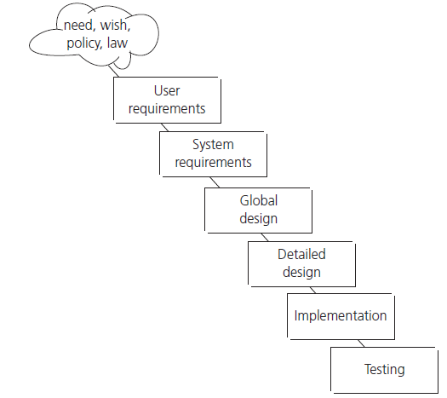

Fig, 1. Waterfall model [2].

Nonetheless, in some cases the pros of the waterfall model outweigh the cons. This model is efficient for small software projects that are carried out by few engineers. The other possibility of using the waterfall approach are projects that have well-defined requirement at the very beginning and these requirements are highly unlikely to be changed at any stage of the project.

## V - model

The V-model has been developed to address some of the problems that are being experienced using the waterfall approach. Bugs are found too late in the life cycle, as testing is not involved at the early stages of the project. The other problem associated with late testing is added lead time difficult to estimate. The fundamental principle provided by the V-model is to begin testing as early as possible in the life cycle. The model is also aimed at showing that testing is not only an execution-based activity and it defines a variety of testing activities that need be performed before the end of the code development phase. Ideally, these activities should be carried out in parallel with development activities.

The V-model illustrates how testing activities, which are validation[[7]](#footnote-7) and verification[[8]](#footnote-8), can be integrated into each phase of the life cycle. Each phase of the V-model has its own test level comprises of a group of testing activities that are organized and managed together. Validation testing takes place especially during the early stages (e.g. reviewing the user requirements), and late in the life cycle (e.g. during user acceptance testing). Verification tasks exist mostly in the middle stages of the V-model. However, in practice, a V-model may have more, fewer or different levels of development and testing.

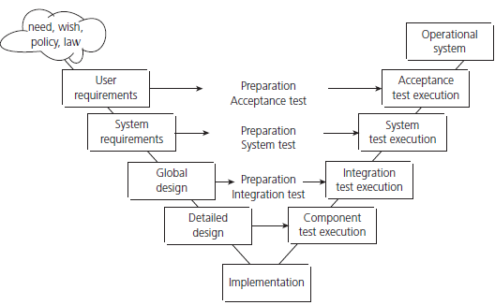

Fig, 2. V - model [2].

The V-model approach is a highly disciplined software development model. it promotes precise design, carefully development, and comprehensive documentation necessary to build stable software products. Hence, this approach is widely used in the applications that require high degree of reliability, which is standard in medical or aerospace industry.

## Iterative life cycles – agile methodologies

The main purpose of iterative or incremental life cycles is cycling through a number of smaller, effective and result-driven life cycles phases for the same project instead of one large development activity.

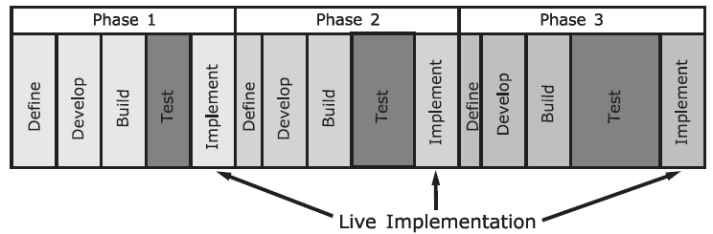

Fig, 3. Iterative development model [2].

A common feature of iterative approach is that the delivery is divided into increments or builds. The main advantage of this approach is that iterative development can give early market presence with critical functionality. As a result, the customer can provide the development team with feedback on the product. It the early versions are not satisfactory, the user or system requirements can be redefined with a little impact to the project time lime. Besides the business value and fitness-for-use of the product that are continuously improved in the subsequent deliveries to the customer, each increment adds a portion of functionality in the overall project requirements.

From the testing perspective, subsequent increments require testing for the new functionality, testing of the existing functionality and integration testing of new and existing code. Agile enthusiasts tend to say that working software is the primary measure of progress. Thus, regression testing plays a crucial role in all iterations after the first one. In some versions of the incremental approach, each phase follows a ‘mini V-model’ with its own design, coding and testing activities.

There are couple examples of incremental development models:

* Rapid Application Development (RAD),
* eXtreme Programming (XP) ,
* Agile methodologies.

For the characteristic of the above models with an emphasis on agile methodologies see section 1.2.

The iterative approach provides greater flexibility throughout the development process, because it allows the software to quickly respond to changes in market requirements or business environment.

# 3. CI and testing throughout software life cycle

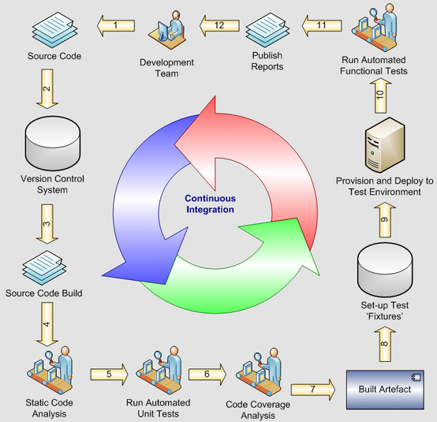

Fig, 4. Phases in a continuous integration pipeline [6].

The continuous integration pipeline presented above illustrates a wide variety of activities, such as checking out and building new versions of code (phases 1. to 4.), running tests (phases 5. To 11.), and providing the development team with feedback on quality of the latest code version (phase 12.). If all testing activities have been executed successfully and no bugs have been found, the software build under test can enter the software deployment phase.

The comparison of the phases in a continuous integration pipelines against the phases of the software development models described in chapter 2. leads to a conclusion that CI activities are present in every phase of the software life cycle, except for the requirements definition phase. However, in parallel to user and system requirements definition, the requirements for a CI server may be defined.

## 3.1. Common principles and best practices of CI process

The objectives of CI have been already mentioned in paragraph 1.2. They are: build and test software automatically and provide developers with immediate feedback about quality of the recent code build. To achieve these objectives, continuous integration relies on the following principles [7]:

* Maintain a code repository.
* Automate the build,
* Make the build self-testing,
* Every commit should be built on an integration machine,
* Keep the build fast,
* Test in a clone of the production environment,
* Make it easy for anyone to get the latest executable version
* Everyone can see the results of the latest build,
* Automate deployment.

The starting point when implementing continuous integration is an assumption that a single command should have the capability of building the system. Once system is built, all subsequent phases of a CI pipeline should run automatically one after another. To put the principles of Continuous Integration into practice, the following requirements for the CI server should be fulfilled [7]:

* The CI server monitors the repository and checks out changes when they occur,
* The CI server builds the system and runs unit and integration tests. The unit and integration test suites shall be extensive,
* The CI server releases deployable artefacts for testing,
* The CI server assigns a build label to the version of the code it just built to make it easy to get the latest deliverables or reproduce the software build in the future,
* If the build or tests fail, the CI server alerts the team,
* The team fixes the issue at the earliest opportunity,
* Continue to continually integrate and test throughout the project,
* The CI pipeline shall be fast and easily maintainable.

If the CI server meets the above criteria, it is intended to produce benefits such as: reduction of overhead across the development and deployment process, reduction in the time and effort for integrations of different code changes what enables the development team to focus on adding features, improvement of collaboration between team members so recent code is always shared or earlier detection and prevention of defects.

## 3.2. Testing activities in software development process

In general, testing is the process that comprises all life cycle activities, both static and dynamic, associated with planning, preparation and evaluation of software products and related work products. The objective of testing is to determine that a software product satisfies specified requirements (verification) as well as demonstrate that the software product is fit for purpose (validation).

Regardless of the software development model, there are several characteristics of good testing. From the high level point of view, these principles can be defined as follows:

* Each test level[[9]](#footnote-9) shall have test objectives specific to that level,
* For every development activity, there shall be a corresponding testing activity,
* Testers shall be involved in a project early in the development life cycle (e.g. as soon as drafts of the documents are available),
* The analysis and design of tests for a specific test level shall begin during the corresponding development activity.

## 3.3. Test levels

The differentiation between particular tests level has been introduced to clearly separate various test activities and assign these activities to a specific phase of a project. The process of defining the various test levels is aimed at identifying missing areas in the testing approach and preventing overlapping and repetition. However, in some cases an intended overlap may be introduced to address and mitigate specific risks. Four test levels are distinguished:

* Component (unit) testing,
* Integration testing,
* System testing,
* Acceptance testing.

To assign the above test level to a specific project phase, refer to the definition of the V-model (see section 2.2., figure 2.).

Based on the scope of this thesis and the test levels that matter most in the Continuous Integration process, unit testing and integration testing are going to be described in detail.

Unit testing searches for defects and verifies functionality of software modules that are separately testable (e.g. programs, objects, classes). To isolate a component under test from the rest of system dependencies, stubs and drivers are used to replace the missing software and create the interface between the software components. A stub is a skeletal or special-purpose implementation of a software components. Stubs are called from the software components and they replace the behavior of a component they are simulating. Drivers, unlike stubs, call a component to be tested. A driver is a software component or test tool that replaces a component that takes care of control or/and the calling of a component or system.

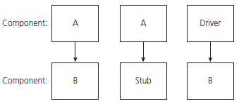

Fig, 5. Stubs and drivers [2].

Component testing may include testing functional characteristics, non-functional requirements such as performance, robustness testing or resource-behavior, as well as structural testing (e.g. statement or decision coverage). Typically, unit tests are written in a unit test framework or debugging toll that can access the code being tested by the programmer who wrote the code.

Agile methodologies support test-driven development which is an approach in component testing to prepare and automate test cases before implementing the code. Test-driven development is highly iterative and it defines cycles of writing test cases, then implementing small pieces of code, building and integrating the code. The components tests are executed unit they pass.

The second test level that is relevant to the thesis is integration testing. It is performed to expose defects in the interactions between integrated components or systems. There is more than one level of integration testing, depending on test objects and varying sizes of systems containing integrated components. There might be component and system integration testing distinguished. Component integration testing is intended to test the interactions between software components and is carried out after unit testing. System integration testing is intended to test the interactions between different systems and may be carried out after system testing.

Integration testing does not lead to isolation of failures to a specific lines in the code. Thus, to find cause of failures and identify the buggy component, the integration sequence and the number of integration steps shall be pre-defined. At each stage of integration, testers focus solely on integration itself. It means that they are not interested in testing functionality of the components, but they are testing interactions between the components to give an evidence if an integrated system meets specified requirements.

Integration testing should investigate both functional and non-functional requirements of the system. Sometimes, testers may also deal with incomplete or undocumented features. Typically, functional testing is carried out based on specification-based (black-box) techniques in a controlled test environment. Due to the fact that integration testing requires a dedicated testware and test data, integration tests are written and executed by the independent testing team responsible for development of the whole test infrastructure. The test environment shall be as close as possible to the final target or production environment.

## 3.4. Test types

A test type is a group of testing activities aimed at testing a component or system focused on a specific test objective [2]. The particular test objectives could be: functional testing, non-functional testing, the structure or architecture testing, confirmation or regression testing. Each of the test types may be performed at all test levels.

Functional testing verifies if the requirements specification on what a system or component does is correctly implemented in the code. Specification-based testing is often referred as black-box testing, because the code is executed without a direct access to that code. A test case has some inputs that launch the code, then the test case checks outputs of the code execution. The outputs should have values that are defined in the system or component specification in the case of the software is used under specified conditions that have been set by the inputs.

Testing of software product characteristics, which is called non-functional testing, focuses on measuring how well something is done. A particular requirement is tested to assess the code implementation under a specific scale of measurement (for example the scale of measurement can be time to respond). The characteristics that are commonly verified in non-functional testing are reliability, usability, efficiency, maintainability or portability. These tests are also executed in the black-box test environment.

In structural testing unlike black-box testing, a test cases has direct access to the code. Testing of software structure or architecture is often referred as white-box testing. This type of testing is most often used in measuring the coverage of a set of structural elements. At component level structural testing may measure code coverage, at component integration level it may be used for checking a calling hierarchy, whereas at system integration level control flow in the code may be verified by a structural test.

Testing related to changes is either conformation or regression testing. Confirmation testing is re-testing of a component or system in which there has been a defect found in the previous build. The goal of confirmation testing is to verify if a new version of the software fixes the bug. Regression testing, like confirmation testing, involves executing the test cases that have been executed before. However, in this case, a new build is verified to give an evidence if the latest version of the software has not introduced or uncovered a different defect elsewhere in the code. Regression tests are executed every single time the software changes, either as a result of bug fixes or new functionality. It is recommended to have a regression test suite at each level of testing.

# 4. Software toolset

To achieve the goal of the thesis and propose a Continuous Integration tool that supports the process by an optimal test suite selection there was a need to use the various programming languages, multiple testing frameworks, a CI automation server, a version control system, an integrated development environment and a software project management tool.

## 4.1. Programming languages

There are two programming languages used in the thesis. The unit under test is implemented in Java SE 8. The script that selects an optimal test suite is implemented in Python 2.7.

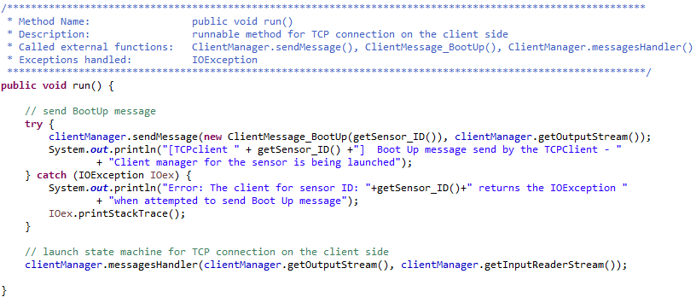

Fig, 6. Java code snippet - a method implementation.

Java Platform, Standard Edition (Java SE) is a computing platform for development and deployment of portable code for desktop and server environments. Java SE defines a set of general-purpose APIs, for example Java APIs for the Java Class Library. It also includes the Java Language Specification and the Java Virtual Machine Specification [8]. The best known implementation of Java SE is Java Development Kit (JDK™). The JDK™ used in the thesis as a development environment for building the unit under test using the Java programming language is JDK 8u161.

A package in Java is a group of related types that provides access protection and name space management. The types refer to classes, interfaces, enumerations, and annotation types. The unit under test includes several packages. Naturally, it calls fundamental classes from java.lang or classes for reading and writing (input and output) from java.io. However, the essential packages that enables the application to provide its basic functionality such as web-based networking or multiple threads to run tasks concurrently are java.net and java.util.concurrent.

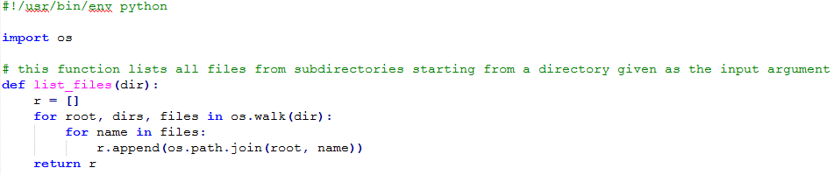

Fig, 7. Python code snippet - a method definition.

Python, unlike Java that is neither interpreted nor compiled, is a pure interpreted programming language. What it means is that instructions are executed directly and freely, without previously compiling a program into machine-language instructions. As a result, particularly in general-purpose programming, additional flexibility over compiled programming languages may be achieved.

One of the main reasons for the choice of Python is that it allows to implement wider range of functionalities in fewer lines in comparison with other programming languages. The additional advantages of Python are speed, efficiency, widespread library support and programmer-friendly data structures. The most challenging requirement for the optimal test suite selector is the desired functionality to crunch a great deal of data varying in size in the limited amount of time. The Python mechanism that are fit for this purpose are extremely flexible lists and the NumPy library. Furthermore, Python supports interaction with git repositories by means of the GitPython library thus all requirements could have been implemented in a single script.

## 4.2. Testing Frameworks

Given the scope of the thesis, there is a need to implement unit and integration tests for the application under test. The tests might have been written in dedicated testing frameworks, separate for each test level. However, multiple testing frameworks would result in greater complexity of the optimal test suite selector. Therefore, a comprehensive testing framework has been chosen that supports both unit and integration tests.

JUnit is an open source framework, which can be used for writing and running tests. Basically, a JUnit test is written in Java programming language. However, the JUnit test framework extends Java by providing some interfaces for the testing purposes. The most commonly used features for quick and easy generation of test cases and test data are:

* Annotations that can annotate variables, parameters, packages, methods to improve source code readability and structure. The following annotation can be found in the unit tests: Before, After, Test, Mock, Spy.
* Assertions that provide methods useful in determining pass or fail status of a test case. There are various types of assertions like Boolean, null, identical etc.
* Test Runners and Test Suites for running tests,
* JUnit Expected Exception Test that traces the exception and also checks whether the code is throwing expected exception or not.

JUnit is a perfect choice for both unit and integration tests, because it is also   
a regression testing framework that can be easily integrated with an IDE and a software project management tool. Nonetheless, JUnit was originally intended to write and run unit tests, hence some features for integration testing are limited. Still, the existing features are sufficient for the purpose of achieving the objective of the thesis.

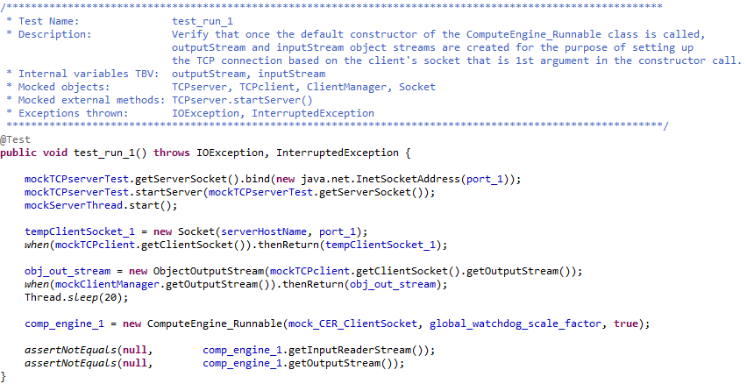

Fig, 8. JUnit code snippet - a sample test case.

As mentioned in paragraph 3.3., unit tests require a mocking framework. Mockito lets the software developer write extensive tests with a clean and simple API. Moreover, the tests are very readable and produce clean verification errors. The following features of Mockito are used in the unit tests:

* mock() - creates a mock object of given class or interface. Mocks in Mockito allow to stub invocations,
* spy() - creates a spy based on class instead of an object. Spies in Mockito allow to stub invocations as well as use real method invocations,
* when() - enables stubbing methods,
* thenReturn() - Sets a return value to be returned when the method is called.
* doAnswer() - stubs a void method with generic Answer,
* machers() - allows flexible verification or stubbing [9].

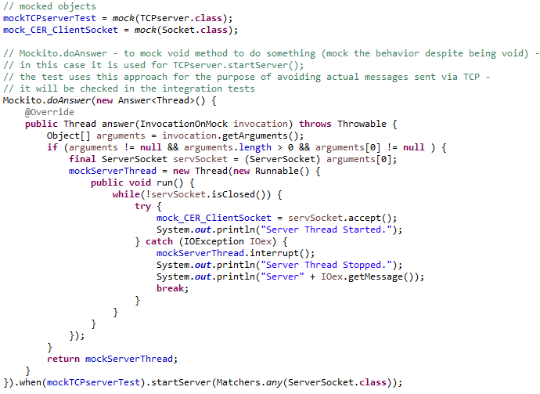

Fig, 9. JUnit code snippet - use of Mockito features to mock dependencies.

## 4.3. Continuous Integration automation server

The CI server used in the thesis is Jenkins. Basically, Jenkins is open source automation server written in Jave SE 8 as a self-contained Java-based program available on every operating system. Jenkins configuration is very easy via its web interface.

There are several beneficial features of this continuous integration environment that enable Jenkins to automate the non-human part of the software development process. Jenkins in the leading CI automaton server with more than 1000 plugins in the Update Center. The plugins enable a software developer to integrate practically every tool in the continuous integration and continuous delivery toolchain. Due to Jenkins extensibility via plugins, there are nearly infinite possibilities for what Jenkins can do.

The Continuous Integration tool for an optimal test suite selection uses the various programming languages, testing frameworks and other tools. Therefore, Jenkins appears to be the ideal choice since it offers a simple way to set up a continuous integration environment for almost any combination of languages, source code repositories and software project management tools using pipelines. A pipeline is a suite of plugins that defines the entire build process, which typically includes stages for building an application, testing it and then delivering it. By modeling a series of related tasks, pipelines add a powerful set of automation tools to Jenkins [10].

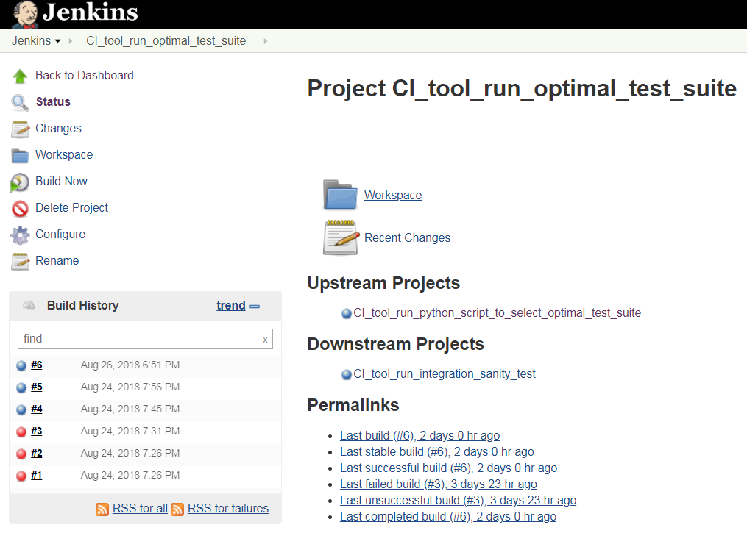

Fig, 10. Jenkins web interface for a project.

## 4.4. Version control system

## 4.5. Integrated development environment

Integrated Development Environment (IDE) provides software developers with   
a possibility to manage workspaces, build, launch and debug applications and finally to share artifacts with a team and version the code. The IDE used in the thesis is Eclipse Oxygen Release (4.7.3a). Similarly to previously described software tools, Eclipse contains an extensible plug-in system for customizing the environment.

Eclipse is free and open-source software most widely used for software project development in Java programming language. A project in Eclipse includes a set of software development tools that are built together based on the source code implementation of the programs for certain software package and software framework. The project after being built is a runnable application.

From the thesis perspective, Eclipse does not only deliver the Java editor, but it also allows to write JUnit tests and run the unit tests with Maven. Furthermore, Eclipse has a the Java Project Wizard that enables a software developer to define how the project should be built. The required build configurations in Eclipse are the default JRE and compiler compliance. Optional build configurations may be whether to optimize the code or include debug information.

To define structure of a project, Eclipse uses source folders. During building Java project, source folders added to the Java build path are translated by the compiler to .class files that will be written to the output folder. The source folders mechanism allows, for example, to separate test from the application as shown in figure 11. Within a source folder, a more detailed structuring can be achieved by using packages.

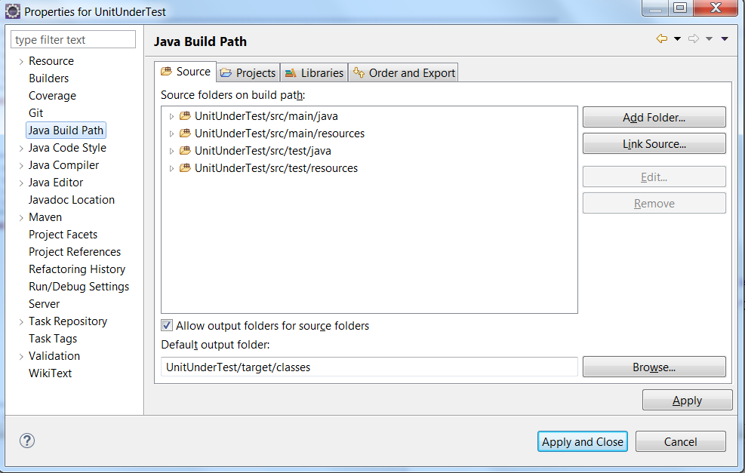

Fig, 11. Java Build Path configuration in Eclipse.

## 4.6. Software project management tool

Software project management tool may be a misleading name since this chapter is intended exclusively for characteristic of the technical toolset used in the thesis. However, in case of software project management, tasks of managing the project do not focus solely on managing the team of engineers working on this project. The objective of software project management tool used for the technical purposes is to define how software is built and describe software dependencies.

It was said in the above subparagraph that an IDE may also define build configuration for a project. A software project management tool would additionally enhance the build process, because it comes with pre-defined targets for performing certain well-defined tasks. These tasks may be, besides the above mentioned build process and dependencies management, description of external modules, components, all required plugins, the build order, directories and compilation of code and its packaging.

The software project management tool used in the thesis is Maven. It is delivered by Apache Software Foundation. Maven uses a concept of a project object model (POM), which is stored in pom.xml. POM provides all the configuration for a single project. In Maven all work is done by plugins that will be executed during the build providing a set of goals such as compile, test, validate, install or deploy.

There are four main features of Maven used in the thesis. All features are configured under the following Maven project descriptors in pom.xml:

* <properties></properties> - Maven properties are value placeholder for properties that are accessible anywhere within a POM.
* <dependencies></ dependencies > - Maven dependency is an element that identifies individual artifacts such as software libraries or modules.
* <profiles></profiles> - Maven profile is an element that changes settings depending on the environment where it is being built.
* <build></build> - Maven build is an element that declares project's directory structure and manages plugins.

For example, the dependencies section of pom.xml is presented in figure 12. The purpose of the below Maven dependencies is to select a version of the testing frameworks used in the thesis: JUnit and Mockito.

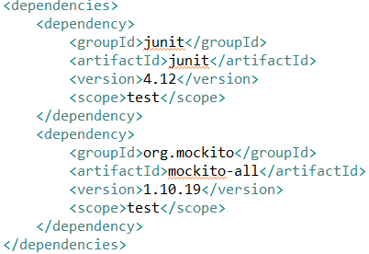

Fig, 12. POM code snippet – dependencies section of pom.xml.

# 5. Unit Under Test

The unit under test is an application written in Java 8 SE. The high level concept of the application includes a data server and nodes that send data to the server. Data is transmitted between server and nodes over the TCP/IP protocol using TCP sockets. Both TCP server and TCP clients program can read from and write to a socket.

## 5.1. Overview of the application

TCP server is a data server. TCP client is a software simulation of a smog sensor that sends its measurements to TCP server. TCP server has two watchdogs: the first one determines the point in time when a measurement data should be received. The second one has much longer time to expiration and it determines the point in time when   
a measurement history should be received. TCP client has one watchdog that is synchronized with the shorter server watchdog after each TCP connection.

The inputs for TCP server are port, list of sensors, number of sensors, measurements limit and watchdog scale factor. The list of sensors contains configuration settings for each sensor that are going to be sent to a particular sensor during initialization. The number of sensors defines how many threads are running in parallel on the TCP server side to handle TCP connection sessions with a particular sensor. The measurements limit is number of measurement data messages that should be followed by a measurement history. The watchdog scale factor is going to be described in the next paragraph.

The outputs of TCP server are serialized files saved on a PC that runs the TCP server. There are at least two files expected from every sensor within a single TCP connection session. The first file is the current configuration and state of a sensor, whereas the second file contains the measurements received from a sensor. There may be more files saved within a session if a measurement history is received or during the sensor initialization phase when the TCP server sends settings to a sensor.

There is only one TCP server, hence the TCPserver class is a static Java class. What it means is that there can be only one instance of the TCPserver class that acts like an entirely separate class. As a result, there is only one server socket. TCP server has to be launched prior to TCP client, because it listens for an incoming TCP connections. Basically, once TCPserver is started, it is going to start its watchdogs and hang in   
a blocking function until it receives an incoming client request. Once a message from TCP client is received, there is a separated thread started that is responsible for handling the TCP connection between the server socket and the client socket that sent that message. Once the TCP connection session is successful, the thread waits until all sensors finishes their connection sessions. If all messages containing configuration data, measurement data and acknowledgments from all sensors have been processed on the TCP server side, the shorter watchdog is kicked. Every once in a while, when the longer server watchdog is close to expire, server threads would expect an additional message containing measurement history. In this case, after the successful TCP session both watchdogs are kicked.

The inputs for TCP clients are port, server host name and sensor ID. TCP clients have no direct outputs, because sensors send their data that is then further processed on the TCP server side.

There are multiple TCP clients, hence every TCP client has its unique socket. Basically, once a TCP client is started, it is going to transmit a message to the TCP server that launches the initialization. After the initialization phase and successful configuration, the TCP connection is ended and the client watchdog starts to count down. Once the client watchdog is close to expiration, next TCP connection session is launched. If the session is successful what means that all messages expected by the TCP server have been sent, the watchdog is kicked and synchronized with the server watchdog and it counts down until it reaches the threshold for launching TCP connection session again.

The entire communication between the TCP server and TCP clients is watchdog-driven. If a client watchdog for any sensor expires, this sensor goes to dead state and it is unable neither to send nor receive messages anymore. If any of server watchdogs expires, the application will crash.

## 5.2. Application code refactoring to make it testable

There have been a lot of minor changes made to many small pieces of the application code for the purpose of being able to verify those pieces of code. However, there no need to put emphasis on those changes, since it is a general practice in the phase of writing unit tests.

It was a deliberate strategy to refer the server watchdogs as shorter and longer in the previous paragraph. Let's figure out, what should be the frequency between the points in time when measurement data or measurement history is received. A reasonable period of time for consecutive smog measurements is one hour. Measurement history, that contains all measurement data since the last message with measurement history has been sent, should be sent once every 24 hours. Is it a dead end for the plan to write tests for the application? Is it worth taking an effort to write an integration test that is going to verify that a measurement history is received every 24 hours and the longer server watchdog has been kicked?

Obviously, execution of an integration test cannot last 24 hours. Fortunately, there is a solution to this kind of problem. The proposed solution creates an interface to the piece of code that is responsible for determining the points in time for setting up TCP connection sessions. The watchdog scale factor, which has been already mentioned in the previous paragraph, accelerates the TCP connections execution cycles by decreasing default values of time left to expiration for the server watchdogs. Watchdog scale factors can be with the range of values between 0.001 to 1.0. If a watchdog scale factor equals 0.001, measurement data will be sent evet 3.6 seconds, whereas measurement history will be sent every 86.4 seconds.

Figure 13. shows that once the constructor of Global\_1h\_Watchdog is called, the parameter that determines a value of time left to expiration for the watchdog (millisecondsLeftUntilExpiration) is multiplied by global\_watchdogs\_scale\_factor.

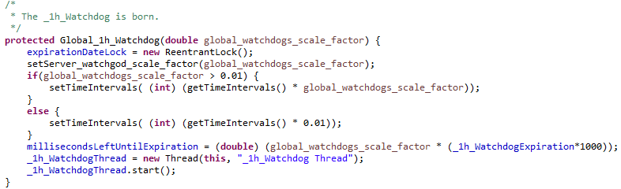

Fig, 13. Interface in the application code that accelerates its execution cycles.

















# 6. Testing in application

# 7. Optimal test suite selection algorithm

# 8. CI tool

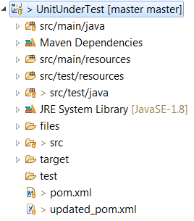 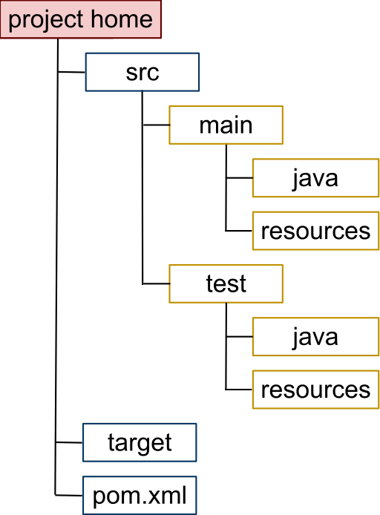

https://en.wikipedia.org/wiki/Apache\_Maven

# 9. Conclusion

**else** **if** (receivedMessage **instanceof** ClientMessage\_SensorInfo && sensor != **null**) {

System.***out***.println("[Compute engine Runnable " +sensor.getSensorID()+"] ClientMessage\_SensorInfo message from sensor: " + sensor.getSensorID() + " has been received.");

SensorImpl received\_sensor = ((ClientMessage\_SensorInfo) receivedMessage).getSensor();

**if** ((sensor.getCoordinates().equals(received\_sensor.getCoordinates())) &&

(sensor.getSoftwareImageID().equals(received\_sensor.getSoftwareImageID())) &&

(sensor.getSensorState().equals(received\_sensor.getSensorState())) &&

(sensor.getLocal\_watchdog\_scale\_factor() == (received\_sensor.getLocal\_watchdog\_scale\_factor()))){

**Bibliography:**

[1] K. Beck, M. Beedle, A. van Bennekum, A. Cockburn, W. Cunningham, M. Fowler, J. Grenning, J. Highsmith, A. Hunt, R. Jeffries, Jon Kern, Brian Marick, Robert C. Martin, Steve Mallor, Ken Shwaber, Jeff Sutherland: The Agile Manifesto. Snowbird, February 2001

[2] RBCS - Rex Black Consulting Services, Inc.: Software Testing Book, 2003-2011

[3] ISTQB Foundation Level 2018 in a Nutshell.   
Available: https://www.istqb.org/certification-path-root/foundation-level-2018.html (visited August 9th, 2018)

[4] Exploring Jenkins Pipelines: a simple delivery flow. Available: https://bulldogjob.pl/articles/726-exploring-jenkins-pipelines-a-simple-delivery-flow

(visited August 10th, 2018)

[5] 10 companies killing it at DevOps. Available: https://techbeacon.com/10-companies-killing-it-devops (visited August 10th, 2018)

[6] Andrew Siemer, graphic posted on LinkedIn profile.

[7] Continuous Integration, Available: https://www.thoughtworks.com/continuous-integration (visited August 25th, 2018)

[8] Java SE 8 Features and Enhancements. Oracle Corporation, JDK 8 Release Notes.

[9] Mockito - Tasty mocking framework for unit tests in Java. Available: https://site.mockito.org/

[10] Jenkins User Documentation. Available: https://jenkins.io/

1. CPU – Central Processing Unit [↑](#footnote-ref-1)
2. IT – Information Technology [↑](#footnote-ref-2)
3. CI – Continuous Integration [↑](#footnote-ref-3)
4. CD – Continuous Delivery [↑](#footnote-ref-4)
5. ISTQB - International Software Testing Qualifications Board [↑](#footnote-ref-5)
6. DevOps - Development and Operations. Focuses on culture that aims at raising awareness of potential benefits for an organization, which are the result of continuous deployment (consists of continuous delivery, continuous integration, and continuous testing) with the lean management principles. [↑](#footnote-ref-6)
7. Validation - aims at giving an evidence that the requirements for a specific use or application have been fulfilled. [↑](#footnote-ref-7)
8. Verification - aims at giving an evidence that the specific requirements have been fulfilled. [↑](#footnote-ref-8)
9. Test level- a group of testing activities that are organized and manager together. A test level is linked to the responsibilities in a project [2]. [↑](#footnote-ref-9)