1. 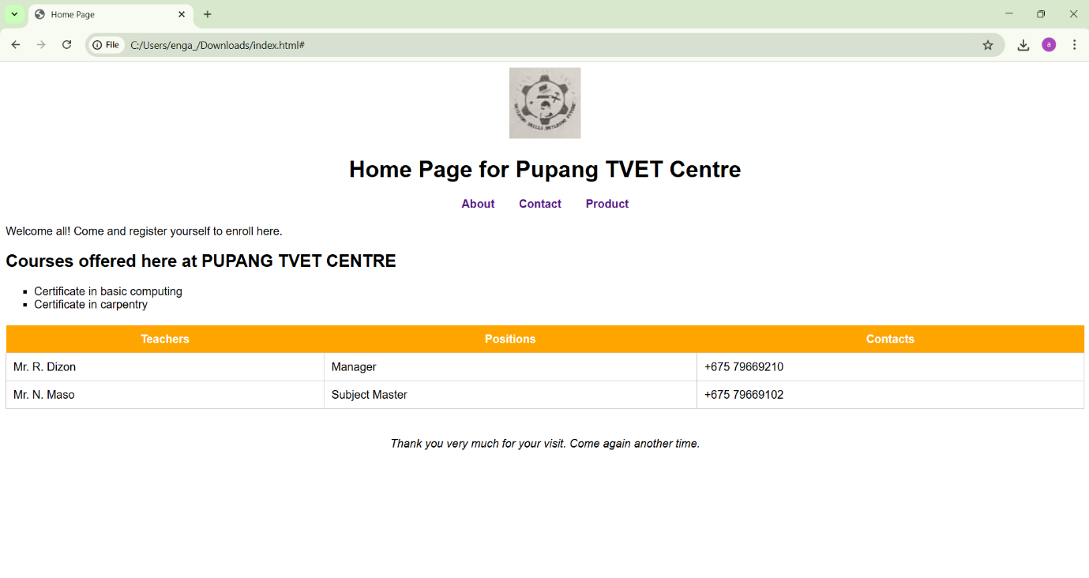Do the sketch design of the webpage

Figure Sketch of the Webpage

1. Insert them into html coding

**HTML CODING BELOW**

**<!DOCTYPE html>**

**<html>**

**<head>**

**<title>Home Page</title>**

**<style>**

**body {**

**font-family: Arial, sans-serif;**

**}**

**header {**

**text-align: center;**

**}**

**nav {**

**margin: 20px 0;**

**text-align: center;**

**}**

**nav a {**

**margin: 0 15px;**

**text-decoration: none;**

**font-weight: bold;**

**}**

**ul {**

**list-style-type: square;**

**}**

**table {**

**width: 100%;**

**border-collapse: collapse;**

**margin-top: 20px;**

**}**

**th {**

**background-color: orange;**

**color: white;**

**padding: 10px;**

**}**

**td {**

**padding: 10px;**

**border: 1px solid #ccc;**

**}**

**footer {**

**margin-top: 40px;**

**text-align: center;**

**font-style: italic;**

**}**

**</style>**

**</head>**

**<body>**

**<header>**

**<img src="logo.png" alt="Pupang VET Centre Logo" height="100">**

**<h1>Home Page for Pupang TVET Centre</h1>**

**</header>**

**<nav>**

**<a href="#">About</a>**

**<a href="#">Contact</a>**

**<a href="#">Product</a>**

**</nav>**

**<section>**

**<p>Welcome all! Come and register yourself to enrol here. </p>**

**<p><h2>Courses offered here at PUPANG TVET CENTRE</h2></p>**

**<ul>**

**<li>Certificate in basic computing</li>**

**<li>Certificate in carpentry</li>**

**</ul>**

**</section>**

**<section>**

**<table>**

**<tr>**

**<th>Teachers</th>**

**<th>Positions</th>**

**<th>Contacts</th>**

**</tr>**

**<tr>**

**<td>Mr. R. Dizon</td>**

**<td>Manager</td>**

**<td>+675 79669210</td>**

**</tr>**

**<tr>**

**<td>Mr. N. Maso</td>**

**<td>Subject Master</td>**

**<td>+675 79669102</td>**

**</tr>**

**</table>**

**</section>**

**<footer>**

**Thank you very much for your visit. Come again another time.**

**</footer>**

**</body>**

**</html>**