***CURRICULUM VITAE***

* Junior Web Developer -

##### Personal informations

**Name:**  O Andrei

**Country:** Romania

City: Constanta

### Studies

Bachelor of Information Technology

### Language Skills

#### English – Fluent

**Technologies that I had experience with**

**Frontend: React, Vue.**

**Backend: Laravel (PHP 7), SpringBoot (Java).**

**„I know this might not be the most complex content of a CV, so I thought myself that I could share some images of a personal project (E-Commerce App) that I’m working on right now (not the best design yet) .”**

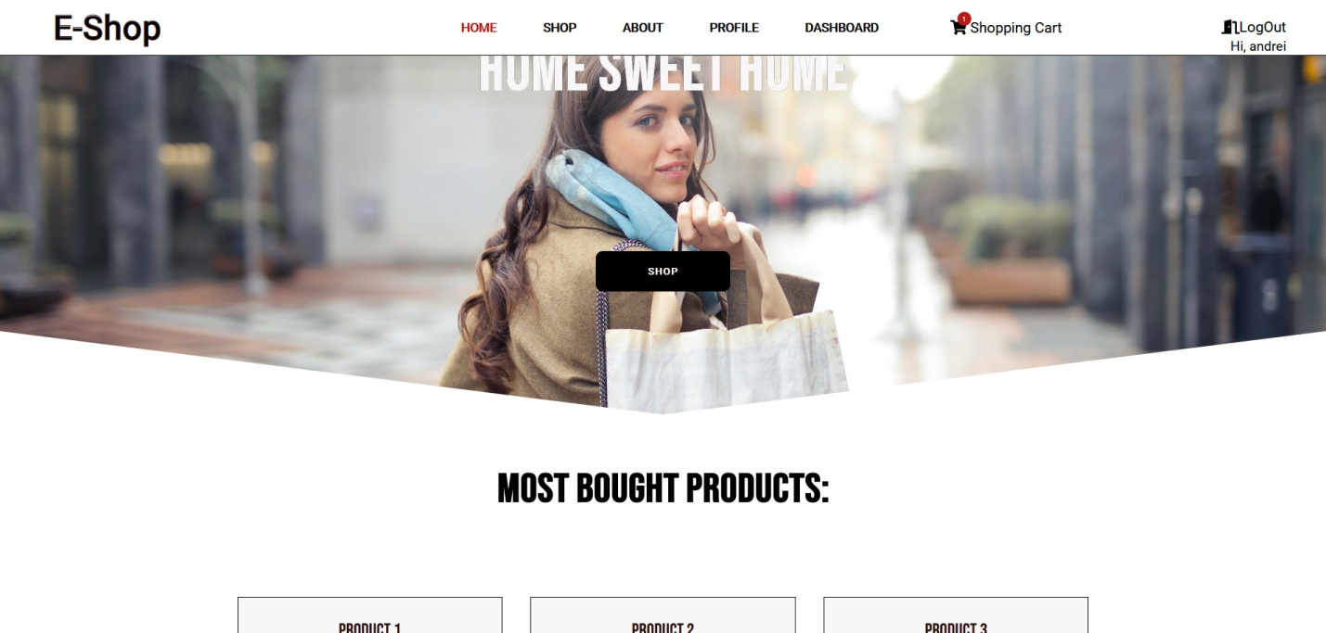

„Here is the landing page. We can see the Navigation Menu Bar, which changes whenever you scroll below 50px from the top of the screen (now it’s changed), a big warmy title that welcomes the customer, and the big button on the center waiting to be clicked!”

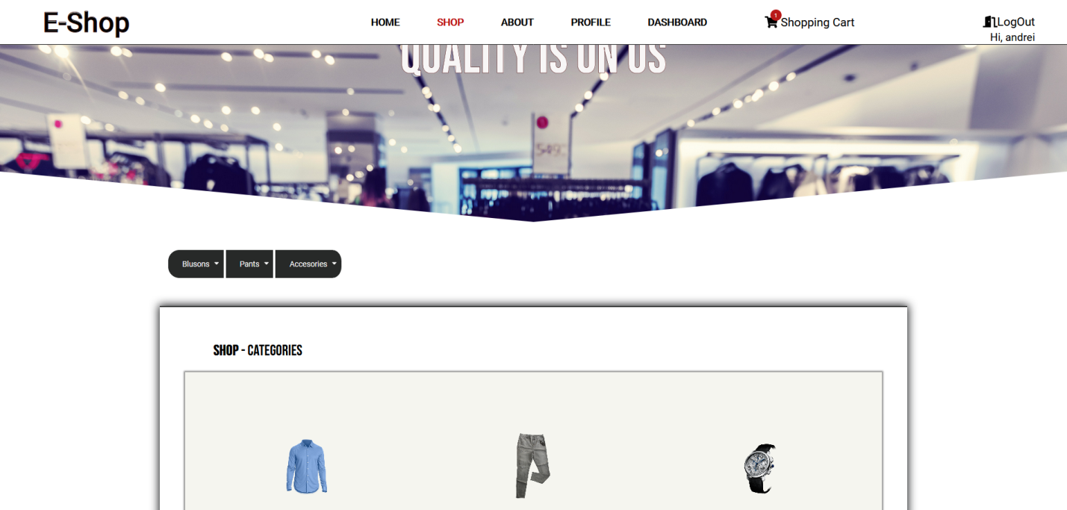

„After the button gets triggered we’re entering into the Shop page where we can see the categories from which we can choose to visualize and maybe buy...”

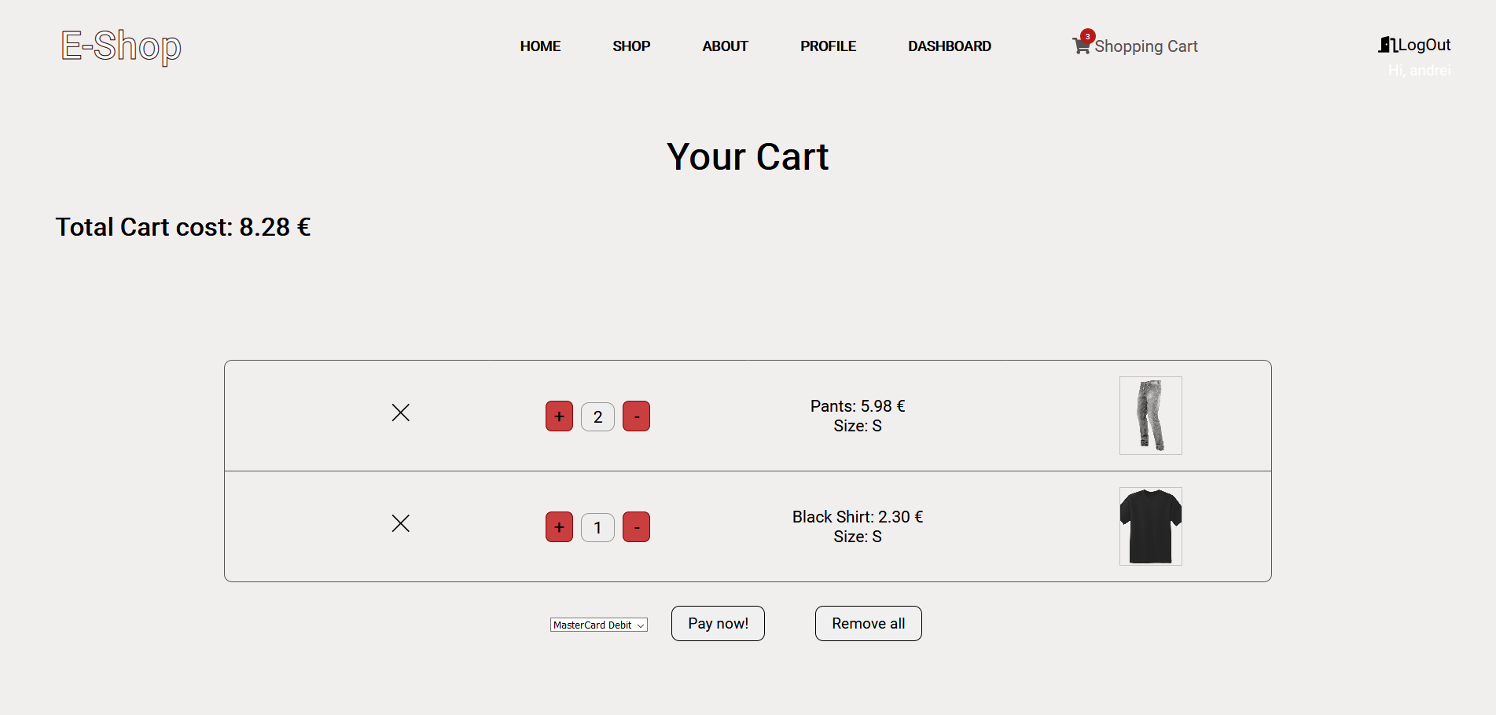

„Now, in the image above we can see the products which have been added to the cart, the price of each and the total cost of them. Also we have actions like adding more products of the named ones, removing some or even all, and ofcourse we can do the payment and get the delivery sent.”

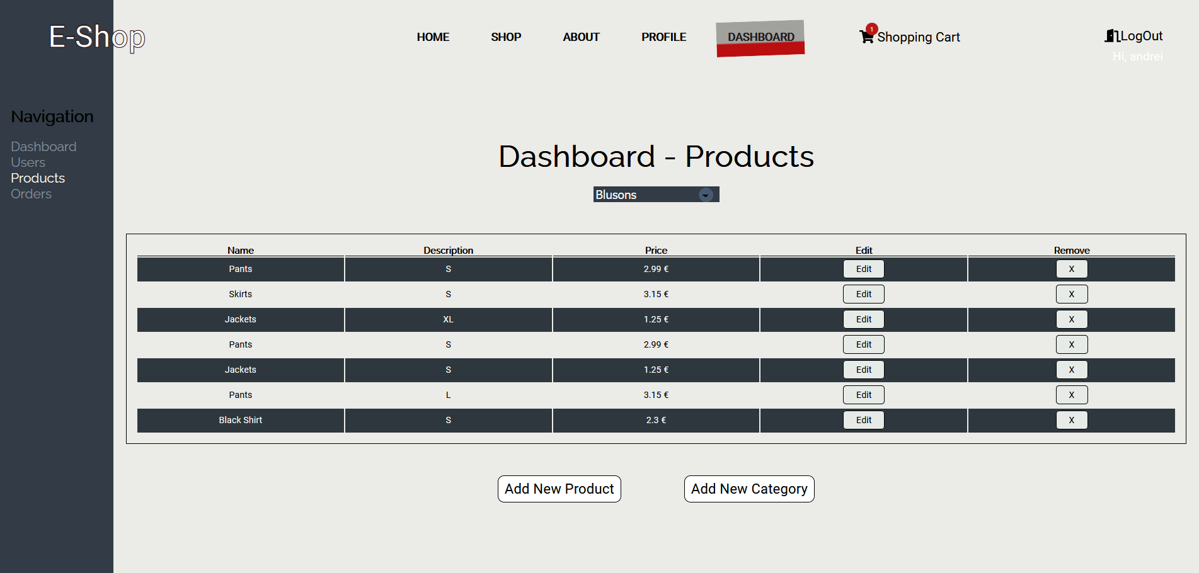

„And last but not least, the must have tool for managing the entire app, the Data Dashboard, which in the image shows us the name of products we have in store for the chosen category.”

More to come...