STACKS:
last in first out(LIFO)
-stack is implemented by the help of List
we are using list type
methods Involved in stacks
- Push() Insert the element at the top
- Pop() remove the element at the top
- Peek() returns the top element
- IsEmpty() it returns true value if it empty
- IsFull() it returns Boolean value based on stack
- Delete() it removes all elements in the stack

Stack Using List:
Easy to implement
speed problem when it grows
We will implement three types of stack
implementation of stack without size Limit
implementation of stack with size Limit

Advantages:
fast performance compared to list (implementation of stack using list is faster than list)
it doesn’t follow the contiguous memory allocation
Disadvantage
Implementation is not easy compared to list

IMPLEMENTATION OF STACK USING LINKEDLIST :
In this we are using Linked List
every element/node value push after the head that means last pushed/inserted element is near to the head and first pushed element is far away from head
operations implemented by using LinkedList
push()
pop()
IsEmpty()
delete()

WHEN TO USE/AVOID STACK :
USE:
where do we need “Last In First Out” functionality
The chance of data corruption is minimum

AVOID:
Random accessing the element is not possible
Ex: if you want pop the last first in element, u have to remove from first to last

QUEUE DATA STRUCTURE:
It follows FIRST IN FIRSTOUT
In Queue the data is pushed at the end ,we can not insert the data (insert and retrieve the data at the middle)
operations performed in Queue
Enqueue add element at the end
Dequeue remove element from starting
Delete Delete entire Queue
IsEmpty it checks Queue is empty or not
peek it returns top value
IsFull it checks Queue is full or not

ex: Printer Queue, Order taking system in Restaurant
WHEN DO WE USE QUEUE
Utilise first coming data first and Other wait for their turn

QUEUE IMPLEMENTATION:
Queue is implemented using Python List
queue with size limit
queue without sizelimit

Queue is implemented using Linked List

Implementation of Circular Queue with Size limit using List:
for normal size the queue gives better performance but coming to large sizes its performance is poor
so that why we are using circular queue with size limit
In normal Queue if you remove element from starting position then we have to shift the all elements to left side(it follows list operation) so it takes O(n) time complexity.but coming to Circular Queue we are adding the element at the deleted element
so due to this we can improve the performance of the code

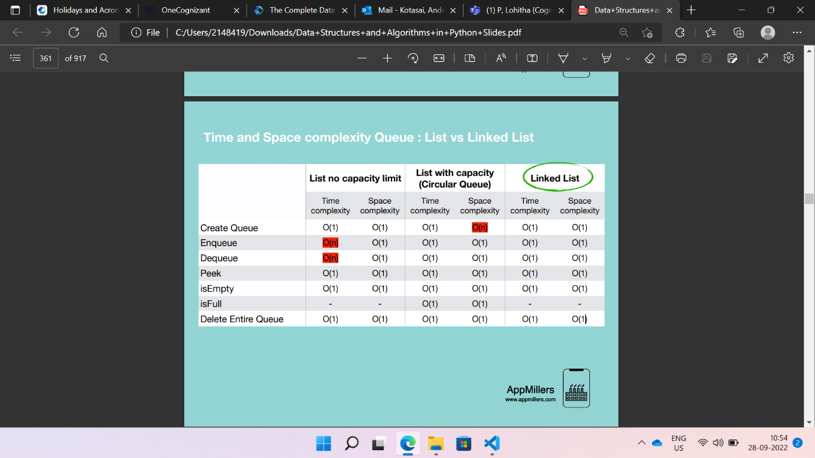

Python Queue Modules
Collection Module
Queue Module
Multiprocessing Module

Collections Module
In this collection Module we are Using Deque class
We have to import that class and create instance or object to that class
from collection import deque
deque supports adding and removing elements from either side with O(1) time complexity
deque is implemented using double Linked List which gives excellence performance for enqueueing and dequeueing elements
deque is applicable for both stack and Queue but now we are using deque module for Queue(FIFO)
methods in dequeue class
deque() create queue with size limit or without size limit
append() it is like Enqueue method that means adding elements at the end
popleft() it is like Dequeue method that means remove the elements from the end
clear() removing all the elements from Queue

if you are created the queue with size limit and if the queue is bounded the max size limit then it comes to starting position and remove the first element and shift all elements to the left and add the new element at the end

1 | 2 | 3 | 4 | 5

this Dequeue is bounded the maximum size limit. Now if you add element ‘6’ then it will add at the end and remove first element shift remaining elements to left

1 | 2 | 3 | 4 | 5

2 | 3 | 4 | 5 | 6

from collections import deque

customdeque=deque(maxlen=3)

customdeque.append(1)
customdeque.append(2)
customdeque.append(3)
deque([1, 2, 3], maxlen=3)

print(customdeque)

customdeque.append(4)
deque([2, 3, 4], maxlen=3)

print(customdeque)
print(customdeque.popleft())
print(customdeque)
2

customdeque.clear()
print(customdeque)
deque([3, 4], maxlen=3)

output:
deque([], maxlen=3)

deque([1, 2, 3], maxlen=3)
deque([2, 3, 4], maxlen=3)
2
deque([3, 4], maxlen=3)
deque([], maxlen=3)

queue Module
first we have to import the Queue from module queue
From queue import Queue
It is especially useful in threated programming when information must be exchanged safely between multiple threats
In this we are passing max size limit that can creates the upper bound to the queue
insertion will block once this upper bound is reached
In this the maximum size less or equal to zero then the queue size will be infinite
there are many methods in Queue but we are using few methods. Those methods are given below
qsize It returns current size of the queue
empty() if the queue is empty then it returns true
full() if the queue is full then it returns true
put() it acts like enqueue that means it add/insert the element at the end
get() it acts like Dequeue that means it removes the firstelement and return it
task_done()
join()

Code
from queue import Queue
customQueue=Queue(maxsize=3)
We have to assign the max size .In this case the maxsize is 3 but if you assign zero then it comes under infinite catefgory that means you can add infinite elements

print(customQueue.empty())
print(f"current Queue size is {customQueue.qsize()}")
customQueue.put(5)
customQueue.put(4)
customQueue.put(3)
print(f"current Queue size is {customQueue.qsize()}")
print(customQueue.full())
print(customQueue.get())

Output:
True
current Queue size is 0
current Queue size is 3
True
5

MultiProcessing Module:
multiprocessing is similar to queue module
importing is like this “from multiprocessing import Queue”
In this also we are using same methods what we had used in queue expect join() and task_done() methods
multiprocessing queue is meant for sharing the data between processes and store any pickable objects
from multiprocessing import Queue
custom=Queue(maxsize=3)
print(custom.empty())

custom.put(2)
custom.put(3)
custom.put(4)
print(custom.full())
print(custom.qsize())
print(custom.get())

output:
True
True
3
2

