HTML & CSS

em-->it is depend on parent selector
Defaltly parent selector size 1em=16px
Rem-->it is depend on root
In html code the root is html
:Root{
<This is applicable to entire application that means html selector>
}
<!doctype>
<Html>
<Head></Head>
<Body></Body>
</Html>
Style:-
vw-->view width
vh-->view height
Width=50vw -->kanapade view width lo 50%(half) width
Height=50vh-->kanapade view height lo 50%(half) height
Calc()-->which is used to calculate or perform some operations in style sheet
Like: width=calc(100vh - 155px)
max-height-->it will extends to up to the max height
max-width-->it will extends up to max width
min-height-->it maintain the min height and extends any height there is no limit for extension
min-width-->it maintain the min width and extends any width there is no limit for extension
Fontfamily
Fontweight
Fontsize
text-indent-->it gives the space to the paragraph firstline
fontstyle
text-align
Text-decoration==>values(none,overline, underline,linethrough)
line-height
word-spacing
letter-spacing
text-transform-->we can convert the text to lowercase/uppercase/capitalize etc
Css- box model
Margin -->margin:10px
Outlet -->outlet:10px solid red
Outlet-offset-->outlet-offset:10px
Border -->border:10px solid red
Padding-->padding:10px
Border -radius,
Block & Inline
Block-->every statement starts in newline and takes full width (each statement arrange row by row)
Ex: name. -->this statement in new line
occupation. -->>this statement in new line
mobile. -->this statement in new line
Display:block
Inline -->every statement prints in same line and takes that sentence width
Ex: name. Occupation. Mobile -->every statement occupies adjacent memory (side by side)
Display:inline
list-style-type:none. ==>list having some notations or symbols like arrow or dot. We can avoid those symbols using none
Note:-margin top and bottom,padding top and bottom is applicable for only block elements but if you want to give margin or padding top and bottom you need to convert from inline elements to block elements
-->block element occupy entire screen width but inline element occupy only element width depending on that we can differentiate
If you want to give margin top and bottom then you can use "inline-block" due to this no need to change from inline element to block element
Display:inline-block
-->we can give margin top and bottom to the inline element
boxsizing : border-boxing
Due to this we can prevent box outside extensions during the padding that means every time it maintain border - boxing size like if you give width=200px and height=200px then box size is fixed ie;200 &200 after that if you give padding then padding occurs inside the box so the size of the box is not change other wise padding occurs outside
Display:none --> content and place both hidden
Visibility:hidden --> content hidden but that place is not hiddem
Opacity:0.1
background - image: url("")
background -repeat:round
background -repeat : none
background-size:cover
background -position : left/right/center/top/bottom
background -attachment : fixed
-->background image fixed it doesn't move(scroll) but text/content is move over that background image
Background -attachment : scroll
-->the text/content move(scroll) along with background image
Gradients
You can give combination of color gradients
background : linear-gradient(<position>,<colors>,<colors>,<colors>------)
<Positions>
If you not give the position it takes default position ( top to bottom )
to bottom -->top to bottom
to top-->bottom to top
to top right -->bottom left to top right
to top left -->bottom right to top left
to bottom right -->top left to bottom right
to bottom left -->top right to bottom left
We can give degrees also
180deg --->right 0 degree to left 180 degree
310deg --> top 130 degree to bottom 310 degree
<Colors>
Red
RGB(20,49,50)
Rgba(30,50,28,0.7)
#994567
We can use any type
Example:
background : linear-gradient (to bottom,red,green)
background : linear-gradient (to bottom left, rgba(30,40,50,0.4),blue,#548943)
We can apply color gradient to background image also
background : linear-gradient (to bottom,red,blue) , url("<image url>")
background :. Url("image link")
background -size : cover
background - position : center
background -attachment: fixed
background -repeat: no-repeat
Instead of writting all these we can mension in background but order should be mandatory
background : url( image link) center/cover no-repeat fixed
Order --> position/size repeat attachment -->ps ra(power star ra)
float : left/right
If you want print the in next line
Clear : left/right/both
overflow:hidden
If the image crosses the border size then this overflow property hides the extended part
Coursor:pointer -->if u take the cursor to button or any link then cursor converts from arrow to hand symbol
Positions
Position:static -->default position
Position: relative
top:10px
If the position is relative and u give top 10px then that text moves 10px from that actual position
Relative means that current position
Position:absolute
Top:20px
If the position is absolute then there are two cases
First case: parent is body
It moves 20px from body
Second case:parent position is relative and parent is not body
it moves 10px from its parent relative position
Position: fixed
Top:10px
If the positiin is fixed then that text or button is fixed .if u scroll down it doesn't move
@media screen and (min-width:450px){
Body{
Background-color:blue;
Text-align:center
}
}
Width above 450px then this styles will execute
@media screen and (max-width:700px){
Body{
Background-color:blue;
Text-align:center
}
}
Width below 700px then this styles will execute
Z-index :
If the images placed one above the other if you want to change there order then we will use z-index this will applicable for position is absolute if the position is static then it is not applicable
Z-index:5;
Qsuedo code:
Qsuedo code is used to add text/any thing before or after the already existing text/image/any thing dynamically
Html:
<p>my name is</p>
Css:
P::before{
Content:"this is ";
}
P::after{
Content:" KOTASAI";
}
O/p :this is my name is KOTASAI
NOTE: we can also add styles to the after and before adding elements also
Descendent child combinators
This can be used to apply the style for directly child to that parent. in this we are using '>' symbol
<div>
<h1> my name </h1>
</div>
<div>
<ul>
<li>
<h1>KOTASAI</h1>
</li>
</ul>
</div>
Css:
div > h1{
Color:blue;
Text-transform:capitalize;
}
0/p: styles apply to my name only because it is directly child to the div
Links:
<a href="www.google.com">search</a>
Link --> if it is link then all those style property s applied to that link
Ex: a:link{
Color:red;
Font weight:bold;
}
visited -->once that link u visited then then this style properties applied
Ex: a:visited {
color:blue;
}
Active --> if you click on link them that properties will applied to that if you remove clicking then that styles will remove
a:active{
Color:green;
}
hover --> if you take cursor on link them the properties will apply
If you want to place the content or img or anything at the center of the page
Display: flex;
Items-align: center;
Justify-content: center
Text-align:center
Transform: translate()/scale()/rotate()/skew()
Translate -->it moves based om given direction
TranslateX(30px or 50℅) -->it moves along x- direction
TranslateY(40rem) --> it moves along y- direction
TranslateZ(50%) --> it moves along z-direction
Ex: transform : translateX(60px)
Scale --> it gives the size to that property dynamically
ScaleX(30px) --> it gives the size in x direction in both sides
ScaleY(30%) --> it gives the size in Y direction in both sides
ScaleZ(30rem) --> it gives the size in Z direction to both sides
Ex: Transform : ScaleX(40px)
Rotate()--> it can be used to rotate that property
Ex: Transform : royateZ(45deg)
Root element
Default root of the html code is body(parent).so the root element is tagged to the body.using this root element we can change the proparties of parent or root element
:Root{
Font-size:12px;
Color:blue;
}
Transition -->property's slowly transferred with in that mention period of time
Syntax:
Transition:<property name> <timeduration> <delaytime>(option)
Ex: transition : background -color 1s
For multiple properties
Transition: background -color 1s,border-radius 1s
For all properties
Transition:all 1s
Transition movements are classified into different types
1.ease/default
2.ease-in -->starting slow
3.ease out -->ending slow
4.linear-->same speed
5.ease in out -->starting and ending are slow
Transition : all 1s linear
Anninations
Syntax
@keyframes <ourown name>{
We can give the properties between 0-100%
}
Note:- this acts like a method we can use for any selector
Html
<div class='anination'>animation</div>
Css
.Animation{
Width:40px;
Height:50px;
Animation name: firstanimation;
Animation-duration : 3sec;
Animation -iteration times:2;
Or
Animation: firstanimation 3s 2;
}
@keyframes firstanimation
{
0%{
Background -color: blue;
}
45%{
Transform: rotate(550deg);
}
100%{
Background-color:yellow;
}
}
Text- shadow: x-axis y-axis blur color
Ex:
Text - shadow : 1px 3px 6px blue;
Box-shadow : x-axis y-axis blur color
Ex:
Box-shadow: 1px 3px 5px green;
Flex
display: flex; -->this takes entire width which width is available
Display : inline-flex --> sufficient space given to the childs
Flex-direction : row;
If you give this property in parent then all the child elements adjusted in a row
Flex-direction : row reverse;
In this property all the child elements arranged in a row but in reverse direction
Flex-direction : column;
All the child elements arranged in verically(column wise)
Flex-direction : column reverse
All the child elements arranged in reverse direction in column wise
Flex wrap : wrap
Once the elements reached border then automatically comes start and will adjust the elements at the starting of the border
Justify content -->it align items in horizontal either center ,left or right
Justify content : flext-start;
Justify-content : flex-end;
Justify-content: center;
Justify-content : space-between;
Justify-content : space -around;
Justify-content : space-evenly;
Align-items -->this is used for arranging the elements vertically center
Align-items : center;
Align-items : flex-start;
Align-items : flex-end;
Align-items : baseline;
Align-items : stretch -->default
Align-content -->this can be used to align The child's at the center and we can distribute the space between them
Align-content : flex -start;
Align-content: flex-end;
Align-content : center
Align-content: space between;
Align-content : space-around;
Main axis &cross axis
Flex-direction : row
-->main-axis - left to right, cross-axis -top to bottom
Flex-direction:column
--> main-axis - top to bottom, cross-axis -left to right
Order -->order can be used to arrange child elements based on order number
Ex:
Order : 1;
Align-self -->this can be applicable for child's only .if all the child's arranged in flex start or flex end or center then you want to give particular position to that child using 'align-self' property
Syntax :
Align-self : flex-start/flex-end/center
Flex-grow -->it is also applicable for child's only
Syntax
Flex-grow : 1
Flex- shrink --> it also applicable to child's only.actually we are giving some width to the child's but based on screen size it will reduces.so for prevent the shrinking we are using this property
Syntax:
Flex-shrink : 0 -->maintain same width/doesn't shrink
Flex - basis -->this can be used to apply width equally to child's
Flex - basis: 200px; -->it apply same width and height to every child
We can apply grow shrink basis at a time
Flex : grow shrink basis;
Flex : 1 0 200px;
display : grid -->for grid we are using this property
Grid - template -column : 200px 300px;
We are alredy created two boxes but using above property we are giving those widths to the two boxes and arranged in vertically
Grid - template - column : 200px 3rem auto
If the parent is containing 6 child's then first 3 arranged in first row (because we given three parameters) and remaining three child's arranged in second row and apply those parameters to columns like first column--200px , second column -->3rem and third column --auto
Auto means remaining all area width occupied by that third column
We can give width in row wise also
Grid-template-row :300px 5em auto 10%;
This is applicable to 4rows
Fr --> means fraction of space
Grid-template-columns : 1fr 1fr 1fr;
Three columns equally distribute
Grid-template-columns: 2fr 1fr 1fr
Second and third columns have same width but first column have double width of second and third columns
Grid -row -gap :10px ;
We can give gap between rows
Grid - column -gap : 10px ;
We can give gap between columns
Grid - gap : rows columns
Grid - gap : 10px 20px ;
New syntax
Row - gap : 30px;
Column -gap : 50px
Gap : 30px 50px -->using one command we can give gap to both columns and rows with different widths
Gap : 30px;. -->we can give same gap between rows and columns
<!DOCTYPE html>
<html lang="en">
<head>
<meta charset="UTF-8">
<meta http-equiv="X-UA-Compatible" content="IE=edge">
<meta name="viewport" content="width=device-width, initial-scale=1.0">
<title>Document</title>
<link rel="stylesheet" href="Grid.css">
</head>
<body>
<div class="container">
<div class="box box1">box1</div>
<div class="box box2">box2</div>
<div class="box box3">box3</div>
<div class="box box4">box4</div>
<div class="box box5">box5</div>
<div class="box box6">box6</div>
</div>

</body>
</html>

.container{
/* height: 100vh; */
display: grid;
grid-template-columns: 100px 100px 100px;
grid-template-rows:100px 100px 100px 100px 100px;
grid-template-areas:
"a a b"
"a a b"
"c c c"
"d d e"
"f f f"
;

}
.box{
border: 3px dotted red;
}

.box1{
background-color: aqua;
grid-area: a;
}
.box2{
background-color: bisque;
grid-area: d;

}
.box3{
background-color: red;
grid-area: b;
}
.box4{
background-color: greenyellow;
grid-area: c;
}
.box5{
background-color: gray;
grid-area: e;
}
.box6{
background-color: royalblue;
grid-area: f;
}

Output: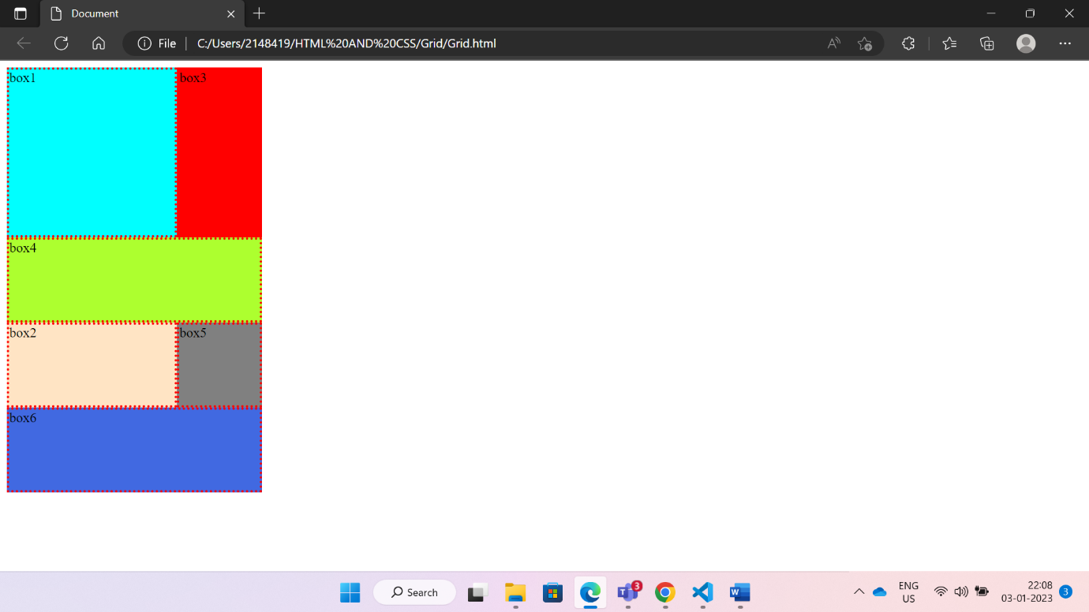

Repeat:
Repeat Is a function. Which is used to give constant width or height
Syntax:
Repeat(<no.of times> , <size>)

grid-template-columns: 1fr 1fr 1fr;
Instead of writing 3times 1fr we are using repeat function
grid-template-columns: repeat(3,1fr)

Order:
Order is a one type of the property. Which can be used to change the order of the boxes
Defaultly each box order is ‘1’
Syntax:
Order:<number>
order:4;

code for order and Repeat()
:root{
--name:bisque; varibale declaration
background-color: var(--name);
}
.container{
display: grid;
/* height: 100vh; */
grid-template-columns: repeat(3,1fr) ;
grid-template-rows: repeat(2,100px);
border:8px double greenyellow;

}
/* .box{
border: 3px dotted red;
} */

.box1{
background-color: aqua;
order:4;
}

.box2{
background-color: cadetblue;
order:5;

}
.box3{
background-color: red;

}
.box4{
background-color: greenyellow;

}
.box5{
background-color: gray;

}
.box6{
background-color: royalblue;
order: -1;

}

Output:
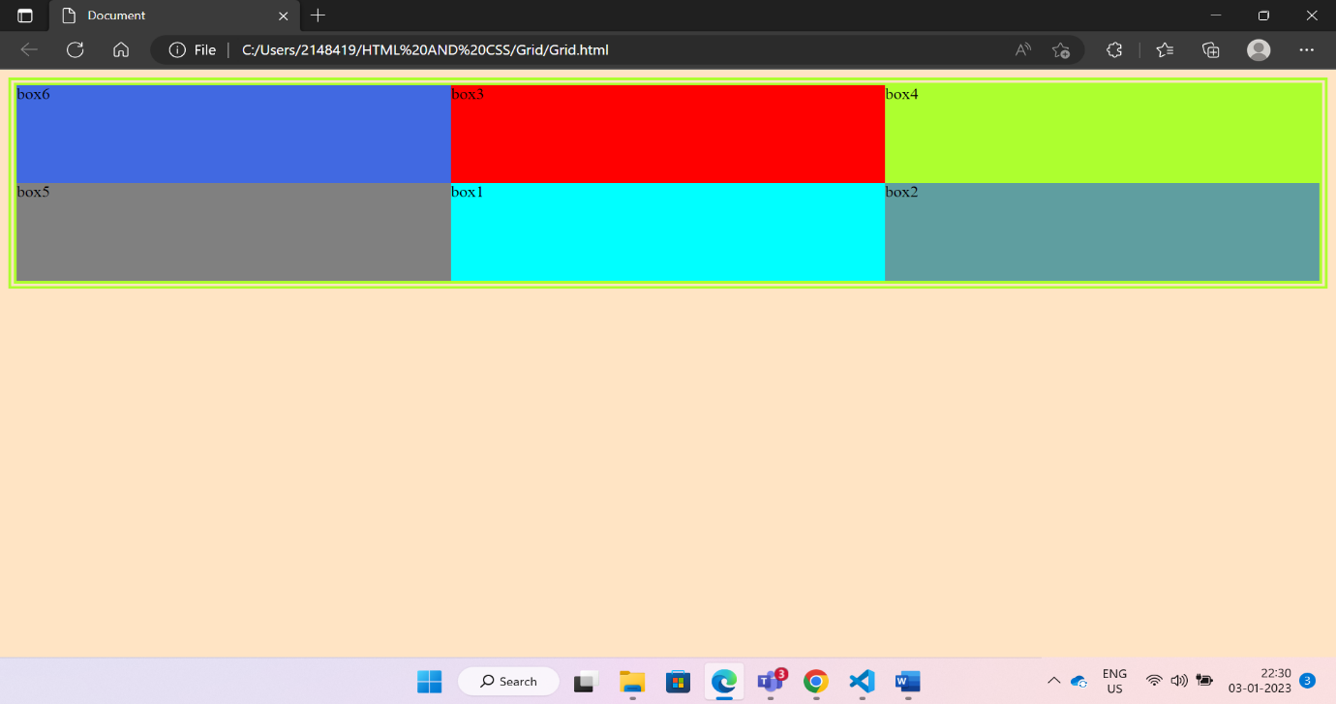

Justify-Content:
Justify content is one of the property which can be used set all items(horizontally) belongs to that parent at center/start/end/provide space between/provide space around/provide space evenly
Syntax:
Justify-content : center/flex-start/flex-end/space-between/space-around/space-evenly

Align-Content:
Align-content also one of the property which is also same like justify content but this is used for arrange the items/content(belong to that parent) vertically
Syntax:
Align-content : center/flex-start/flex-end/space-between/space-around/space-evenly

Code:

.container{
border: 3px solid red;
height:100vh;

display:grid;
grid-template-columns: repeat(3,100px);
grid-template-rows: repeat(2,100px);
/* justify-content: flex-end;
justify-content: flex-start;
justify-content: space-around;
justify-content: space-between;
justify-content: space-evenly; */
justify-content: center;
align-content:center;

}

.box1{
background-color: aqua;

}

.box2{
background-color: cadetblue;

}
.box3{
background-color: red;

}
.box4{
background-color: greenyellow;

}
.box5{
background-color: gray;

}
.box6{
background-color: royalblue;

}
Output:
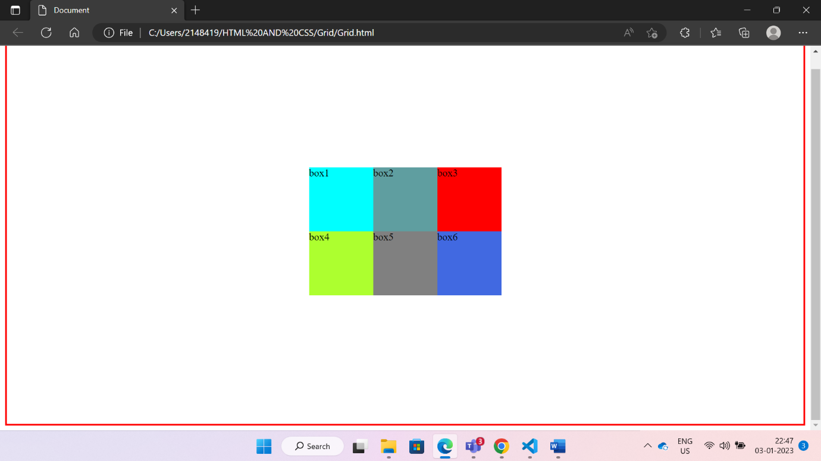

Justify-item:
This property can be used to align the item horizontally center/flex start/flexend based on the cell
Justify-content align the items/content horizontally based on the size of the parent element
That means justify-content based on width/height of the parent
Justify-items is based on width/height of the cell

Syntax:
Justify-item:center/flex-start/flex-end

Align-item:
This property can be used to align the item vertically center/flex start/flexend based on the cell
align-content align the items/content vertically based on the size of the parent element
That means align-content is based on width/height of the parent
align-item Is based on width/height of the cell

Align-item justify-item
item
cell
cell

item

Justify-self:
We can arrange the each element/item horizontally to center/flex start/flex end without parent

Syntax:
Justify-self : center/flex-start/flex-end

Align-self:
We can arrange the each element/item vertically to center/flex start/flex end without parent

Syntax:
align-self : center/flex-start/flex-end

Code:
*{
margin:0px;
padding: 0px;
box-sizing: border-box;
}
.container{
border: 3px solid red;
height:80vh;
margin: 100px;

display:grid;
grid-template-columns: repeat(3,1fr);
grid-template-rows: repeat(2,1fr);
align-items: center;
justify-items: center;

}
.box{
width:100px;
height:100px;
display: flex;
justify-content: center;
align-items: center;
}

.box1{
background-color: aqua;
align-self:flex-start;
justify-self: flex-start;

}

.box2{
background-color: cadetblue;

}
.box3{
background-color: red;

}
.box4{
background-color: greenyellow;

}
.box5{
background-color: gray;

}
.box6{
background-color: royalblue;
align-self: flex-end;
justify-self: flex-end;

}

Output:

