**HO CHI MINH CITY NATIONAL UNIVERSITY**

**INTERNATIONAL UNIVERSITY**



**DATA SCIENCE AND DATA VISUALIZATION**

**Semester 2, 2019-2020**

PROJECT REPORT:

*AVID COVID DATA SIMPLIFIER OF VIETNAM*

*Group members:*

Nguyen Thi Hoai An (ITDSIU18024)

Nguyen Thi Truong An (ITDSIU18002)

Nguyen Ngoc Khanh (ITDSIU18025)

Tran Quynh Anh (ITDSIU18046)

**INDEX**

1. **Introduction**
2. **Explanation for Charts**
   * + 1. Geographical Map
       2. Line Chart
       3. Pie Chart and Horizontal Stacked Bar Chart
       4. Parallel Coordinates Chart
3. **Conclusion**
4. **Introduction**

The Coronavirus, also known as COVID-19, has been under the spotlight since its outbreak in December 2019. It is no doubt that fear and panic bubble caused by COVID-19 is worse than the virus itself, therefore, it is crucial for people from all classes to understand the actual situation’s seriousness. Since its global effects on healthcare, politics and economics aspects have been digitalized by the government and World Health Organization, it is easy for viewers who possess some statistical knowledge to gain valuable information from the data. Nevertheless, it is important to emphasize that not all people are statistically educated. This project, named “AVID COVID DATA SIMPLIFIER OF VIETNAM”, was created to help Vietnamese people overcome the panic bubble caused by COVID-19 by providing them the actual view of the pandemic using data visualization. The data announced by the government on website: <https://ncov.moh.gov.vn/> is made use of to show viewers what Vietnam has been through since the virus outbreak, so that Vietnamese can confidently draw out the answer to the question that the whole world has been asking: “How did Vietnam win its war against Coronavirus?”*.* This project’s objective is to deliver a view on how Vietnam has been step by step winning over this invisible enemy. It simplifies what is considered as “hard to digest” into accessible COVID-19 information to people with little or zero knowledge on statistics.

This project is developed by 4 students of the course Data Science and Data Visualization: Nguyen Thi Truong An, Nguyen Thi Hoai An, Nguyen Ngoc Khanh and Tran Quynh Anh.

Visit the Github repository link below to have an look at the project’s files of codes: [https://github.com/justhoaian/DSDV_AvidCOVIDDataSimplifier.git](https://github.com/justhoaian/DSDV_AvidCOVIDDataSimplifier.git?fbclid=IwAR0xoyK6sYqo6hIWZCxv_9ei4QLne_uBCN7nT_jTDfuT6TVhQJwaHrBCCQQ)

1. **Explanation of charts**

The project “Avid COVID Data Simplifier Of Vietnam” includes 5 charts, separated into 4 horizontal blocks on an HTML web page: The project’s title is placed in the first block, the second block is for the geographical map and line chart, next are pie chart and horizontal stacked bar chart, and parallel coordinates chart on its own takes place in the last block.

1. ***Geographical Map***

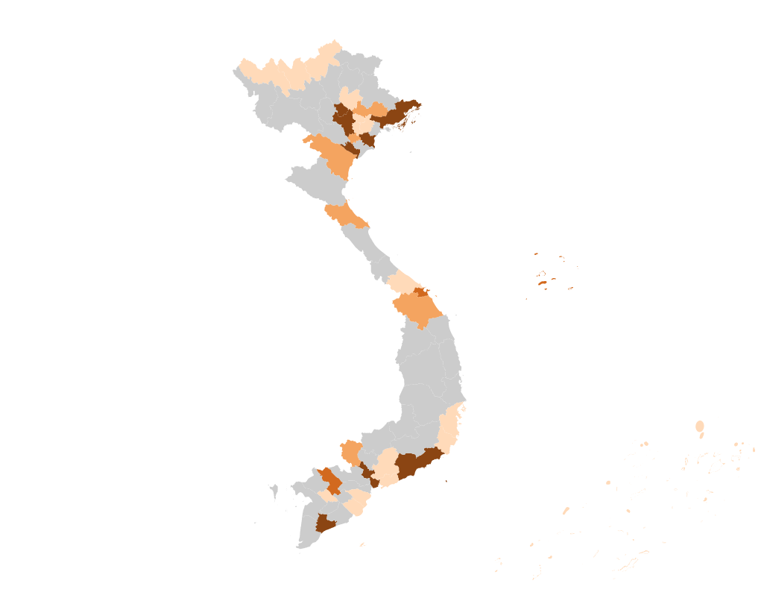

*Geographical Map*

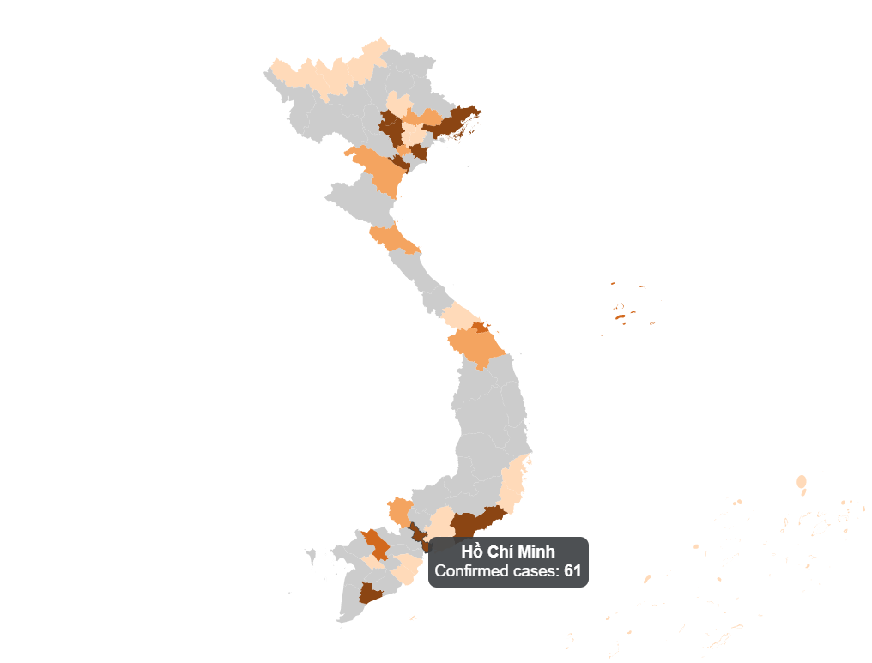

*Geographic Map with tooltip*

To start off with, the geographical map (also known as geomap) is now analyzed. This project’s target viewers are Vietnamese or foreigners living in Vietnam, and it is common sense to know that there is no icon more representative of this country than the “S” shaped map, therefore the geomap is intentionally placed on the left side of the first block of charts since humans naturally scan an image from left to right and from top to bottom, emphasizing that this dashboard is created based on the data of Vietnam. This geomap illustrates the number of confirmed cases in provinces. The more confirmed cases the province has, the more saturated the color on the province is. A tooltip is integrated on this graph: whenever the mouse is moved onto a province, a tooltip box will show the province’s name and the number of confirmed cases of that province.Another noticeable feature is that the geomap can be zoomed in and out by double-clicking.As can be seen from the graph, Ha Noi holds the highest number of confirmed cases, followed by Ho Chi Minh City. This is no surprise because to prevent Coronavirus from spreading, social-distancing is the key; on the other hand, Ha Noi and Ho Chi Minh City have the highest population densities across the country, therefore, social-distancing does not work as well in these two provinces as in other provinces. Another noteworthy point is that provinces from center to East of Northern Vietnam have higher numbers of confirmed cases comparing to the other regions of the country. It is also noticeable that Central Vietnam has the lowest number of confirmed cases comparing to that of Northern and Southern Vietnam.

1. ***Line Chart***

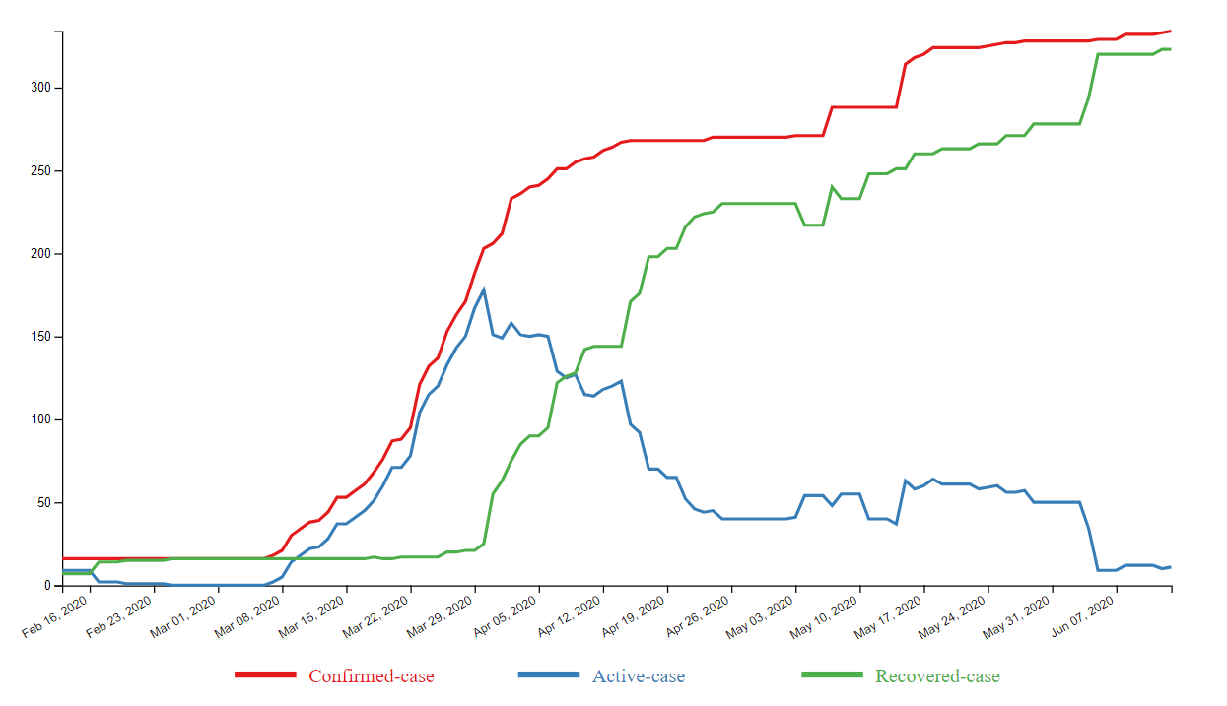

*Line Chart*

*Line Chart with tooltip on lines*

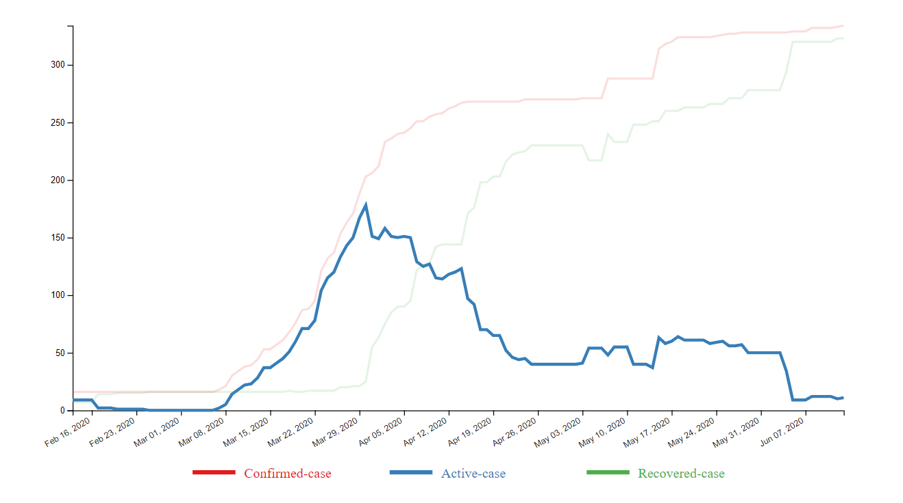

*Line Chart with tooltip on legends*

Moving on to the next chart. On the right-hand side of the geomap is the line chart. This line chart consists of 3 attributes which are: confirmed cases, recovered cases, and active cases. These 3 attributes are the type of common knowledge that people from all classes want to know, therefore it is placed in the first block of chart. A tooltip is integrated for viewers to track down data day by day. Additionally, to enable viewers to focus on the trend of one attribute out of the three, when the mouse is moved onto the desired attribute’s legend, the two other attributes’ lines will turn transparent. The first date on this chart is February 13th, 2020, this is the milestone when Vietnam started the twenty-two-day period of not recording any new case, therefore, all of the three attributes did not fluctuate much in this period, until March 7th, 2020, when the 17th patient is recorded. This patient came back to Vietnam on March 2nd from a Europe trip and had experienced symptoms but refused to voluntarily have a COVID-19 check. After the event of recording the 17th case, the three attributes shared the same trend of increasing dramatically until April 1st, when the Prime Minister’s instruction of quarantining the whole society was activated. After that, the number of active cases started to have a trend of declining, and as this report been written, there is only “…” active cases left in Vietnam.

1. ***Pie chart and Horizontal Stacked Bar Chart***

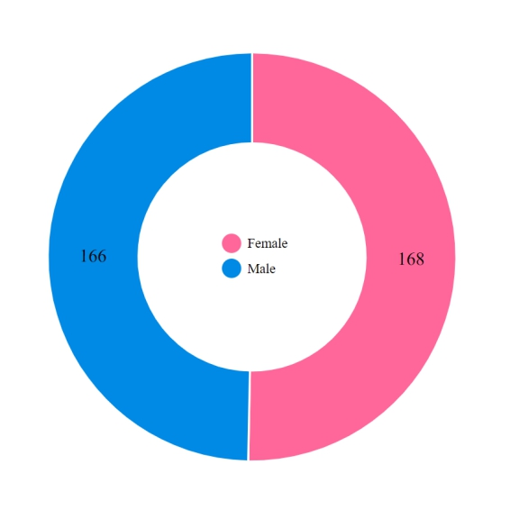

*Pie Chart Pie Chart with tooltip*

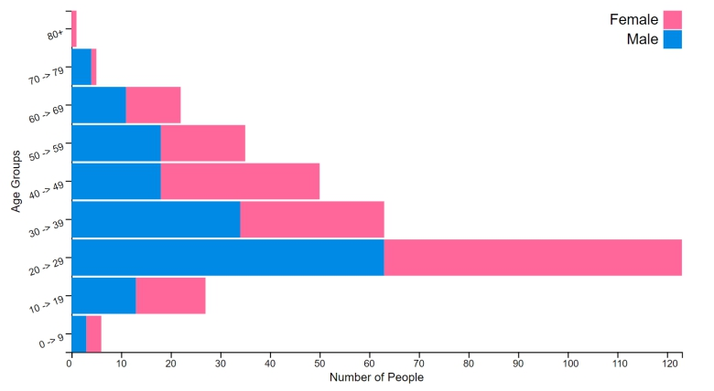

*Horizontal Stacked Bar Chart*

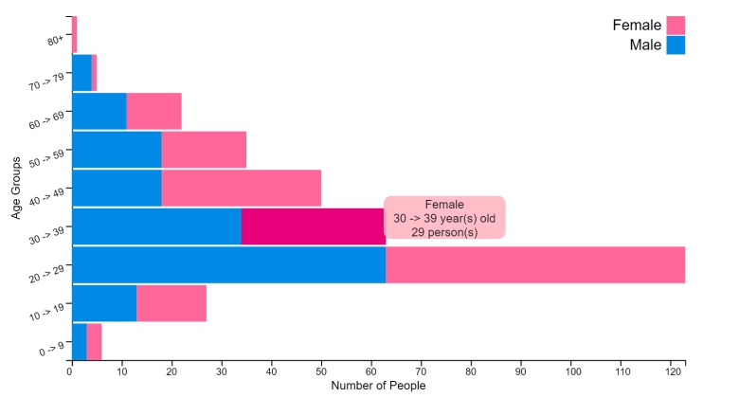

*Horizontal Bar Chart with tooltip*

In the third block, pie chart and stacked bar chart analyze the number of cases in terms of gender and age. These two charts are placed next to each other since they share the same attribute of male and female. From the pie chart, it is clear that the percentage of female and male who are Coronavirus infected are approximately equal, (“…” and “…” respectively). This can be easily understood if we look at the stacked bar chart at the same time: 6 out of 9 age groups (from 10 to 69, except for the age group from 40 to 49) are almost balance between male’s versus female’s number of confirmed cases. For the exceptional age group 40 to 49, the number of recorded female cases is 32, nearly twice as much as that of male, which is 18 cases. For both genders, the number of confirmed cases peaks at the 20 to 29 age group in the latest record (men: “…”, women: “…”). It is noticeable that the working-age age groups (from 20 to 59) have higher number of confirmed cases comparing with the youngsters and elders since many of them still had to go to work during social quarantine because they are their families’ main source of income. The difference between the number of infected people who are 10->19 years of age and 60->69 years of age is negligible. In the latest record, “…” is the ratio of confirmed cases between the 70+ age group and the total number of that of the other age groups.

1. ***Parallel Coordinates Chart***

*Parallel Coordinates Chart*

*Parallel Coordinates Chart with brush*

Finally, parallel coordinates chart provides viewers more details about which provinces the coronavirus spreads from in Vietnam based on the number of confirmed cases, recovered cases, F0 who were quarantined immediately after entering the country, F0 found in society, F1, and F2. This chart is placed in the last block of charts since it has so many attributes and requires the viewer to spend more time to understand. If this chart is put in the first or second block of charts, viewers will surely be overwhelmed by the amount of data and will stop scrolling down to see other charts. It can be seen from the chart, Ha Noi records the highest number of confirmed cases with 114 cases and this figure is twice as much as that in the city having the second-highest number of confirmed cases: Ho Chi Minh City (59 cases). Likewise, the numbers of F0 (quarantined), F0 (social), and F2 recorded in Ha Noi are the highest in all of the three attributes. Therefore, the government decided that the Coronavirus status in Ha Noi should be raised to Alter 3. On the other hand, even though Thai Binh is ranked third in terms of confirmed cases, all cases are quarantined right after the patients’ entrance to the country. Only 9 cases are found in Binh Thuan province, but all the 9 were found in society (with 1 F0 case and 8 F1 cases - the highest record of F1 attribute).

1. **Conclusion**

To put it in a nutshell, this project delivers a general view about the COVID-19 epidemic in Vietnam using geomap, line chart, pie chart, stacked bar chart, and parallel coordinates chart. The data visualizations clearly points out that with “…” confirmed cases, “…” cases found in social and “…” recovered cases, SARS-COVI-2 pandemic is now under control in Vietnam, thanks to the government’s and Ministry of Health’s efforts, combined with Vietnamese residents’ cooperation. Hopefully by using this project, Vietnamese will gain enough understandings about the outbreak to overcome the panic wave created by fake news and show equivalent appreciation to the Vietnamese government and Ministry of Health.