LATIN AMERICA INTERNET BILL OF LADING QUESTIONNAIRE

To Our Valued Customers,

We thank you for your interest in our Internet Bill of Lading Service.

Please complete and email the “below questionnaire to:

Insert LAT Contact information

This form is to insure that your company is properly registered with HMM, so please answer the below questions in its entirety and send to the above email address.

- Is your company (please select one “X”):
Direct  Shipper |  | NVOCC |  | *Freight Forwarder |  | Service Contract  No(s) and/or Last Shipment (BKG/BL#)
*If Freight Forwarder please have your customer submit on their letterhead written authorization for you to produce B/L’s via Hyundai website.

- Internet service option (please select one “XX”):
Input & Print |  | Input only

3. Contact information:
Company Name____________________________________________________
Name_____________________________________________________________
Address___________________________________________________________
Phone_____________________________________________________________
Fax_______________________________________________________________
E-mail address_____________________________________________________

4. Please provide your, HMM website (www.hmm21.com) User ID_______________
Password_______________ if already issued. If not, one will be created for you.
To produce B/L’s at multiple locations, send a list of contacts and locations and
Hyundai will setup each office with their User ID and Password.

If you have any questions, please contact our DCS Administrator.

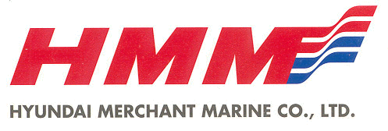
Hyundai America Shipping Agency, Inc.

