**Rostow and Wallerstein**

**Development theory is a conglomeration or a collective vision of theories about how desirable change in society is best achieved. Such theories draw on a variety of social science disciplines and approaches. In this article, multiple theories are discussed, as are recent developments with regard to these theories. Depending on which theory that is being looked at, there are different explanations to the process of development and their inequalities.**

The **Rostow's five-stage model** of economic growth and core-periphery concept of **Wallerstein’s three-part world system** theory are both used to identify a country's development. However, there are differences between the two models.

The analysis **of Rostow's model is the national-level analysis**. The model looks at the country's economic development, which are affected by the innovative activity within the country. **Wallerstein’s three-part world system theory is a international-level analysis**. It focuses on the characteristics of the three parts of the world and the international relations among the parts.

**Rostow's model is the capitalist point of view** since it focuses on the innovation of the industry that will help developing the country. **Wallerstein's three-part world system theory is the socialist point of view since it prioritizes the difference and the conflict of the status**. In Wallerstein's theory, the core state will exploit the periphery and semi-periphery countries through means such as Foreign Direct Investment (FDI).

**Modernization Theory** is used to explain the process of modernization within societies. Modernization refers to a model of a progressive transition from a 'pre-modern' or 'traditional' to a 'modern' society. Modernization theory originated from the ideas of German sociologist Max Weber (1864-1920), which provided the basis for the modernization paradigm developed by Harvard sociologist Talcott Parsons (1902-1979). The theory looks at the internal factors of a country while assuming that with assistance, "traditional" countries can be brought to development in the same manner more developed countries have been. Modernization theory was a dominant paradigm in the social sciences in the 1950s and 1960s, then went into a deep eclipse. It made a comeback after 1990 but remains a controversial model.

Modernization theory both attempts to identify the social variables that contribute to social progress and development of societies and seeks to explain the process of social evolution.

Modernization theory maintains that traditional societies will develop as they adopt more modern practices. Proponents of modernization theory claim that modern states are wealthier and more powerful and that their citizens are freer to enjoy a higher standard of living. Developments such as new data technology and the need to update traditional methods in transport, communication and production, it is argued, make modernization necessary or at least preferable to the status quo. That view makes critique of modernization difficult since it implies that such developments control the limits of human interaction, not vice versa. It also implies that human agency controls the speed and severity of modernization. Supposedly, instead of being dominated by tradition, societies undergoing the process of modernization typically arrive at forms of governance dictated by abstract principles. Traditional religious beliefs and cultural traits, according to the theory, usually become less important as modernization takes hold.

***NATIONAL-LEVEL ANALYSIS*-Rostow's five-stage model emphasizes on the development process of countries (Modernization Theory)**. Countries' economic development will go through five stages: traditional society, preconditions for takeoff, takeoff, drives to maturity, and age of mass consumption. Countries will achieve each stage by innovative activities. For example, a country moves from the stage of traditional society, which the economy bases on the primary sector, to the stage of precondition to take off by the innovative economic activities, such inventing more efficient farming equipment, of the elites that increase agricultural activity.

**Rostow’s Theory is based on Linear Theory (Moving Forward Not Backward)**

The linear stages of growth model is an economic model which is heavily inspired by the Marshall Plan which was used to revitalize Europe’s economy after World War II. It assumes that economic growth can only be achieved by industrialization. Growth can be restricted by local institutions and social attitudes, especially if these aspects influence the savings rate and investments. The constraints impeding economic growth are thus considered by this model to be internal to society.

According to the linear stages of growth model, a correctly designed massive injection of capital coupled with intervention by the public sector would ultimately lead to industrialization and economic development of a developing nation.

* Viewed the process of a state’s development as a series of successive stages of economic growth
* Mixture of saving, investment, and foreign aid was necessary for economic development
* Emphasized the role of accelerated capital accumulation in economic development
* Rostow’s five stages are an example of Linear Development

**International Trade and Rostow’s Five Stages**

**Rostow and stage theories**

It is opportune now to turn to Walt Whitman Rostow. Rostow became a Nobel Laureate development economist who focused heavily on the role of investment as the dynamic force in the path to development. He is also a bridge to the theorists who conceived of economic development in terms of an expanding capitalist nucleus within the underdeveloped economy, the subject of next week’s lecture. I want to separate Rostow from the other theorists because of the heavy Cold War overtones to his work. Rostow had high ambitions for his book, The Stages of Economic Growth, published in 1960. He claimed in the preface, that he was providing ‘an alternative to Karl Marx’s view of modern history’. In Rostow’s version of economic development, economies pass through five successive stages. They begin as a traditional society, where science and technology are traditional, based on superstition and offer little confidence in the ability to control the physical world. These societies can increase their output, and may be subject to major changes in organization. They may even see major inventions and innovations, but their growth is constrained by the generally backward nature of science and technology. This tends to give low productivity, and societies with low productivity tend to devote many of their productive resources to agriculture. Some societies may reach the preconditions for the take-off into intensive, rather than extensive, growth. The main change is to use science to develop new ways of producing food, but especially to change the way that manufactures are produced. This sort of society is really a dual economy, though Rostow did not use the term. As the force of tradition was extremely powerful in such societies, Rostow suggested that the shift from a traditional society to the preconditions for take-off would probably involve the intervention of some outside agency, possibly the rapid development of a neighboring country. Once the modern sector attains a sufficient size, the economy will proceed to the ‘take off’ into self-sustained economic growth (modelled on the classic British industrial revolution). After take-off, economies pass through the drive to maturity (when available technology can be applied to all known resources within the boundaries of the nation), and finally reside in that very American and anti-Marxist spot, the age of high, mass consumption. Rostow was a pioneer development economist whose empirical work had been on the British industrial revolution and whose world-view was that of a Cold Warrior. His economic ideas are very similar to those of Kuznets and modern economic growth. Both looked at the developed economies to find models for poorer countries. Both regarded investment and technical change as the keys to development, but both recognized the immense power in developing nations of ideas and institutions inherited from the past. Rostow’s vigorous, even rabid, anti-communism did however set him apart. Throughout the Stages of Economic Growth Rostow tries to present the USSR (which he always terms “Russia”) as an aberration. Having reached economic maturity, it should have progressed to the age of high, mass consumption but chose instead to impose communism. Rostow believed that the “reactive nationalism” of Soviet leaders placed a burden on the economy (by channeling vast resources into the arms economy), which its population could not tolerate in the longer run. The collapse of the Soviet empire in 1990 gives his analysis great power in retrospect, but his efforts to create a grand theory of economic history to counter Marxist historical materialism very quickly came to nothing because of a range of other theoretical and empirical flaws. His ideas do, however, contain points of interest for development economics, particularly the preconditions for take-off and the take-off itself.

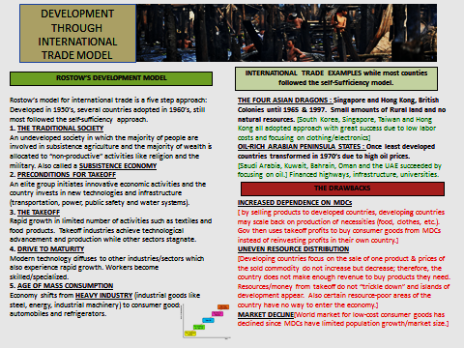

**Countries fund Investment for economic Growth Internally**

**Rostow regarded an increase in the share of savings and investment in the national income as the critical factor that lifts an economy out of low-income stagnation onto a path of self-sustained growth**.

According to Rostow, development requires substantial investment in capital. For the economies of LDCs to grow, the right conditions for such investment would have to be created. If aid is given or foreign direct investment occurs at stage 3 the economy needs to have reached stage 2. If the stage 2 has been reached then injections of investment may lead to rapid growth.

**Article about Africa and need for Internal Investment for Growth**

Development analysts say Africa has realized that traditional sources of development finance, such as official development assistance and foreign direct investment, which have buoyed the continent’s development efforts over the years, are not sustainable and cannot be relied upon as its main sources of funding, as was shown during the 2007–2008 global financial crisis.

Oswell Binha, president of the Association of SADC (Southern African Development Community) Chambers of Commerce and Industry, says Africa can create a $2 trillion dollar economy if it can simplify rules that govern trade and domestic investment. “When you look at the thread of World Trade Organization and economic partnership discussions around the continent, Africa has realized that intra-Africa trade is a serious opportunity from which to raise internal resources,” Binha told Africa Renewal.

Mateus Magala, African Development Bank (AfDB) resident representative in Zimbabwe, says Africa has the greatest investment potential of all frontier markets globally.

“These include sovereign wealth funds, pension funds, foreign reserves and remittances, among others. In addition, the continent has substantial natural resources and countries with extractive industries can tap into this important source of revenue,” Magala said in an interview with Africa Renewal.

He noted that with political determination and leadership to create appropriate governance mechanisms, Africa’s extractive revenues could drive the continent’s transformation by enabling it to invest in competitiveness, diversification and efficient and sustainable use of resources.

At an African Group Perspective Conference on FfD in March, stakeholders said they were committed to funding sustainable development by mobilizing domestic resources, clamping down on corruption and illicit financial flows (IFFs) and addressing issues surrounding good governance.

“To finance its development priorities, Africa has developed a financing framework that prioritizes domestic resource mobilization and trade as main sources of financing structural transformation and sustainable development, with a focus on infrastructure, human capital and sustainable agriculture, which is essential for achieving African Sustainable Development Goals [SDGs],” Adam Elhiraika, the director of macroeconomic policy at the ECA, said at a recent regional meeting in Addis Ababa.

ECA says Africa’s resource potential is enormous. The continent can support, develop and implement viable domestic finance instruments such as financial flows from securitizing remittances, earnings from minerals and mineral fuels, international reserves held by central banks and the growing marketplace for private equity funds.

This is bolstered by evidence from the New Partnership for Africa’s Development (NEPAD) and other sources, which show that African countries raise more than $527.3 billion annually from domestic taxes, compared to $73.7 billion received in private flows and $51.4 billion in official development assistance.

Mr. Magala says $550 billion can be raised from official foreign reserves, $200 billion from pension funds, $150 billion from sovereign wealth funds, $50 billion from foreign direct investments, $60 billion from remittances and $20 trillion from monetizing natural resources.

**Domestic savings**

Carbon-finance mechanisms can also be explored in greater depth for the implementation of some of the continent’s projects. A number of African countries are considering carbon taxation as a form of mobilizing additional financial resources and tackling the challenges posed by climate change.

However, the ECA says that compared to domestic savings in other developing regions, those in Africa remain low largely due to an unbanked population, though the potential exists if the informal sector’s resources are tapped and the sector is given incentives to use formal banking services. Africa’s savings-to-GDP was about 22% between 2005 and 2010, compared to 46% in East Asia and the Pacific and 30% for middle-income countries.

Mr. Binha says African governments should also foster an environment for high-level public-private sector consultations, considering that the private sector has so far played a limited role in implementing Africa’s development. “Engaging with the private sector genuinely increases investments internally and also becomes an effective means of attracting external investment. There is no rapport between governments and the private sector. There is a them-and-us syndrome,” notes Mr. Binha.

The ECA estimates the private equity market in Africa to be worth about $30 billion. In 2011 alone, private equity firms raised $1.5 billion for business in Africa.

**Reducing the cost of remittances**

**Note Definition of Remittance**

A remittance is a transfer of money by a foreign worker to an individual in his or her home country. Money sent home by migrants competes with international aid as one of the largest financial inflows to developing countries. Workers' remittances are a significant part of international capital flows, especially with regard to labor-exporting countries. In 2014, $436 billion went to developing countries, setting a new record. Overall global remittances totaled $582 billion in 2015. Some countries, such as India and China, receive tens of billions of US dollars in remittances each year from their expatriates. In 2014, India received an estimated $70 billion and China an estimated $64 billion.

While remittances have increased, averaging $21.8 billion over the past decade, with countries such as Nigeria and Senegal receiving about 10% of their GDP in remittances, experts say the cost of sending remittances to Africa has remained the highest in the world, with the cost of transfers within Africa even higher. For remittances to have an impact, they must be made cheaper and used effectively to spur development.

Sometimes tough anti–money laundering laws and counter-surveillance regulations meant to combat financial terrorism can stifle remittances, thereby negating the continent’s progress. This recently happened when US banks plugged remittance services to Somalia.

Curtailing IFFs remains a major challenge that Africa must vigorously undertake. Such outflows from Africa may have been as high as $854 billion between 1970 and 2008, which amounts to an annual average of close to $22 billion in lost finances—more than half of it coming from the extractive industries sector. The domestic resource mobilization effort will receive a significant boost if IFFs from the continent are curtailed.

Several policy options have been suggested to stem the flows, such as raising awareness and sharing best practices among African policymakers and other stakeholders on the magnitude and development impact of the IFFs.

Some of the key initiatives taken so far include African Union finance ministers’ setting up the High Level Panel on Illicit Financial Flows from Africa, and the establishment of regional initiatives such as the African Regional Anti-Corruption Programme (2011–2016) and the African Tax Administrative Forum.

Mr. Binha says Africa’s biggest challenges are confidence, the unfavourable policy matrix, the rigidities of domestic trade and intra-trade and differences across nations. “Confidence is a huge deterrent to attracting sustainable, dependable and credible internal investment. African states have to create a dashboard around which there is proper governance, accountability and dependability with investors. The potential is there but Africa has to first clearly define its priorities in Agenda 2063, their cost and the mechanisms to meet them,” added Mr. Binha. Agenda 2063 is the African Union’s economic development blueprint for the 50 years following 2013, when it was adopted.

**Maintaining growth**

According to the World Bank, to raise enough funds from domestic sources, Africa will need to grow at a rate of 5% of GDP for the next two decades. The bank forecasts that economic growth for African countries will slow to 4.0% in 2015 from 4.5% in 2014, a downturn that largely reflects the sharp fall in global prices for oil and other key commodities.

The World Bank’s chief economist, Francisco Ferreira, told African finance ministers and central banks chiefs during a recent spring (April) meeting in Washington, DC, that the forecast was below the 4.4% average annual growth rate of the past two decades and well short of Africa’s peak growth rates of 6.4% in 2002–2008. Although the boom is over, Ferreira noted, the “Africa Rising” phenomenon predated the boom and should be able to outlive it.

Innovative domestic financing mechanisms such as Africa50, launched by the AfDB last year, are therefore expected to lead or complement other external resources and new financing forces like the BRICS countries (Brazil, Russia, India, China and South Africa) to achieve Africa’s ambitious development needs.

**Economic Change that focuses on a Single Country using the Rostow Model**

**An example would be India’s transition from Self-sufficiency to International trade and the Rostow model. See Notes from PPT or Textbook**

**Uneven Global Development will be lessened with the Rostow Model**

Emphasizes a trickle-down modernization effect from urban industry and western influence to develop a country as a whole.

Countries identify distinctive economic assets

Country can develop economically by concentrating scarce resources on expansion of its distinctive local industries, sale of products in world market brings funds into country

Each country is in one of Rostow's five stages, MDCs in 4 or 5, LDCs in 1-3

Countries that concentrate on international trade benefits from exposure to other consumers, to remain competitive, industries constantly must evaluate changes in consumer preferences

**Examples**

The Four Asian Dragons

First countries to adopt international trade alternative were South Korea, Singapore, Taiwan, Hong Kong --"four dragons", "four little tigers" "gang of four"

- Singapore and Hong Kong (UK colonies) have no natural resources, so promoted development by concentrating on producing handful of manufactured goods like clothing and electronics = low labor costs let them sell inexpensively

Petroleum-rich Arabian Peninsula states

- Saudi Arabia, Kuwait, Bahrain, Oman, UAE

- used petroleum revenues to finance projects like housing

- landscape changed by diffusion of consumer goods

- Islamic religious principles conflict with business practices in MDCs

**Does not emphasize the role of Colonialism/Imperialism or/Neocolonialism**

SEE Document on Website

**Western/Capitalist or Liberal Viewpoint**

In particular, Rostow rejects the Marxian foresight which maintained the prognosis of revolutionary communism as the rational and inevitable outcomeof history. Rostow performs his own inversion, so to speak, by arguing that the age of high mass-consumption is the “inner” tendency of modern history, while communism, as he describes it toward the book’s end, was merely a “kind of disease which can befall a transitional society if it fails to organize effectively those elements within it which are prepared to get on with the job of modernization” (Stages, 164).

In Rostow’s view, to abate the “disease” of communism so-called developing countries needed to integrate and maximize the preconditions of modernization that would lead to “take-off.” For Rostow, these preconditions act like a force which help break down the “traditional” or “pre-modern” socio-cultural structures that encumber industrialization. Importantly, this force, according to Rostow, is external: it is something that comes from the outside. Rostow writes: “the stage of preconditions arise not endogenously but from some external intrusion by more advanced societies. These invitations—literal or figurative—shocked the traditional society and began or hastened its undoing; but they also set in motion ideas and sentiments which initiated the process by which a modern alternative to the traditional society was constructed out of the old culture” (Stages, 6, my emphasis). Here, the agent of change does not emerge from native to traditional societies but is given to them from an alien source which they then accept and experience as shock. But it is a shock that must be endured if “the old blocks and resistances to steady growth are finally [to be] overcome” (Stages, 7). Rostow identifies three necessary conditions that need to be present in order for a country to take-off: GDP growth rates must increase to at least 5-10% per annum; manufacture must be revolutionized from agrarian to industrial modes of production; and, finally, political institutions must be installed in order to channel these conditions for maximal output. The combined effects of these three conditions produce the concrete situation in which a country’s productive energies reach such a critical level that they stimulate the take-off of “massive and progressive structural transformation” (Stages, 40).

The problem of underdevelopment is therefore explained in terms of a country’s inability to efficiently absorb and implement the external forces of modernization. In Rostow’s scheme, at any given historical period, one can analyze the degree to which a society has harnessed the optimal conditions of production, which, in turn, can be summed up and exploited at some point along the five stages-of-growth. The persistence of poverty and underdevelopment around the globe was seen as an effect either of countries lagging behind and simply needing to catch up or of countries being obstinate about letting their national economy become exposed to capitalist forces. Just as the concept of development became equated with economic growth, so progress would be linked to economic performance, such that whatever differences each national economy exhibited they could be explained with reference to a single measure and timeline of economic development. This, we might say, is the modernism of Rostow, whose stages-of-growth, like a cubist painter, visually collapses historical time: diachronic differences (uneven development) become flattened by a synchronic representation of modernization (linear development).Walt Rostow: the intellectual context

**Economic Liberalism**

Economic liberalism is the ideological belief in organizing the economy on individual lines, meaning that the greatest possible number of economic decisions is made by individuals or households and not by collective institutions or organizations.

**ROSTOW AND BRAZIL**

**Read Document found on my Webpage or Google information explaining Brazil and it’s development through the Rostow stages**

**Wallerstein's three-part world system theory (Dependency Theory)**

**International-Level of Analysis**

**Wallerstein's three-part world system theory (Dependency Theory)** focus on the characteristics of the three parts of the world includes the core, semi-periphery, and periphery, and the **international relations among the parts**. The core states are the most economically developed and diversified, wealthy, and powerful countries with strong governments, such as **United States, Canada, and Germany**. The periphery states are the countries that have the least developed and diversified economy and weak governments, such as the **Sub-Saharan Africa and Caribbean countries**. The semi-periphery states are the countries developing towards the core states, such as **China, Brazil, and Mexico**. .

**Dependency Theory:** Dependency theory is essentially a follow up to structuralist thinking, and shares many of its core ideas. Whereas structuralist did not consider that development would be possible at all unless a strategy of delinking and rigorous ISI was pursued, dependency thinking could allow development with external links with the developed parts of the globe. However, this kind of development is considered to be "dependent development", i.e., it does not have an internal domestic dynamic in the developing country and thus remains highly vulnerable to the economic vagaries of the world market. Dependency thinking starts from the notion that resources flow from the ‘periphery’ of poor and underdeveloped states to a ‘core’ of wealthy countries, which leads to accumulation of wealth in the rich states at the expense of the poor states. Contrary to modernization theory, dependency theory states that not all societies progress through similar stages of development. Periphery states have unique features, structures and institutions of their own and are considered weaker with regards to the world market economy, while the developed nations have never been in this colonized position in the past. Dependency theorists argue that underdeveloped countries remain economically vulnerable unless they reduce their connections to the world market.

Dependency theory states that poor nations provide natural resources and cheap labor for developed nations, without which the developed nations could not have the standard of living which they enjoy. When underdeveloped countries try to remove the Core's influence, the developed countries hinder their attempts to keep control. This means that poverty of developing nations is not the result of the disintegration of these countries in the world system, but because of the way in which they are integrated into this system.

In addition to its structuralist roots, **dependency theory has much overlap with Neo-Marxism and World Systems Theory**, which is also reflected in the work of Immanuel Wallerstein, a famous dependency theorist. Wallerstein **rejects the notion of a Third World, claiming that there is only one world which is connected by economic relations (World Systems Theory). He argues that this system inherently leads to a division of the world in core, semi-periphery and periphery. One of the results of expansion of the world-system is the commodification of things, like natural resources, labor and human relationships.**

Immanuel Wallerstein characterizes the world system as a set of mechanisms which redistributes resources from the periphery to the core. In his terminology, the core is the developed**, industrialized, democratic** part of the world, and the periphery is the underdeveloped, raw materials-exporting, poor part of the world; the market being the means by which the core exploits the periphery.

Nowadays, this has changes as the core countries are moving into 3rd and higher level sector jobs and the periphery is taking on the second sector factory jobs.

The core nations primarily own and control the major means of production in the world and perform the higher-level production tasks. The periphery nations own very little of the world’s means of production (even when they are located in periphery nations) and provide less-skilled labor. Like a class system with a nation, class positions in the world economy result in an unequal distribution of rewards or resources. The core nations receive the greatest share of surplus production, and periphery nations receive the least. Furthermore, core nations are usually able to purchase raw materials and other goods from noncore nations at low prices, while demanding higher prices for their exports to noncore nations.

Parts and basic Descriptions

**Core**

Processes that incorporate higher levels of education, higher salaries, and more technology

Generate more wealth in the world economy

**Periphery**

Processes that incorporate lower levels of education, lower salaries, and less technology

Generate less wealth in the world economy

**Semi-periphery**

Places where core and periphery processes are both occurring. Places that are exploited by the core but then exploit the periphery.

Serves as a buffer between core and periphery

**Core nations**

* The most economically diversified, wealthy, and powerful (economically and militarily)

* Highly industrialized

* Tend to specialize in information, finance and service industries

* Produce manufactured goods rather than raw materials for export

* More often in the forefront of new technologies and new industries. Examples today include high-technology electronic and biotechnology industries. Another example would be assembly-line auto production in the early twentieth century.

* Have more complex and stronger state institutions that help manage economic affairs internally and externally

* Have a sufficient tax base so these state institutions can provide infrastructure for a strong economy

* Have more means of influence over noncore nations

* Relatively independent of outside control

**Periphery nations**

* Least economically diversified

* Tend to depend on one type of economic activity, such as extracting and exporting raw materials to core nations

* Are often targets for investments from multinational (or transnational) corporations from core nations that come into the country to exploit cheap unskilled labor for export back to core nations

* Tend to have a high percentage of their people that are poor and uneducated.

* Inequality tends to be very high because of a small upper class that owns most of the land and has profitable ties to multinational corporations

* Have relatively weak institutions with little tax base to support infrastructure development

* Tend to be extensively influenced by core nations and their multinational corporations. Many times they are forced to follow economic policies that favor core nations and harm the long-term economic prospects of periphery nations.

**Semiperiphery nations**

Semiperiphery nations are those that are midway between the core and periphery. They tend to be countries moving towards industrialization and a more diversified economy. “While they are weaker than core societies, they are trying to overcome this weakness and are not as subject to outside manipulation as peripheral societies.”

Throughout the history of the modern world-system there has been a group of core nations competing with one another for access to the world’s resources, economic dominance, and hegemony (leadership or dominance, especially by one country or social group over others) over periphery nations. According to Immanuel Wallerstein, a core nation dominates over peripheries when it has a lead in three forms of economic dominance over a period of time:

1. Productivity dominance allows a country to produce products of greater quality at a cheaper price compared to other countries.

2. Productivity dominance may lead to trade do trade dominance. Now, there is a favorable balance of trade for the dominant nation since more countries are buying the products of the dominant country than it is buying from them.

3. Trade dominance may lead to financial dominance. Now, more money is coming into the country than going out. Bankers of the dominant nation tend to receive more control of the world’s financial resources.

Note: parts of this definitely apply better to colonial times rather than more modern times.

-conflict over dominance was more colonial

-production now tends to take place in the periphery

-today, one could argue that the core countries still consume and use more and the periphery produce materials for them to use and that most trade revolves around that.

**The structure of Wallerstein’s three-part world system theory can also be applied to the national-level analysis**. The core state can be seen as the core part of the nation, which is the more economic activity, centralized and diversified region within the country, such as New York.  On the other hand, the periphery states of a country can be seen as the periphery part, which is least economic activity centralized and diversified, such as Arizona. Also, the Central Business District can be seen as the core part within a city since it's more economically developed. The residential zone can be seen as the semi-periphery part within the city since it is developing towards the downtown but more economically developed than the rural areas.

**The backwardness model is a theory** of economic growth created by Alexander Gerschenkron. The model postulates that the more backward an economy is at the outset of economic development, the more likely certain conditions are to occur. USSR leader Mikhail Gorbachev once said: "If you don't move forward, sooner or later you begin to move backward."

The model suggests that the more backward the economy, the more likely it is that the following things will occur:

Special institutions, including banks or the state, will be necessary to properly channel physical capital and human capital to industries.

There will be an emphasis on the production of producer goods rather than consumer goods.

There will be an emphasis on capital-intensive production rather than labor-intensive production.

There will be a great scale of production and enterprise.

There will be a reliance on borrowed rather than local technologies.

The role of the agricultural sector, as a market for new industries, will be small.

There will be a reliance on productivity growth.

Thorstein Veblen's 1915 Imperial Germany and the Industrial Revolution is an extended essay comparing the United Kingdom and Germany, and concluding that the slowing of growth in Britain and the rapid advances in Germany were due to the "penalty of taking the lead".

British industry worked out, in a context of small competing firms, the best ways to produce efficiently. Germany's backwardness gave it an advantage in that the best practice could be adopted in large-scale firms.

The backwardness model is often contrasted with the take-off model developed by W.W. Rostow, which presents a more linear and structuralist model of economic growth, planning it out in defined stages. The two models are not mutually exclusive, however, and many countries appear to follow both models rather adequately.

**READ ECONOMICALLY BACKWARD COUNTRIES: Document page on my website**

**Economic Change that focuses on spatial relationships between countries (trade, interdependence, interaction)**

Economic interdependence is a consequence of specialization or the division of labor. The participants in any economic system must be part of a trading network to obtain the products they cannot produce efficiently for themselves. Any change in such a network affects other participants, so that the demands for various products and the incomes of the participants are interdependent.

Global economic interdependence has grown exponentially in the span of a generation, as a result of great technological progress and associated policies that were aimed at opening national economies internally and externally to global competition.

Investment and international trade have drastically increased over the last 100 of years except during World War I and World War II. Over time, economic interdependence has incorporated other aspects that were brought about by contemporary globalization - as a result of the onset of the age of computerization, telecommunications and low-cost travel and shipping. As international trade have been increasing at a rate beyond 8% during the 1950s to 1970s, and has also been driven by improvements in information technology in the 1990s, economic interdependence between countries have increased even more rapidly.

Given such rapid increase in international trade and capital flows that are traditionally associated with globalization, there has been increasing interest in the issues of financial and economic interdependence, partly driven by the contagion that resulted from the financial crisis.

**Geopolitical Approach**

Another way of measuring the degree of economic interdependence is via a geopolitical approach, which is based on the presumption that economic interdependence may exist because states trade with each other to obtain strategic goods that are needed for national industry and defense. The geopolitical approach is based on both vertical and horizontal interdependence. Vertical interdependence measures how a change in the price of a good in Country X will affect Country Y (or how changes in price in State A will affect State B), whilst horizontal interdependence calculates the degree of bilateral trade, transactions and investment involved between both countries.[6] Both vertical and horizontal interdependence data must be used to measure economic interdependence. This is because that in the given situation that there is a high correlation of vertical interdependence between country X and country Y, if there is no horizontal interdependence (transaction of goods, services or capitals) between both countries, country X and country Y will have little/no economic interdependence. Vertical interdependence without horizontal may arise due to other factors such as changes in worldwide economic forces. For instance, consider the case of trade and the flow of factors among Arab states (which is typically very limited); whilst we observe parallel movements in factor prices, this may just be due to the effect of global market forces that affect all economies in the same fashion.

**Uneven Global Development is a basic Characteristic of the Wallerstein Model**

**SEE FOLOWING TOPIC**

**International Trades Strengthens development of Core Countries (Exporting manufactured Goods) and constrains development in Peripheral Countries (Exporting Resources).**

**Peripheral Countries are dependent on core countries to finance investment for economic growth**

**Go to your textbook Key Issue 4 for more information**

**Of the 500 largest transnational corporations in 2011, 384 had headquarters in developed countries.**

**133 in the US and 164 in Europe**

***China=location of 61 of the 116 headquarters in developing countries.***

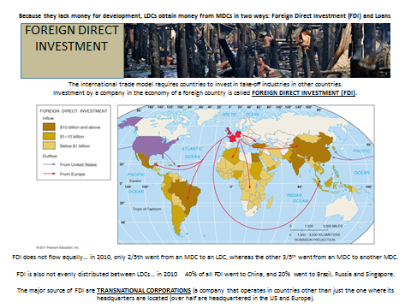

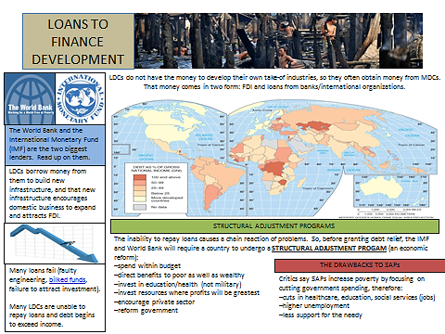

**International Trades Strengthens development of Core Countries (Exporting manufactured Goods) and constrains development in Peripheral Countries (Exporting Resources).**

Modern nation states are all part of the world-system of capitalism, and it is this world-system that Wallerstein seeks to understand. Wallerstein believes that there are only three basic types of social systems.

The Modern World-System

* Mini-systems
* World empires
* World-economies

The first he terms as “mini-systems,” these are the small, homogenous societies studied by anthropologists. Hunting and gathering, pastoral, and simple horticultural societies are relatively self-contained economic units, producing all goods and services within the sociocultural system itself. The second type of social system is a “world-empire.” This system has an economy that is based on the extraction of surplus goods and services from outlying districts. Much of this tribute goes to pay for the administrators who extract it and for the military to ensure continued domination, the rest goes to the political rulers at the head of the empire. The third type of social system, according to Wallerstein, is the world-economies. Unlike world-empires, the world-economies have no unified political system; nor is its dominance based on military power alone. However, like a world-empire, a world-economy is based on the extraction of surplus from outlying districts to those who rule at the center.

From the start, Wallerstein argues, capitalism has had a division of labor that encompassed several nation states. The capitalist world-system began in Europe in about 1500 and under the spur of the accumulation of capital, expanded over the next few centuries to cover the entire globe. In the process of this expansion the capitalist world system has absorbed small mini-systems, world-empires, as well as competing world-economies. The capitalist world-economy was created by establishing long-distance trade in goods and linking production processes worldwide, all of which allowed the significant accumulation of capital in Europe. But these economic relationships were not created in a vacuum. The modern nation state was created in Europe along with capitalism to serve and to protect the interests of the capitalists. What was in the interest of early European capitalists was the establishment of a world-economy based on an extremely unequal division of labor between European states and the rest of the system. Also in the interest of early European capitalists was the establishment of strong European states that had the political and military power to enforce this inequality.

For Wallerstein, the capitalist world-economy is a mechanism of surplus appropriation that is both subtle and efficient. It relies upon the creation of surplus through constantly expanding productivity. It extracts this surplus for the benefit of the elite through the creation of profit. The capitalist world-system is based on a two-fold division of labor in which different classes and status groups are given differential access to resources within nation states; and the different nation states are given differential access to goods and services on the world market. Both types of markets, those within and those between nation states, are very much distorted by power.

**Core & Periphery**

Wallerstein divides the capitalist world-economy into three areas:

peripheral areas.

Semi-peripheral

Core states

The peripheral areas are the least developed; they are exploited by the core for their cheap labor, raw materials, and agricultural production. The semi-peripheral areas are somewhat intermediate, being both exploited by the core and take some role in the exploitation of the peripheral areas. In the recent past they have been expanding their manufacturing activities particularly in products that core nations no longer find very profitable. The core states are in geographically advantaged areas of the world—Europe and North America.

These core states promote capital accumulation internally through tax policy, government purchasing, sponsorship of research and development, financing infrastructural development (such as sewers, roads, airports—all privately constructed but publically financed), and maintaining social order to minimize class struggle. Core states also promote capital accumulation in the world-economy itself. These states have the political, economic, and military power to enforce unequal rates of exchange between the core and the periphery. It is this power that allows core states to dump unsafe goods in peripheral nations, pay lower prices for raw materials than would be possible in a free market, exploit the periphery for cheap labor, dump in their environment, abuse their consumers and workforce, erect trade barriers and quotas, and establish and enforce patents. It is the economic, political, and military power of the core that allows significant capital to be accumulated into the hands of the few, the capitalist world-system that produces and maintains the gross economic and political inequalities within and between nations.

As with capitalism within nation states, this unequal power between nation states is not uncontested. It is the subject of struggle. There are internal contradictions that with the passage of time cause political and economic instability and social unrest. Eventually, according to Wallerstein, a world-wide economic crisis will be reached and the capitalist world-system will collapse, opening the way for revolutionary change.

**Emphasizes the role of Colonialism/Imperialism or Neocolonialism**

Those countries traditionally referred to as the Third World are often divided into two groups to indicate important differences in their levels of development. Newly industrializing countries (NICs) like South Korea have shown swift economic development, social stability, and greater democratization, while less-developed countries (LDCs) like Ghana display weak economic growth, and political and social instability.

While they are increasingly moving apart in their development, these countries share a legacy of colonialism and imperialism, which has some long-term implications.

**Imperialism and Colonialism**

Empires are single political authorities that have, under their sovereignty, a large number of external regions or territories.

**Imperialism is the system whereby a state extends its power to directly control territory, resources, and people beyond its borders.** This should not be confused with colonialism, which involves a greater degree of physical occupation of a territory by settlers or the military.

Modern imperialism can be dated to the 1500s, when technological development in Europe, the Middle East, and Asia (particularly advanced seafaring and military technology) allowed these states to project their military might far overseas. European imperialism was driven by economic and strategic motives, but also by evangelical religious beliefs. These empires stretched far into Asia, Africa, and the Middle East. In the twentieth century, Japan engaged in imperialism for a short time.

**Institutions of Imperialism**

When imperialist nations conquered territories, they brought the idea of the modern state to these regions. State power often manifested itself in the form of bureaucracy, a new national language (the imperialist’s), roads, taxes, and military and police. Empires established control by installing loyal local leaders or by setting up new central authorities themselves. The imposition of the state had mixed effects.

Imperialism often brought new notions of ethnic identity (deeming some people superior to others even though those divisions did not exist previously) and national identity (nationalism and the idea of self-determination eventually led to colonies to demand independence from the empire). Scholars disagree on how imperialism shaped gender roles (some argue that imperialism was positive for women’s equality and rights, others say it was detrimental).

Colonizers created cash-based, mercantilist economies to extract wealth and natural resources from the colonies. The colonies also became captive markets for the finished goods of the home country (colonies were allowed to trade only within the empire). This new economy created wealth for the empire, but was often not sustainable for the colonial economy.

**The Challenges of Post imperialism**

After achieving independence, former colonies have struggled with building state capacity and autonomy, forging social identities, and generating economic growth.

**After colonialism, newly industrializing and less-developed countries have struggled to create and maintain coherent societies. The ethnic hierarchies created by imperialism led to clashes over economic power and political control, and have made establishing a strong national identity challenging.**

Gender roles imposed or reinforced by colonial rule persisted in many societies following independence, leading to gender imbalances. At the extreme level, gender inequality contributes female infanticide and may be linked civil conflicts.

**Economically, newly industrializing and less-developed countries were still dependent upon their former empires—a continuation of the unequal, imperialist structure called neocolonialism.**

To build their economies, some LDCs turned to import substitution, restricting imports in favor of locally produced goods, a policy with little success that was criticized as prone to corruption. Several Asian countries pursued a more successful policy of export-oriented industrialization, focusing on producing goods that could be exported, but even those countries experienced a significant economic downturn in the 1990s. These countries were encouraged to employ structural adjustment programs (or the Washington Consensus) dictated by the World Bank and International Monetary Fund and requiring privatization of industries, more open markets, and more encouragement of foreign investment; these reforms have been controversial and their results mixed.

**Puzzles and Prospects for Democracy and Development-Internal Efforts**

Political scientists increasingly agree on why some newly industrializing and less-developed countries have been more successful than others. We know, for instance, that a high degree of ethnic divisions is linked to greater economic and political instability, that natural resources limit political and economic development, and that these problems cannot be addressed without an effective state. However, scholars differ widely in how to solve these challenges. **The view of the state as a tool or obstacle to development in the postcolonial world has shifted over time. Early foreign aid was channeled into state-dominated large-scale, top-down development projects like dams or health care**, while the Washington Consensus sought to roll back state power, encourage private industry, and limit regulation in the belief that market forces could succeed where states had failed. Both approaches have their failures and critics.

Some scholars advocate democratic development to promote growth and may advocate for devolving power as a way to tackle corruption and increase state legitimacy, but critics point out that devolution (the transfer or delegation of power to a lower level/ Example UK turning powers over to Scotland), especially by central government to local or regional administration can lead to political polarization and instability.

Some scholars argue that changing politics and society in these countries requires massive international efforts, with international organizations having a strong influence on the politics, health, agriculture, and education of the nation. This approach, however, may undermine sovereignty and is unpopular in developing areas.

A final problem of many less-developed countries is that most of the economy exists in the informal economy, not regulated or taxed by the state, which can limit potential growth.

To reform these economies, some scholars call for establishment of property rights and more extensive use of microcredit (providing small loans to local people to allow them to start businesses) or **microfinance (**a broader spectrum, including credit, savings, insurance, and financial transfers). Other scholars call for larger-scale initiatives, such as liberalization of trade policy.

**Neo-colonialism is a State which in theory, independent and has all the outw** **ard trappings of international sovereignty. In reality its economic system in which its political policy is directed from outside.**

Neocolonialism is a term used by post-colonial critics of developed countries' involvement in the developing world. Critics of neocolonialism argue that existing or past international economics arrangements created by former colonial powers were, or are, used to maintain control of their former colonies and dependencies after the colonial independence movements of the post-World War II period.

The methods and form of this direc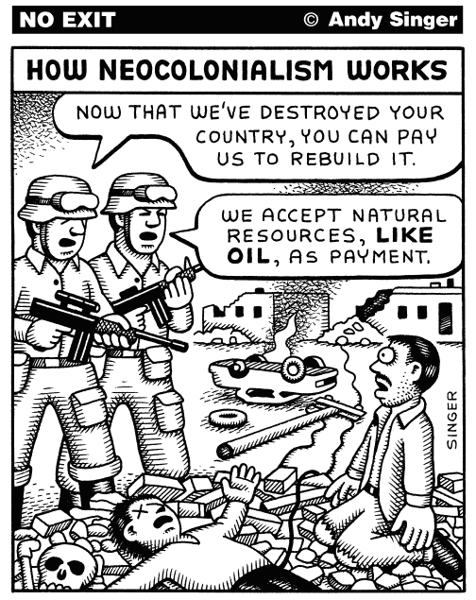tion can take various shapes. For example, in an extreme case the troops of the imperial power may garrison the territory of the neo-colonial State and control the government of it. More often, however, neo-colonialist control is exercised through economic or monetary means. The neo-colonial State may be obliged to take the manufactured products of the imperialist power to the exclusion of competing products from elsewhere. Control over government policy in the neo-colonial State may be secured by payments towards the cost of running the State, by the provision of civil servants in positions where they can dictate policy, and by monetary control over foreign exchange through the imposition of a banking system controlled by the imperial power.

**The result of neo-colonialism is that foreign capital is used for the exploitation rather than for the development of the less developed parts of the world. Investment under neo-colonialism increases rather than decreases the gap between the rich and the poor countries of the world.**

**Marxist/Structuralist Viewpoint**

Wallerstein began as an expert of post-colonial African affairs, which he selected as the focus of his studies after attending international youth conferences in 1951 and 1952. His publications were almost exclusively devoted to this until the early 1970s, when he began to distinguish himself as a historian and theorist of the global capitalist economy on a macroscopic level. His most important work, The Modern World-System, has appeared in four volumes since 1974, with additional planned volumes still forthcoming. In it, Wallerstein draws on several intellectual influences:

Karl Marx, whom he follows in emphasizing underlying economic factors and their dominance over ideological factors in global politics, and whose economic thinking he has adopted with such ideas as the dichotomy between capital and labor, and criticizes the traditional Marxian view of world economic development through stages such as feudalism and capitalism, belief in the accumulation of capital, dialectics, and more;

Dependency theory, most obviously its concepts of "core" and "periphery".

He also argued that the end of the Cold War, rather than marking a triumph for liberalism, indicates that the current system has entered its 'end' phase; a period of crisis that will end only when it is replaced by another system. Wallerstein anticipated the growing importance of the North–South divide at a time when the main world conflict was the Cold War. He has argued since 1980 that the United States is a "hegemon in decline". He was often mocked for making this claim during the 1990s, but since the Iraq War this argument has become more widespread. Overall, Wallerstein sees the development of the capitalist world economy as detrimental to a large proportion of the world's population. Similar to Marx, Wallerstein predicts that capitalism will be replaced by a socialist economy.

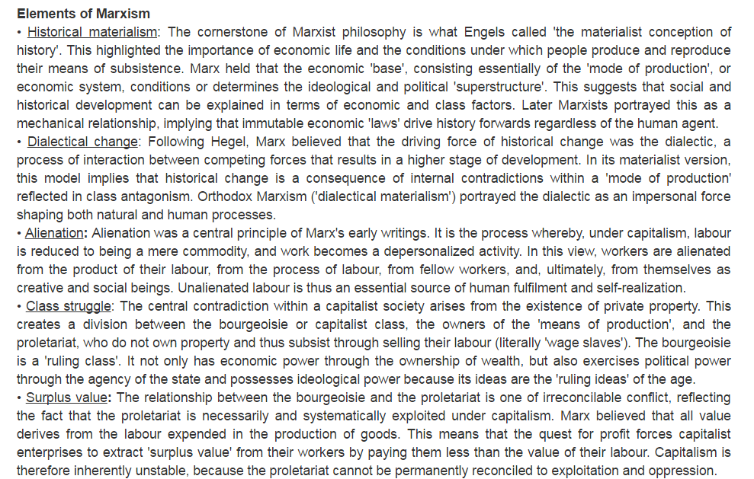

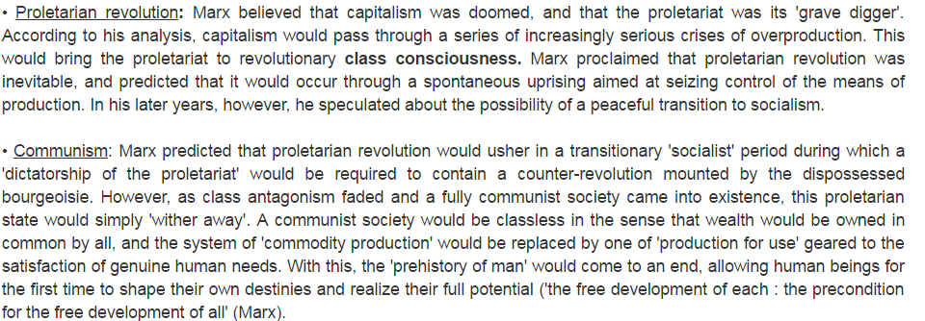

Structuralism: is a development theory which focuses on structural aspects which impede the economic growth of developing countries. The unit of analysis is the transformation of a country’s economy from, mainly, a subsistence agriculture to a modern, urbanized manufacturing and service economy.

Policy

* Major government intervention in the economy to fuel the industrial sector, known as import substitution industrialization (ISI). This structural transformation of the developing country is pursued in order to create an economy which in the end enjoys self-sustaining growth.
* This can only be reached by ending the reliance of the underdeveloped country on exports of primary goods (agricultural and mining products), and pursuing inward-oriented development by shielding the domestic economy from that of the developed economies.
* Trade with advanced economies is minimized through the erection of all kinds of trade barriers and an overvaluation of the domestic exchange rate; in this way the production of domestic substitutes of formerly imported industrial products is encouraged.
* The logic of the strategy rests on the infant industry argument, which states that young industries initially do not have the economies of scale and experience to be able to compete with foreign competitors and thus need to be protected until they are able to compete in the free market.

Structuralists argue that the only way Third World countries can develop is through action by the state. Third world countries have to push industrialization and have to reduce their dependency on trade with the First World, and trade among themselves. The roots of structuralism lie in South America, and particularly Chile. In 1950, Raul Prebisch went to Chile to become the first director of the Economic Commission for Latin America. In Chile, he cooperated with Celso Furtado, Anibal Pinto, Osvaldo Sunkel, and Dudley Seers, who all became influential structuralist.

Structuralist economists try to identify specific rigidities, lags as well as other characteristics of the structure of developing countries in order to assess the way economies adjust and their responsiveness to development policies. A normal assumption within this approach is that the price mechanism fails as an equilibrating mechanism, to deliver steady growth, to produce a "desired" income distribution.

• the importance of political and institutional factors in the analysis of economic problems.

• the need to raise the level of domestic saving in order to raise the rate of investment given that external sources of finance are likely to be hard to come by inflation as a "social phenomenon" requiring for its elimination social, psychological and political-institutional changes, as well as orthodox monetary and fiscal policies.

the false nature of dilemmas between — planning and the market — agriculture and industry.

• the need to strengthen the productive and technological base.

• the importance of trying to improve the terms on which countries are integrated into the global economy and to improve international competitiveness.

• structural adjustment as only one component of structural change.

• More recent contributions to structuralist economics have highlighted the importance of institutions and distribution across both productive sectors and social groups.

**Wallerstein and Mexico**

Wallerstein's three-part world system theory characterizes each part. Mexico, which is a newly industrializing country, is a semi-periphery country based on Wallerstein’s theory. First of all, Mexico's economy is based on the secondary sector, which is manufacturing, and developing towards the core country. Mexico is exploited by the United States and other core countries due to the cheap labor in the country. Big companies from the core countries set up factories in Mexico in order to minimize the cost of labor force. However, the quality of working condition of the workers is low, such as low pay, over working, and grimy working places. Furthermore, the toxic waste from the factory pollutes the land. On the other hand, Mexico also plays the role of exploiting other countries, such as Honduras. Human traffickers traffic people from Honduras to subject to forced labor in Mexico.