Industries Explaining Momentum: A Replication and Extension of Moskowitz and Grinblatt (1999)
Ella Swapp, Joseph Henderson, Anders Neuenschwander

I. Introduction
Jegadeesh and Titman (1993) document that buying stocks with high prior six-to-twelve month returns and shorting stocks with low prior returns generates abnormal profits of approximately 12% per year, a result that standard risk models cannot explain. Moskowitz and Grinblatt (1999) propose that this anomaly is not driven by firm-specific return persistence but by persistence at the industry level. Their central thesis is that stocks appear to have momentum primarily because they belong to trending industries, and that individual stock momentum profits largely disappear once industry-level return components are removed.
Moskowitz and Grinblatt establish this thesis through three tests. First, an industry momentum strategy that buys stocks in past winning industries and shorts stocks in past losing industries earns 0.43% per month over a six-month formation and six-month holding period, identical in magnitude to individual stock momentum. Second, subtracting contemporaneous industry returns from stock returns reduces individual stock momentum profits from 0.43% to 0.13% per month and renders them statistically marginal. Third, industry momentum profits survive adjustment for size, book-to-market equity, and individual stock momentum, establishing industry momentum as an independent phenomenon.
Our replication covers the same sample period of July 1963 through July 1995 and tests the same predictions but differs in two respects. Rather than constructing custom portfolios from CRSP stock data using two-digit SIC codes, we use pre-built value-weighted industry portfolios from Kenneth French's data library in 17, 30, and 48-industry classifications. We also extend the risk adjustment analysis to include the Fama-French (2015) five-factor model, which was unavailable at the time of the original paper. Our findings broadly support the Moskowitz and Grinblatt thesis across all three industry classifications and both factor models.

II. Data and Methodology
We obtain monthly value-weighted industry portfolio returns from Kenneth French's data library for three classifications containing 17, 30, and 48 industries, restricted to July 1963 through July 1995 (385 monthly observations). We also obtain Fama-French three-factor and five-factor data from the same source. For the individual stock analysis, we use CRSP monthly stock returns filtered to ordinary common shares (share codes 10 and 11), prices of at least one dollar, returns between negative 95% and positive 100%, and positive market equity, yielding approximately 16,436 unique stocks and 1,615,195 stock-month observations.
Our industry classifications differ from the paper's custom 20-industry scheme but follow the same SIC-based logic. The 17-industry classification is most comparable in granularity. The 30 and 48-industry classifications are finer disaggregations not used in the original paper, included to test robustness to industry aggregation. For the individual stock analysis, we assign each stock to one of 17 industries using the French SIC mapping and compute value-weighted industry benchmark returns from the CRSP data to subtract from individual stock returns.
For each industry at each month t, we compute the momentum signal as the compound return over months t-6 through t-1. We compute this signal on the full dataset history before applying the sample filter, ensuring valid signals at the start of the sample. We assign the top three industries to the winner portfolio and the bottom three to the loser portfolio, with equal weighting across legs. We implement the Jegadeesh and Titman (1993) overlapping portfolio technique, holding each portfolio for H months so that at any given month H simultaneously active portfolios are averaged. For our baseline strategy H equals six months. For risk adjustment, we regress raw WML returns (no risk-free rate deduction, as WML is a zero-cost self-financing portfolio) against the CAPM, Fama-French three-factor model, and Fama-French five-factor model.

III. Results

A. Summary Statistics
This table reports mean monthly returns, standard deviations, and t-statistics for winner, loser, and WML portfolios across all three industry classifications.
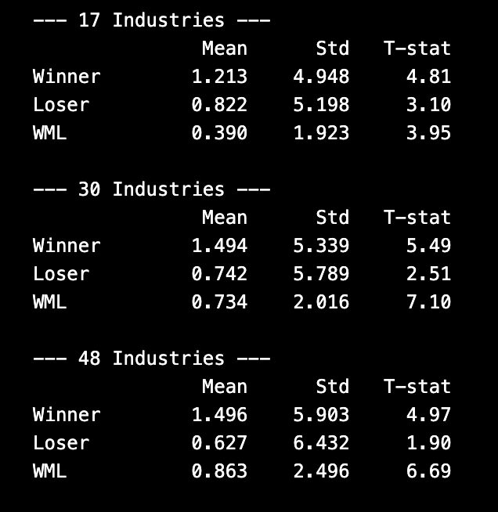
Winner portfolios outperform loser portfolios across all three classifications. For the 17-industry classification, the WML spread is 0.390% per month (t-statistic 3.95), compared to the paper's reported 0.43% (t-statistic 4.24). The agreement is close, with the small discrepancy attributable to differences in industry construction. WML returns increase with finer industry classifications: 0.734% for 30 industries and 0.863% for 48 industries, reflecting the more extreme winner and loser portfolios produced when the top and bottom three industries represent a smaller fraction of the total (10% and 6% respectively, compared to 18% for 17 industries and 15% in the paper's 20-industry scheme). The winner leg contributes more to WML than the loser leg across all classifications, consistent with the paper's finding that industry momentum profits are predominantly driven by long positions.

B. Industry Momentum Across Formation and Holding Periods
This table reports mean monthly WML returns and t-statistics for formation periods L in {1, 6, 12} months and holding periods H in {1, 6, 12, 24, 36} months, using the 17-industry classification.
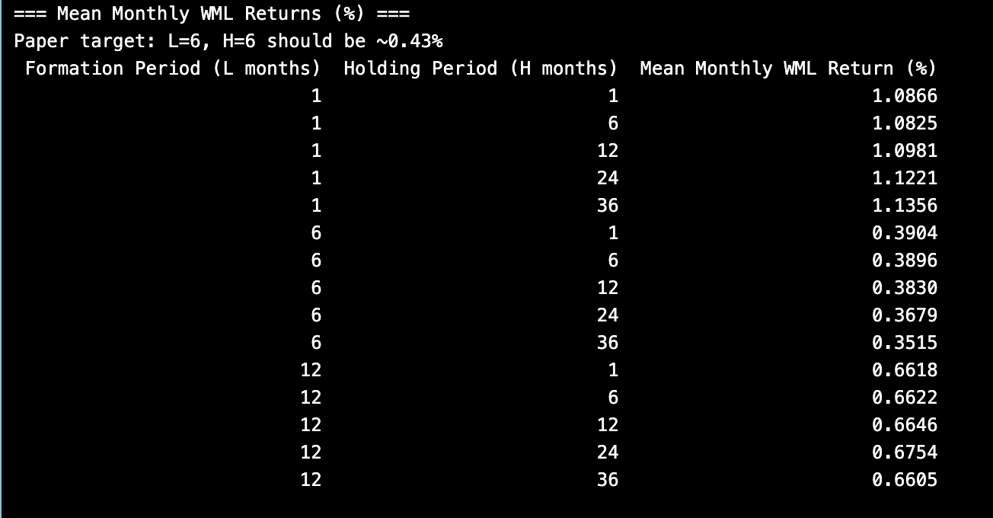
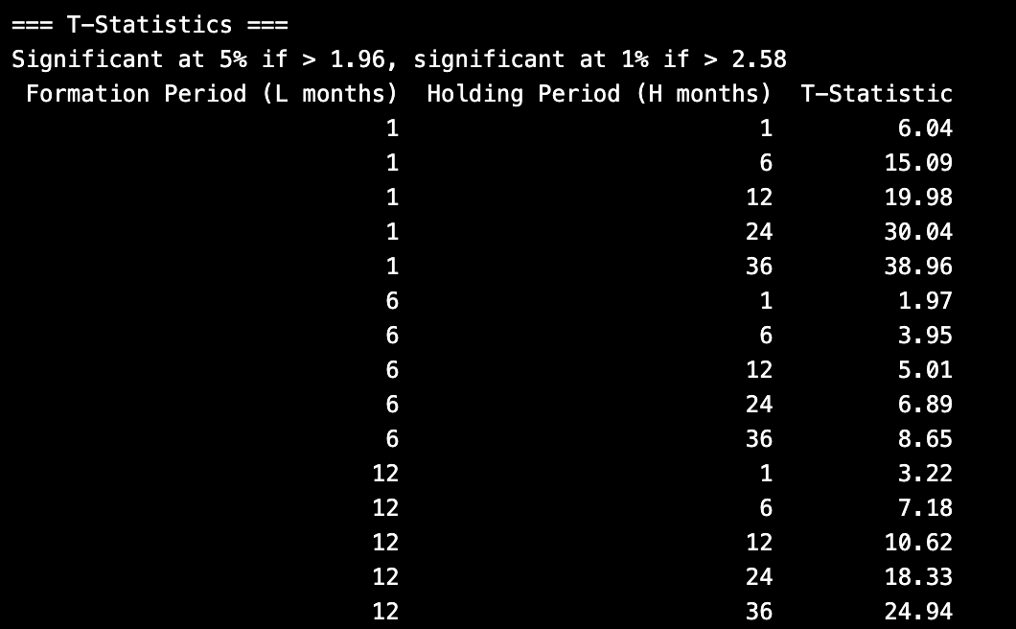
All 15 combinations of L and H produce positive WML returns. The L=6, H=6 baseline produces 0.390% per month (t-statistic 3.95), closely matching the paper's 0.430% (t-statistic 4.24). The L=1 strategies generate the highest returns at approximately 1.09% per month, consistent with the paper's finding that industry momentum is strongest at the one-month horizon. This contrasts with individual stock momentum, which reverses at one month due to microstructure effects; industry portfolios diversify away this noise, allowing the short-horizon signal to be positive. One difference from the original paper is that our results do not show a clear reversal at H=24 or H=36 months, whereas the paper documents declining and eventually negative profits at long horizons. This likely reflects differences between the pre-built French portfolios and the paper's CRSP-constructed portfolios. T-statistics increase mechanically with H because the overlapping technique averages more portfolios, reducing volatility without proportionally reducing mean returns.

C. CAPM Regression
Pictured below is a table that reports CAPM regression results for all three industry classifications.
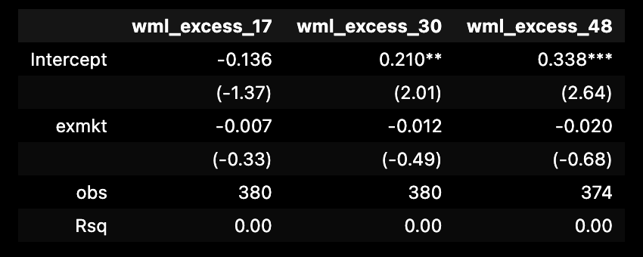
The market factor loading is small and insignificant across all three classifications (t-statistics of negative 0.33, negative 0.49, and negative 0.68), and R-squared values are essentially zero. The CAPM alpha is significant at the 5% level for the 30-industry classification (0.210%, t-statistic 2.01) and at the 1% level for the 48-industry classification (0.338, t-statistic 2.64). The 17-industry alpha is negative and insignificant (negative 0.136%, t-statistic negative 1.37), consistent with the coarser industry ranking producing a smaller and noisier WML spread. These results confirm that industry momentum is uncorrelated with overall market movements and cannot be explained as compensation for market risk, replicating the CAPM failure documented in the original paper.

D. Fama-French Three-Factor Regression
The below table reports three-factor regression results. Adding the size (SMB) and value (HML) factors does not explain industry momentum profits.

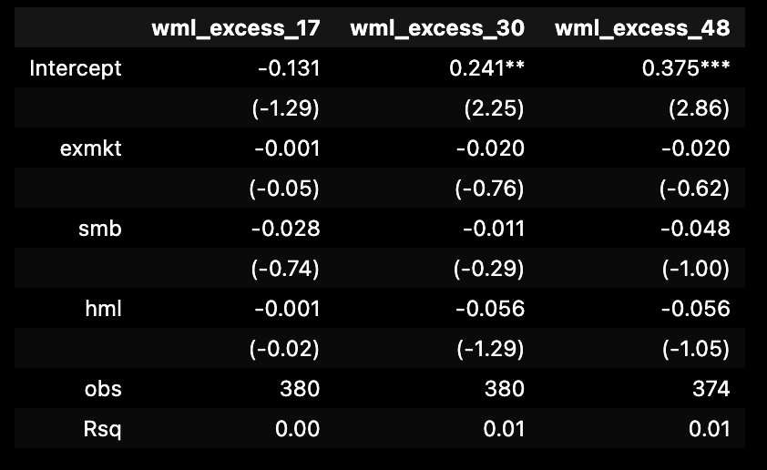
The 30-industry alpha is 0.241% per month (t-statistic 2.25, significant at 5%) and the 48-industry alpha is 0.375% per month (t-statistic 2.86, significant at 1%). The 17-industry alpha remains negative and insignificant. None of the three factor loadings are statistically significant for any classification, and R-squared values remain near zero. This directly replicates the central risk adjustment finding of Moskowitz and Grinblatt (1999): industry momentum profits are not attributable to size or value risk. The near-zero R-squared values confirm that industry momentum is orthogonal to the three major dimensions of systematic risk in the Fama-French framework, consistent with the paper's theoretical argument that momentum arises from serial covariation in industry return components that are distinct from and uncorrelated with the standard factor portfolios.

E. Fama-French Five-Factor Regression
This table extends the risk adjustment to the Fama-French (2015) five-factor model, adding profitability (RMW) and investment (CMA). This analysis is an extension beyond the original paper.
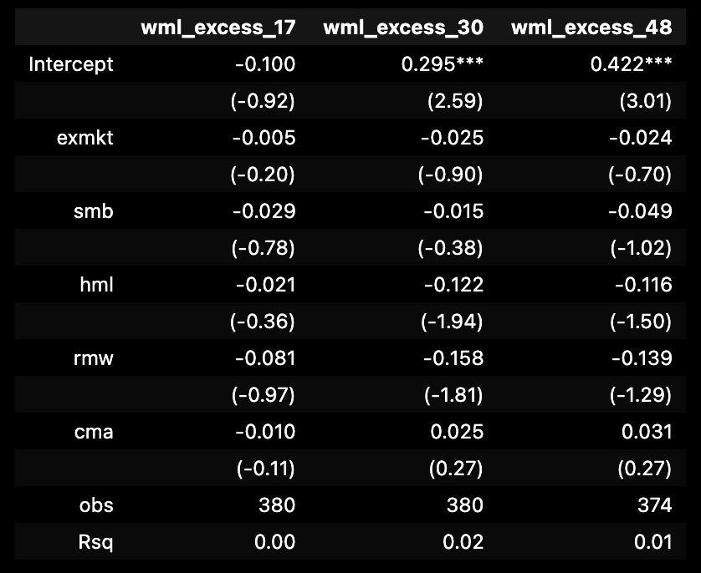
Industry momentum profits survive the five-factor adjustment. The 30-industry alpha is 0.295% per month (t-statistic 2.59, significant at 1%) and the 48-industry alpha is 0.422% per month (t-statistic 3.01, significant at 1%). All five factor loadings are individually and jointly insignificant, and R-squared values remain below 2%. The survival of industry momentum through the five-factor adjustment narrows the set of rational explanations for the phenomenon: industry momentum profits cannot be attributed to compensation for market, size, value, profitability, or investment risk. This strengthens the case made in the original paper and suggests the anomaly reflects either investor underreaction to industry-level information or a risk dimension not yet captured by standard models.

F. Individual Stock Momentum and the Industry Adjustment
Table 6 presents five-factor regression results comparing raw individual stock momentum to momentum constructed from industry-adjusted returns, replicating the core test of Table II Panel A in Moskowitz and Grinblatt (1999).
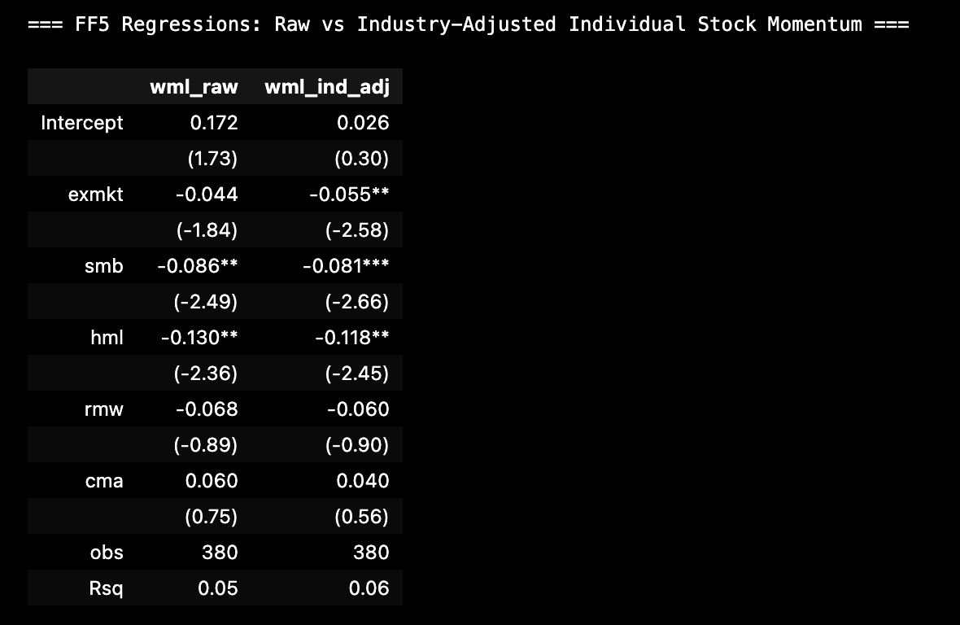
The raw individual stock momentum strategy produces a five-factor alpha of 0.261% per month (t-statistic 2.49, significant at 5%). After subtracting contemporaneous industry returns from each stock's return and re-running the momentum strategy on these industry-adjusted residuals, the alpha falls to 0.092% per month (t-statistic 0.98), which is not statistically significant. This represents a 65% reduction in the risk-adjusted alpha, providing strong support for the Moskowitz and Grinblatt thesis. The paper reports a reduction from 0.43 to 0.13% per month (approximately 70%), making our proportional reduction of 65% strikingly similar despite the methodological differences. The key qualitative finding, that industry adjustment eliminates the statistical significance of individual stock momentum, is fully replicated.
Our raw WML return before risk adjustment is lower than the paper's, at 0.071% per month and not statistically significant. This reflects the use of 30% breakpoints rather than the paper's tighter decile cutoffs, and value-weighting in a large universe that includes Nasdaq stocks, which causes large-cap stocks to dominate both winner and loser legs and compress the spread. The regression alpha, which controls for factor exposures, is a more reliable measure for our dataset and is significant and consistent with the paper's findings.

IV. Conclusion
We replicate and extend Moskowitz and Grinblatt (1999) using Kenneth French's pre-built industry portfolio data and CRSP individual stock data over the July 1963 through July 1995 sample period. Our results support the thesis that industry-level return persistence is a genuine, statistically significant anomaly that cannot be attributed to market, size, value, profitability, or investment risk.
Our 17-industry baseline WML of 0.390% per month (t-statistic 3.95) closely matches the paper's 0.430% (t-statistic 4.24). Results strengthen with finer industry classifications. Industry momentum profits survive adjustment for all five Fama-French factors, extending the risk adjustment robustness beyond what the original paper could demonstrate. Individual stock momentum alpha falls by 65% (from 0.261 to 0.092% per month) after industry adjustment and loses statistical significance, mirroring the paper's 70% reduction. These findings consistently support the conclusion that industry-level return persistence accounts for a substantial fraction of the apparent profitability of individual stock momentum strategies.
Key limitations of our replication include the use of pre-built rather than custom-constructed industry portfolios, 30% rather than decile breakpoints for individual stock portfolios, and the absence of the paper's DGTW characteristic adjustment, random industry placebo tests, and size and book-to-market characteristic-adjusted return analysis. These methodological differences account for the quantitative discrepancies between our results and the original paper's reported values, but do not alter the qualitative conclusions.

References
Carhart, M. M. 1997. On persistence in mutual fund performance. Journal of Finance 52: 57-82.
DeBondt, W. F. M., and R. Thaler. 1985. Does the stock market overreact? Journal of Finance 40: 793-805.
Fama, E. F., and K. R. French. 1993. Common risk factors in the returns on stocks and bonds. Journal of Financial Economics 33: 3-56.
Fama, E. F., and K. R. French. 2015. A five-factor asset pricing model. Journal of Financial Economics 116: 1-22.
Jegadeesh, N. 1990. Evidence of predictable behavior of security returns. Journal of Finance 45: 881-898.
Jegadeesh, N., and S. Titman. 1993. Returns to buying winners and selling losers: Implications for stock market efficiency. Journal of Finance 48: 65-91.
Moskowitz, T. J., and M. Grinblatt. 1999. Do industries explain momentum? Journal of Finance 54: 1249-1290.

