Q1:

i. Bezier curve
Beizer curves use at least three points to define a curve. The two endpoints of the curve are called anchor points, and the other points, which define the shape of the curve, are called handles, tangents points, or nodes. Attached to each handle are two control points. By moving the handle themselves, you can modify the shape of the curve.

ii. Chromaticity
Chromaticity is the quality of the color, independent of the brightness. It generally consists of two independent parameters, hue and colorfulness.

iii. Lambert’s Cosine Law
Lambert's cosine laws says that the radiant intensity or luminous intensity observed from an ideal diffusely reflecting surface is directly proportional to the cosine of the angle θ between the direction of the incident light and the surface normal.

iv. Affine Transformation
Affine transformation is a function between affine spaces which preserves points, straight lines, and planes. Sets of parallel lines remain parallel after an affine transformation. The affine transformation technique is typically used to correct for geometric distortions or deformations that occur with non-ideal camera angles.

v. Convolution
In mathematics, convolution is a mathematical operation on two functions f and g, producing a third function that is typically viewed as a modified version of one of the original functions. In image processing, we use the mathematical definition loosely. In image processing convolution refers to the process of multiplying an image by a kernel to get some kind of result.

Q2:
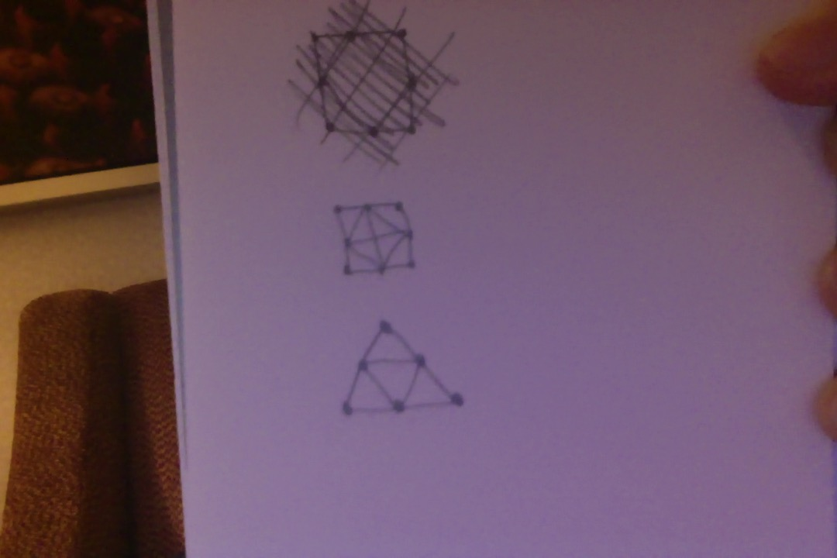

Q3:
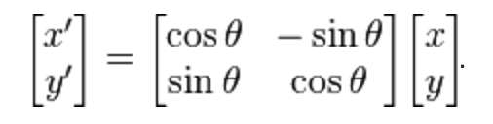

This is the rotation formula in 2d. We would use this matrix to calculate the new coordinates after ϕ had been rotated counterclockwise.

Q4:

Assumption: the middle value is not part of the 'surrounding neighborhood'.
= floor(40/8) = floor(5) = 5

The new pixel value is 5

Q5:

What is the darkest color?

1. Northeastern Red
2. Pittsburgh Pirates Gold
3. Detroit Tigers Orange
4. Boston Red Sox Blue
5. UCLA Blue

