1.

a.
53₁₀
53-32 => 00100000, 18 left
21-16 => 00110000, 5 left
5-4 => 00110100, 1 left
1-1 => 00110101, 0 left
= 00110101

b.
FA₁₆
F = 1111, A = 1010
= 11111010

2.

a.
19₁₀ → ( ? )₂
19-16 => 00010000, 3 left
3-2 => 00010010, 1 left
1-1 => 00010011, 0 left
= 00010011

b.
-13₁₀→ ( ? )₂
13-8 => 00001000, 5 left
5-4 => 00001100, 1 left
1-1 => 00001101, 0 left
Flip it to negative: 11110010
Add 1: 11110011
= 11110011

c.
-23₁₀ → ( ? )₁₆
23-16 => 00010000, 7 left
7-4 => 00010100, 3 left
3-2 => 00010110, 1 left
1-1 => 00010111
Flip it to negative: 11101000
Add 1: 11101001
Make it hex: E9
= 0xFFFFFFFFFFFFFFE9

d.
ED₁₆ → ( ? )₁₀
Make it binary: 11101101
11101101 => 1 + 4 + 8 + 32 + 64 +128 = 237
= 237

3.
a.
0xABCD or 0x9876
0xABCD => 1010 1011 1100 1101
0x9876 => 1001 1000 0111 0110
1010 1011 1100 1101 or
1001 1000 0111 0110
= 1011 1011 1111 1111
= 0xBBFF

b.
0xFEED and (not(0xBEEF))
0xFEED => 1111 1110 1110 1101
0xBEEF => 1011 1110 1110 1111
not (0xBEEF) => 0100 0001 0001 0000
1111 1110 1110 1101 and
0100 0001 0001 0000
= 0100 0000 0000 0000
Convert to hex: 0x8000
= 0x8000

4. Code:

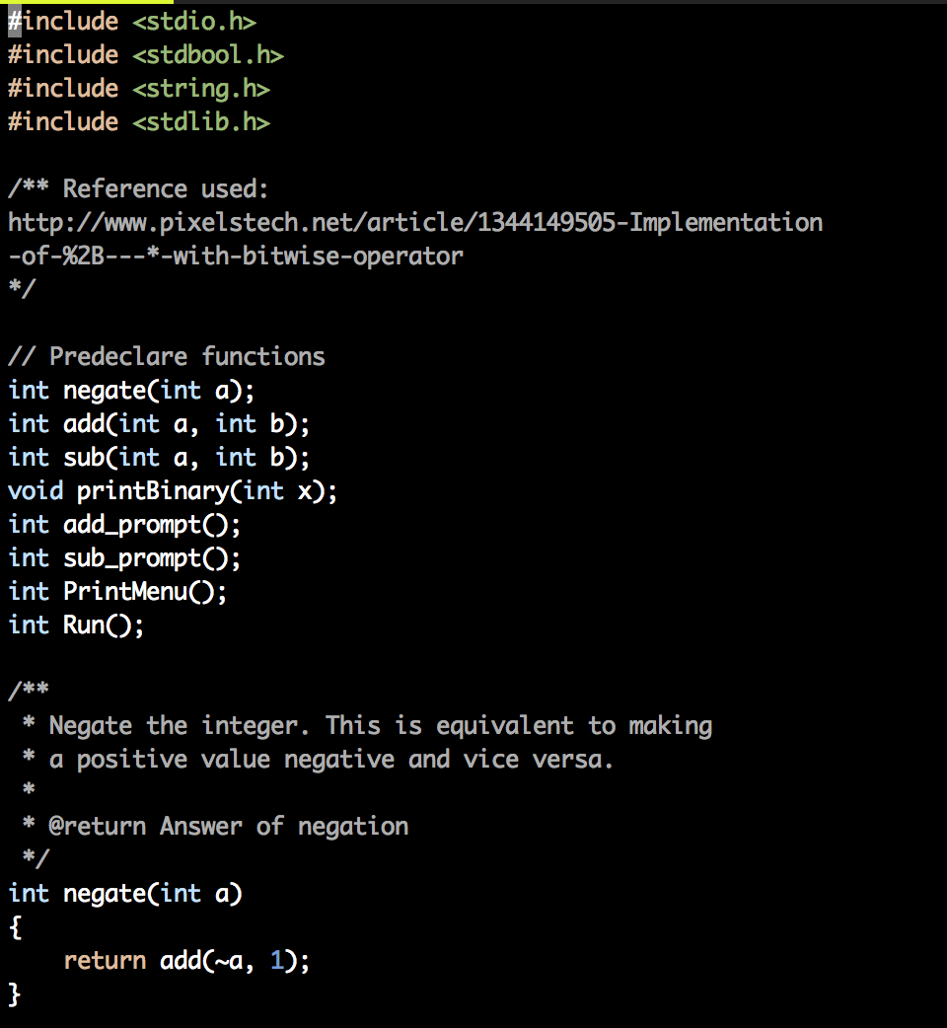

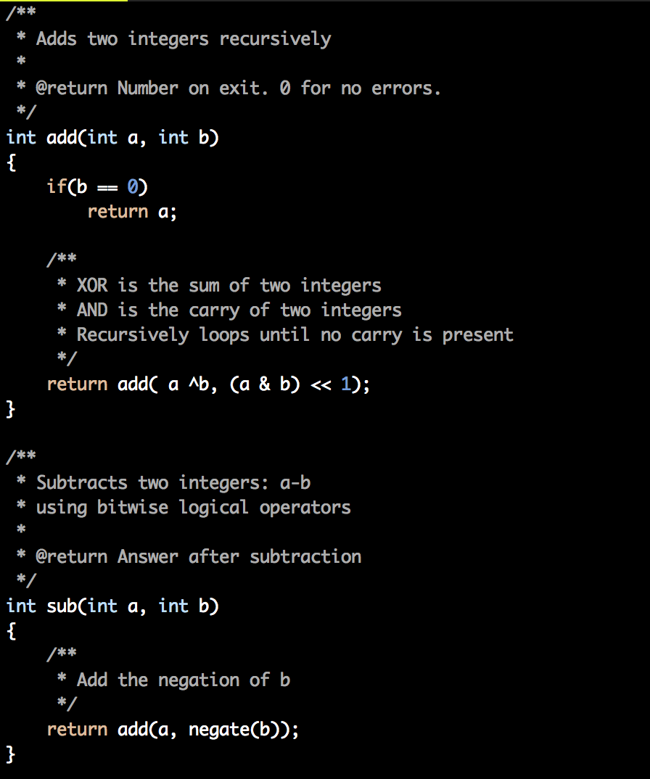

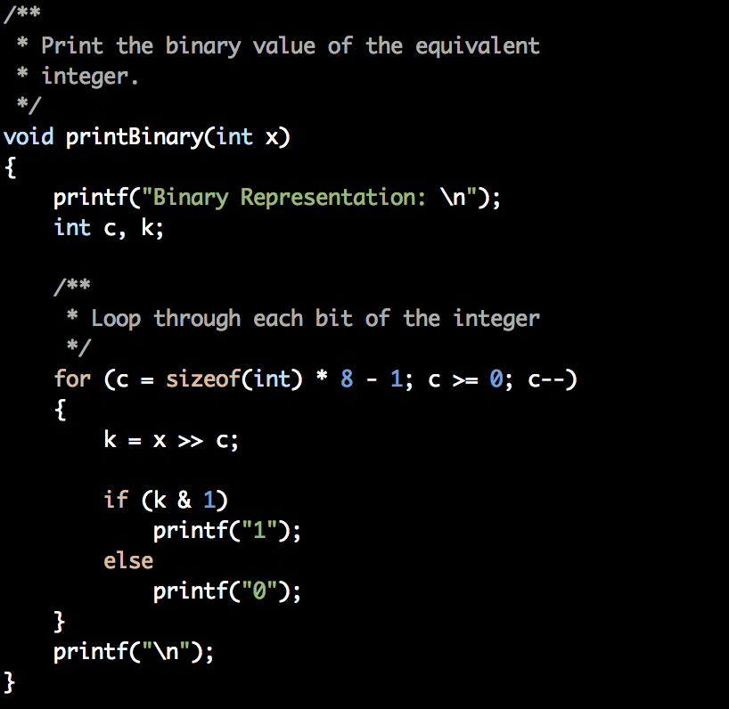

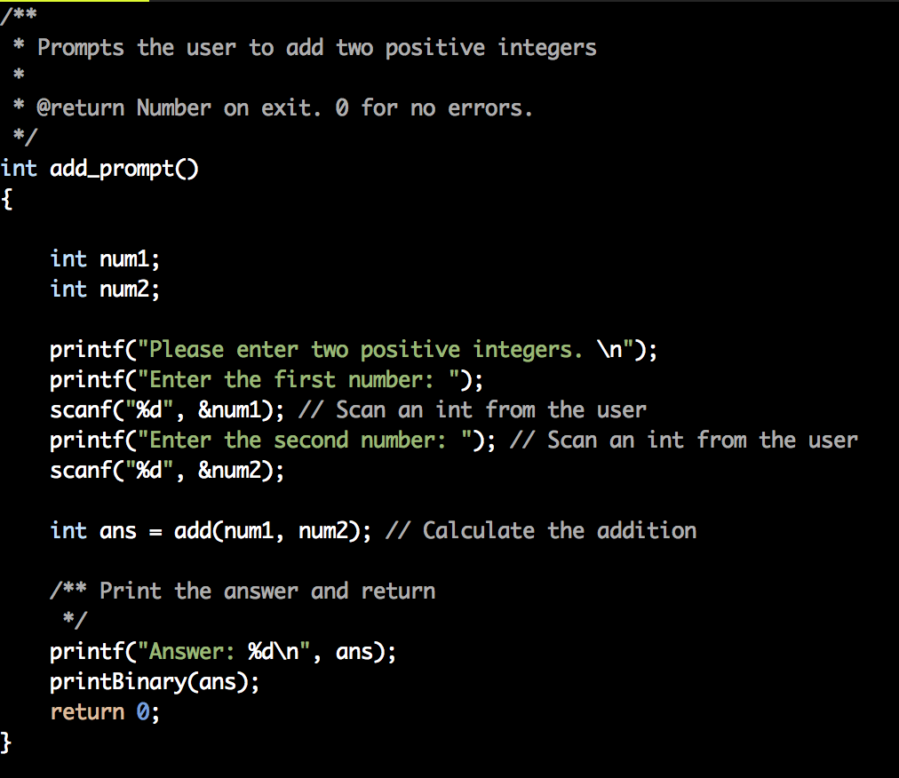

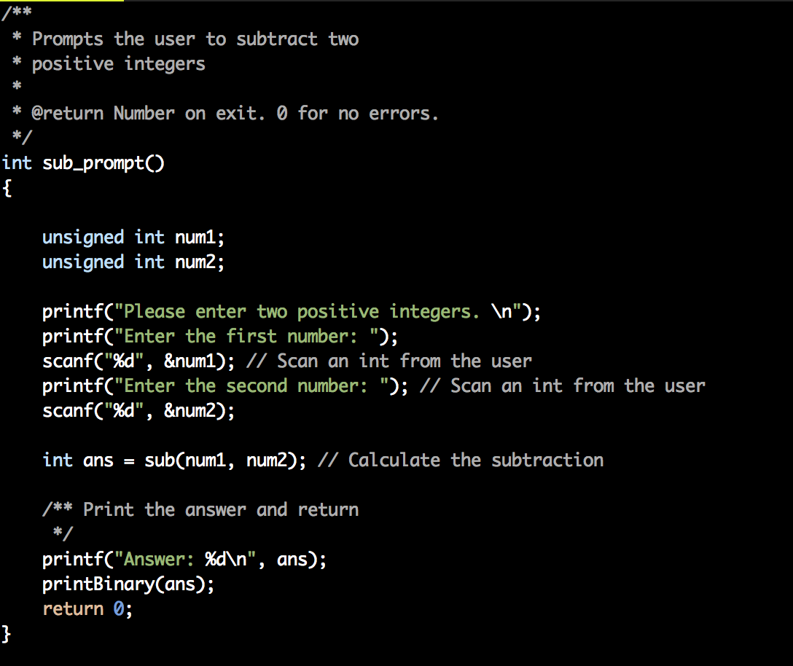

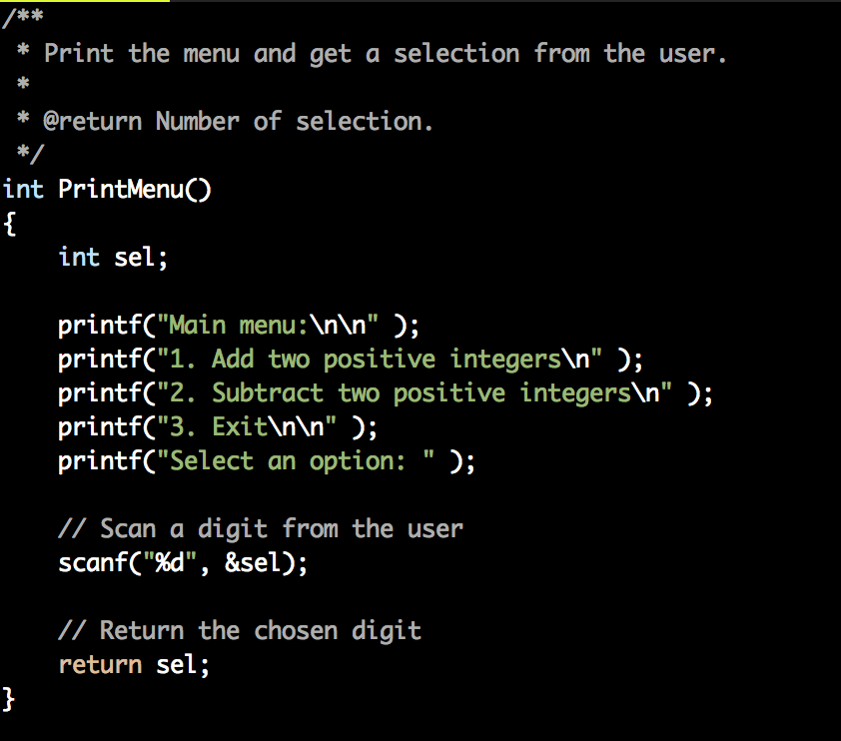

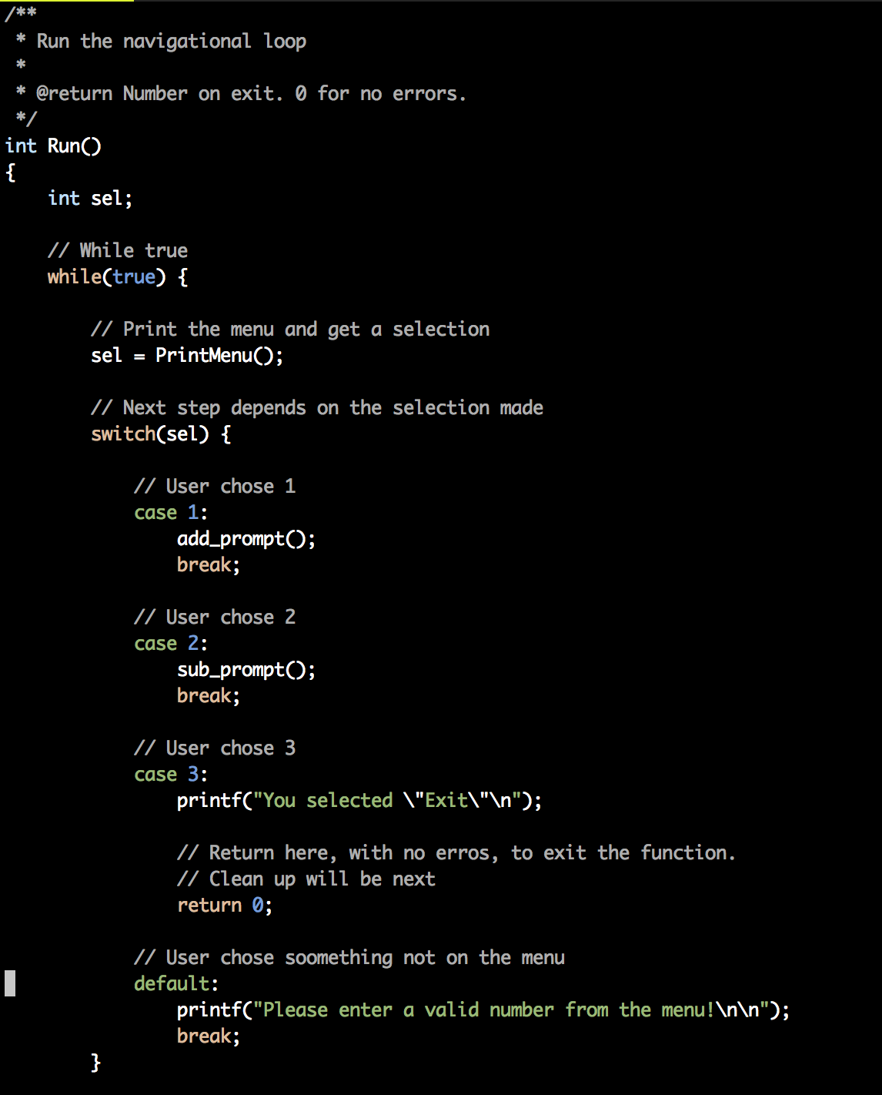
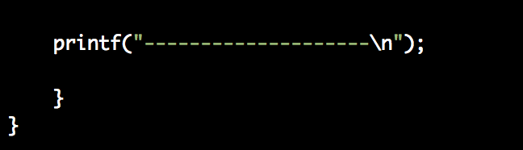

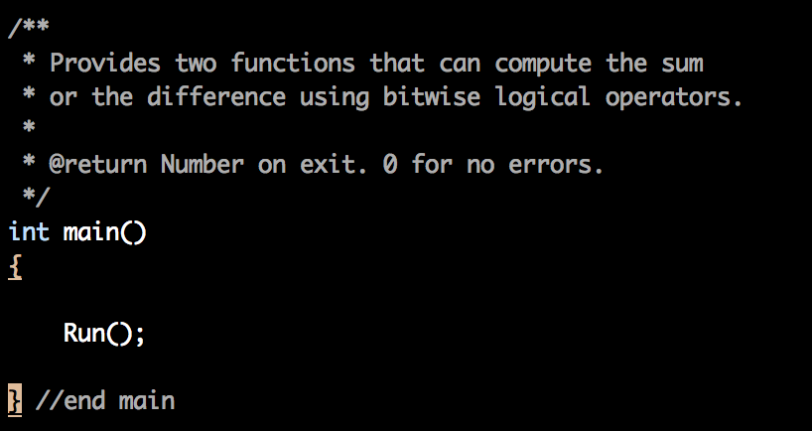

4. Running the Code:
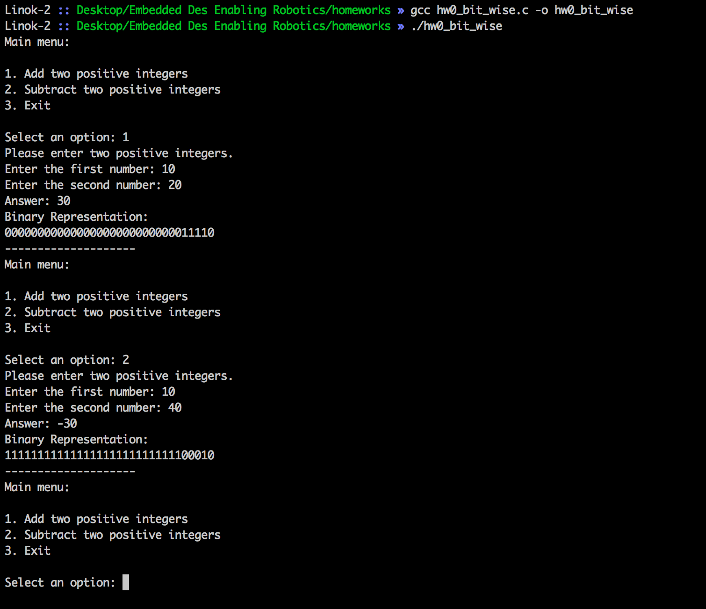

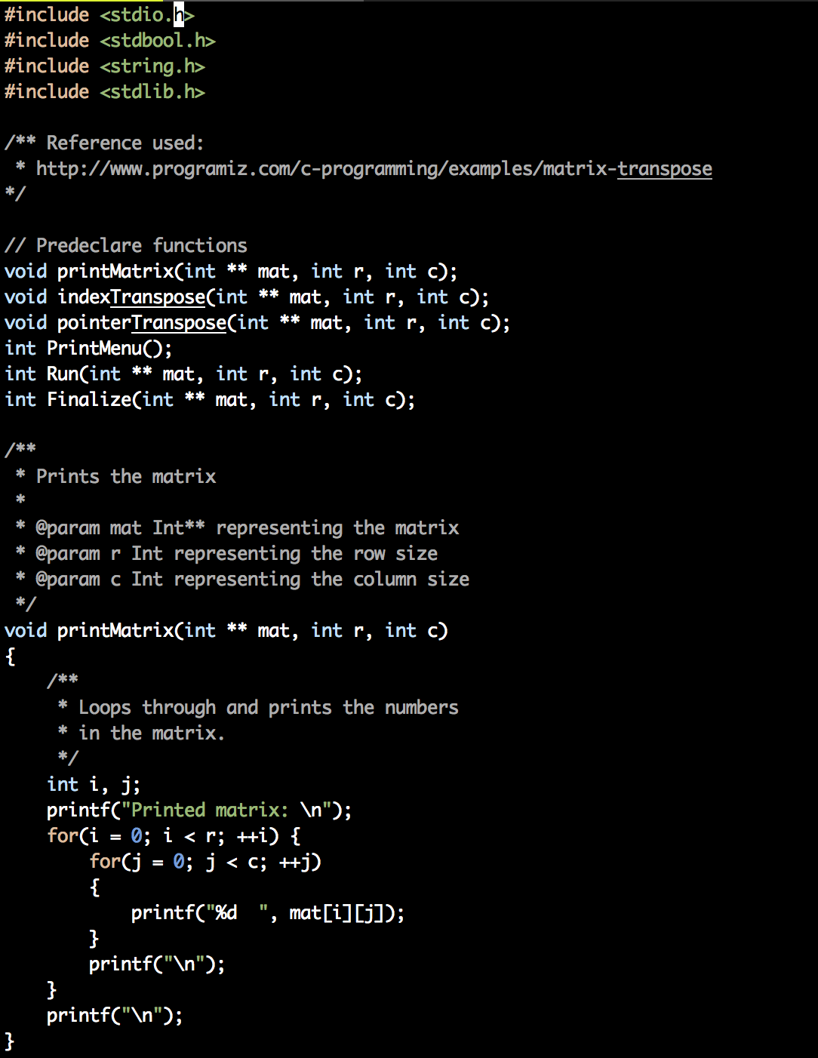
5. Code:
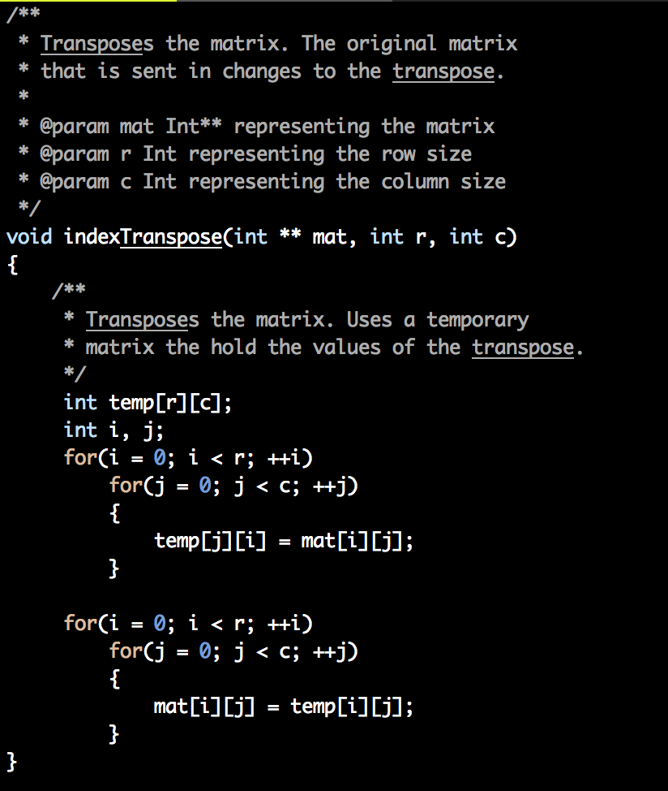

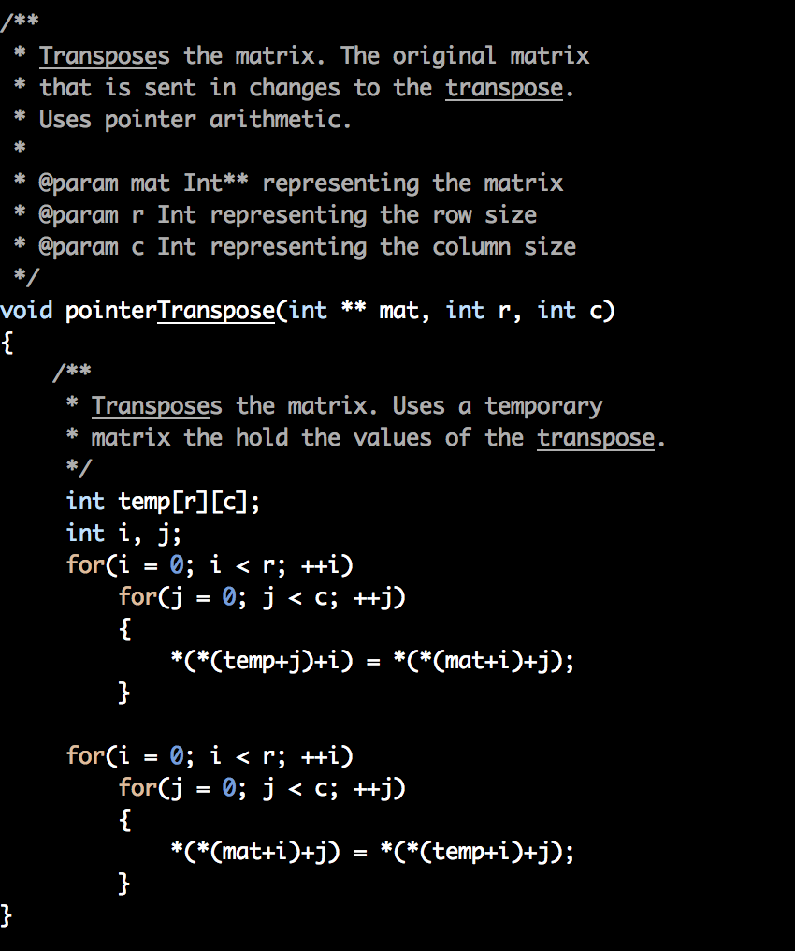

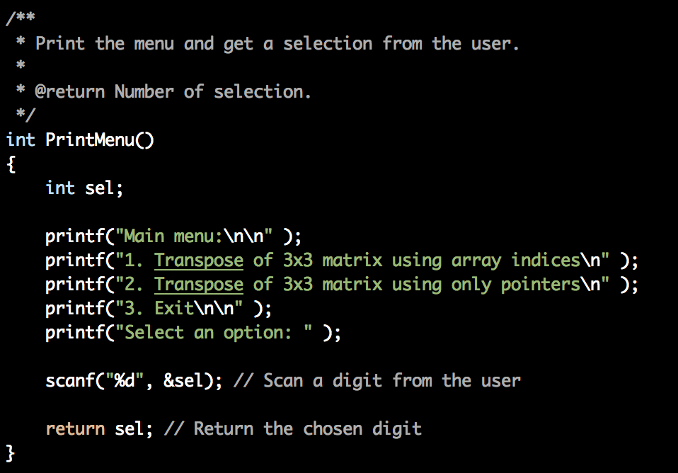

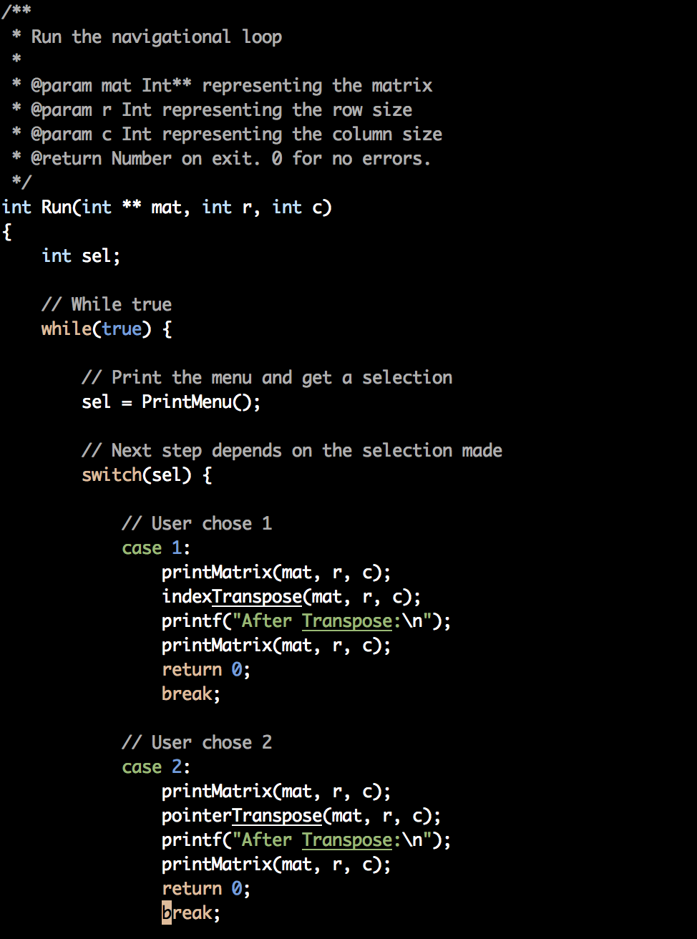
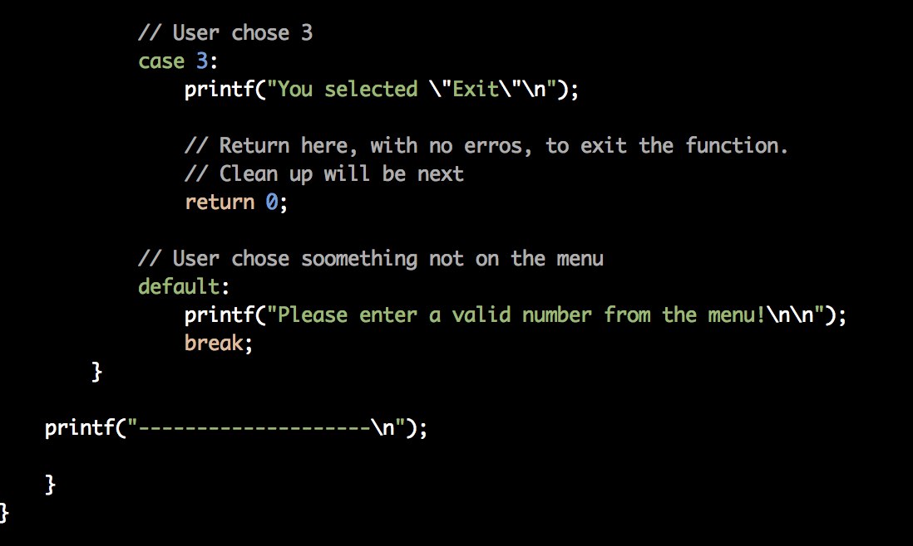
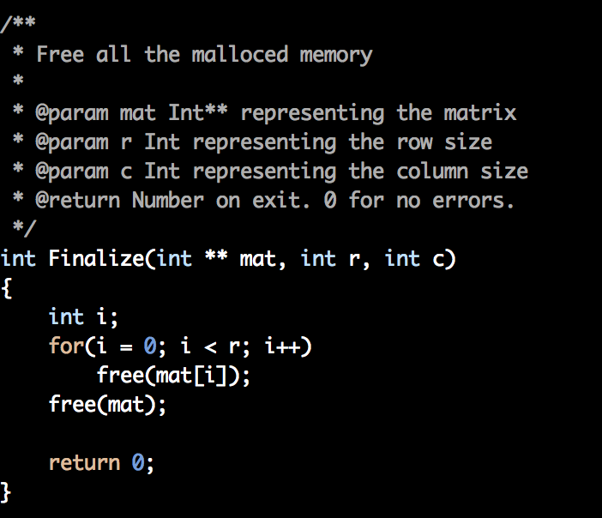

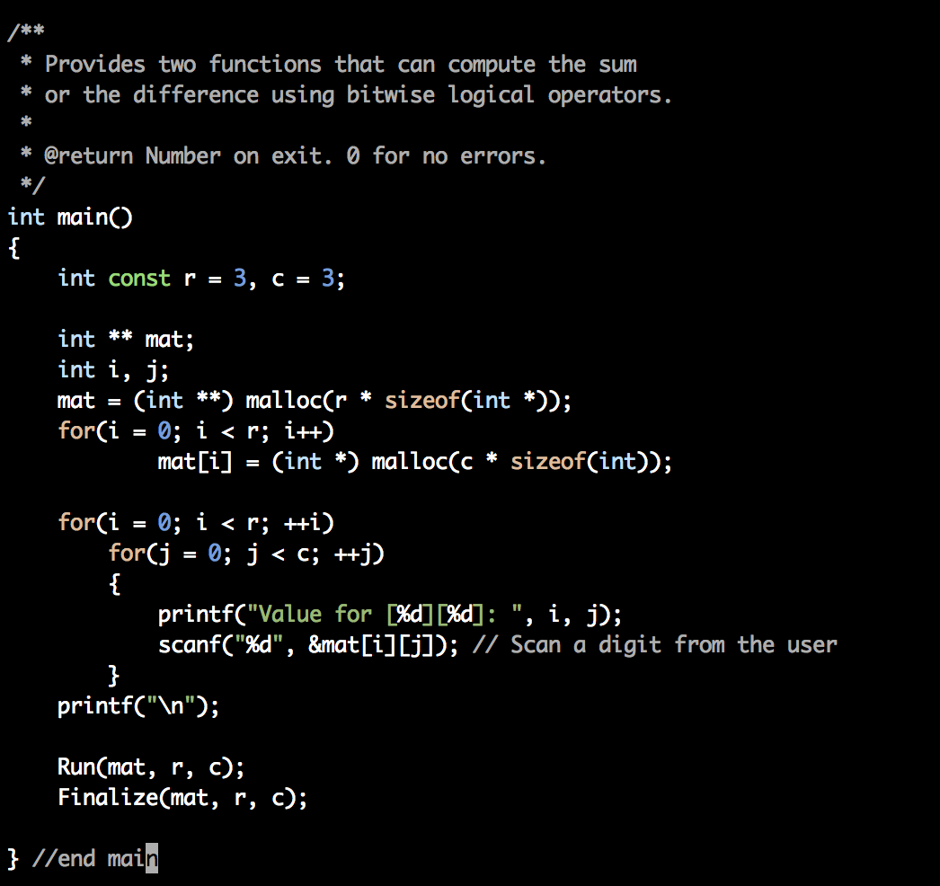

5. Run Program:

