Lab Assignment 1
Zedboard Linux Getting Started

Patricia Gavelek, Anders Dahl
Gavelek.p@husky.neu.edu
dahl.a@husky.neu.edu

Submit date: 1/21/16
Due Date: 1/20/16

Abstract
The goal of this first lab was to get started and familiarized with the Zedboard, Linux command line, and the C programming language. Connections were formed to the board through the use of SSH. Working with the Zedboard requires familiarity with the Linux command line. For the final part of the lab, various C programs were written on the Zedboard. We used Vim as our text editor of choice.

Introduction
The goal of this first lab was to get started and familiarized with the Zedboard, Linux command line, and the C programming language. From the Linux command line, one is able to securely connect to the Zedboard through the use of SSH. The command line also allows for general navigation once on the system. Getting comfortable with the C programming language was a major part of the lab. We looked at some simple programs – hello world, sort 10 integers, and sort 10 strings. We used Vim as our text editor of choice.

Lab Discussion
In this lab, a computer, a Zedboard and all its’ corresponding cables are all the parts that are needed. MobaXterm is the program on the computer used to run a secure shell which connects to the Zedboard. An IP address and username were used to SSH into the Zedboard. STFP was used to transfer files from the Zedboard back to our computers. SSH and SFTP are used because they encrypt information, whereas Telnet and FTP use plain text, which can be more easily read by third parties. [1]

Results and Analysis
Lab 0.1 Connecting to ZedBoard
The Zedboard is connected to the host via Ethernet to the RJ45 connector. The host connects from the USB to Ethernet adapter. Once the Zedboard is powered on, a secure connection can be made with the use of SSH. The IP address is 192.168.1.10, and the user is a combination of the section and group number. A password also needs to be entered.
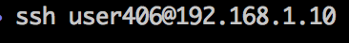
Lab 0.2 User Accounts and ZedBoard Login
The root user has access to all files and commands. Because the root user has access to everything, files that are not supposed to be accessed may be tampered with and in general being the root user can cause security issues. This is why we are logged in as user406 instead.
Lab 0.3 Hello World on ZedBoard
“Hello world” is the most basic of codes and is used to introduce almost every single programming language.

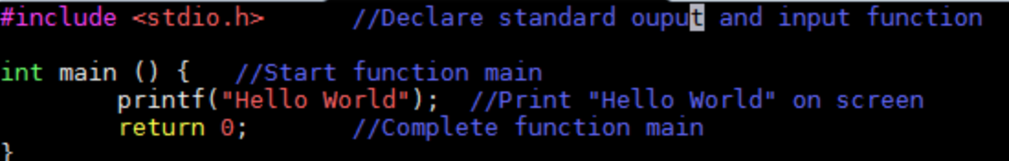
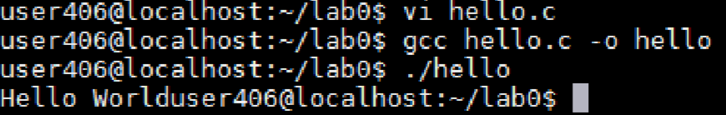
The gcc hello.c –o hello compiles the text file into an executable file that the computer can read and carry out. Running this newly produced file displays the “Hello World” in the terminal. SFTP was used to transfer the files back to our other computers.
Lab 0.4 Sorting 10 integers
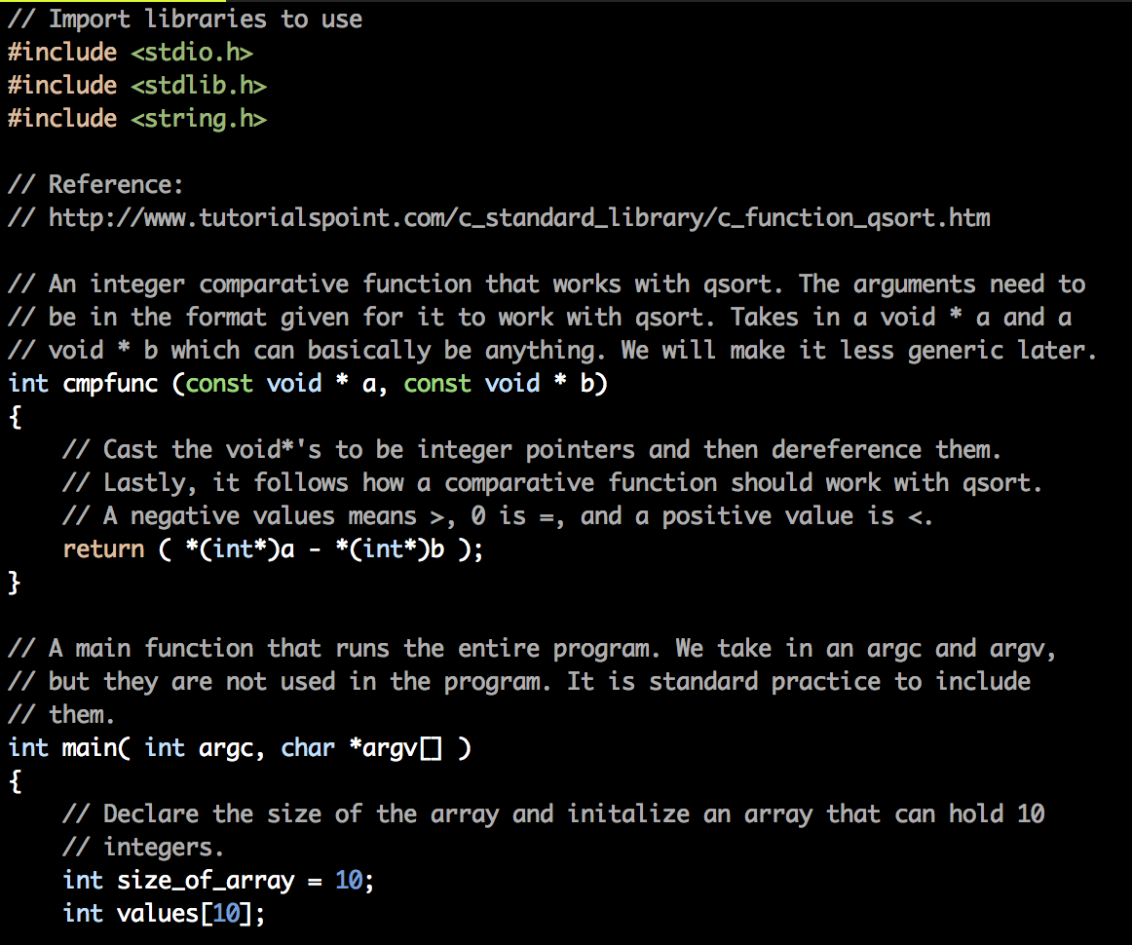

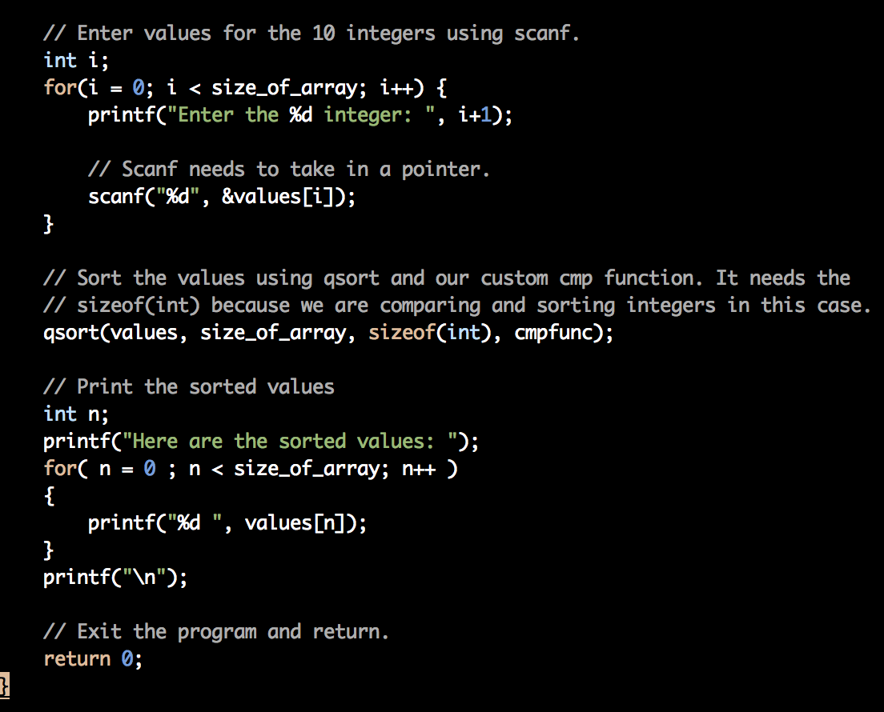

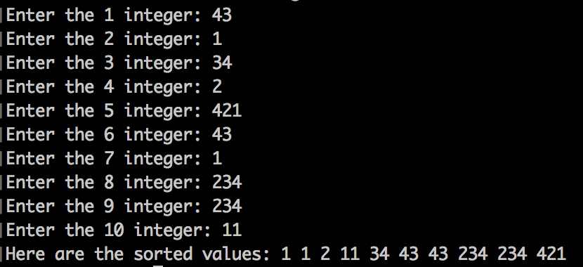

Extra credit. Sorting 10 strings
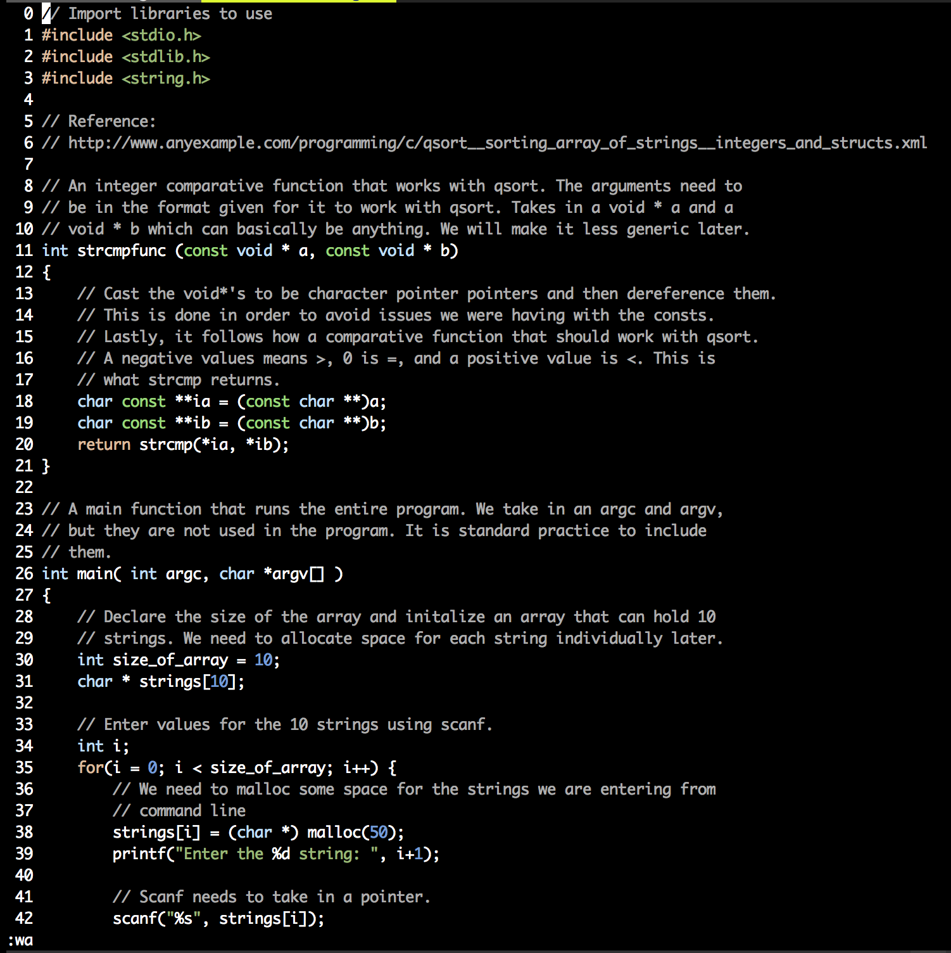

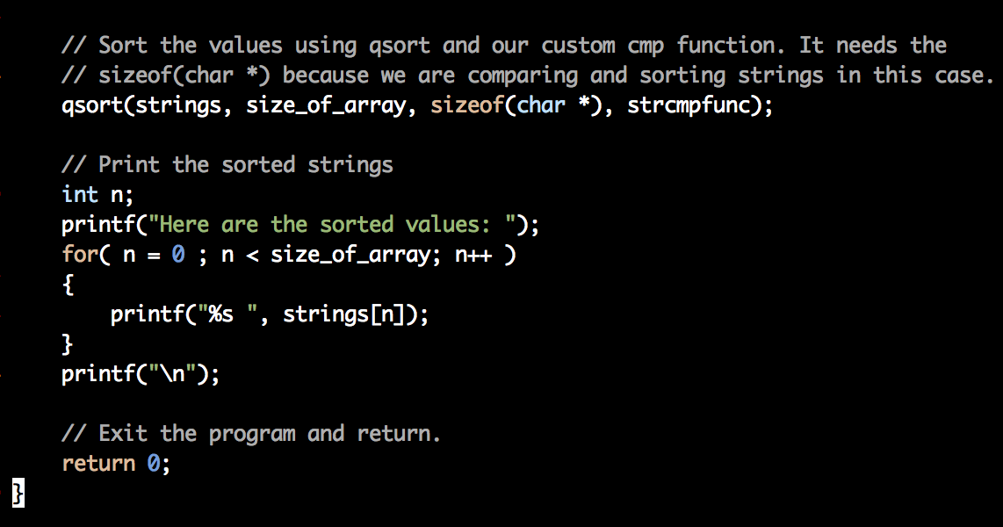

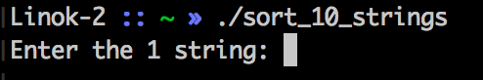

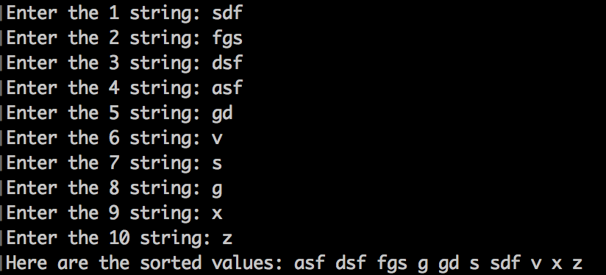

Conclusion
After having completed this lab, one should be able to program on the Zedboard using mobaxterm and write a simple sort in C. There are significant differences between C++ and C, which doing this lab made abundantly clear.

References
- http://www.itcs.umich.edu/ssh/

